# **Loan Status Prediction Using IBM Watson Machine Learning**

**INDEX:**

**1.Introduction**

**2.Literature Survey**

**3.Theoretical Analysis**

**4.Experimental Investigations**

**5.Flow Chart**

**6.Result**

**7.Advantages & Disadvantages**

**8.Applications**

**9.Conclusion**

**10.Future Scope**

**11.Bibliography**

**12.Appendix**

**Introduction**

**OVERVIEW :**

In India, the number of people applying for loans gets increased for various reasons in recent years. The bank employees are not able to analyze or predict whether the customer can pay back the amount or not (good customer or bad customer) for the given interest rate. The aim is to find the nature of the client applying for a personal loan and find if they paid the loan or not.

The result of the analysis shows that short term loans are preferred by the majority of the clients and the clients majorly apply loans for debt consolidation. The results are shown in graphs that help the bankers to understand the client’s behavior.

Loans are the core business of banks. The main profit comes directly from the loan’s interest. The loan companies grant a loan after an intensive process of verification and validation. However, they still don’t have assurance if the applicant is able to repay the loan with no difficulties.

**PURPOSE** :

Build a predictive model to automate the process of targeting the right applicants and find if the loan is paid or not. Loans are the core business of loan companies. The main profit comes directly from the loan's interest. The loan companies grant a loan after an intensive process of verification and validation

**Literature Survey**

**Existing problem :**

At present if we need to know about the status of the loan one must go to bank and need to enquiry about their loan. This is a tedious process and takes more time of both the person who took the loan and employee of the bank to check the status of the person’s loan.

**Proposed solution :**

Now, we would propose a solution for this tedious process. First, we will collect the details of the person regarding their loan and then preprocess the data and give it to the machine learning model that we developed and the model will give the report whether the person has paid the loan or not.

**Theoretical Analysis**

**Block diagram :**

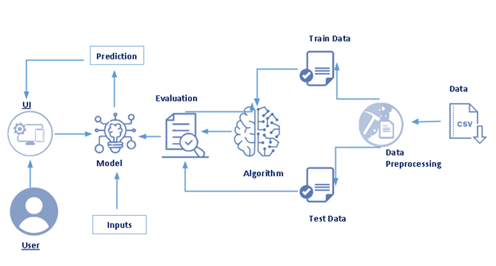

**Hardware / Software designing :**

**Skills Required:**

Python, Python Web Frame Works, Machine Learning, Classification Algorithms, Python-Flask

To build Machine learning models you must require the following packages

**Software Installations**

In order to develop this project we need to install following software/packages

**Anaconda Navigator:**

Anaconda Navigator is a free and open-source distribution of the Python and R programming languages for data science and machine learning related applications. It can be installed on Windows, Linux, and macOS.Conda is an open-source, cross-platform, package management system. Anaconda comes with so very nice tools like JupyterLab, Jupyter Notebook,

QtConsole, Spyder, Glueviz, Orange, Rstudio, Visual Studio Code. For this project, we will be using Jupyter notebook and Spyder

**Numpy:**

* It is an open-source numerical Python library. It contains a multidimensional array and matrix data structures and can be used to perform mathematical operations

**Scikit-learn:**

* + It is a free machine learning library for Python. It features various algorithms like support vector machine, random forests, and k-neighbours, and it also supports Python numerical and scientific libraries like NumPy and SciPy
* **Matplotlib and Seaborn:**
  + Matplotlib is mainly deployed for basic plotting. Visualization using Matplotlib generally consists of bars, pies, lines, scatter plots and so on. Seaborn: Seaborn, on the other hand, provides a variety of visualization patterns. It uses fewer syntax and has easily interesting default themes.
* **Flask:**
  + Web framework used for building Web applications

**Experimental Investigations**

* Different fields in our data set can be classified as shown below:

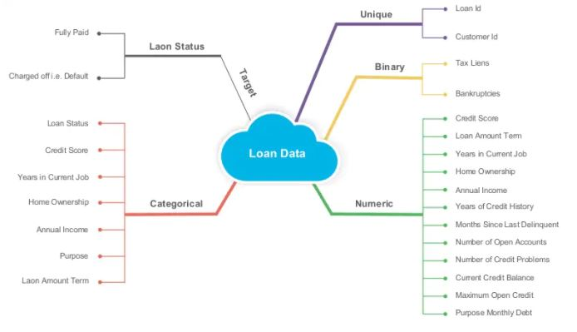

* Decision tree example can be as shown below:

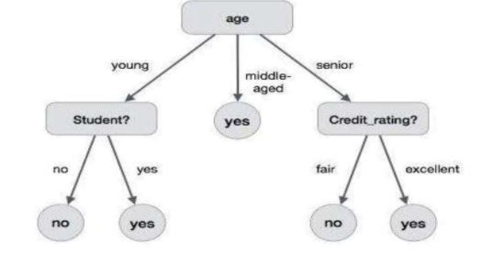

**Flowchart**

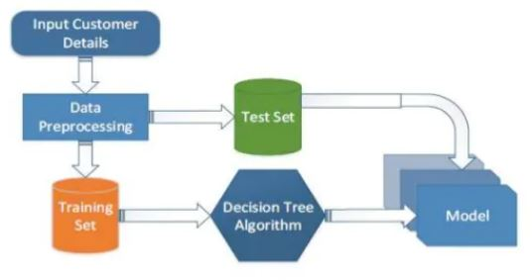

**Result**

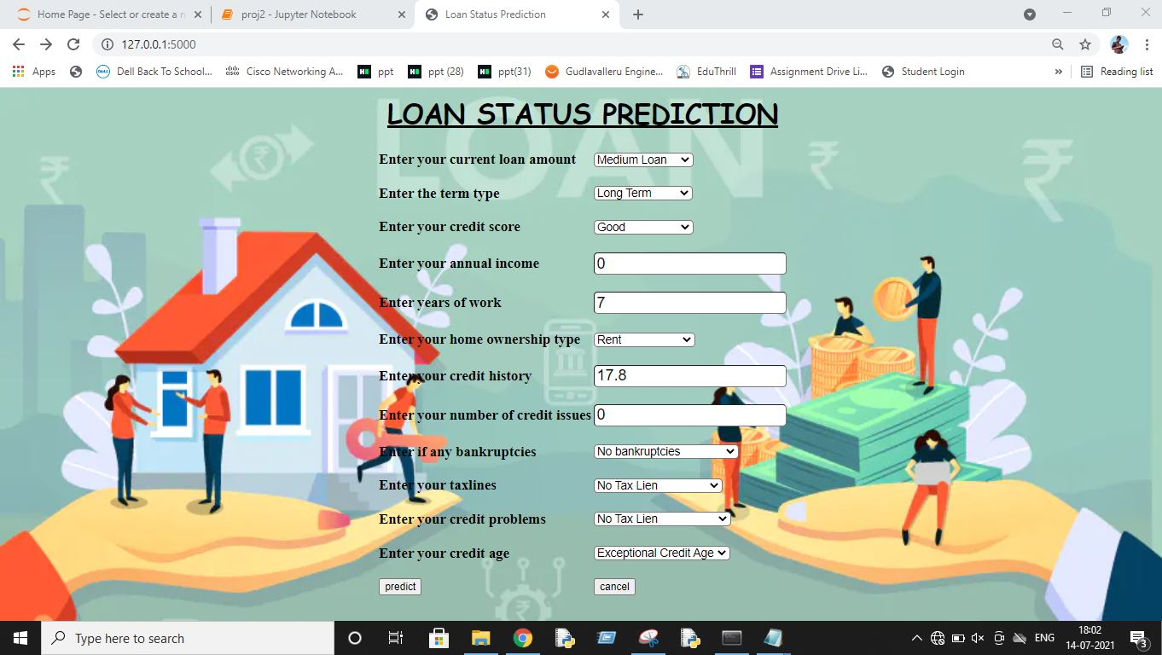

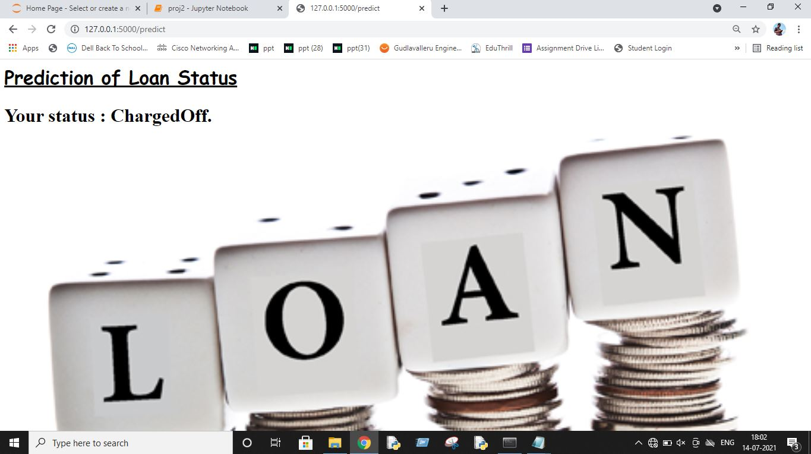

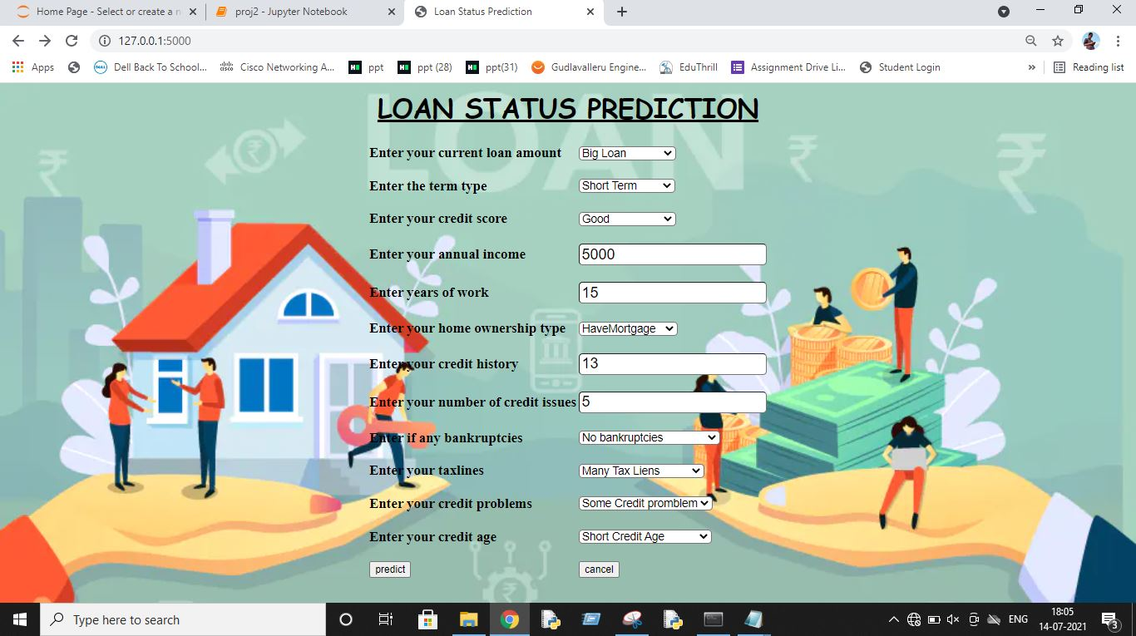

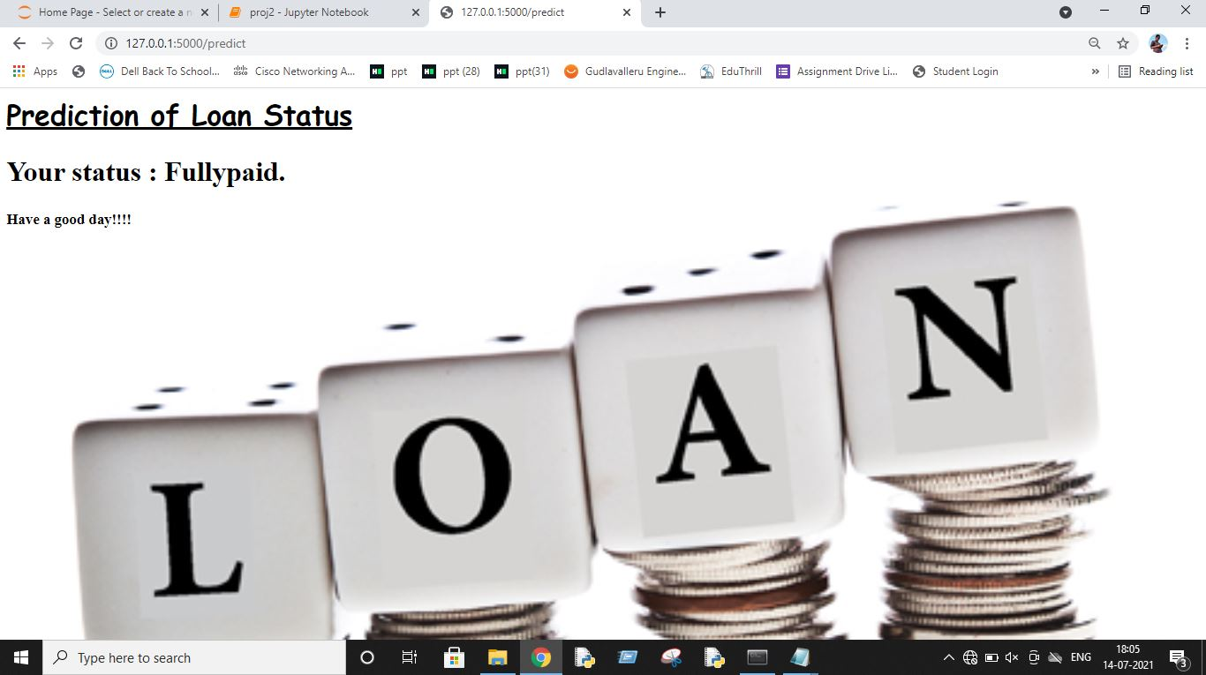

**Advantages & Disadvantages**

**Advantages** :

* Reduces time for person who want to check their loan status.
* Simple to use.

**Disadvantages** :

* People with less technical knowledge may not be benifited with this.

**Applications**

Nowadays loans have been part of most of the people’s life. So in order to repay the loan amount to the banks from which they have taken they need to keep check on the status of the loan amount to be paid. So this can be used in banks for bank employees to reduce their time to check the loan statuses and can be helpful to the people who took the loan from banks.

**Conclusion**

From this project one can learn basics of python, how to remove null values from data ,how to encode the data present, how to preprocess the data and applied different machine learning algorithms to the data like Linear, Logistic, Decision tree, Random forest etc and developed the model using best algorithm that suited that is Decision tree, after that we developed a model and UI to check the working of the model. Through this project one can able to find whether the loan amount taken by them is paid or not.

**Future Scope**

Future scope for this project can be used predict not only the loan status like paid or not, but also can find how much amount that need to paid or amount that have already paid by the customer to the bank.

**Bibliography**

[1] Sivasree M. S. ,P. G. Scholar, Rekha Sunny T. “Loan Credibility Prediction System Based on Decision Tree Algorithm”, IRJET vol.4 Issue 09.September 2015.

**Appendix**

**Source code :**

https://github.com/smartinternz02/SI-GuidedProject-3438-1624856932

**UI output Screenshot :**









M.D.N.V.S.Prasanthi(18481A1261)

V.Bhanu Sri(18481A12A5)

S.Naga Sirisha(19485A1216)

T.Leela Supriya(18481A1298)