S ABISHEK

[abishek.s2019@vitstudent.ac.in](mailto:abishek.s2019@vitstudent.ac.in)

ASSIGNMENT-2

Develop an "Automatic garage door opening system". Use an Ultrasonic sensor to detect if there is a vehicle in front of the garage. if any vehicle is detected open the garage door (rotate the servo motor) for some time and close it.

CODE:

#include<Servo.h>

Servo s;

void setup()

{

s.attach(7);

pinMode(2, OUTPUT);

pinMode(3, INPUT);

Serial.begin(9600);

}

void loop()

{

digitalWrite(2, LOW);

digitalWrite(2, HIGH);

delayMicroseconds(10);

digitalWrite(2, LOW);

float dur = pulseIn(3, HIGH);

float dis = (dur \* 0.0343)/2;

Serial.print("Distance in cm: ");

Serial.println(dis);

if(dis<100)

{

s.write(180);

delay(1000);

}

else

{

s.write(0);

delay(1000);

}

}

CIRCUIT DESIGN:

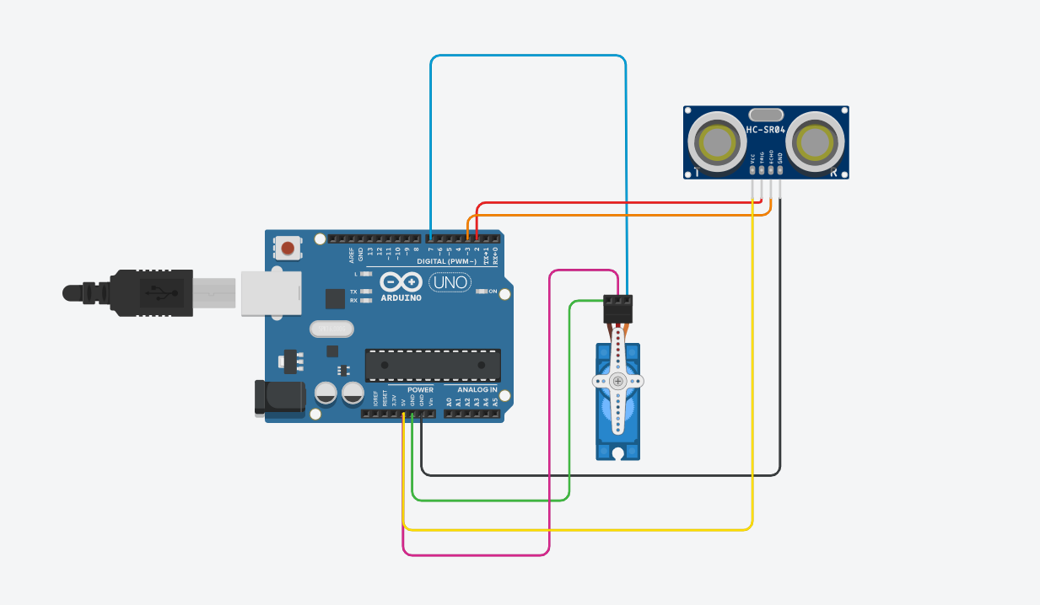

AFTER SIMULATION:

