S ABISHEK

[abishek.s2019@vitstudent.ac.in](mailto:abishek.s2019@vitstudent.ac.in)

ASSIGNMENT-3

Develop a code to upload the water tank level and light intensity values to the IBM IoT platform and visualize them in the web application.

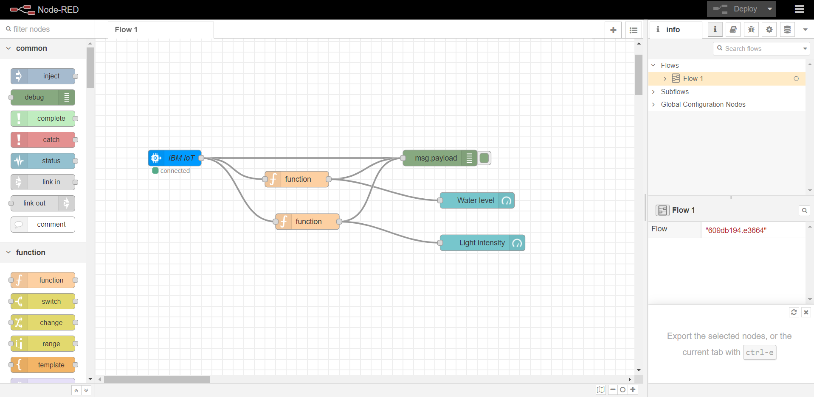

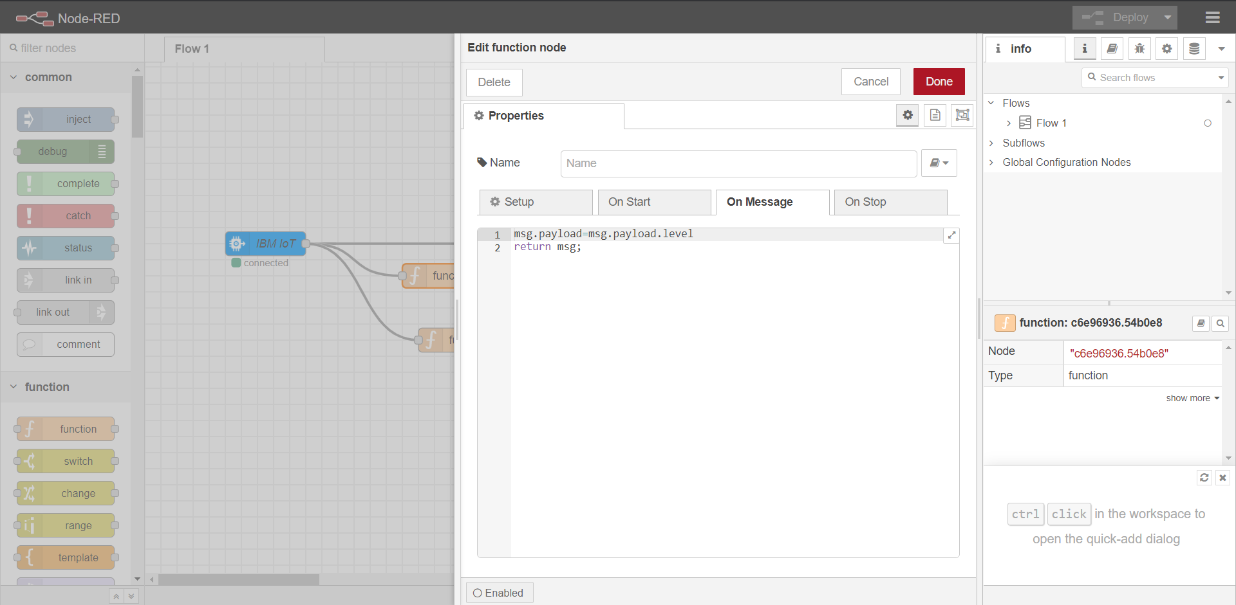

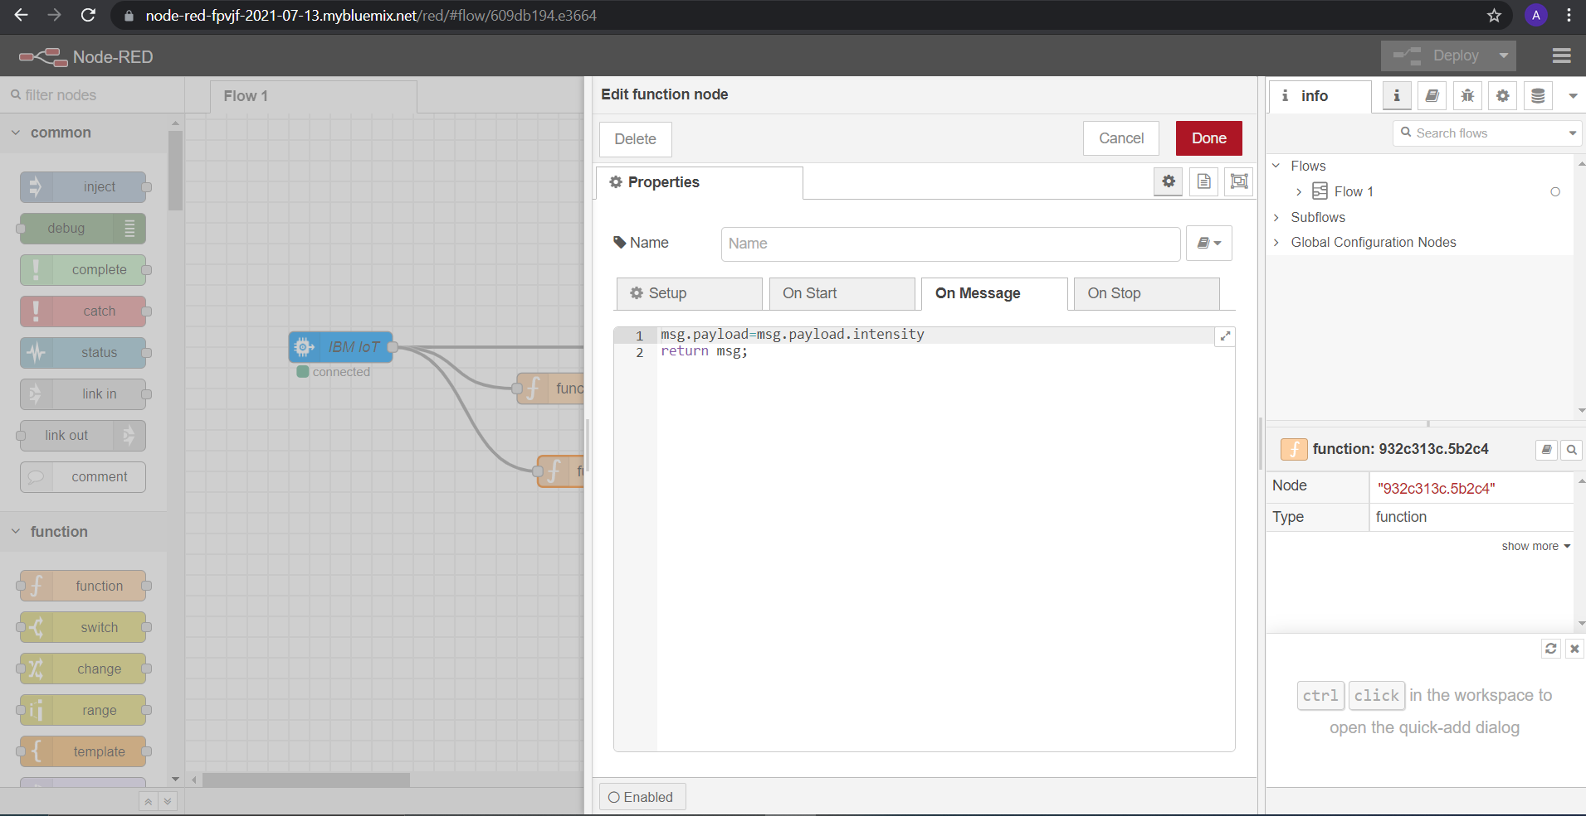

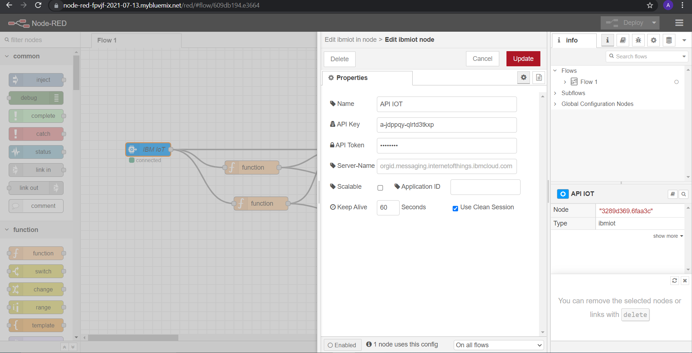

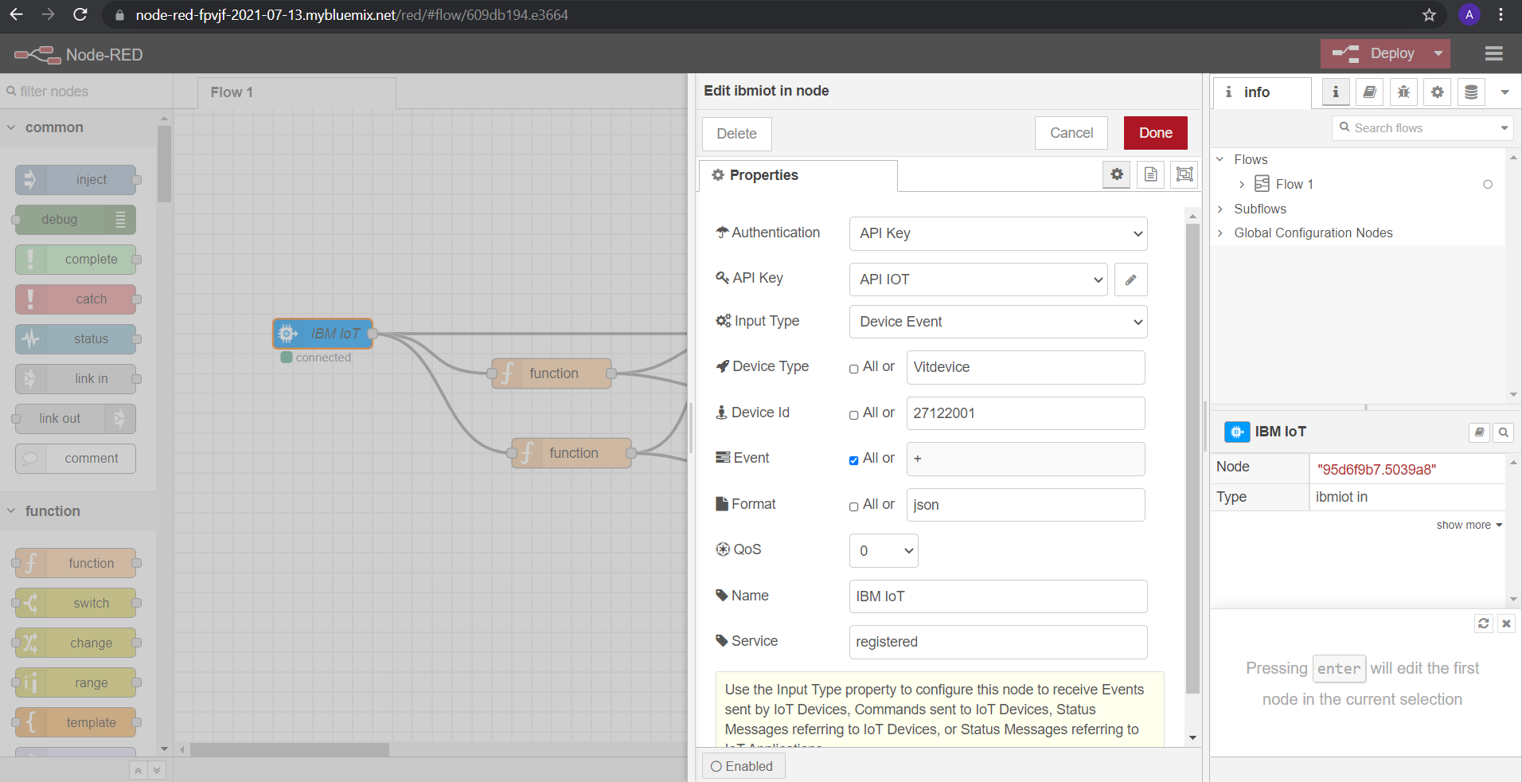

CODE:

import wiotp.sdk.device

import time

import random

myConfig = {

"identity": {

"orgId": "jdppqy",

"typeId": "Vitdevice",

"deviceId":"27122001"

},

"auth": {

"token": "12345678"

}

}

def myCommandCallback(cmd):

print("Message received from IBM IoT Platform: %s" % cmd.data['command'])

m=cmd.data['command']

client = wiotp.sdk.device.DeviceClient(config=myConfig, logHandlers=None)

client.connect()

while True:

level=random.randint(0,100)

intensity=random.randint(100,1400)

myData={'level':level, 'intensity':intensity}

client.publishEvent(eventId="status", msgFormat="json", data=myData, qos=0, onPublish=None)

print("Published data Successfully: %s", myData)

client.commandCallback = myCommandCallback

time.sleep(2)

client.disconnect()

SIMULATION

