S ABISHEK

[abishek.s2019@vitstudent.ac.in](mailto:abishek.s2019@vitstudent.ac.in)

ASSIGNMENT-5

Assignment-5: Create a web dashboard to take user input for scheduling the pump controller (date & time). store the data in the Cloudant DB.

Software: IBM

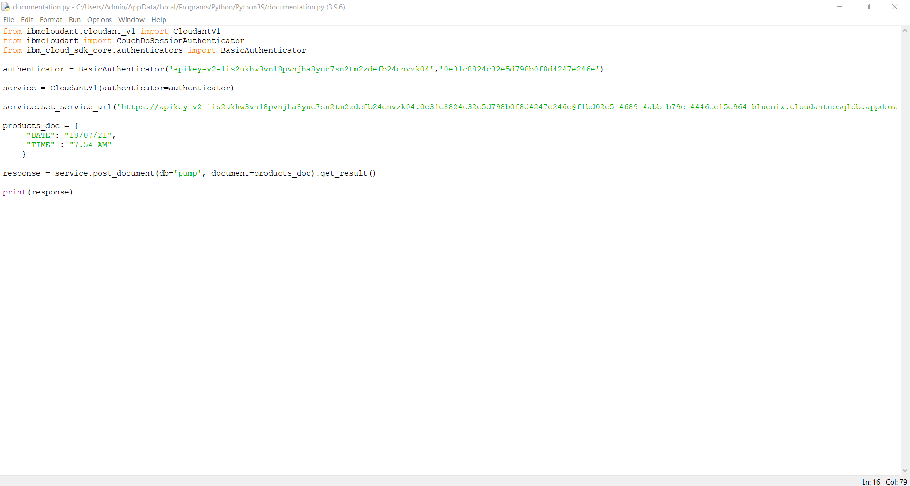

Here, BasicAuthenticators are username & password of Cloudant DB We need to store the time and date in the cloudant DB

CREATION OF DB:

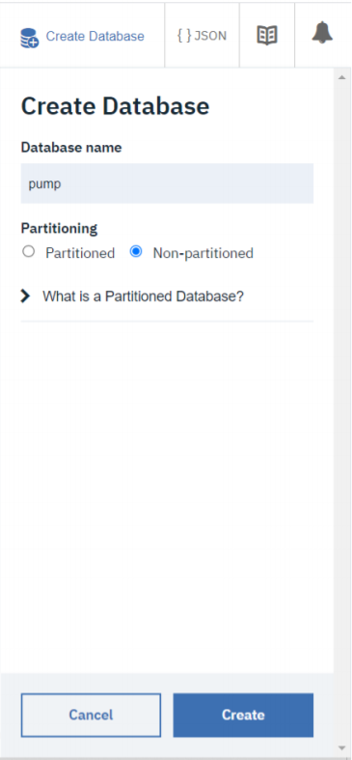

After the code execution we can view the data in the cloudant DB

