**ASSIGNMENT – 03**

**Vighnesh M**

NODE-RED FLOW:

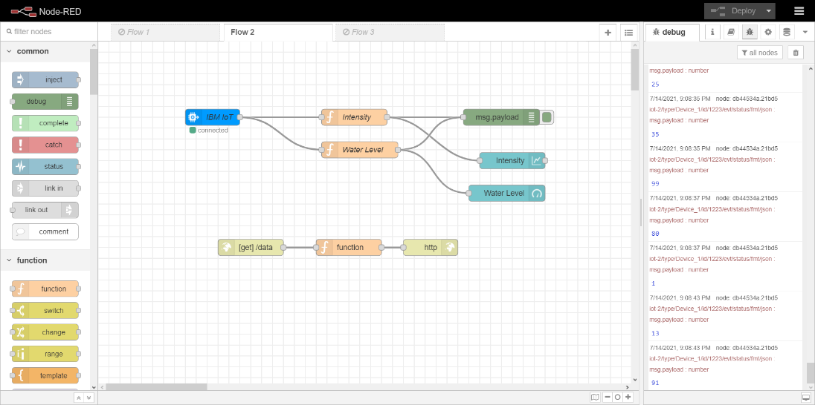

NODE-RED DASHBOARD OUTPUT:

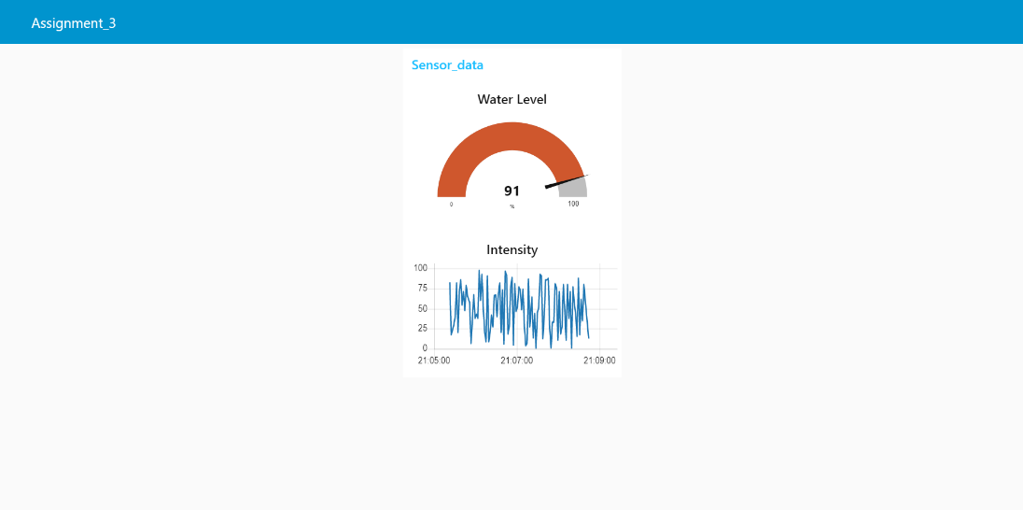

MIT APP BUILDER BLOCKS:

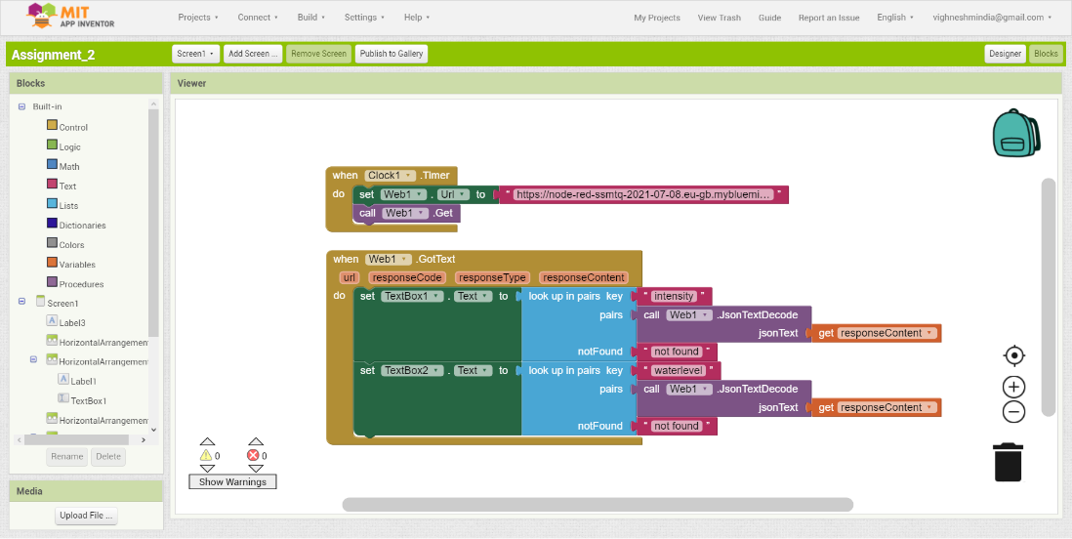

JSON Output in URL

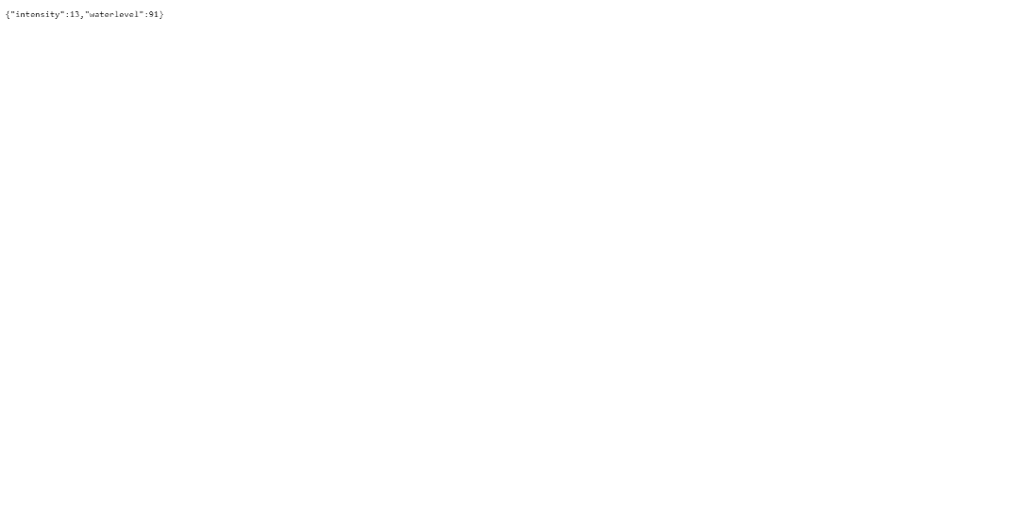

IBM CLOUD OUTPUT:

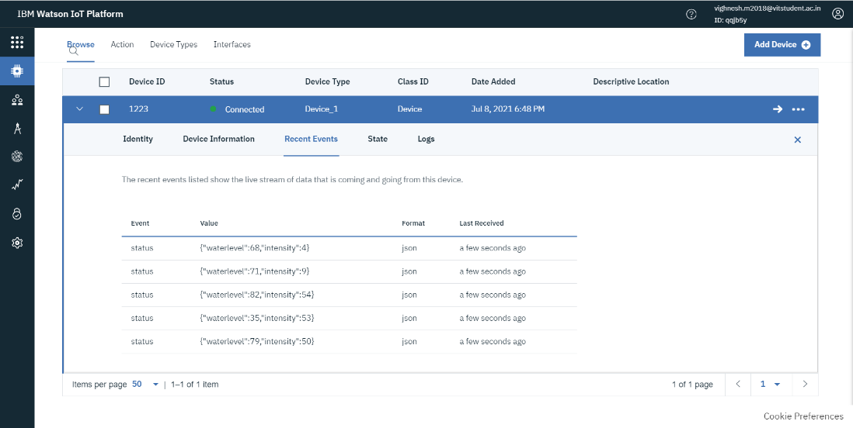

CONSOLE OUTPUT IN PYTHON:

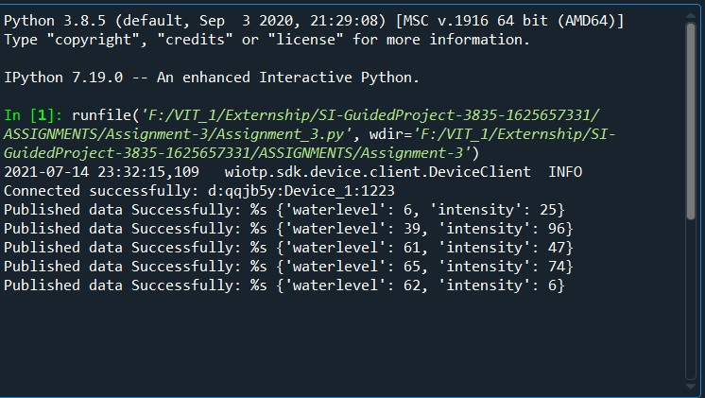

MOBILE APPLICATION:

