**ASSIGNMENT – 04**

**Vighnesh M**

NODE-RED FLOW:

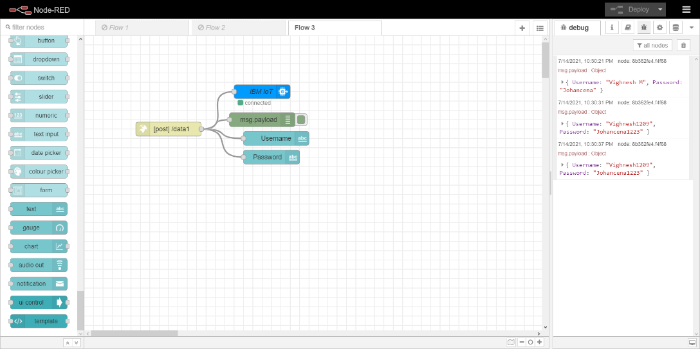

NODE-RED DASHBOARD OUTPUT:

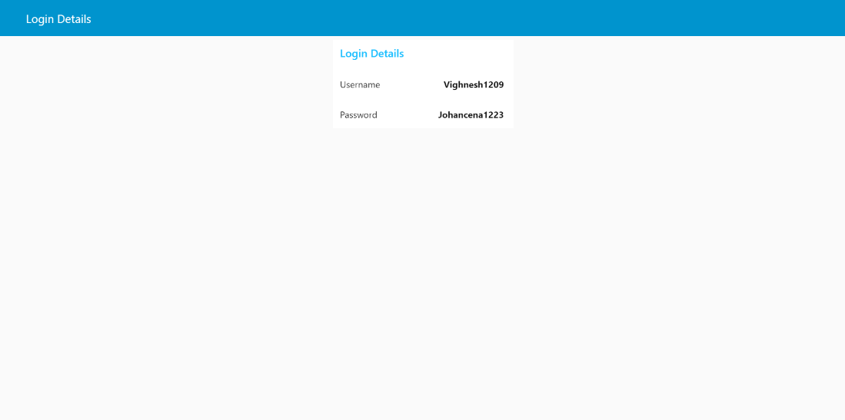

MIT APP BUILDER BLOCKS:

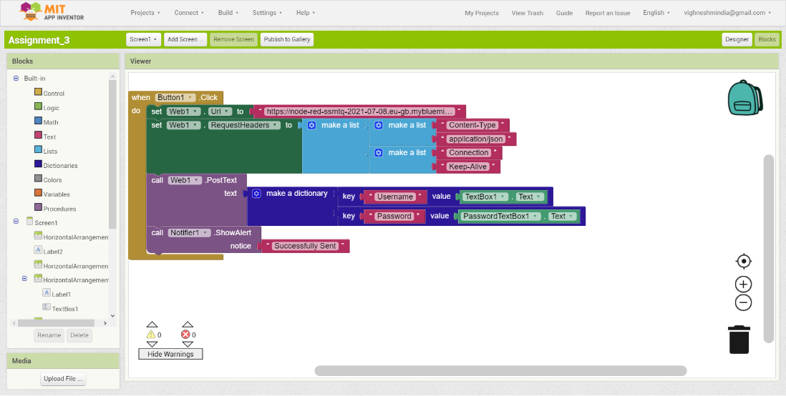

CONSOLE OUTPUT IN PYTHON:

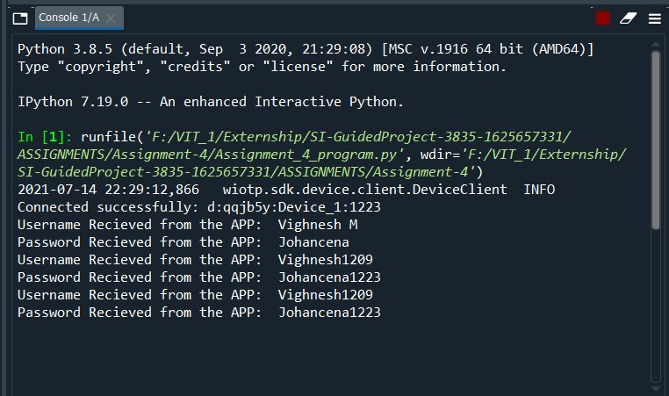

MOBILE APPLICATION:

