**ASSIGNMENT – 05**

**Vighnesh M**

NODE-RED FLOW:

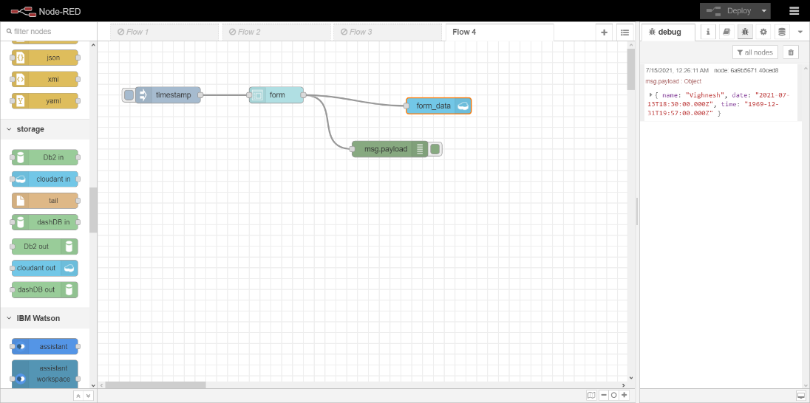

NODE-RED DASHBOARD OUTPUT:

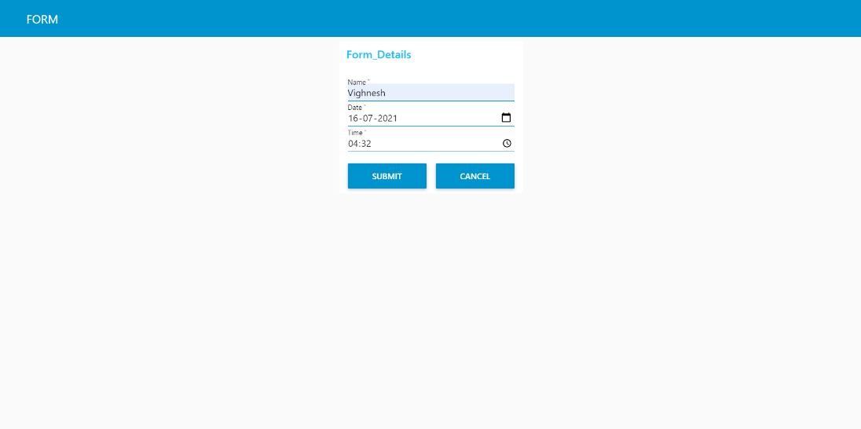

IBM CLOUDANT DB OUTPUT:

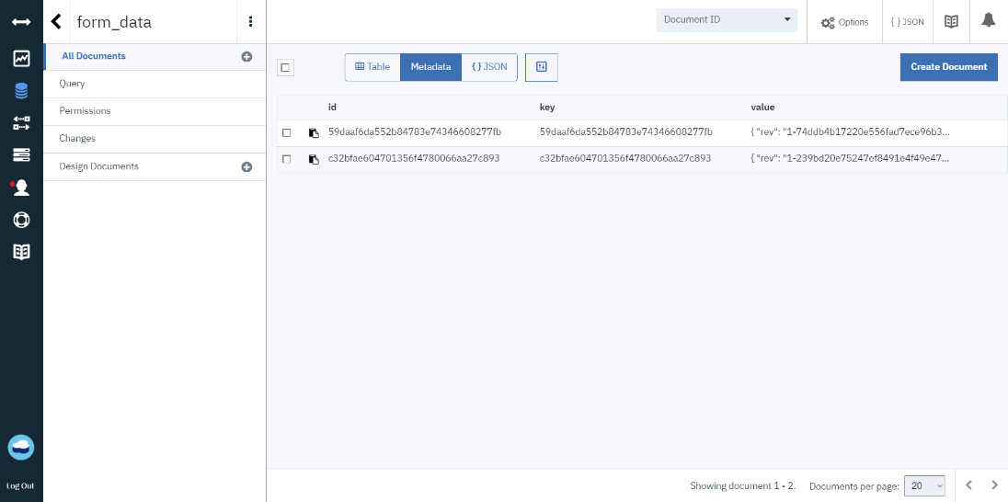

IBM CLOUDANT DB IN JSON FORMAT OUTPUT:

