Assignment-2

S. Vaideeshwaran

18BLC1106

Develop an "Automatic garage door opening system". Use an Ultrasonic sensor to detect if there is a vehicle in front of the garage. If any vehicle is detected open the garage door (rotate the servo motor) for some time and close it.

**Circuit in tinkercad:**

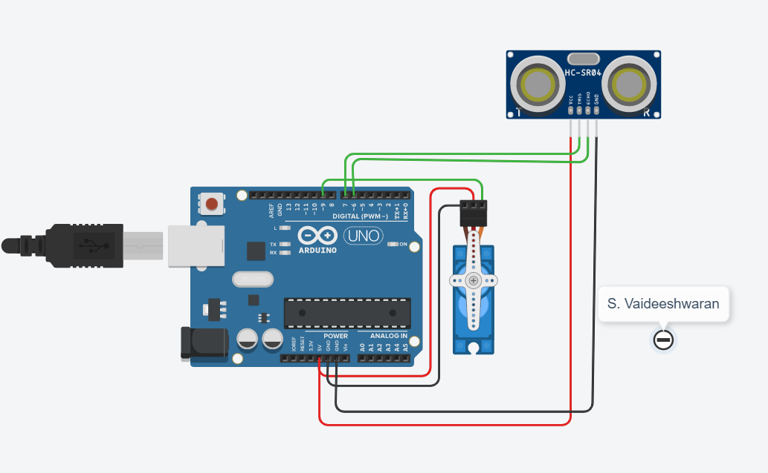

**Code:**

#include <Servo.h>

int pos = 0;

int t=7;

int e=6;

Servo s;

void setup()

{

s.attach(9, 500, 2500);

pinMode(t,OUTPUT);

pinMode(e,INPUT);

Serial.begin(9600);

s.write(0);

}

void loop()

{

digitalWrite(t,LOW);

digitalWrite(t,HIGH);

delayMicroseconds(10);

digitalWrite(t,LOW);

float d=pulseIn(e,HIGH);

float dis=(d*0.0343)/2;

Serial.print("Distance in cm:");

Serial.println(dis);

if(dis<150)

{ for (pos = 0; pos <= 180; pos += 1) {

s.write(pos);

delay(15); // Wait for 15 millisecond(s)

}

delay(2000);//wait 2 sec after opening the door

for (pos = 180; pos >= 0; pos -= 1) {

s.write(pos);

delay(15); // Wait for 15 millisecond(s)

}

}

}

**OUTPUT:**

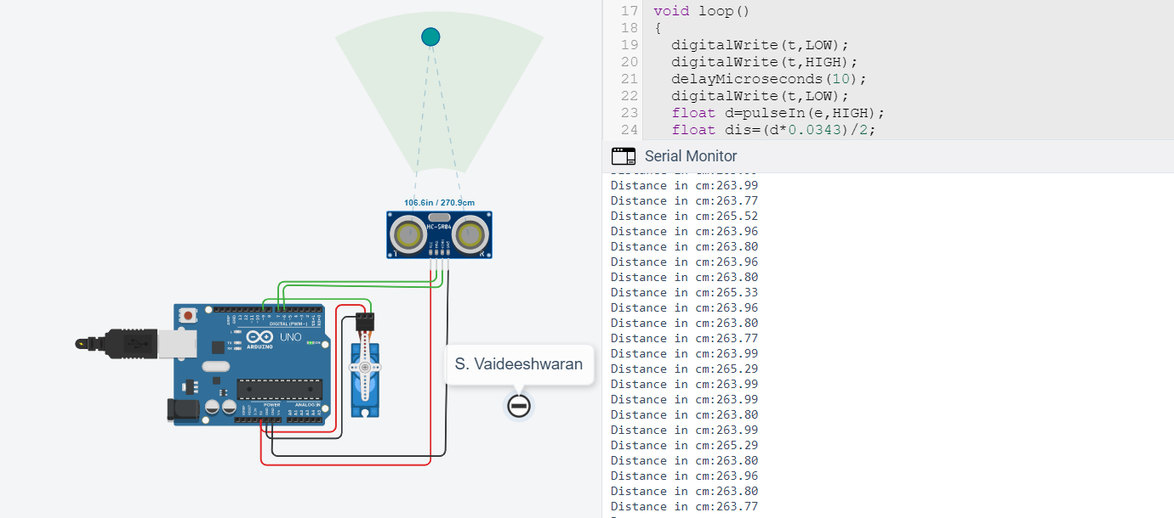

*Distance greater than 150*

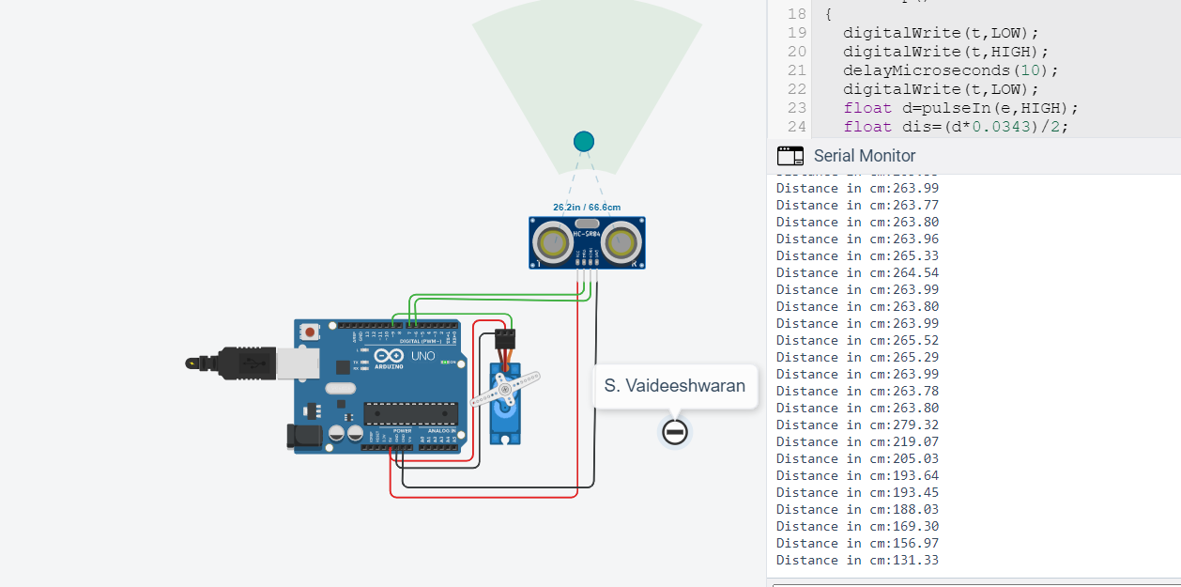

*Distance less than 150, servo motor automatically open, wait for 2 seconds and closes*

**Tinkercad Link:**

<https://www.tinkercad.com/things/kS8850oT9px-sizzling-amberis/editel?sharecode=4f1Q7-JUY5Y54qkPngpB8FInVxPvXN5C-twO0LLohh4>