**ASSIGNMENT-5**

NAME:JEYVARSHA.S

REGNO :19BEE1096

Create a web dashboard to take user input for scheduling the pump controller (date & time). store the data in the Cloudant DB.

You can use Form Nodes in dashboard nodes to take user input.

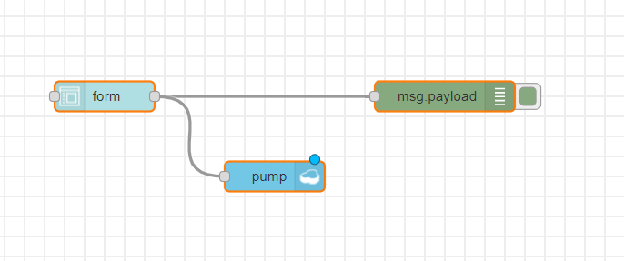

**INPUT TO THE CLOUD:** 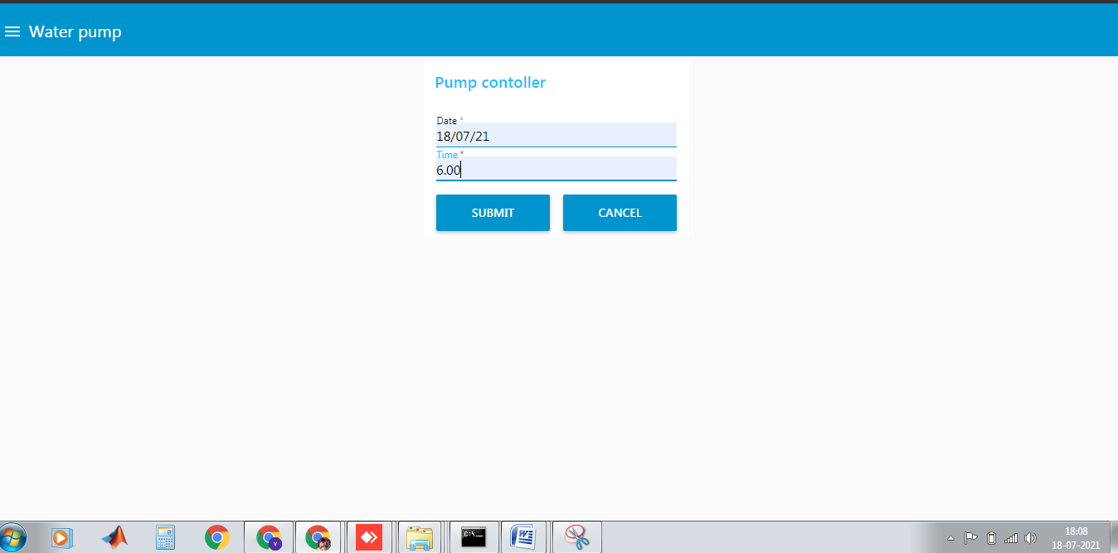

**OUTPUT:**

