**ASSIGNMENT-2:**

**NAME:**JEYVARSHA.S **REG NO:** 19BEE1096

Develop an "Automatic garage door opening system". Use an Ultrasonic sensor to detect if there is a vehicle in front of the garage. if any vehicle is detected open the garage door (rotate the servo motor) for some time and close it.

CIRCUIT:

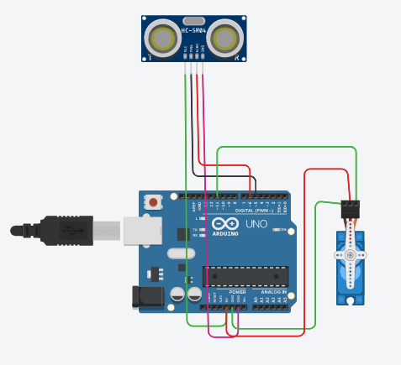

**OUTPUT:**

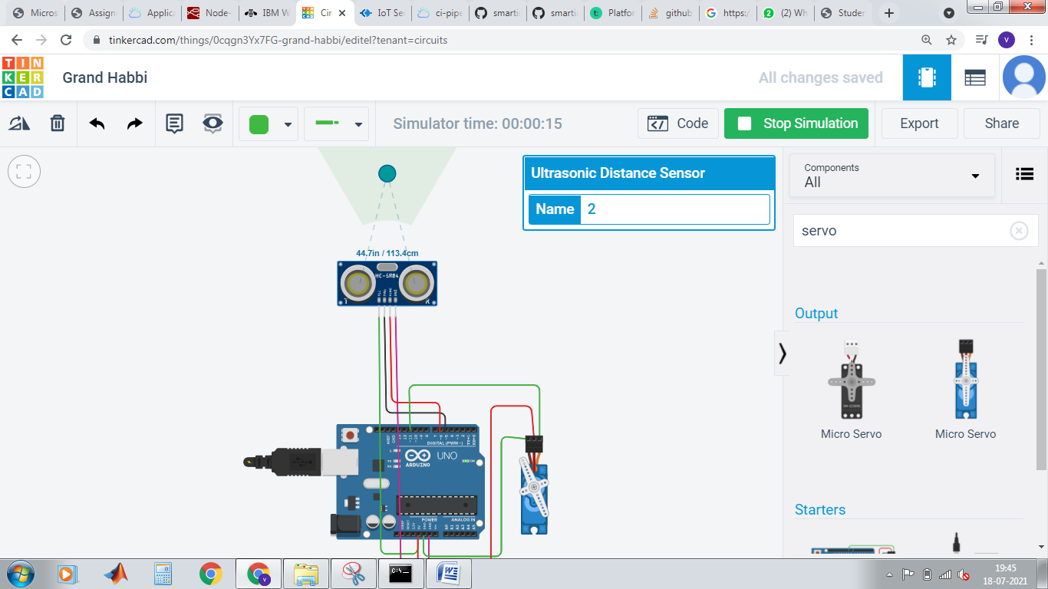

**CODE:**

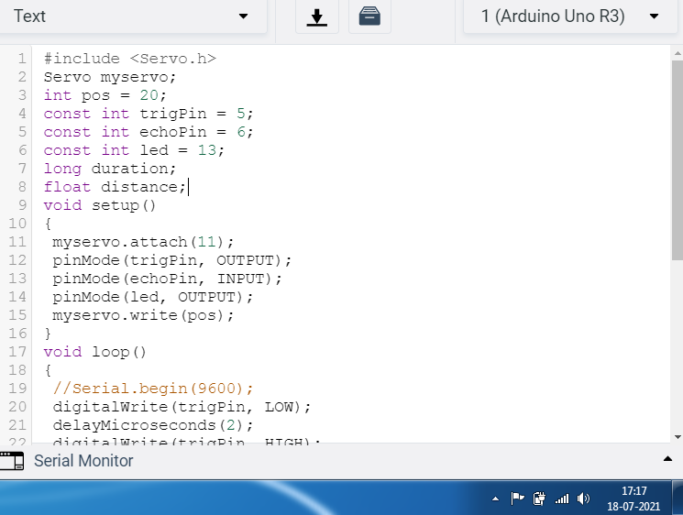

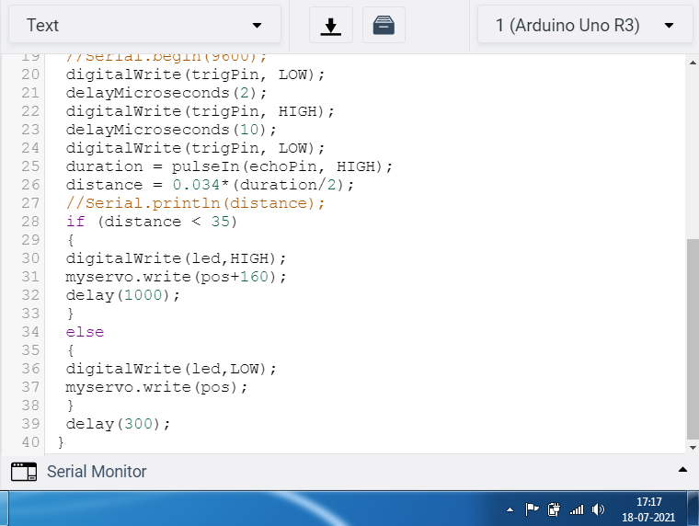

**CODE:**

#include <Servo.h>

Servo myservo;

int pos = 20;

const int trigPin = 5;

const int echoPin = 6;

const int led = 13;

long duration;

float distance;

void setup()

{

myservo.attach(11);

pinMode(trigPin, OUTPUT);

pinMode(echoPin, INPUT);

pinMode(led, OUTPUT);

myservo.write(pos);

}

void loop()

{

//Serial.begin(9600);

digitalWrite(trigPin, LOW);

delayMicroseconds(2);

digitalWrite(trigPin, HIGH);

delayMicroseconds(10);

digitalWrite(trigPin, LOW);

duration = pulseIn(echoPin, HIGH);

distance = 0.034*(duration/2);

//Serial.println(distance);

if (distance < 35)

{

digitalWrite(led,HIGH);

myservo.write(pos+160);

delay(1000);

}

else

{

digitalWrite(led,LOW);

myservo.write(pos);

}

delay(300);

}