**Assignment 2**

**CODE: -**

The door opens if it detects something closer than 250cm (ideally the distance should be greater but because of the sensor limitations its 2.5m). If it doesn’t detect anything it keeps the door closed/closes the door if open and it stops detecting.

#include<Servo.h>

Servo s;

int t=4;

int e=5;

void setup()

{

s.attach(3);

pinMode(t, OUTPUT);

pinMode(e, INPUT);

Serial.begin(9600);

s.write(0);

}

void loop()

{

digitalWrite(t, LOW);

digitalWrite(t, HIGH);

delayMicroseconds(10);

digitalWrite(t, LOW);

float dur = pulseIn(e,HIGH);

float dis = (dur * 0.0343)/2;// convert m to cm

Serial.print("distance in cm: ");

Serial.println(dis);

if (dis <= 250)

{

Serial.println (" Door open ");

Serial.print (" Distance= ");

Serial.println (dis);

delay (500);

for(int i=0;i<=90;i++)

{

s.write(i);

delay(100);

}

delay(2000);

}

else {

s.write(0);

Serial.println (" Door closed ");

Serial.print (" Distance= ");

Serial.println (dis);

delay (100);

}

}

Dis <= 250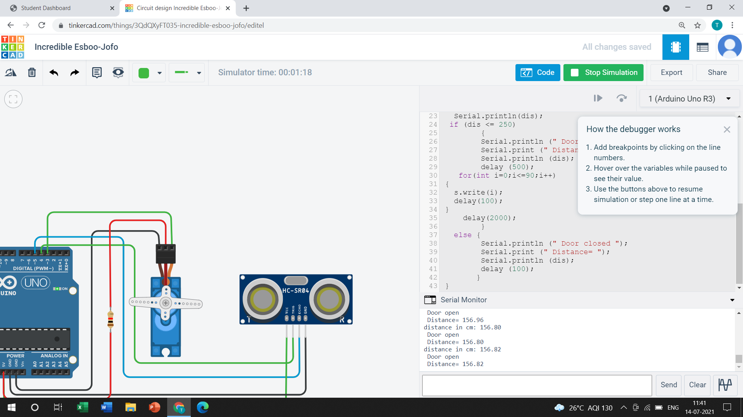

Dis > 250

