**Assignment #2**

**Develop an "Automatic garage door opening system". Use an Ultrasonic sensor to detect if there is a vehicle in front of the garage. if any vehicle is detected open the garage door (rotate the servo motor) for some time and close it.**

**Arduino circuit consisting of Ultrasonic Distance Sensor and servo motor:**

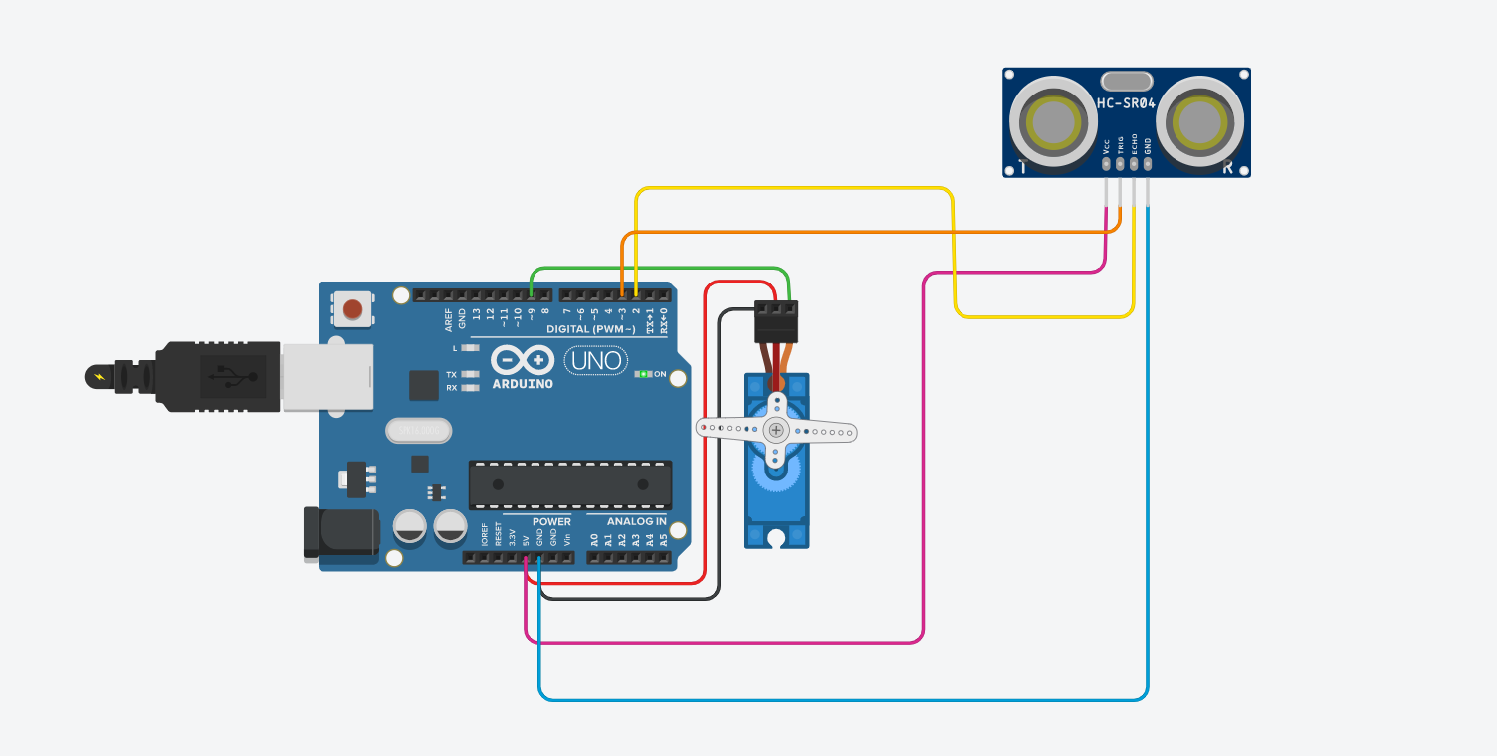

**Code:**

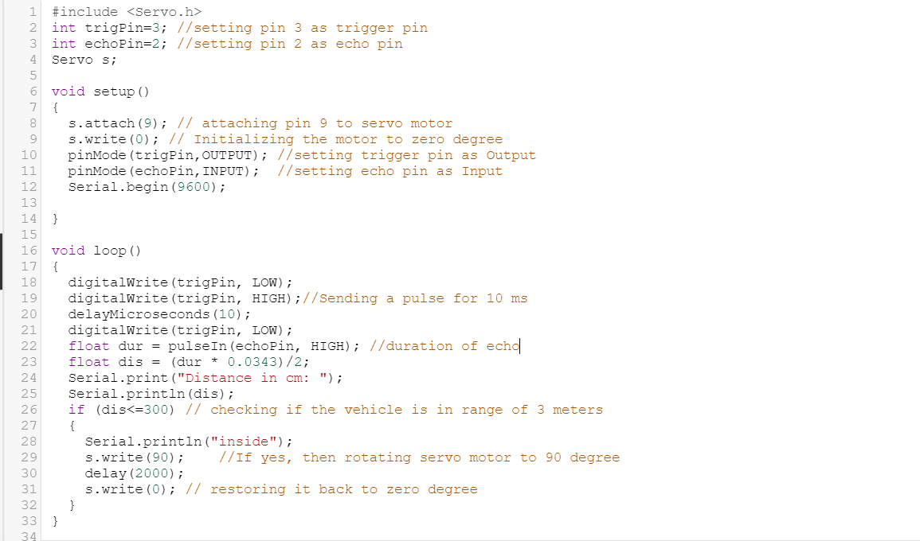

**Test Cases:**

**Case 1:**

**When the vehicle is Inside the range i.e. 3 meters**

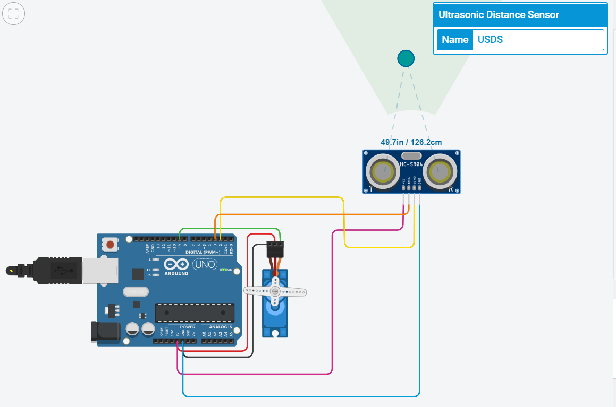

**Output:**

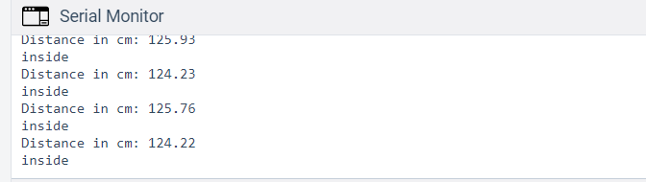

**Case 2:**

**When it’s not in range of Ultrasonic Distance Sensor**

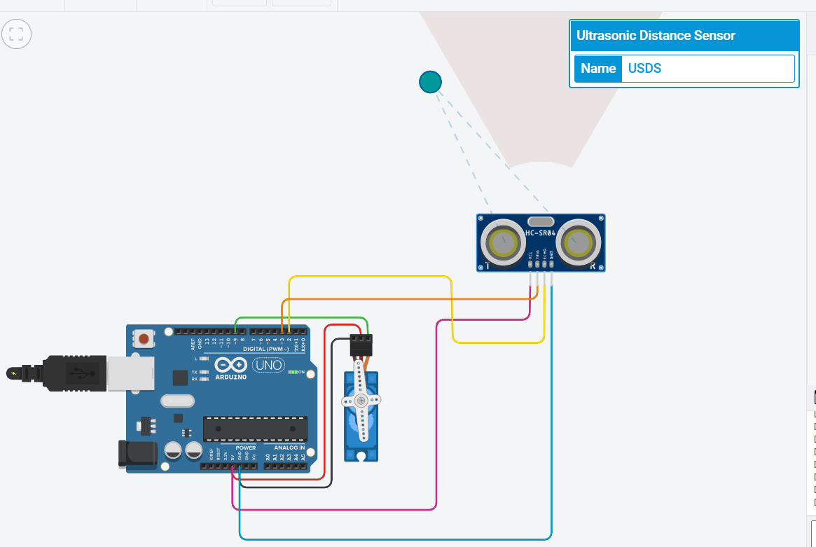

**Output:**

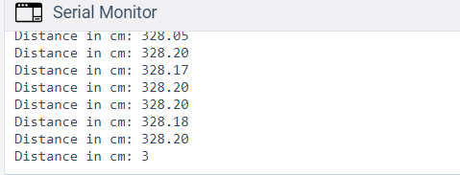

**Conclusion:**

The trigger pin sends the pulse and when the vehicle is in range of Ultrasonic Distance Sensor ,and echo is experinced by USDS and the servo motor rotates to 90 degrees hence open the gate and closes it after sometime.