ASSIGNMENT 1

1. pwd
This command Displays the current working directory of the terminal.

2. echo “rajat”
This command writes its arguments to standard output.

3. su
This command is used to switch to root-user so that superuser permissions can be used to execute commands.

4. su <username>
This command is used to switch to a different user whose name is passed as the argu

5. sudo
This command executes only that command with root/ superuser privileges.

6. clear
This command is used to clear the terminal screen. Contents will not actually be deleted in this case, only scrolled down. You can also clear the screen by pressing Ctrl+L on the keyboard.

Linux Commands: Working with Files

7. cp

This command copies files and directories. A copy of the file/directory copied, still remains working directory.

8. mv
This command moves files and directories from one directory to another. The file/directory once moved, is deleted from the working directory.

9. rm
This command removes files from a directory. By default, the rm command does not remove directories. Once removed, the contents of a file cannot be recovered.

10. grep
This command is used to search for a particular string/ word in a text file. This is similar to “Ctrl+F”, but executed via a CLI.

11. cat
This command can read, modify or concatenate text files. It also displays file contents.

12. ls
This command lists all the contents in the current working directory.

13. cd
This command is used to change the current working directory of the user.

14. sort
This command sorts the results of a search either alphabetically or numerically. Files, file contents and directories can be sorted using this command.

15. mkdir
This command is used to create a new directory.

16. rmdir
This command is used to remove a specified directory. Although by default, it can only remove an empty directory, there are flags which can be deployed to delete the non-empty directories as well.

17. chmod
This command is used to change the access permissions of files and directories. Consider the example below.

18. touch
create file and type code in it, ususlaly opened in a folder

19. wc
counts the total number of words and chracter in the document

20. history
shows history of all the previous commands run over the CLI

ROS Topics

Some nodes provide information for other nodes, as a camera feed would do, for example. Such a node is said to publish information that can be received by other nodes. The information in ROS is called a topic A topic defines the types of messages that will be sent concerning that topic.
The nodes that transmit data publish the topic name and the type of message to be sent. The actual data is published by the node. A node can subscribe to a topic and transmitted messages on that topic are received by the node subscribing.

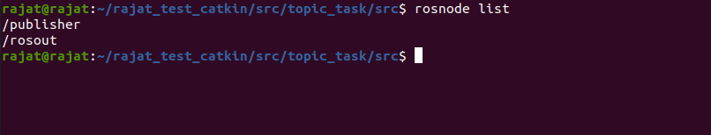

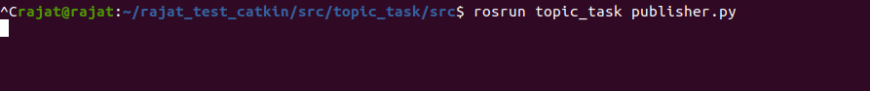

ROS SERVICES:

A Service, which is defined by a pair of messages: one for the request and one for the reply. A providing ROS node offers a service under a string name, and a client calls the service by sending the request message and awaiting the reply. Client libraries usually present this interaction to the programmer as if it were a remote procedure call.

Various related services:
1) clear: Clears the turtlesim background and sets the color to the value of the background parameters.
2) reset: Resets the turtlesim to the start configuration and sets the background color to the value of the background.
3) kill: Kills a turtle by name.

