**Estimate The Presence Of Impurities In Iron Ore Using Machine Learning**

**Department Of Computer Science And Engineering**

**Chalapathi Institute Of Engineering & Technology**

### Team Members:

**1.Ramya madhumanchi**

**2. Maneesha Mupparaju**

**3. Sravanthi Upputuri**

**4. Srujana Nalam**

**Introduction:**

Iron ores are rocks and minerals from which metallic iron can be economically extracted. Iron is usually found in the form of Magnetite, Hematite, Goethite, Limonite, or Siderite.  Usually, Magnetite Iron ore concentrate contains an impurity of 3–7% of silica. Estimation of silica involves a lot of chemical analysis which is time-consuming and involves high operational cost. In order to cut down the operational cost and also to help engineers by predicting at a faster rate, we make use of  Machine Learning (ML). So the main goal of this project is to build a Machine Learning model to predict the impurities present in an Iron ore.

**Architecture:**

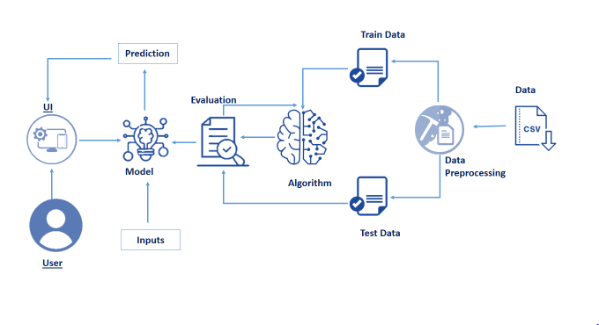

**Environment and Tools:**

1.Numpy

2.Pandas

3.Matplotlib

4.Scikit-learn

5.Flask

**Dataset:**

**.** Collect the dataset or Create the dataset

**Data Preprocessing:**

* + Import the Libraries.
  + Importing the dataset.
  + Checking for Null Values.
  + Data Visualization.
  + Taking care of Missing Data.
  + Label encoding.
  + One Hot Encoding.
  + Feature Scaling.
  + Splitting Data into Train and Test.

**Project Flow:**

* The user interacts with the UI (User Interface) to enter the data
* Entered data is analyzed by the model which is integrated
* Once the model analyses the input, the prediction is showcased on the UI

### Project Objectives:

By the end of this project**:**

* You’ll be able to understand
* Regression and Classification Problems
* To grab insights into data through visualization.
* Applying different algorithms according to the dataset.
* How to find accuracy of the model.
* How to build a web application using the Flask framework.

### Collection Of Dataset:

ML depends heavily on data, without data, it is impossible for an “AI” to learn. It is the most crucial aspect that makes algorithm training possible. In Machine Learning projects, we need a training data set. It is the actual data set used to train the model for performing various actions.

### Data Preprocessing:

Data pre-processing is a process of cleaning the raw data i.e. the data is collected in the real world and is converted to a clean data set. In other words, whenever the data is gathered from different sources it is collected in a raw format and this data isn’t feasible for the analysis.

### Model Building:

### The model building includes the following main tasks

### Import the model building Libraries

* Initializing the model
* Training and testing the model
* Evaluation of Model
* Save the Model

### Application Building:

### In this section, we will be building a web application that is integrated to the model we built. A UI is provided for the uses where he has to enter the values for predictions. The enter values are given to the saved model and prediction is showcased on the UI.

This section has the following tasks

* Building HTML Pages
* Building server-side script

### Build Python Code:

### 

* Importing the flask module in the project is mandatory. An object of Flask class is our WSGI application. Flask constructor takes the name of the current module (__name__) as argument Pickle library to load the model file.
* Here we will be using declared constructor to route to the HTML page which we have created earlier.
* In the above example, ‘/’ URL is bound with index.html function. Hence, when the home page of the webserver is opened in the browser, the HTML page will be rendered. Whenever you enter the values from the HTML page the values can be retrieved using the POST Method.

### Run The App:

* Open anaconda prompt  from the start menu
* Navigate to the folder where your python script is.
* Now type “python app.py” command
* Navigate to the localhost where you can view your web page
* Now type “python app.py” command.
* It will show the local host where your app is running on http://127.0.0.1.5000/
* Copy that localhost URL and open that URL in the browser. It does navigate you to them where you can view your web page.
* Enter the values, click on the predict button, and see the result/prediction on the web page.

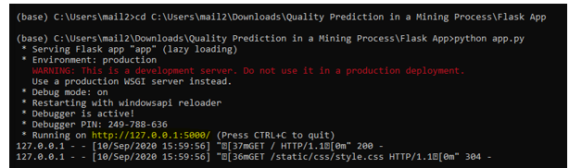

**Conclusion:**

In This study, we showed that, Determination of percentage iron in the given hematite ore solution using standard **K2Cr2O7** by external indicator method. Theory: Hematite is an important ore of iron containing mainly Fe2O3 and a small amount of silica (SiO2). ... The excess of SnCl2 added is oxidized by treating the solution with mercuric chloride.

