SMARTBRIDGE: PROJECT

Predictive Maintenance Of Industrial Motors Using IBM Cloud

**TEAM MEMBERS:**

1. P. Mohan Sai

mohansai.pragada2019@vitstudent.ac.in

1. S. Abishek

abishek.s2019@vitstudent.ac.in

1. P.V.N.S Sai Saran

Paramathmuni.saisaran2019@vitstudent.ac.in

INTRODUCTION:

OVERVIEW:

To predict the industrial motor will work or won’t, we can achieve this by measuring the values of the motors.

OBJECTIVE:

We have to measure the values of current, voltage, temperature. We can measure this characters by using ML, a machine learning model can be developed by using IBM CLOUD. To develop it we are using AUTO AI mode of IBM cloud.

SURVEY:

* 1. Existing model:

General model which can detect without proper data.

* 1. Solution:

We can integrate this model with IBM cloud with introducing to AUTO AI .to get the data correctly

BLOCK DIAGRAM:

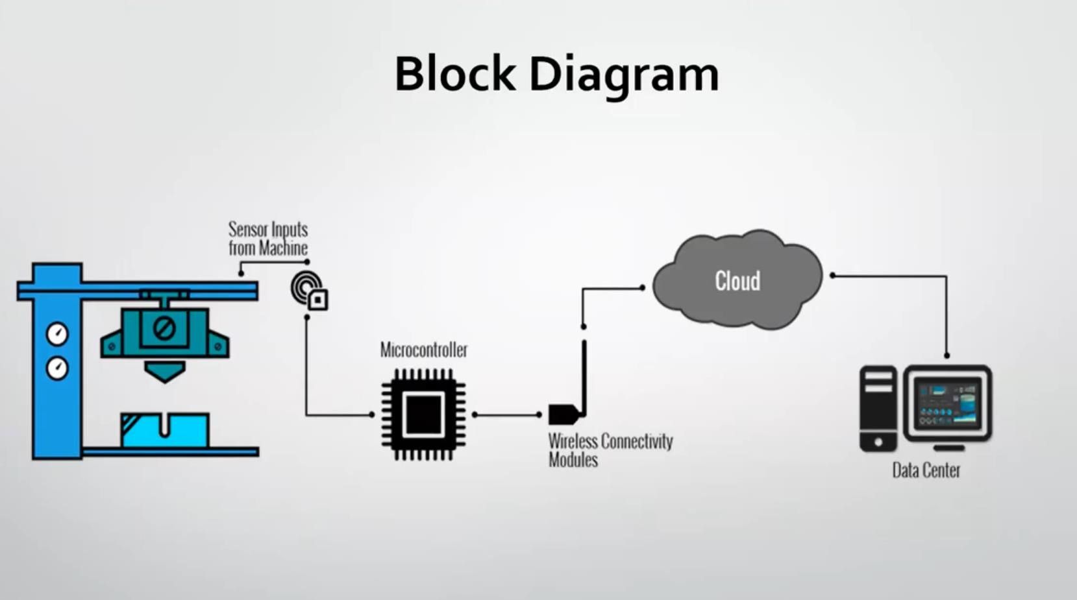

REQUIREMENTS:

Python IDLE

IBM ACCOUNT

Node-red

AUTO AI

MIT APP

FLOW CHART:

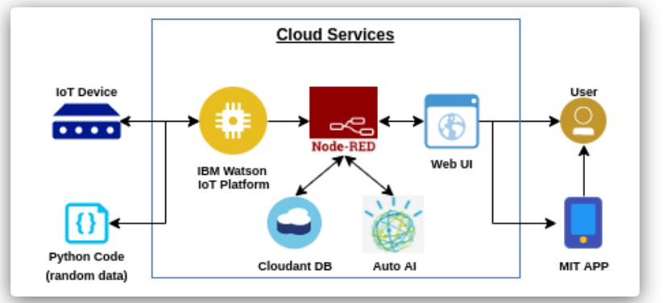

PROCEDURE:

Develop the code

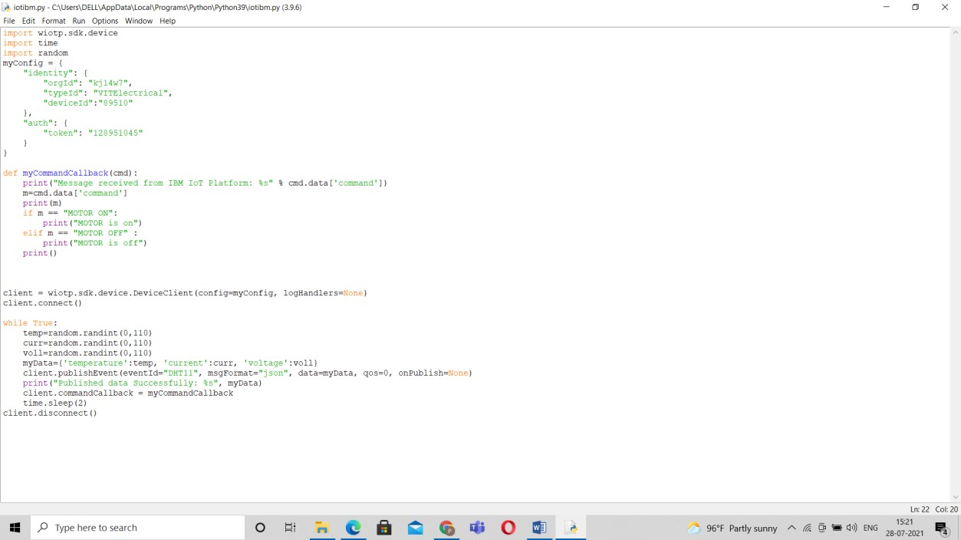

Creating the AUTO-AI application

To get the application we need to add a dataset of the motor



After giving the data set we will get our ML page in IBM Cloud

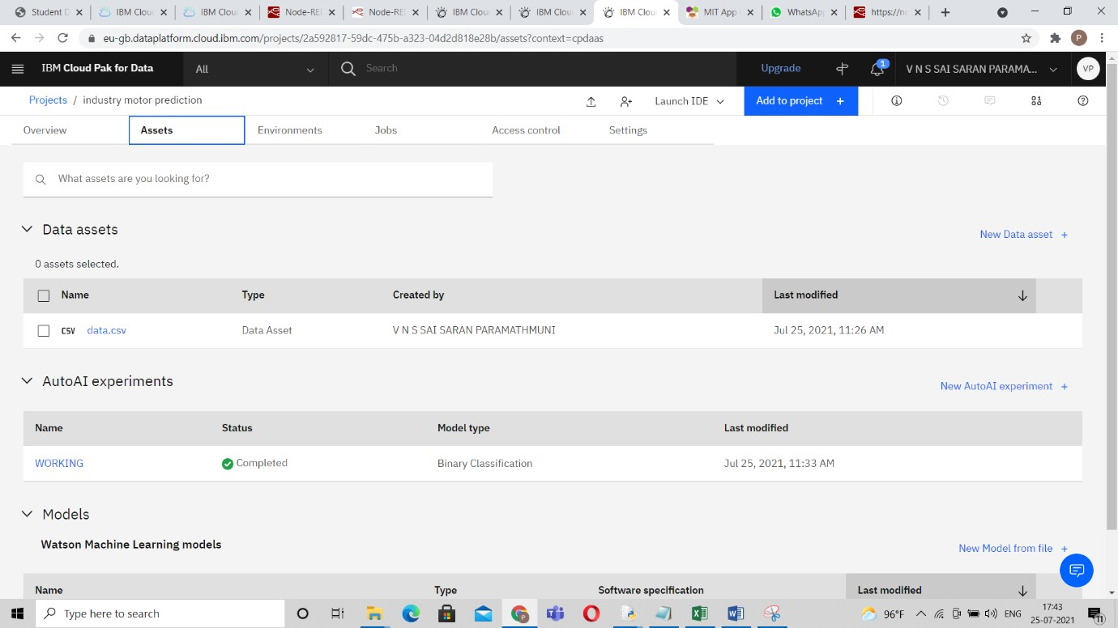

We need to select the model from the created pipelines, after that we need to get the end point URL for the model which we have deployed

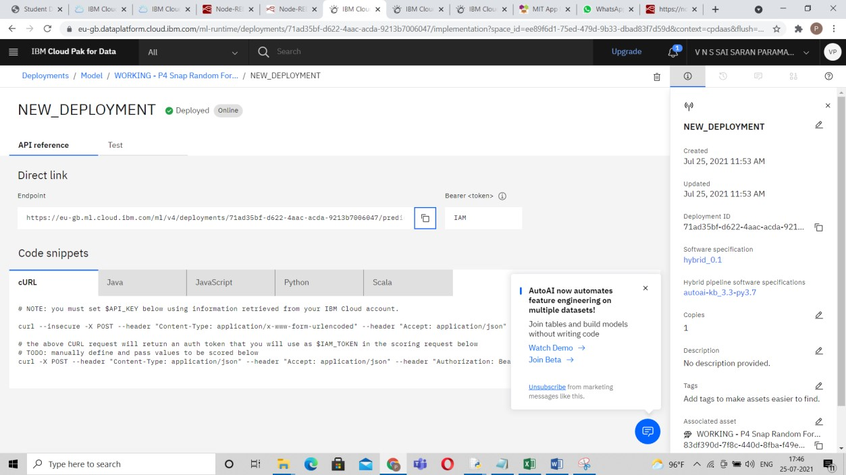

To develop a node-red application we need to get an “JSON” file to run after getting that json file into the node red, just fill the required details which are needed

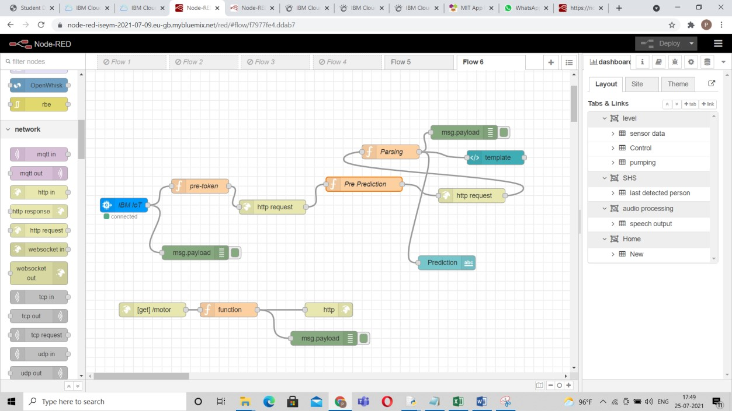

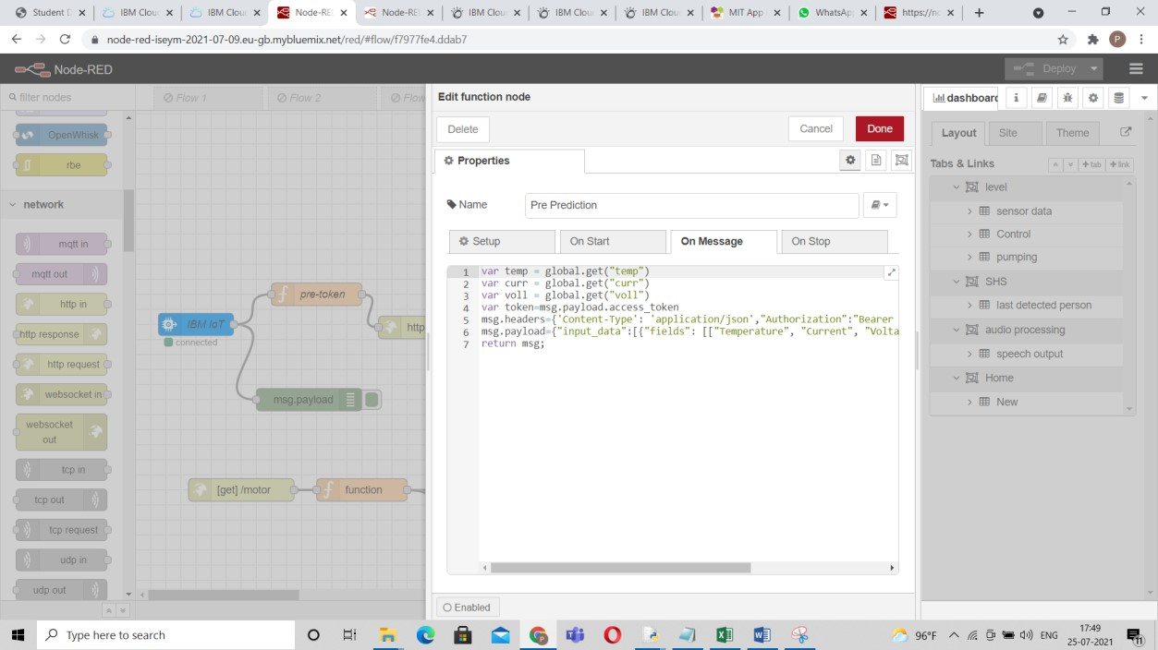

After setting the function we need to generate API-KEY

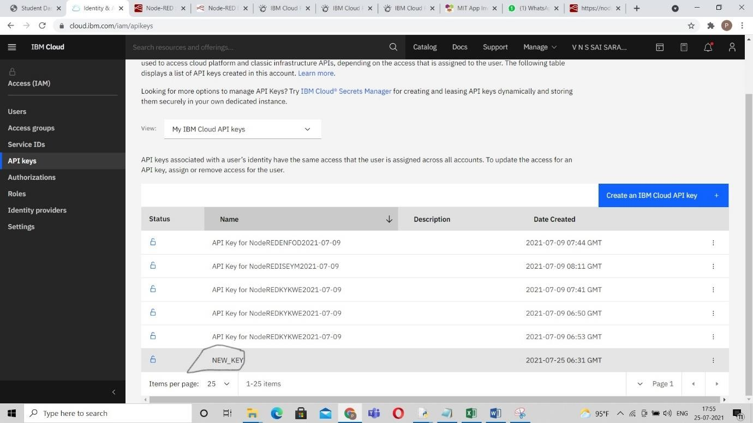

Giving that API-KEY in the function and create that function

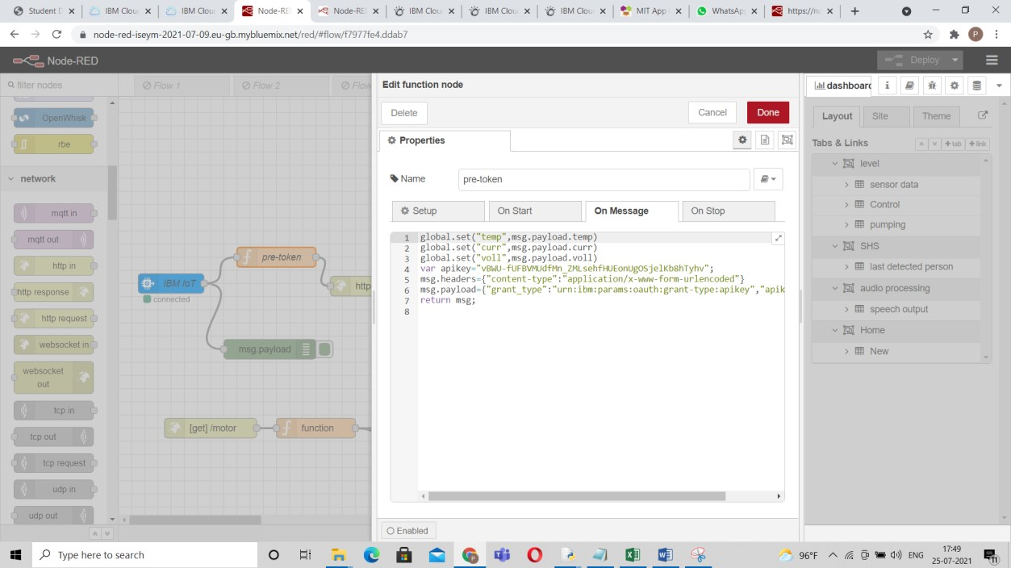

Giving some commands in the functions:

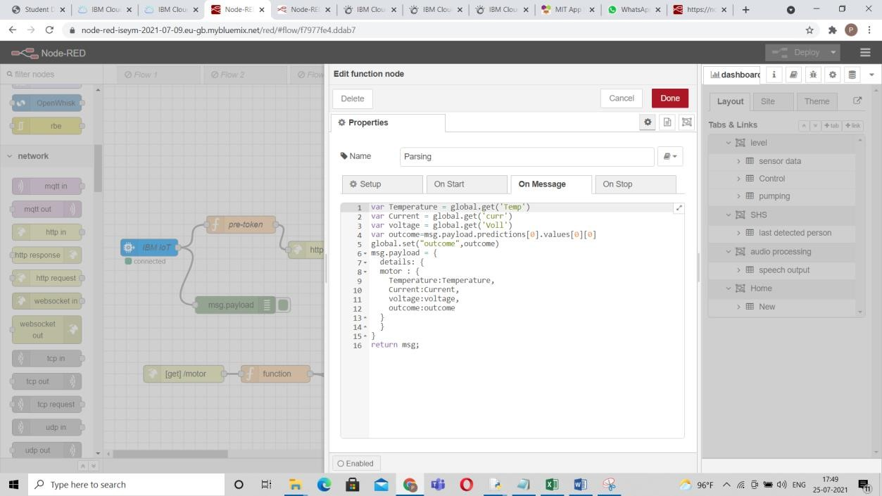

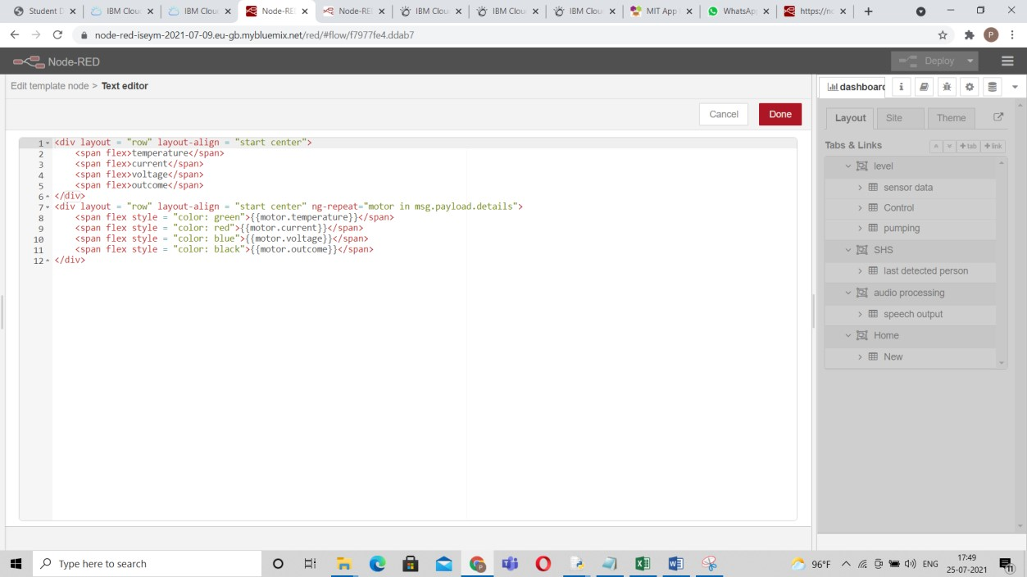

We need to give that end point URL at the one http request node

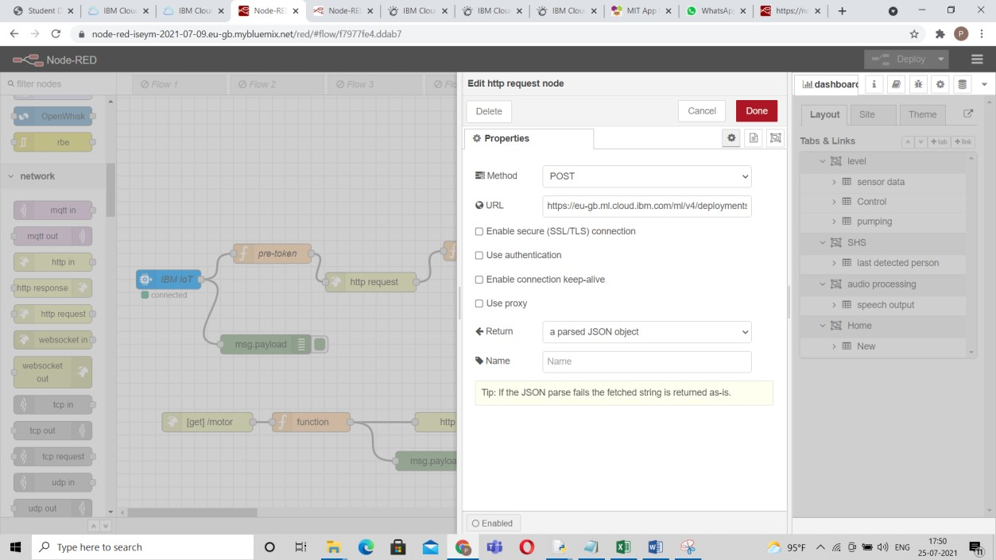

Before deploying the schematic we need to run the python code and after that deploy the schematic we need to view (user interface) the web view of the application

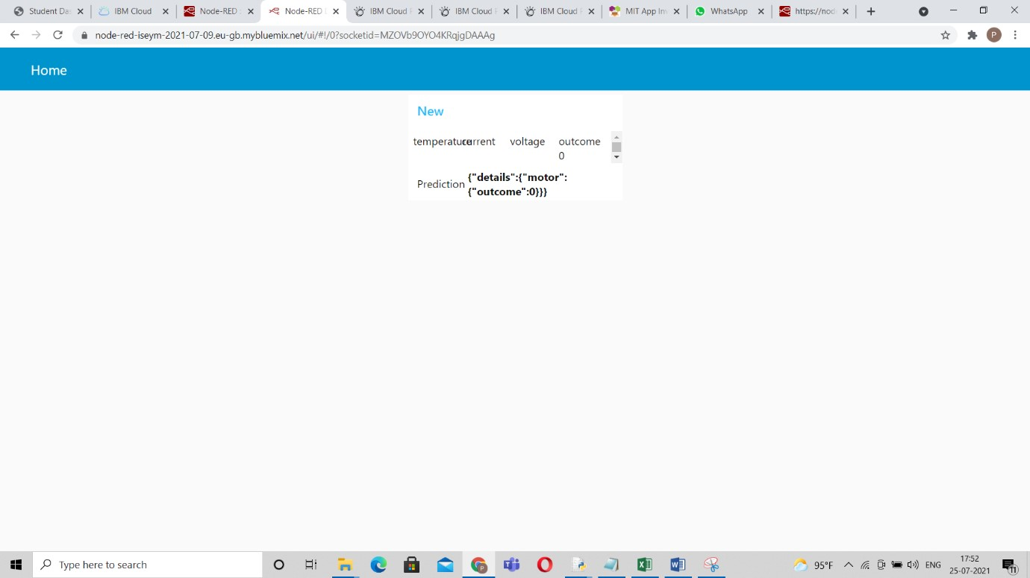

After setting this we need to develop for the app view for that we need get some connections with the same “http/in “ & “http/response” node with including some functions and to develop an app we are using the help of MIT APP INVERTER



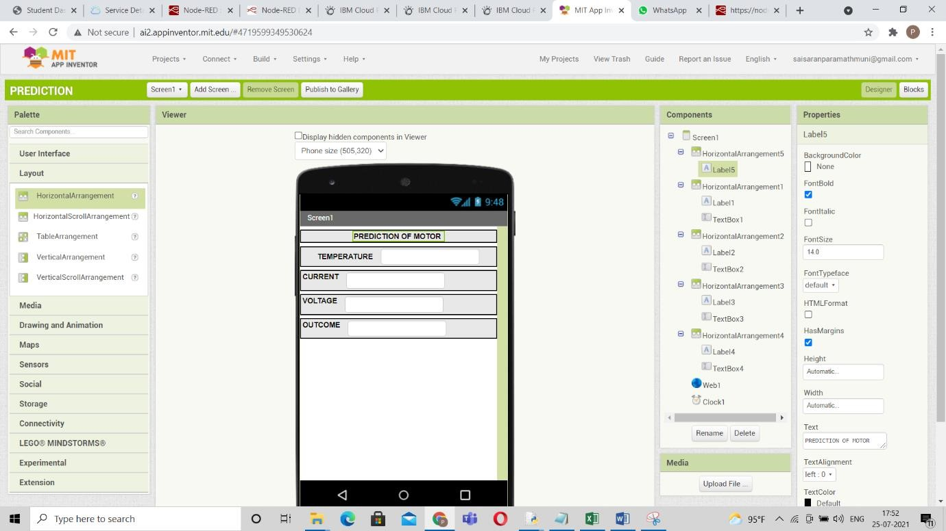

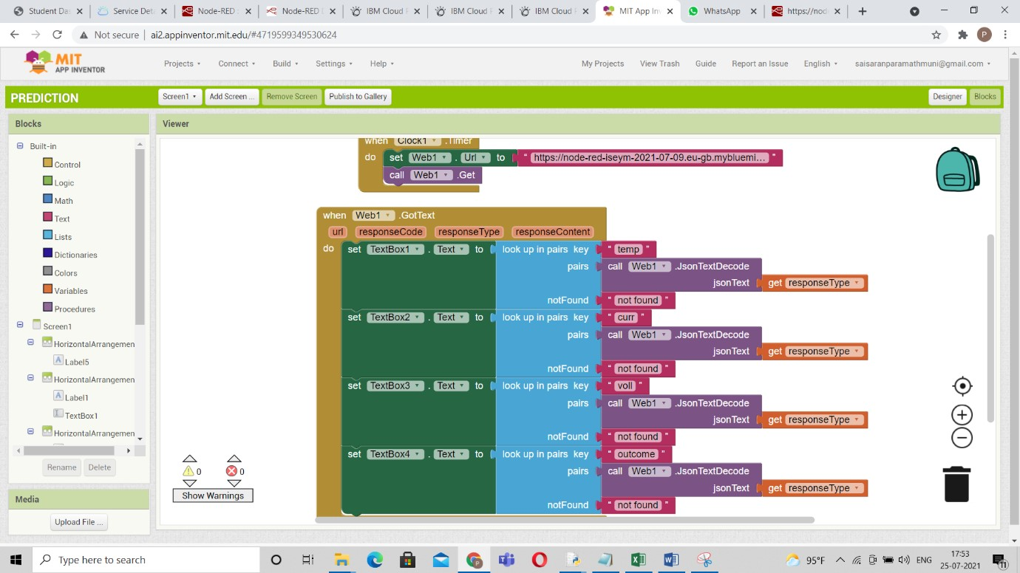

After creating the interface and back-end of the app we need to scan and view it in the app in the phone

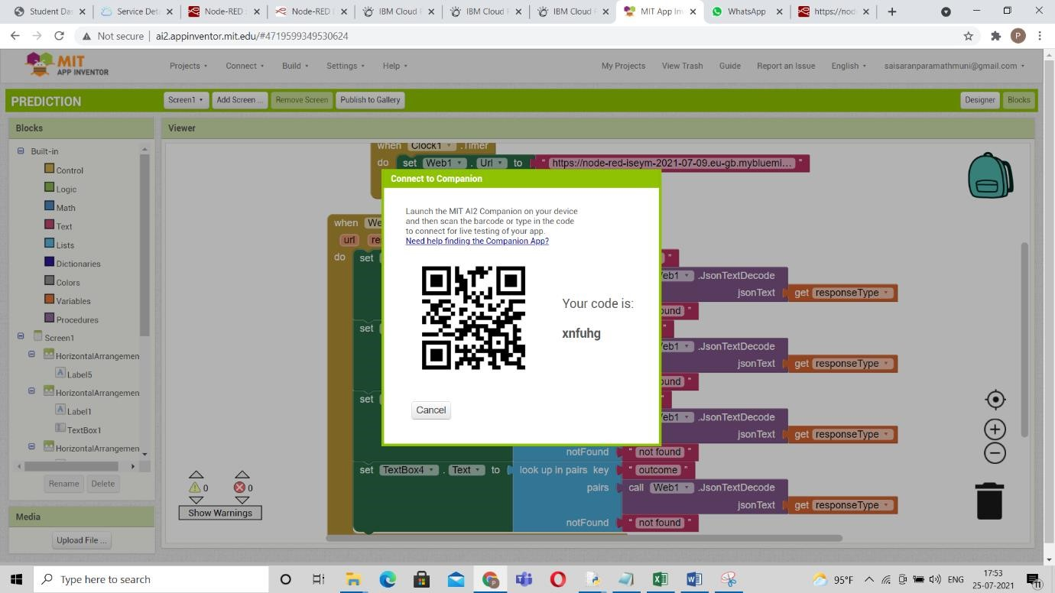

https://github.com/gnaneshwarbandari/IOT/blob/main/ibm_code.p

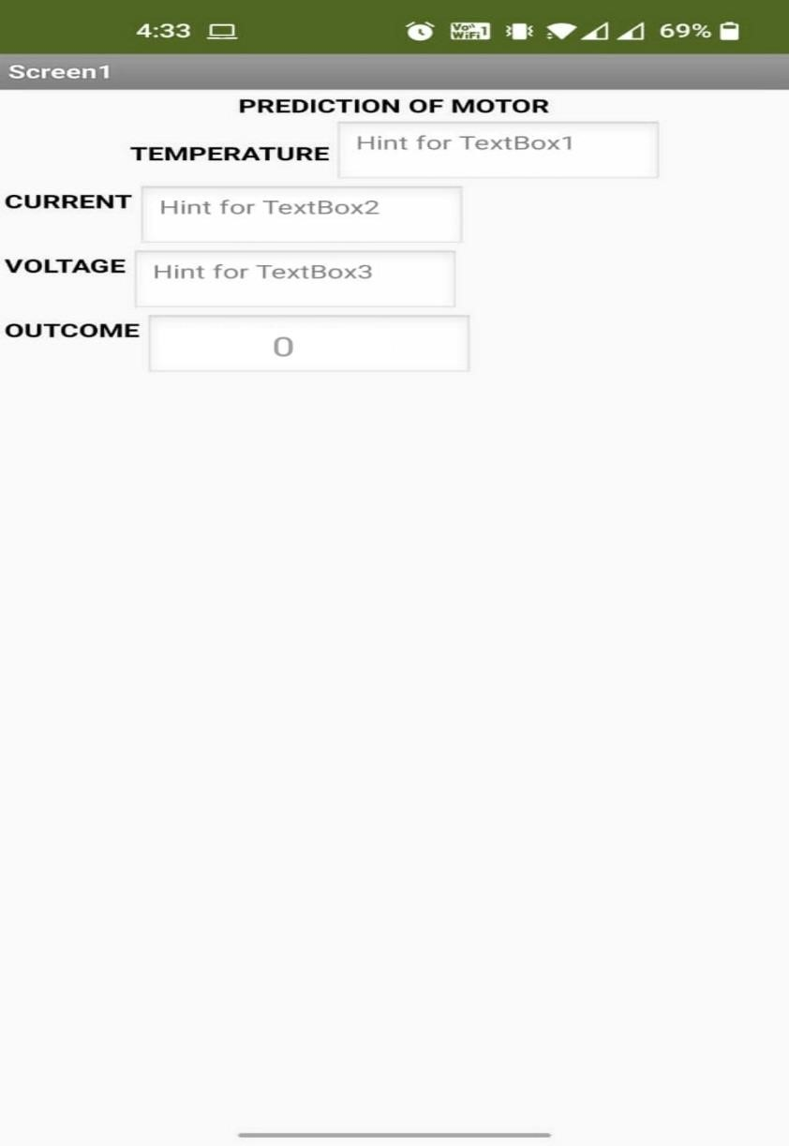

The user will have a connection to this app so he can view it

ADVANTAGES & DISADVANTAGES:

Reduction in maintenance costs

Reduction in machine failures

Life time of service parts will increase

Safety operator

Increases investment in diagnostic equipment

Savings potential is readily seen by management

Increases investment in staff training

CONCLUSION:

This project is mainly focused on the problem of carrying out predictive maintenance in a industrial motors and presented the results of the preliminary data analysis and feature selection that were performed on a sample of the collected data sheet. The derived data from IOT device gives the status of industrial motors about temperature, current & voltage from the equipment is continuously monitored to avoid any short circuits and line breakage. So predictive maintenance of industrial motors plays a major roll in maintaining it. In order to reduce the risk factor in this the process has to be carefully planned and carried out by well trained workers

1. – it won’t work
2. – it will work

BIBLIOGRAPHY:

Smart bridge lecture videos IBM platform videos

[https://drive.google.com/file/d/1W4skAVwWkVhKBbSMAMXtnrvP6MbdqvtG/view?us p=sharing](https://drive.google.com/file/d/1W4skAVwWkVhKBbSMAMXtnrvP6MbdqvtG/view?usp=sharing)

[https://drive.google.com/file/d/1tX2MhuhqvMfHpirDlRhpSODV1gFtXqL9/view?usp=s haring](https://drive.google.com/file/d/1tX2MhuhqvMfHpirDlRhpSODV1gFtXqL9/view?usp=sharing) [https://drive.google.com/file/d/1oL_KpIKNeSuwVNnsJhQ6rgY3MlRogHvS/view?usp =sharing](https://drive.google.com/file/d/1oL_KpIKNeSuwVNnsJhQ6rgY3MlRogHvS/view?usp=sharing)

SOURCE CODE:

[https://github.com/gnaneshwarbandari/IOT/blob/main/ibm_code .py](https://github.com/gnaneshwarbandari/IOT/blob/main/ibm_code.py)