|  |
| --- |
| CROP PROTECTION FROM ANIMALS  PROJECT REPORT  TEAM NEURAL NETWORKS  Anushka Shukla  Prashant Maikhuri  Tharani Kumar  Vishwa Hatwalne |

Abstract:

Agriculture is a means of employment for 58% of India’s population, a key contributor to the country’s GDP and a source of raw materials for the country’s industries. Crop damage is a problem that leads to many losses for farmers and an efficient method to ensure complete security of the crops has not yet been developed. In this project, we have proposed a system based on Artificial Intelligence that works to protect the crops from animals. The system works on a web application with a live video stream of the farmlands. A Convolutional Neural Networks model is used to detect animals in the feed. When an animal that could potentially damage crops is discovered, an alarm sound is emitted. This helps in alerting the farmers to the intruders and thus assists in preventing crop damage.

Introduction:

The field of agriculture is the primary source of livelihood for more than half of India’s population and a great contributor to the economy. However, the lives of farmers are rife with many toils and troubles. One among the many problems is the damage inflicted on crops by animals. Whether the damage occurs due to wild and local animals consuming the crops, uprooting them or stampeding them, it is a significant problem which farmers find difficult to face.

The farmlands are vast and there are never-ending tasks to be done in them, so it is impossible for the farmers to constantly monitor the crops. Manual methods of protection are also difficult, since their efficiency is not the best and there is potential danger to farmers in chasing away certain ferocious animals. Therefore, it is necessary to come up with a system which can work efficiently to protect the crops.

It must also be noted that no harm should come to the animals because of the system, as several crop protection methods include electric fences and similar features which cause injury and fatality to the animals. Thus, an ethical system must be arrived at which optimizes crop protection while ensuring minimal damage to the animals.

Literature Survey:

Dr. R. S. Sabeenian, N.Deivana and B. Mythili, in their paper, “Wild Animals Intrusion Detection using Deep Learning Techniques” sought to overcome the problems faced by farmers due to the attack of wild animals on their farms, which ruined the crops. They used the concept of deep neural networks, which is a division of computer vision, as well as a machine learning model, various libraries and concepts of convolutional neural networks. Their project involved setting up a camera which would record the surroundings of the crops and regular monitoring of it. A sound would be played to drive the animals away if they were to be detected.

Davide Adami, S. Giordano et al. in their paper, “IoT Solutions for Crop Protection against Wild Animal Attacks” provided a system that would repel and monitor in order to protect crops from weather conditions as well as wild animal attacks. Their project was based on the Internet of Things and employed the usage of low power devices and open source systems to build a repeller device, a back-end system and a weather monitoring system.

Dr. M. Chandra Mohan Reddy, Keerthi Raju et al., in their paper, “Smart Crop Protection System From Living Objects and Fire Using Arduino” aimed at the design and execution of advanced embedded systems to protect crops from calamities such as fires and attacks by local animals. Their automatic crop protection system was based on an arduino uno. Smoke sensors and motion sensors were used, in order to detect fires and approaching animals respectively. A microcontroller was employed to sound an alarm to scare the animals away, as well as send an SMS alert and a call to the farmer. If smoke is detected, a motor is immediately turned on. Thus, the complete safety of the crops is ensured.

Aishwarya Premdas, Rohith R et al, in their paper, “Smart Crop Protection using Deep Learning Approach '', focused on providing a crop protection system which prevented damage to the plants without harming the animals which would cause the damage. Raspberry pi was employed to protect the crops from the animals. PIR sensors were used to detect intrusions and Pi cameras were used to capture images. Convolutional Neural Network was used to classify the intruding animals as local/wild animals. Noises were used to fend off the animals and SMS alert was sent regarding the intrusion to the farmer. All the data was stored in a cloud to collect useful information which could further be used to develop systems and more measures.

R. Arjun, Devika Sunil et al, in their paper, “Smart Crop Protection System from Birds Using Deep Learning”, proposed an automatic system which included 24/7 monitoring of the crops by the use of various cameras. This provided a live video stream on which YOLO object detection was used to detect intruding birds. Upon detection, ultrasonic sound waves were used to generate a blaring sound which would irritate the birds, causing them to flee and the crops would remain safe. Manual labour needed for surveillance would be reduced due to this application of deep learning.

Problem Statement:

The aim of the project is to develop a method to ensure the safety of crops, by protecting them from animal intrusion.

Solution:

The damage done to crops by animals can be avoided or, at the very least, minimised by developing a system which would detect the presence of animals in the area surrounding the crops. If an animal is detected, the system would generate an alarm sound, which would alert the farmers to take necessary steps to barricade against the animals or drive them away. This can be done by using Artificial Intelligence, implemented in Python.

Convolutional Neural Networks:

A way that we can make an accurate and reliable animal detection system is through the use of Convolutional Neural Networks — a type of deep neural network that is used to analyze images. Before we get into CNN’s, let’s backtrack a little bit and take a look at how neural networks work. Neural networks are essentially computer programs that are modeled in a similar fashion as to how a human brain works. Like our brain, neural networks consist of a whole bunch of neurons that can’t do much individually, but when connected together in a network, can do some pretty incredible tasks.

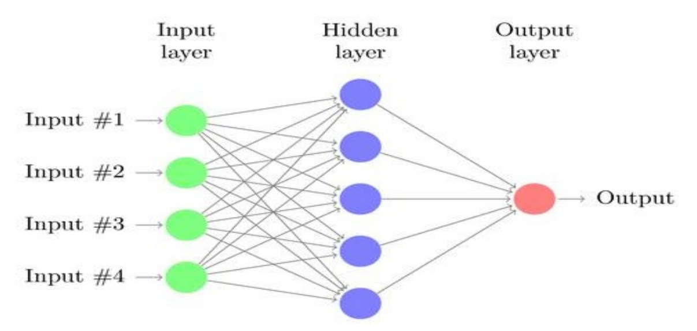

The job of a neuron is quite simple, it takes in a couple inputs; let’s call them X1, X2, and X3,X4, as per the diagram, and then spits out an output. Each of the inputs has a certain weight coefficient associated with them. These weights affect the output of the neuron and they are constantly changed to get an improved output .

Convolutional Neural Networks are different from normal neural networks because they contain a special type of layer called a Convolution Layer, which contains a filter that is able to understand certain types of patterns in the image.

Usually, layers that are right at the start would be used for something pretty simple like edge detection. Later on, layers can detect more complex features like eyes, noses, and fingers. All of these feature maps are put into a long list of features at the end of the network, which is used to finally classify the image.

Software Specifications:

Python version 3.6.9 in Google Colab is used for the implementation of the program to build a detection model. HTML is required for developing the web application.

In the model building process, the Python library numpy was used to convert the data into arrays. Tensorflow version 2.x is required to convert the arrays into tensors, construct and build the model, add layers and to preprocess the data.

In the web application development process and integration with the model, OpenCV is required for video capturing and generating frames from them to run the model on. The library flask is required to implement the program on a HTML page. Flask's render template is for rendering the html page, rewsponse is for responding to html page with video feed, load_model is used to load the trained and stored model and winsound is used to produce an alert sound whenever an animal is detected.

Hardware Specifications:

The GPU used for the implementation is Tesla P100 and the required RAM capacity is 25.46 GB.

Experimental Investigations:

An initial model was built with six layers of convolution, which gave training and testing accuracies to be 67% and 76% respectively.

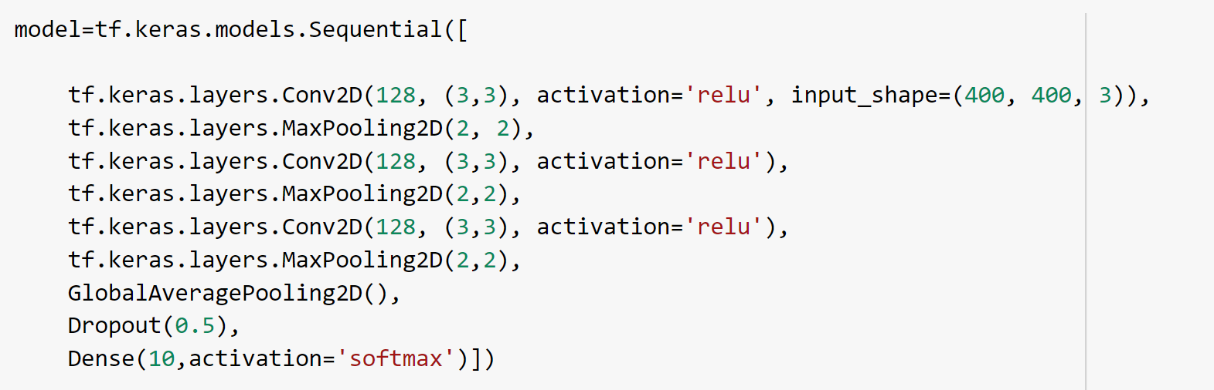

Another model was trained and tested with varying values of epochs and batch size, as well as different optimizers to get the best values of accuracy.

A training accuracy of 88.54% and a testing accuracy of 68% were reached by using the optimizer, “Adam” with 100 epochs being used, along with batch sizes of 256 for the training set and 64 for the testing set.

When 50 epochs were used with batch sizes of 128 for the training set and 32 for the testing set, accuracies of 76% and 67% were reached for training and testing respectively.

The model achieved a training accuracy of 91% and testing accuracy of 87% after applying transfer learning on it. Inception Resnet V2 was used for transfer learning and ‘imagenet’ was used for the weights. The activation function used was ‘Softmax’. This model was chosen for the system.

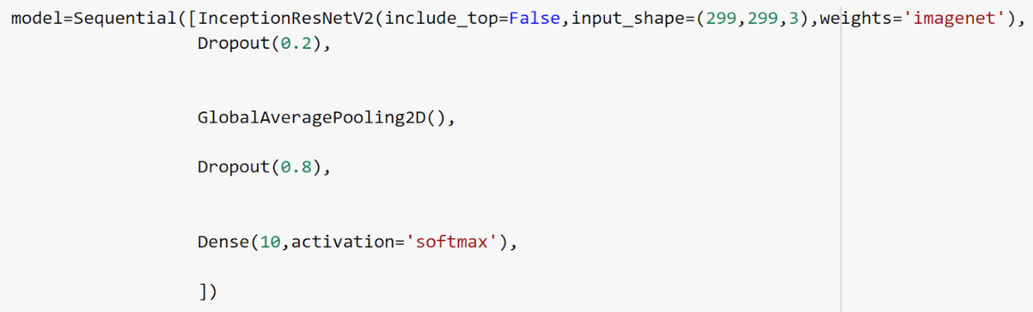

Web Application:

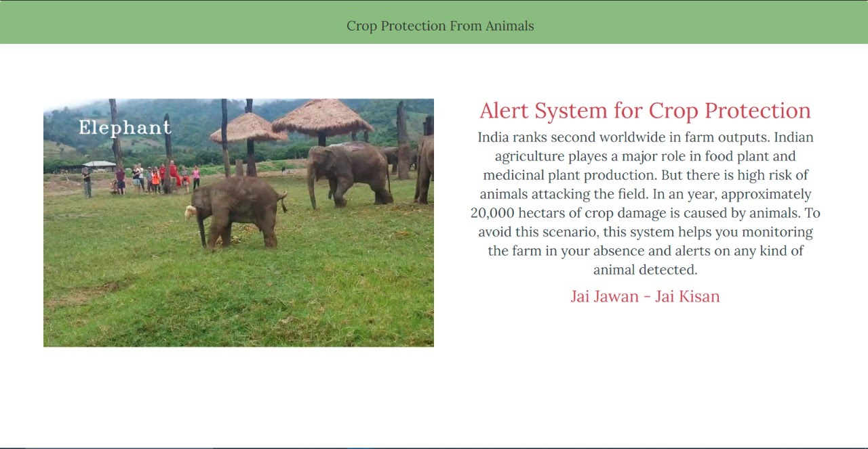

The above image shows a screen capture of the website. On the left, the live video feed of the farmlands is depicted and when an animal is detected, it displays the name of the animal on the feed, as well as below it. On the right, a brief description about the Indian agriculture feed is visible.

Working of the System:

The web application has a live feed of the farmlands in the form of a video feed built into the server. The path of the feed is captured and provided to the OpenCV video capture function. This function is used to convert the video into images (each frame of the video is converted to an image) by retrieving each frame and resizing it to 299 pixels. The image is then pre- processed, normalizing it and flipping it when necessary. The goal of this is to customize the image in such a way that the model is able to understand it and work with it efficiently.

When the image is ready, it is fed into the CNN model. The CNN model is built to scan the images and detect the presence of animals. It can detect a total of ten animals, namely, Butterfly, Cat, Chicken, Cow, Dog, Elephant, Horse, Sheep, Spider and Squirrel. If an animal is detected, it returns the index corresponding to said animal (the indices correspond to the alphabetical order of the animal).

If an animal is detected in the given image by the CNN model, an alarm is sounded, unless the animal which is detected is a butterfly, spider or squirrel. The alarm is generated using ultrasonic sound waves at a frequency of 2500 Hz for a duration of 1 second. A message showing what type of animal is detected will also be displayed.

Flowchart:

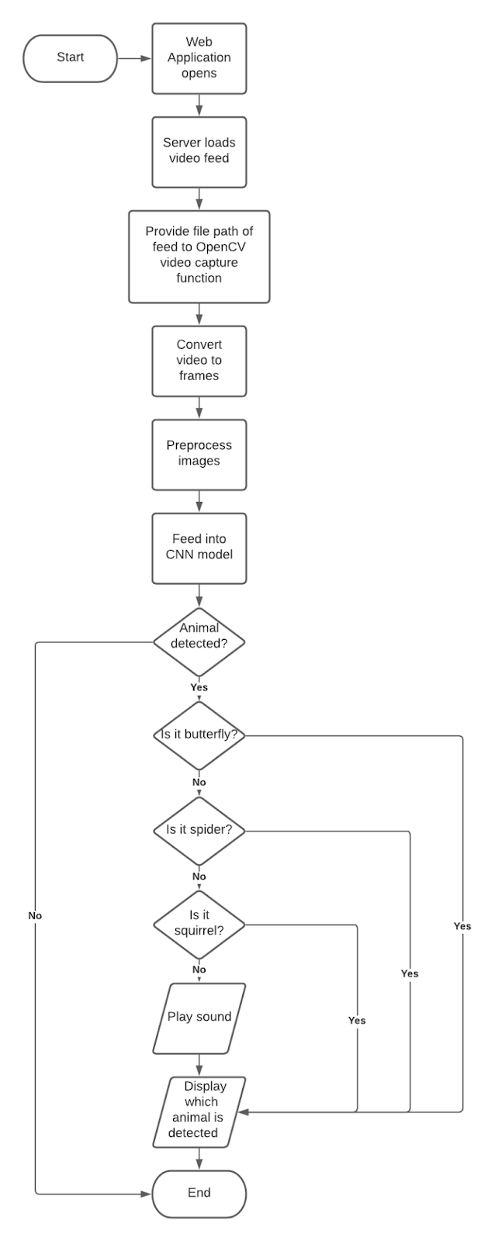

Future Scope:

In the future, practical applications of this system can be made in farmlands, with cameras and a web network supporting a live feed. The system could be integrated with the Cloud and a record could be maintained of the different animal intrusions, which can be used to predict the attacks based on factors such as time period where attacks are frequent, type of crops grown, fertilizers used, etc. The reach of what the system can detect can also be expanded to birds and pests.

Endangered species of animals can also intrude upon farmlands and damage crops, in cases where there are wildlife sanctuaries or national parks nearby. A collection of endangered animals can be added to the system and when such an animal is detected, an alert could be sent to the forest officials nearby, who can safely guide the animals back to their habitats.

If a certain pest infestation is prominent in the field, the system can be configured to recommend a pesticide or insecticide to the farmer on the web application. The user could input the type of crops grown so that a pesticide could be recommended which does not cause harm  to the crops. Economical home remedy recipes for getting rid of pests can also be suggested.

Conclusion:

The web application is user friendly and successfully depicts the output of the system. It is simple, easy to understand and made accessible to all kinds of users. The live video feed of the farmland ensures constant and vigilant monitoring of the crops. Manual labour required by farmers or workers in patrolling the field can be greatly reduced due to this.

The model used in the project has achieved an accuracy of 87% and is able to successfully detect the presence of an animal in a given image and convey what animal has been detected to the user. The alarm sound is sufficient to alert the farmers regarding the animal intrusion.

Thus, the system is capable of efficiently protecting crops from damage by animals, while not causing harm to the animals as well. It will provide a smart solution to the woes of the farmers, especially as the government is also working to assist them through the Digital India movement.

References:

1. Giordano, S. & Seitanidis, Ilias & Ojo, Mike & Adami, Davide & Vignoli, Fabio. (2018). IoT solutions for crop protection against wild animal attacks. 1-5. 10.1109/EE1.2018.8385275.

1. R.S, Dr.Sabeenian & Deivanai, N & Mythili, B. (2020). Wild Animals Intrusion Detection using Deep Learning Techniques. 10.31838/ijpr/2020.12.04.164.

1. Aishwarya, Kavita H M, Rashmi Reddy K, Srikanth N, Soumya D B. (2019). Smart Crop Protection System from Animals and Fire using Arduino. International Journal of Engineering Research in Electronics and Communication Engineering (IJERECE) Vol 6, Issue 4.

1. S. Vidhya, Vishwashankar, T. J., Akshaya, K., Premdas, A., and Rohith, R. (2019) Smart crop protection using deep learning approach, International Journal of Innovative Technology and Exploring Engineering, vol. 8, pp. 301-305.

1. Sunil D., Arjun R., Ashokan A., Zakir F., John N.P. (2021) Smart Crop Protection System from Birds Using Deep Learning. In: Hassanien A.E., Bhattacharyya S., Chakrabati S., Bhattacharya A., Dutta S. (eds) Emerging Technologies in Data Mining and Information Security. Advances in Intelligent Systems and Computing, vol 1300. Springer, Singapore.

1. Abhishek Paliwal, Omkar Kekre, Rohit Hazare, Srushti Mehatkar, (2020) International Research Journal of Engineering and Technology (IRJET) Volume: 07 Issue: 05.

1. K.S. Rao, R.K. Maikhuri, S. Nautiyal, K.G. Saxena. (2002) Crop damage and livestock depredation by wildlife: a case study from Nanda Devi Biosphere Reserve, India, Journal of Environmental Management, Volume 66, Issue 3.

1. Piyush Mehta,Negi Arun, Chaudhary Rashmi, Janjua Yasmin and Thakur Pankaj. (2008)

“A Study on Managing CropDamage by Wild Animals in Himachal Pradesh”, International Journal of Agriculture Sciences. Volume 10, Issue 12.