**ASSIGNMENT-4**

NAME: CHAITANYA KRISHNA M

REGNO: 18BIS0013

VELLORE INSTITUTE OF TECHNOLOGY

1. Navigation messages, Geometry Messages, and sensor messages.

**Navigation messages:**

nav_msgs defines the common messages used to interact with the navigation stack.

The following are the message types in navigation messages:

|  |  |  |
| --- | --- | --- |
| **ROS Message Types** |  |  |
| [GridCells](http://docs.ros.org/en/api/nav_msgs/html/msg/GridCells.html) [MapMetaData](http://docs.ros.org/en/api/nav_msgs/html/msg/MapMetaData.html) [OccupancyGrid](http://docs.ros.org/en/api/nav_msgs/html/msg/OccupancyGrid.html) [Odometry](http://docs.ros.org/en/api/nav_msgs/html/msg/Odometry.html) [Path](http://docs.ros.org/en/api/nav_msgs/html/msg/Path.html) |  |  |

**ROS Service Types**

[GetMap](http://docs.ros.org/en/api/nav_msgs/html/srv/GetMap.html)  
 [GetPlan](http://docs.ros.org/en/api/nav_msgs/html/srv/GetPlan.html)  
 [LoadMap](http://docs.ros.org/en/api/nav_msgs/html/srv/LoadMap.html)  
 [SetMap](http://docs.ros.org/en/api/nav_msgs/html/srv/SetMap.html)

|  |
| --- |
| **ROS Action Types** |

GetMap

An example for a navigation message is the Odometry message type. Given below is a raw definition message of Odometry message type.

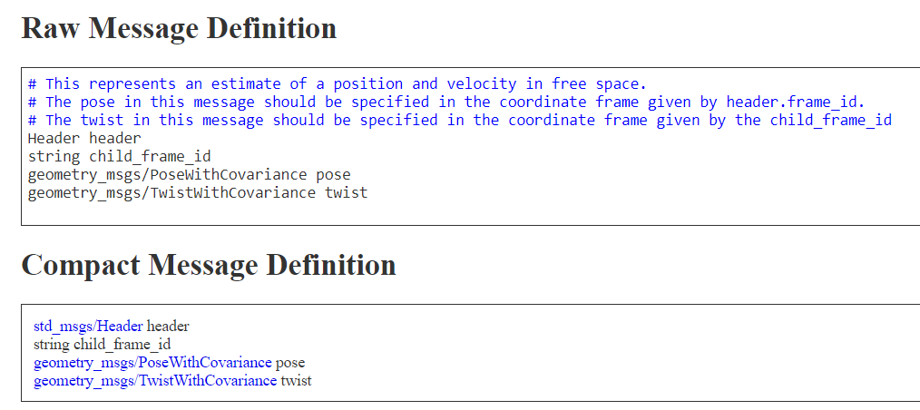

**Geometry messages:**

geometry_msgs provides messages for common geometric primatives such as points, vectors, and poses. These primatives are designed to provide a common data type and facilitate interoperability throughout the system.

The following are the message types in geometry messages:

* Accel
* AccelStamped
* AccelWithCovariance
* AccelWithCovarianceStamped
* Inertia
* InertiaStamped
* Point
* Point32
* PointStamped
* Polygon
* PolygonStamped
* Pose
* Pose2D
* PoseArray
* PoseStamped
* PoseWithCovariance
* PoseWithCovarianceStamped
* Quaternion
* QuaternionStamped
* Transform
* TransformStamped
* Twist
* TwistStamped
* TwistWithCovariance
* TwistWithCovarianceStamped
* Vector3
* Vector3Stamped
* Wrench
* WrenchStamped

An example for a geometry message is the Twist message type. Given below is a raw definition message of Twist message type.

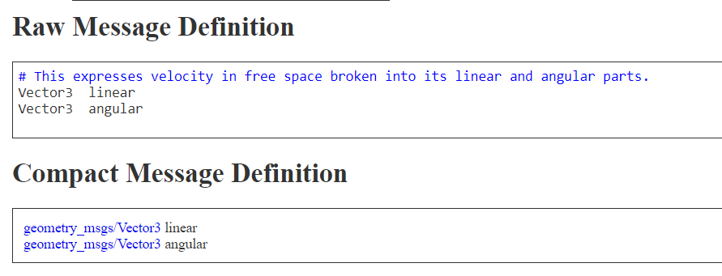

**Sensor messages:**

This package defines messages for commonly used sensors, including cameras and scanning laser rangefinders.

* BatteryState
* CameraInfo
* ChannelFloat32
* CompressedImage
* FluidPressure
* Illuminance
* Image
* Imu
* JointState
* Joy
* JoyFeedback
* JoyFeedbackArray
* LaserEcho
* LaserScan
* MagneticField
* MultiDOFJointState
* MultiEchoLaserScan
* NavSatFix
* NavSatStatus
* PointCloud
* PointCloud2
* PointField
* Range
* RegionOfInterest
* RelativeHumidity
* Temperature
* TimeReference

An example for sensor message type is laserscan message. Given below is the raw message definition for the laserscan message type.

