**ASSIGNMENT 6**

**NAME: CHAITANYA KRISHNA M**

**REG NO: 18BIS0013**

Build the 4 wheeled Robot using ROS URDF and Xacro methods.

**IMAGE:**

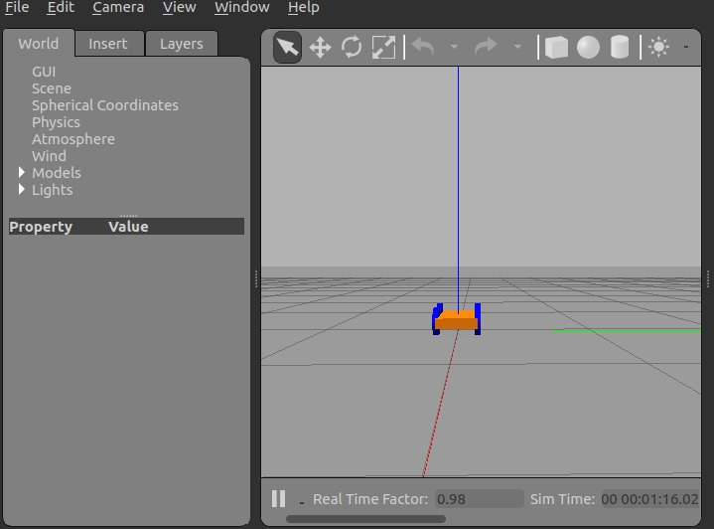

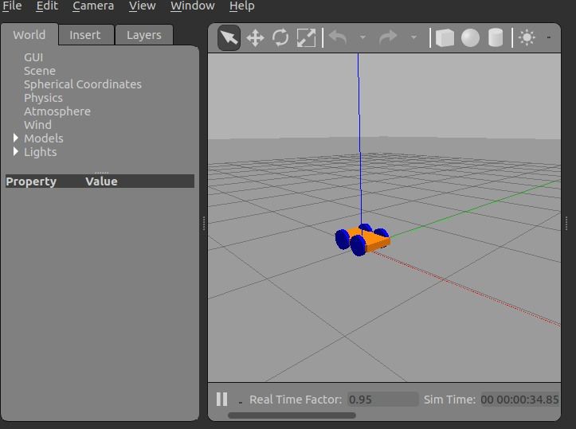

**CODE:**

<?xml version="1.0" ?>

<robot name="mybot" xmlns:xacro="https://www.ros.org/wiki/xacro" >

<material name="black">

<color rgba="0.0 0.0 0.0 1.0"/>

</material>

<material name="blue">

<color rgba="0.203125 0.23828125 0.28515625 1.0"/>

</material>

<material name="green">

<color rgba="0.0 0.8 0.0 1.0"/>

</material>

<material name="grey">

<color rgba="0.2 0.2 0.2 1.0"/>

</material>

<material name="orange">

<color rgba="1.0 0.423529411765 0.0392156862745 1.0"/>

</material>

<material name="brown">

<color rgba="0.870588235294 0.811764705882 0.764705882353 1.0"/>

</material>

<material name="red">

<color rgba="0.80078125 0.12890625 0.1328125 1.0"/>

</material>

<material name="white">

<color rgba="1.0 1.0 1.0 1.0"/>

</material>

<gazebo reference="link_chassis">

<material>Gazebo/Orange</material>

</gazebo>

<gazebo reference="link_left_wheel_f">

<material>Gazebo/Blue</material>

</gazebo>

<gazebo reference="link_right_wheel_f">

<material>Gazebo/Blue</material>

</gazebo>

<gazebo reference="link_left_wheel_b">

<material>Gazebo/Blue</material>

</gazebo>

<gazebo reference="link_right_wheel_b">

<material>Gazebo/Blue</material>

</gazebo>

<gazebo>

<plugin filename="libgazebo_ros_diff_drive.so" name="differential_drive_controller">

<alwaysOn>true</alwaysOn>

<updateRate>20</updateRate>

<leftJoint>joint_left_wheel</leftJoint>

<rightJoint>joint_right_wheel</rightJoint>

<wheelSeparation>0.4</wheelSeparation>

<wheelDiameter>0.2</wheelDiameter>

<torque>0.1</torque>

<commandTopic>cmd_vel</commandTopic>

<odometryTopic>odom</odometryTopic>

<odometryFrame>odom</odometryFrame>

<robotBaseFrame>link_chassis</robotBaseFrame>

</plugin>

</gazebo>

<link name="link_chassis">

<!-- pose and inertial -->

<pose>0 0 0.1 0 0 0</pose>

<inertial>

<mass value="5"/>

<origin rpy="0 0 0" xyz="0 0 0.1"/>

<inertia ixx="0.0395416666667" ixy="0" ixz="0" iyy="0.106208333333" iyz="0" izz="0.106208333333"/>

</inertial>

<!---Body-->

<collision name="collision_chassis">

<geometry>

<box size="0.5 0.3 0.07"/>

</geometry>

</collision>

<visual>

<origin rpy="0 0 0" xyz="0 0 0"/>

<geometry>

<box size="0.5 0.3 0.07"/>

</geometry>

<material name="blue"/>

</visual>

</link>

<!-- Wheel Right Front -->

<link name="link_right_wheel_f">

<inertial>

<mass value="0.2"/>

<origin rpy="0 1.5707 1.5707" xyz="0 0 0"/>

<inertia ixx="0.00052666666" ixy="0" ixz="0" iyy="0.00052666666" iyz="0" izz="0.001"/>

</inertial>

<collision name="link_right_wheel_f_collision">

<origin rpy="0 1.5707 1.5707" xyz="0 0 0" />

<geometry>

<cylinder length="0.04" radius="0.1"/>

</geometry>

</collision>

<visual name="link_right_wheel_f_visual">

<origin rpy="0 1.5707 1.5707" xyz="0 0 0"/>

<geometry>

<cylinder length="0.04" radius="0.1"/>

</geometry>

</visual>

</link>

<!-- Joint for right wheel front -->

<joint name="joint_right_wheel_f" type="continuous">

<origin rpy="0 0 0" xyz="-0.12 0.15 0"/>

<child link="link_right_wheel_f" />

<parent link="link_chassis"/>

<axis rpy="0 0 0" xyz="0 1 0"/>

<limit effort="10000" velocity="1000"/>

<joint_properties damping="1.0" friction="1.0" />

</joint>

<!-- Wheel Right Back-->

<link name="link_right_wheel_b">

<inertial>

<mass value="0.2"/>

<origin rpy="0 1.5707 1.5707" xyz="0 0 0"/>

<inertia ixx="0.00052666666" ixy="0" ixz="0" iyy="0.00052666666" iyz="0" izz="0.001"/>

</inertial>

<collision name="link_right_wheel_b_collision">

<origin rpy="0 1.5707 1.5707" xyz="0 0 0" />

<geometry>

<cylinder length="0.04" radius="0.1"/>

</geometry>

</collision>

<visual name="link_right_wheel_b_visual">

<origin rpy="0 1.5707 1.5707" xyz="0 0 0"/>

<geometry>

<cylinder length="0.04" radius="0.1"/>

</geometry>

</visual>

</link>

<!-- Joint for right wheel back -->

<joint name="joint_right_wheel_b" type="continuous">

<origin rpy="0 0 0" xyz="0.12 0.15 0"/>

<child link="link_right_wheel_b" />

<parent link="link_chassis"/>

<axis rpy="0 0 0" xyz="0 1 0"/>

<limit effort="10000" velocity="1000"/>

<joint_properties damping="1.0" friction="1.0" />

</joint>

<!-- Left Wheel link Front -->

<link name="link_left_wheel_f">

<inertial>

<mass value="0.2"/>

<origin rpy="0 1.5707 1.5707" xyz="0 0 0"/>

<inertia ixx="0.00052666666" ixy="0" ixz="0" iyy="0.00052666666" iyz="0" izz="0.001"/>

</inertial>

<collision name="link_left_wheel_f_collision">

<origin rpy="0 1.5707 1.5707" xyz="0 0 0" />

<geometry>

<cylinder length="0.04" radius="0.1"/>

</geometry>

</collision>

<visual name="link_left_wheel_f_visual">

<origin rpy="0 1.5707 1.5707" xyz="0 0 0"/>

<geometry>

<cylinder length="0.04" radius="0.1"/>

</geometry>

</visual>

</link>

<!-- Joint for left wheel front -->

<joint name="joint_left_wheel_f" type="continuous">

<origin rpy="0 0 0" xyz="-0.12 -0.15 0"/>

<child link="link_left_wheel_f" />

<parent link="link_chassis"/>

<axis rpy="0 0 0" xyz="0 1 0"/>

<limit effort="10000" velocity="1000"/>

<joint_properties damping="1.0" friction="1.0" />

</joint>

<!-- Left Wheel link Back -->

<link name="link_left_wheel_b">

<inertial>

<mass value="0.2"/>

<origin rpy="0 1.5707 1.5707" xyz="0 0 0"/>

<inertia ixx="0.00052666666" ixy="0" ixz="0" iyy="0.00052666666" iyz="0" izz="0.001"/>

</inertial>

<collision name="link_left_wheel_b_collision">

<origin rpy="0 1.5707 1.5707" xyz="0 0 0" />

<geometry>

<cylinder length="0.04" radius="0.1"/>

</geometry>

</collision>

<visual name="link_left_wheel_b_visual">

<origin rpy="0 1.5707 1.5707" xyz="0 0 0"/>

<geometry>

<cylinder length="0.04" radius="0.1"/>

</geometry>

</visual>

</link>

<!-- Joint for left wheel Back -->

<joint name="joint_left_wheel_b" type="continuous">

<origin rpy="0 0 0" xyz="0.12 -0.15 0"/>

<child link="link_left_wheel_b" />

<parent link="link_chassis"/>

<axis rpy="0 0 0" xyz="0 1 0"/>

<limit effort="10000" velocity="1000"/>

<joint_properties damping="1.0" friction="1.0" />

</joint>

</robot>