**ASSIGNMENT 3**

NAME: CHAITANYA KRISHNA M

REG NO: 18BIS0013

VELLORE INSTITUTE OF TECHNOLOGY

**Identify the two ROS based autonomous Robots apart from the Turtlebot family and Write about it.**

* **Jet:**

Jet is a ROS based autonomous robot co-developed by NVIDIA and the robotics department at California Polytechnic State University. Jet is a smart, autonomous robot based on the NVIDIA Jetson embedded development platform utilizing Servocity Acotobotics components. Jet’s brain is built around the NVIDIA Tegra SoC and uses the same NVIDIA computing cores designed into supercomputers. This gives Jet compute-intensive computer vision, artificial intelligence (AI), and self-driving capabilities in a low-cost package.

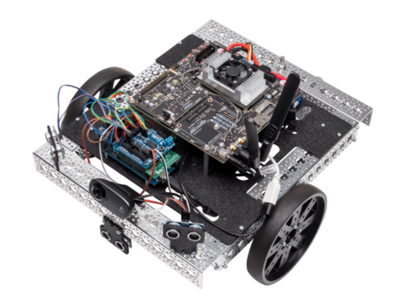

* **Copernicus**

Botsync Copernicus is a rugged and easy to integrate ground vehicle designed to support your prototyping and research needs. Copernicus uses the Robot Operating System (ROS) out of the box and provides access to motion commands through a serial interface.

The system has been designed to support multiple third part sensors and manipulators. The support covers the software as well as the electromechanical integration of the sensors that you need, such that your effort in setting up the system that you need for your research efforts is as minimal as possible.

The following are packages used for building the robot:

1. Copernicus_base
2. Copernicus_control
3. Copernicus_description
4. Copernicus_localization
5. Copernicus_msgs
6. Copernicus_navigation

