Liver Patient Analysis

A PROJECT REPORT

Submitted by

Rabindra Kumar (19BCE10033)

Kanhaiya Singh (19BCE10288)

Harshit Johri (19BCE10292)

Prakash Kanan (18BCE1300)

Naveen Karthikeyan (18BCE1337)

**BONAFIDE CERTIFICATE**

Certified that this project report titled “Liver Patient Analysis " is the Bonafide work of “Rabindra Kumar (19BCE10033) ,Kanhaiya Singh (19BCE10288) Harshit Johri (19BCE10292), Prakash Kanan (18BCE1300) Naveen Karthikeyan (18BCE1337)” who carried out the project work under my supervision, certified further that to the best of my knowledge the work reported here does not form part of any other project / research work on the basis of which a degree or award was conferred on an earlier occasion on this or any other candidate.

**ACKNOWLEDGEMENT**

Primarily, I would like to thank the Lord Almighty for his presence and immense blessings throughout the project work. I wish to express my heartfelt gratitude to our instructor Surya Tej, for continually guiding and actively participating in our project, giving valuable suggestions to complete the project work. I would like to thank all the technical and teaching staff of the smart internz and smart bridge, who extended directly or indirectly all support. Last but not the least, I am deeply indebted to my parents who have been the greatest support while I worked day and night for the project to make it a success.

**Liver Patient Analysis Using IBM Watson**

**Introduction**

Liver disease is any disturbance of liver function that causes illness. The liver is responsible for many critical functions within the body and should it become diseased or injured, the loss of those functions can cause significant damage to the body. Patients with Liver disease have been continuously increasing because of excessive consumption of alcohol, inhale of harmful gases, intake of contaminated food, pickles and drugs.  
This data set contains 416 liver patient records and 167 non liver patient records collected from North East of Andhra Pradesh, India. The “Dataset” column is a class label used to divide groups into liver patient (liver disease) or not (no disease). This data set contains 441 male patient records and 142 female patient records. . The main objective of this project is to analyse the parameters of various classification algorithms

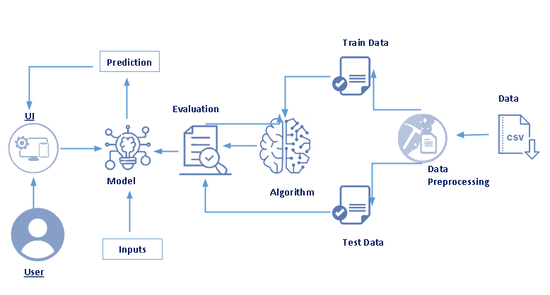

**Pre requisites:**

To complete this project, you must require following software and packages

**Software Required**

**\* Anaconda navigator:**

https://www.anaconda.com/products/individual https://www.youtube.com/watch?v=5mDYijMfSzs&ab_channel=ProgrammingKnowledge

**Packages installation**

If you are using anaconda navigator, follow below steps to download required packages:  
Open the anaconda prompt.  
Type “pip install jupyter notebook” and click enter.  
Type “pip install spyder” and click enter.  
Type “pip install numpy” and click enter.  
Type “pip install pandas” and click enter.  
Type “pip install matplotlib” and click enter.  
Type “pip install seaborn” and click enter.  
Type “pip install sklearn” and click enter.  
Type “pip install Flask” and click enter.

**Learning Outcomes**  
By the end of this project:  
You’ll be able to understand the problem to classify if it is a regression or a classification kind of problem.  
You will be able to know how to pre-process / clean the data using different data pre-processing techniques.  
You will be able to analyse or get insights of data through visualization.  
Applying different algorithms according to dataset and based on visualization.  
You will be able to know how to find the accuracy of the model.

You will be able to learn how to build a web application using the Flask framework.

**Project Flow:**

To accomplish this, we have to complete all the activities and tasks listed below

### **Dataset Collection**

ML depends heavily on data, without data, it is impossible for an “AI” to learn. It is the most crucial aspect that makes algorithm training possible. In Machine Learning projects, we need a training data set. It is the actual data set used to train the model for performing various actions.

### **Data Pre-Processing**

Data Pre-processing includes the following main tasks

1. Import the Libraries.
2. Reading the dataset.
3. Analyse the data.
4. Taking Care of Missing data.
5. Data Visualization.
6. Splitting the Dataset into Dependent and Independent variables.
7. Splitting Data into Train and Test

### **Model Building**

Predictive modeling is a mathematical approach to create a statistical model to forecast future behaviour based on input test data.

**Steps involved in predictive modeling:**

**Algorithm Selection:**

When we have the structured dataset, and we want to estimate the continuous or categorical outcome then we use supervised machine learning methodologies like regression and classification techniques. When we have unstructured data and want to predict the clusters of items to which a particular input test sample belongs, we use unsupervised algorithms. An actual data scientist applies multiple algorithms to get a more accurate model.

**Train Model:**

After assigning the algorithm and getting the data handy, we train our model using the input data applying the preferred algorithm. It is an action to determine the correspondence between independent variables, and the prediction targets.

**Model Prediction:**

We make predictions by giving the input test data to the trained model. We measure the accuracy by using a cross-validation strategy or ROC curve which performs well to derive model output for test data.

Model building includes the following main tasks

1. Training and testing the model
2. Evaluation of Model
3. Save the model
4. Predicting the output using the model

### **Application Building**

Application Building involves following steps

1. Create an HTML file
2. Build a Python Code
3. Run the app

### Train The Model On IBM

Register account on IBM Cloud

Train Model on IBM Cloud

**Output**

**Model 1- FLASK** 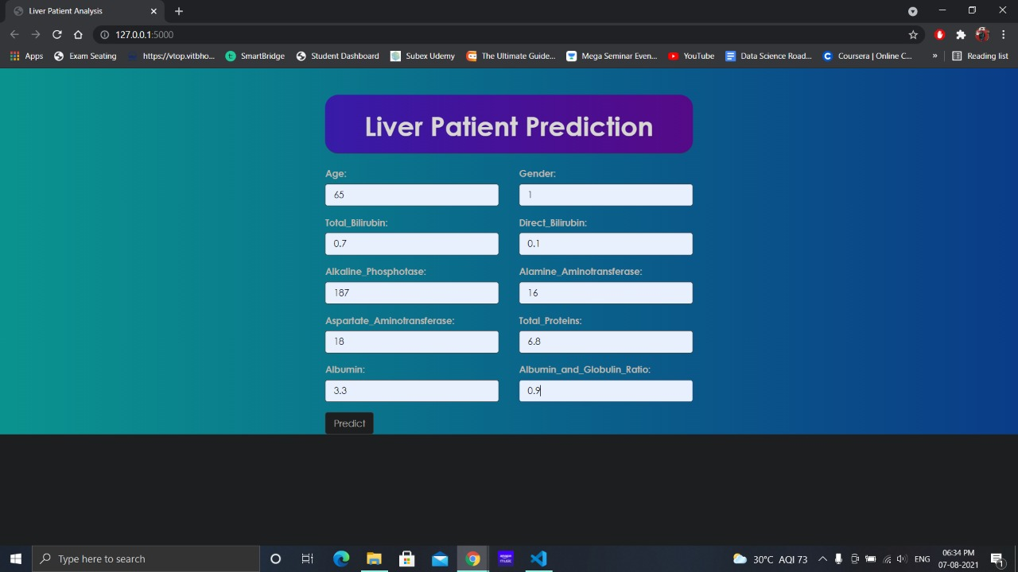 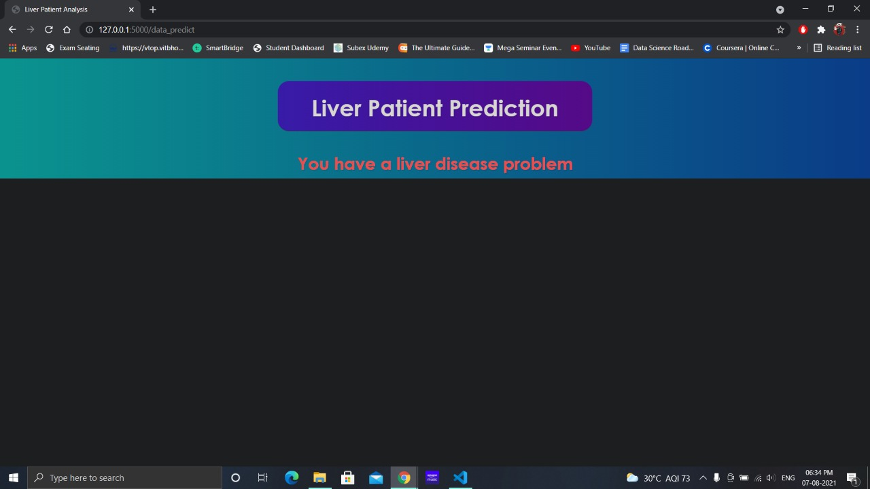

**Model 2 IBM CLOUD**

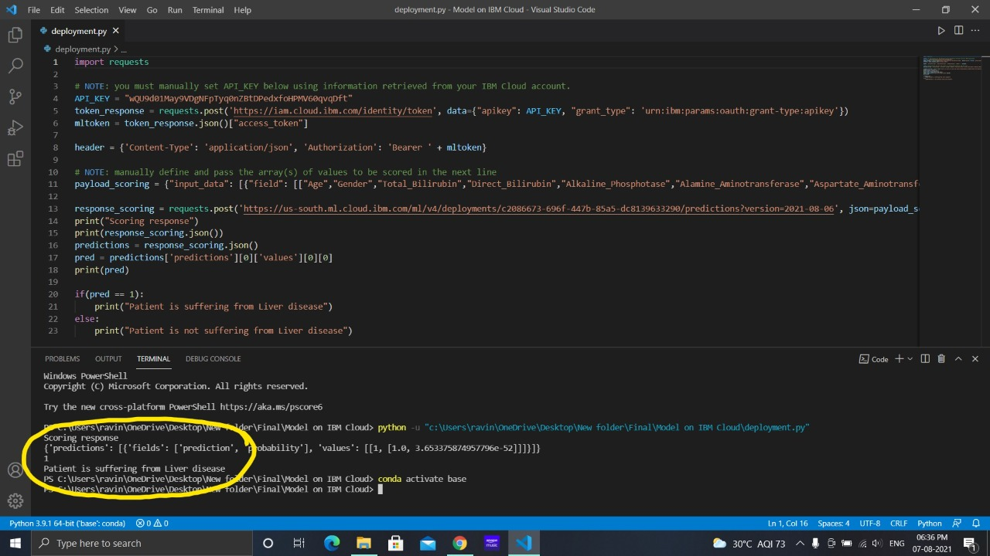

**BIBLIOGRAPHY**

https://medium.com/analytics-vidhya/healthcare-ml-web-application-end-to-end-project-implementation-with-deployment-148f10b0807b

https://kk3239.medium.com/?p=4d0a9f4b7ec2