

of

MAY 2022

**MADHYA PRADESH - 466114**

**KOTHRIKALAN, SEHORE**

**VIT BHOPAL UNIVERSITY**

SCHOOL OF COMPUTING SCIENCE AND ENGINEERING

**PROGRAM OF STUDY**

in

**BACHELOR OF TECHNOLOGY**

degree

in partial fulfillment for the award of the

**19BAI10053**

**Kushagra Bajpai**

**Submitted by**

**A PROJECT REPORT**

**IBM Cognos Analytics**

**Inventory Management Using**

16

14,15

13

12

12

11

11

10

10

Flowcharts

Monthly stock(HeatMap)

Year Wise Stock(Line Graph)

7

Block Diagrams(Common & Functional)

8

Result & DashBoard

Revenue Year(Bar Graph)

6

9

Year wise Price(Line Graph)

2

1

Page No.

Title

Figure No.

List Of Figures

4

Monthly Price(Pie Chart)

5

Monthly Sales(TreeMap)

3

2

3

Proposed Solution

4-5

Goal

Steps

INTRODUCTION

6-9

14-15

16

10-13

17-18

19-21

22

7

RESULT

8

ADVANTAGES AND DISADVANTAGES

9

APPLICATIONS

10

CONCLUSION

1.1

**TABLE OF CONTENTS**

CHAPTER

NO.

TITLE

PAGE NO.

1

List of Figures

2

Table of Contents

3

4

LITERATURE SURVEY

5

THEORETICAL ANALYSIS

3.1 Block Diagram

6

FLOWCHART

Introduction

•

based in a single unknown factor: the demand for the next periods.

Current inventory management models have many solutions to place the correct order, but they are all

•

•

other hand lack of inventory leads to lost sales, unhappy customers and a damaged brand.

hand too much inventory means working capital costs, operational costs and a complex operation. On the

Eery retail business in the world faces a fundamental question: how much inventory should I carry? In one

balance - having the right amount of stock, in the right place, at the right time

may only deal with finished stock items ready for sale. Either way, inventory management all comes down to

assets - AKA its inventory. For some businesses, this involves raw materials and components, while others

Inventory management is the process of ordering, handling, storing, and using a company’s non-capitalized

•

•

Build the Corelation Matrix and Scatter and Density Plots.

•

Building of Visualizations with Analysis of Forecasting of Goods.

•

Preparing Dataset

•

Loading the Dataset

•

Understand the Dataset

Working with the Dataset

•

Steps:

•

forecasting goods.

To find How much Inventory should be maintained by Retail and Consumer Industry for short-term

•

Goal

receiving it. This time is known as lead-time. Every company desires a reduction in time that is consumed to deliver a

customer’s future requirement. But this assumption is not true for all types of products

life time. This means that an item once stocked will always remain in perfect condition and will be ideal to satisfy the

control, usually in most of all developed inventory models it is assumed that the products during storage have endless

period of time only. (c) Survey of Inventory Models with Deterioration In the available literature related to inventory

used. Normally, when a seasonal product comes to the market, the demand for these products exists for a certain

represent the sale pattern of the products at various stages of its life cycle generally timevarying demand functions are

field related to inventory management. (b) Survey of Inventory Models with Seasonal Demand Rate In market to

can put the companies at a risk of shortages before the arrival of stock. Lead time plays a very important role in every

is not certain and varies from time to time, to decrease the lead time becomes very important, since a long lead time

product in the market. In business, lead time minimization is normally preferred. In the cases where customer’s demand

supply chain process frequently. Generally it was observed that the supplier needs some time to fulfill an order after

places an order to the moment it is received by the customer. Lead time can be observed in manufacturing process and

Survey of Inventory Models with Variable Lead Time Lead time is defined as the time from the moment the customer

customer service, Make sure your stock should be optimum.Some of the Survey of Inventory Model are as follows : (a)

incoming and outgoing stock. Inventory management impacts every portion of your business. From expense to

may not realize the importance of the efficient system.It is fundamental for any business with a constant flow of

Inventory Management System is one of the primary phases of any business. Those who have never run the business

•

Literature Review and Survey

inventory models without considering the effect of inflation will lead a wrong estimation. Inflation should be included as a

flows, the dependency relationship between the demand and return process is not explicitly modelled.

external orders and recovery. Since the demand and the return processes are assumed to be continuous deterministic

was proposed by Schrady [106]. The model comes with constant demand and returns rates and fixed lead-time for

preservation technology. (j) Survey of Inventory Models with Closed Loop Supply Chain A first model of reverse logistic

extending the product expiration date. To reduce the deterioration rate in order to preserve the products is known by

Inventory Models with Preservation Factor Generally, enterprises invest in equipment to reduce the deterioration rate and

levels in a supply chain. The requirement of durable and reliable business has raised a typical competition. (i) Survey of

the customer service and profitability and to minimize the total cost. This competition is not limited to the particular

of globalization, a great competition occurs in the market. So every subsystem of a supply chain has a need to maximize

products with spiky random fluctuations in demand. (h) Survey of Inventory Models with Integrated Inventory In this era

decisions in the supply chain are crucial for its success. These decisions become more important for the high-margin

multiple-product version of the inventory problems with capacity constraints has been explored in recent years. Inventory

permanent parameter in the formulation of an inventory system. (g) Survey of Inventory Models with Multi Items A

the time increases, inflation plays a significant role and the associated costs of the model changes. So to develop the

assumed that different costs associated with the inventory models will always be same. But practically, this is not true. As

In traditional inventory models most of all researchers ignored the effect of inflation. In developing the models they

all the payment, during which no interest is charged on the balance amount. (f) Survey of Inventory Models with Inflation

always true in the real world. Practically it was observed that the supplier permits a credit period to the retailer to make

to pay the supplier for all of the purchasing, at the moment he receives the stock, but generally this assumption is not

Inventory Models with Permissible Delay in Payments Usually in EOQ models it was silently assumed that the retailer has

out some of the customers wait for next replenishment, while some impatient customers go elsewhere. (e) Survey of

either all demand is backlogged or completely lost. But in real life situation it is not practically true. In reality, during stock

(d) Survey of Inventory Models with Partial Backlogging Most of the inventory models assume that during the stock out

•

Proposed Solution(Techniques)

Transporting

•

Purchase

•

Requisition

•

Ordering

•

Receiving

•

: it includes the cost of the following:

•

Inspecting

•

Storing

•

Ordering cost differ according to the orders placed. The clerical and the staff costs remain the same as long as they are committed costs.

On the other hand if the quantity of the order increases, the clerical and staff costs may increase. If the quantity is reduced the clerical and

the staff force can be used in other departments hence the cost can be included to the ordering cost. As the ordering costs is proportionate

with the number of orders placed a large inventory helps in reducing the order cost as the number of orders reduce.

How much should be ordered? (economic order quantity)

•

One of the vital objectives of a firm is to manage inventories efficiently in accordance with the shareholders. Optimum

utilization of the inventories aids to achieve that objective, as well as reap profit. The inventories which are controlled

efficiently make the firm flexible and avoid disasters like running out of stock and pilling up of unnecessary stock which

increases the level of investment and does not bring the firm profit. The following questions help to manage the inventories

properly.

•

•

When should it be ordered? (re-order point )

•

ECONOMIC ORDER QUANTITY

•

Economic order quantity deals with problems like the amount of stock to be furnished on the depletion of stock, the planning of production.

So the firm has established the economic lot size. This involves two types of costs:

•

**Ordering costs**

Proposed Solution(Techniques)

•

The storage costs include warehousing cost, stores handling cost and administrative cost. Carrying costs differ

with inventory size and is in contrast with that of ordering cost which reduces with the increase in inventory

level.

•

Re-order point: it means the point at which the firm should restock its inventory. In order to be certain of the

time of restock, the firm should know the following:

•

Lead time (normal replenishing time i.e. reorder= lead*avg. usage)

•

Average use

•

Economic order quantity

•

Safety stock: the actual delivery time might differ from the normal lead time. If there is an increase in actual

usage or delay in delivery of stock it may prove to be expensive for the firm so in order to protect themselves

from such mishaps they can maintain a safety or back-up stock

Adolescence and to maintain the level of inventory.

•

Deterioration

•

Taxes

•

Insurance

•

Storage

•

it includes the cost of the following:

**Carrying cost:**

•

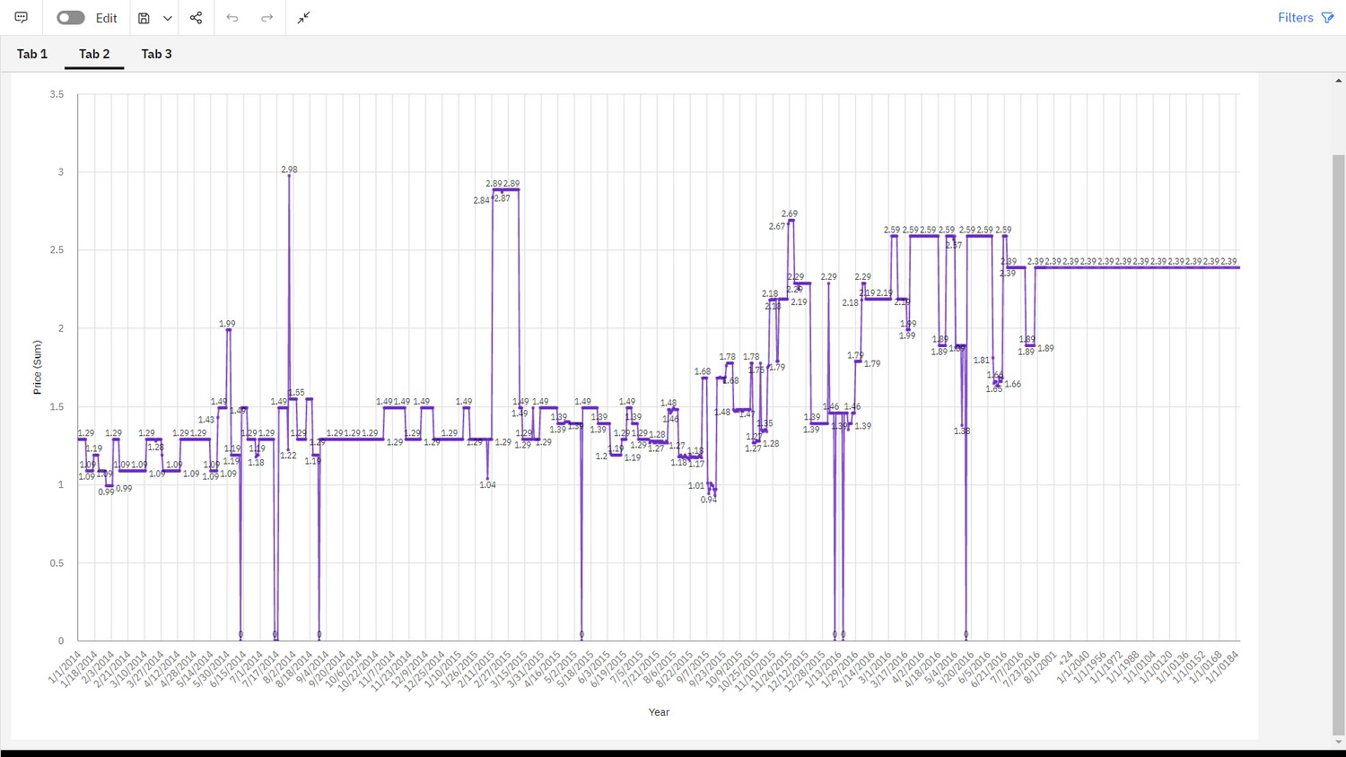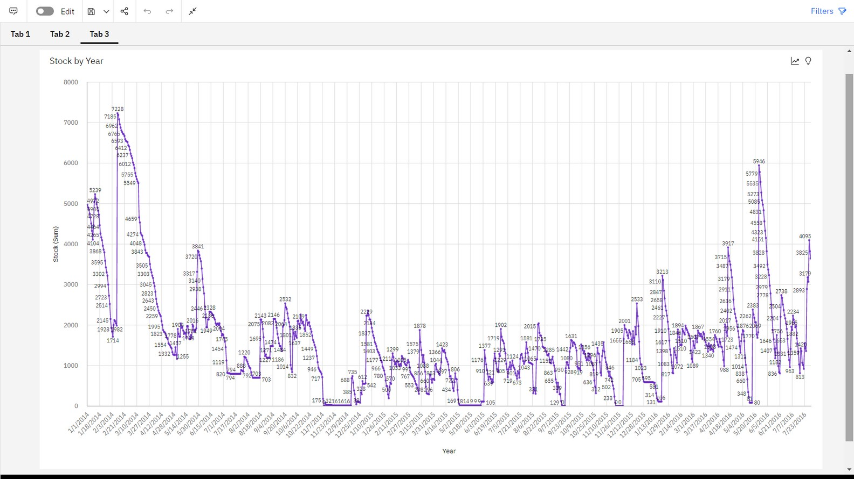

Result

•

**Year Wise Price Using Line Graph**

**Year Wise Stock Using Line Graph**

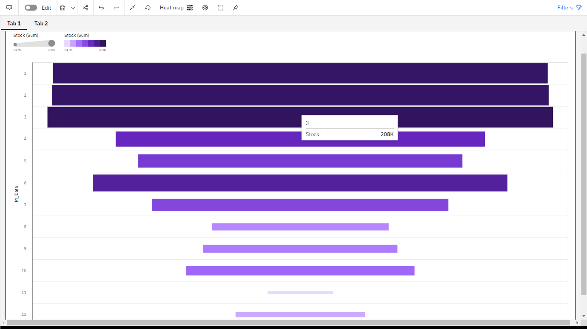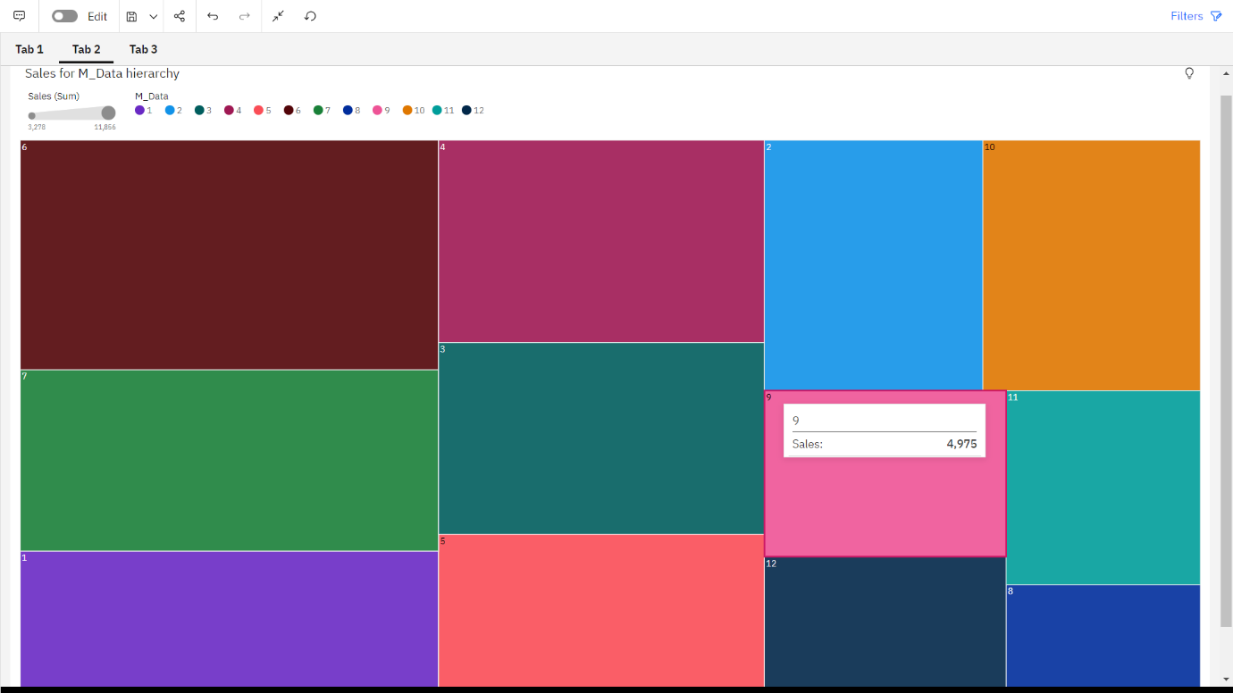

Result

•

**Monthly Stock Using Heat Map**

•

**Monthly Sales Using Tree Map**

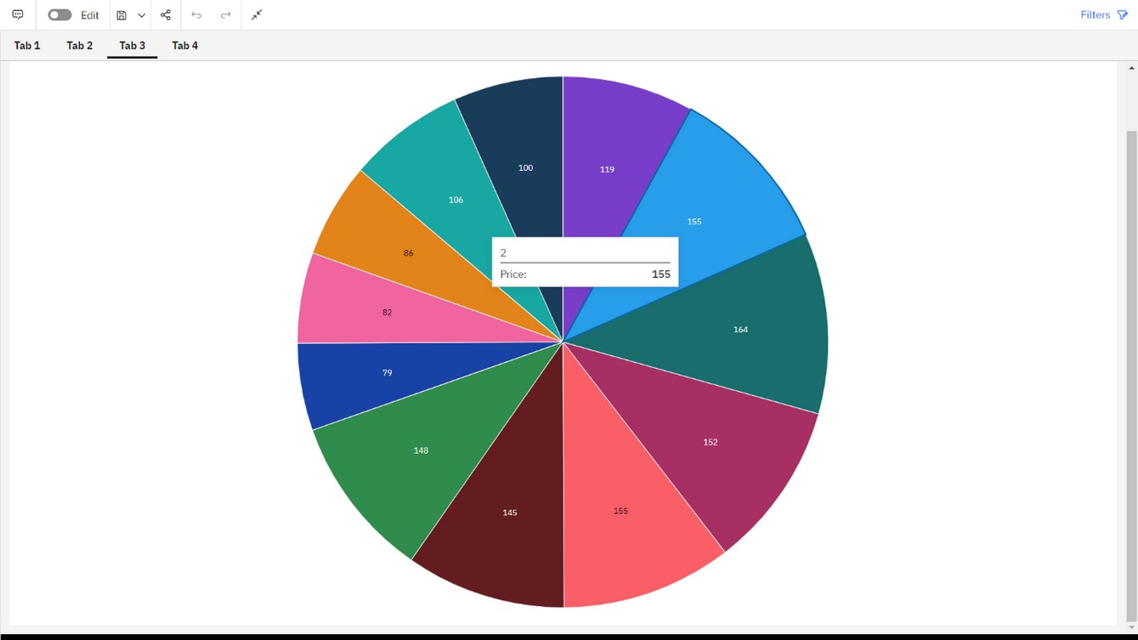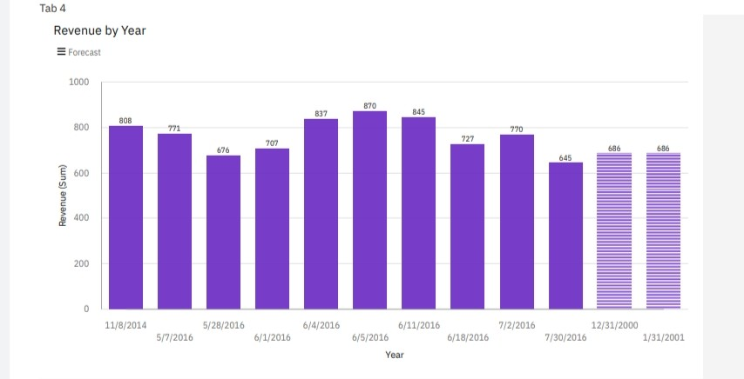

Result

•

**Monthly Price by Pie Chart**

•

**Revenue by Year by Bar Graph**

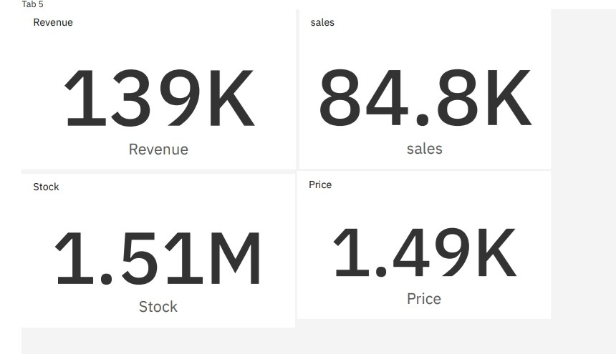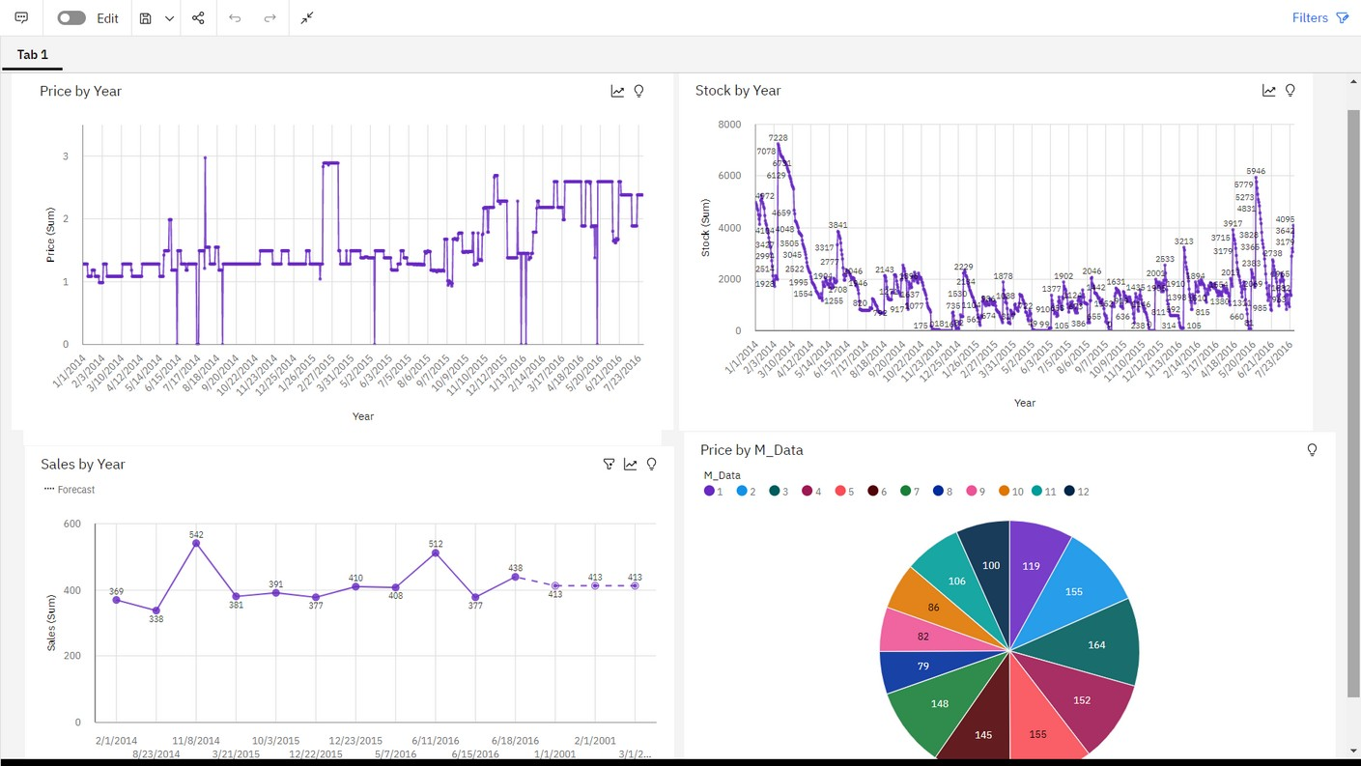

Result

•

**Summary Cards of Total Revenue, Sales, Stock, Price**

**DashBoard**

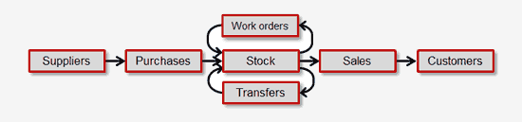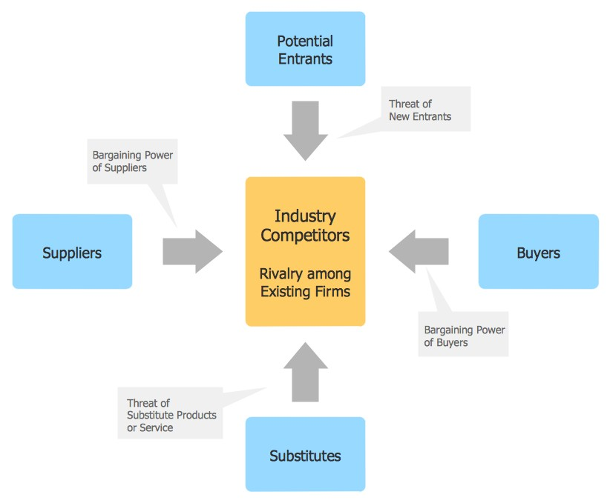

Theoretical Analysis

•

Block Diagram:

•

Block diagram is a simple chart that use blocks to show some elements or activities, and connectors that show the

relationship between neighboring blocks. They are commonly simple, giving an overview of a process without necessarily

going into the specifics of implementation.

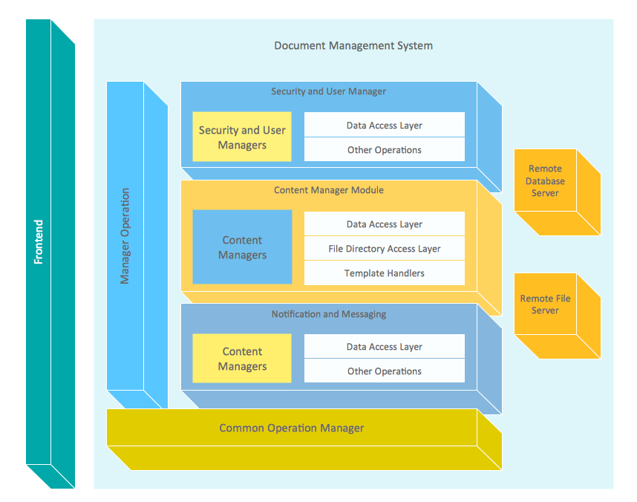

Theoretical Analysis

•

The vector stencils libraries: Block Diagrams, Blocks with Perspective, Callouts, Connectors, Raised Blocks from the

solution Block Diagrams contain specific block diagram symbols such as arrows, input/output symbols, start/end

symbols, processing symbols, conditional symbols, commenting symbols, callouts, connectors, etc. for ConceptDraw

PRO diagramming and vector drawing software. The Block Diagrams solution is contained in a "Diagrams" area of

ConceptDraw Solution Park.

Use the libraries from the Block Diagrams solution to draw block diagrams for your business documents,

presentations and websites in a few minutes.

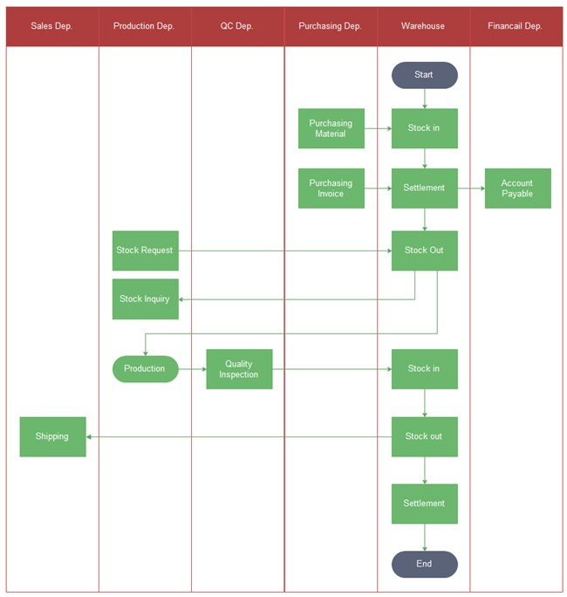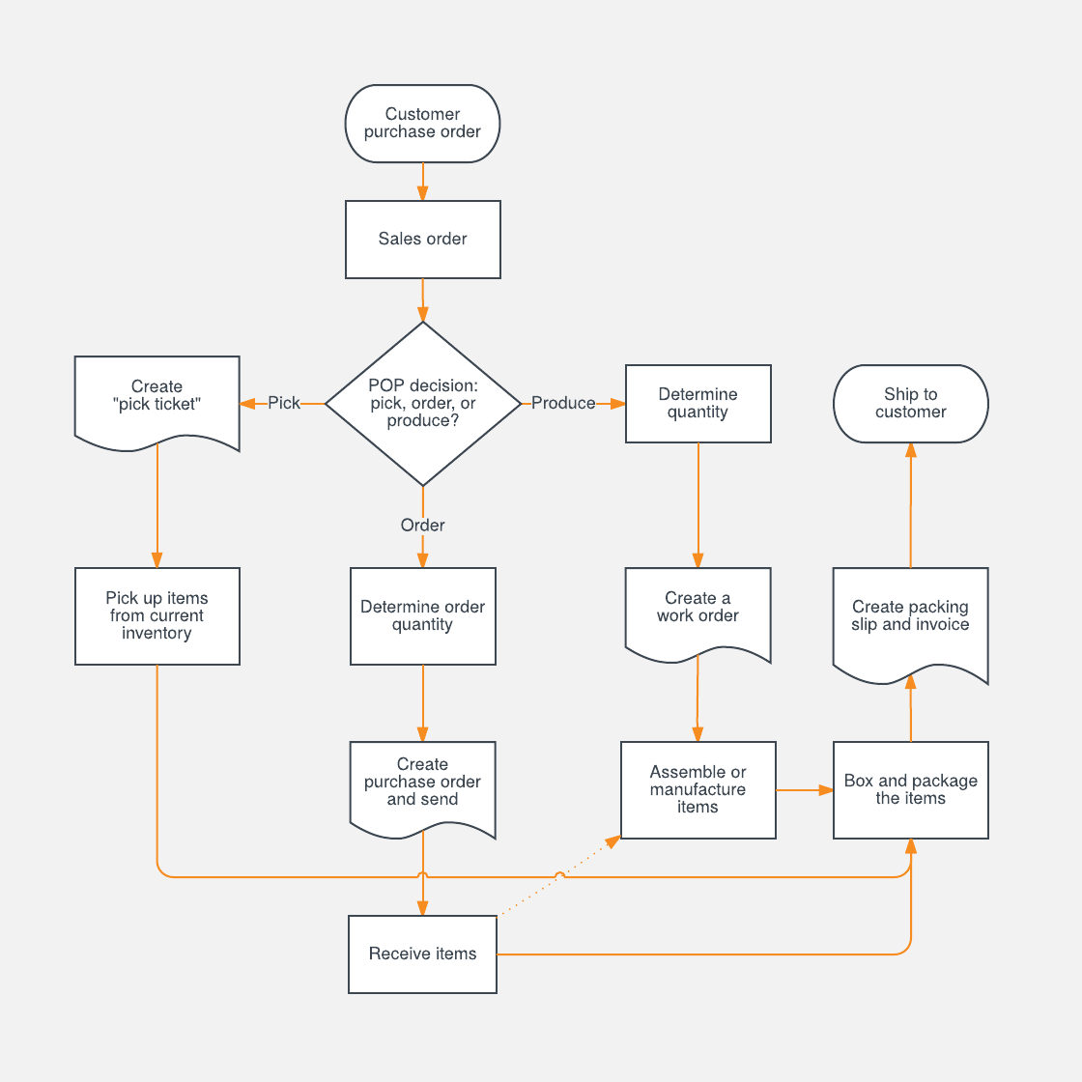

Inventory Management Process

Flowchart

maintained.

•

This automation, in turn, helps in increasing the overall efficiency of the organization. With the help of the software, many tasks perform automatically like

a **collection of data, creation of records, conducting calculations, etc.**

•

3. Updated data:

•

Yet another advantage of inventory management is the maintenance of updated data.

•

Due to the use of an inventory management system/software, and up-to-date and real-time data of the levels of inventory can be successfully

With the help of inventory management software, the tasks which relate to inventory automated.

•

4. Data security:

•

Since the user rights for this system can restrict, the authorized person/manager can grant suitable/limited rights to the other employees or

the subordinates while accessing the data.

•

With the grant of partial rights, there is no fear of data leakage or the data misplaced

.

•

Advantages and Disadvantages

•

Advantages:

•

1.Cost Saving:

•

If taken into consideration, the inventory of any organization comprises of the maximum investment along with the workforce employed.

So, there lies a need to maintain the inventory in the best possible manner. The responsible person should look at the fact that there is no unnecessary wastage of

the inventory by overstocking and there is no shortage as well at the same time

.

•

2

.

Increased efficiency:

•

•

benefits. Although there are few disadvantages associated with it the benefits turn out to be more in number.

After considering the pros and cons of the inventory management system, it is always advisable to install the software in the organization as it finally leads to many

•

restricted but fail to make the entire process risk proof.

The system helps in controlling many risks but the fear of facing and encountering many others is still open. Hence, with this system in use, many kinds of risks

•

Although the management system helps the business in eliminating many kinds of risk, even after using the system, the business is open to many other risks.

•

3. Limited elimination of business risk:

•

But once successfully installed and training completed, it can prove to be a blessing for the business and it helps a great deal in the smooth operation.

•

Learning how to operate the system can be lengthy, cumbersome as well as complex.

•

Special training sessions and manuals should be adhered to, to successfully operate the system.

Although the use of an inventory management system makes handling the inventory quite easy but learning how to operate it is quite a task.

•

2. Complexity:

•

not feasible to maintain such software.

Big time businesses can cover up the cost or the one time investment in some time but in the case of small or medium-sized businesses, it is at times

•

Although the system provides such great features and makes the entire business a lot better and efficient, all this comes at a cost.

•

Extremely beneficial in many aspects, this management software is available in the market at a high cost.

•

1. Expensive:

•

Disadvantages

consuming and challenging. However, developers must build such a map to make meaningful changes, remove

environment migration, updates to foundational application elements, or just after release.

application control or data flow. Your apps are especially susceptible to significant downtime during host

A common cause for prolonged application downtime is a misunderstanding or lack of understanding of

•

**Reduce Downtime**

•

it, by testing and following in-application method calls, is procedural and can be automated.

Mapping and understanding application flow is a significant part of a programmer’s job. The way they perform

•

features.

obsolete functions and modules, address dependencies, and operate effectively on back-end application

Especially when working with older legacy code, this piece of maintenance and support is by far the most time-

A significant portion of developers’ valuable time is spent mapping application structure and data flow.

•

applications.

Among the benefits of AIM is the ability for an enterprise to interact smoothly and flexibly with their

•

**Maintain Applications Efficiently**

•

Applications

•

AIM obsolescence analysis is a novel way to automatically identify unused functions, methods, and modules in your application.

•

errors.

Obsolete code not only contributes to security vulnerabilities. It can consume computing resources wastefully and produce runtime

•

**Detect and Remove Obsolescence**

•

code that is no longer used may sustain access to sensitive data.

Another source of dangerous vulnerabilities is lingering obsolete functions and modules. Any piece of your application

•

data are passed or visible, when encryption keys are exposed, or when back doors to sensitive data exist.

Vulnerabilities arise when calls for sensitive data are not vetted for caller authorization when unnecessary volumes of

and passing in every instance in each of your applications.

Removing vulnerabilities from your applications requires a complete understanding of data sourcing, storage, referencing

•

**Address Security Vulnerabilities and Breaches**

•

functions or functions that rely on removed dependencies.

That’s why programmers need to refer to a data flow map to search for the source of faulty data, calls to missing

of the problem. Error reports often point to a different function than that which produced the faulty data initially.

To properly address critical runtime errors, developers need to rapidly assess program flow and identify the source

Applications

Sometimes, the biggest unknown in making business decisions around application changes is the impact,

reference to maintain your application effectively.

be affected by a change. A good team of developers will build and maintain a working application flow map for

and on-demand, but it also provides pinpoint accuracy as to all of the related pieces of your application that will

complete picture of the impact of a change on your application. Not only does it generate an analysis quickly

AIM enables your business to perform a thorough impact analysis on your application architecture to get a

•

picture, at best, of the impact of a change proposal on your application.

potential downtime, and costs of proposed changes. Empirical developer insight provides an approximate

•

**Make Informed Business Decisions**

•

By removing obsolete code, you can keep your applications running optimally and securely with AIM.

•

Applications

•

Saved and visualized the final dashboard in the IBM Cognos Analytics

➤

•

•

Used the analyzed chart creation of dashboard

➤

•

Created multiple analysis charts / graph.

➤

•

•

From this project, we have successfully:

•

Conclusion