**Vanshika Bansal**

**(vanshika.bansal2020@vitbhopal.ac.in)**

**20BCY10053**

**Assignment -1**

**Kali**

**Title: Linux Command List Assessment**

**Instructions: -**

The following assessment aims to test your understanding and practical knowledge of various Linux commands. Perform the tasks given below using the appropriate commands. Write down the command(s) used to complete each task. You can use any Linux distribution or command-line interface of your choice. Ensure that you provide the correct output or results for each task.

Note: It is recommended to perform this assessment on a Linux machine or virtual environment.

**File and Directory Operations:**

ls: List files and directories

cd: Change directory

pwd: Print working directory

mkdir: Make directory

touch: Create an empty file

cp: Copy files and directories

mv: Move or rename files and directories

rm: Remove files and directories

find: Search for files and directories

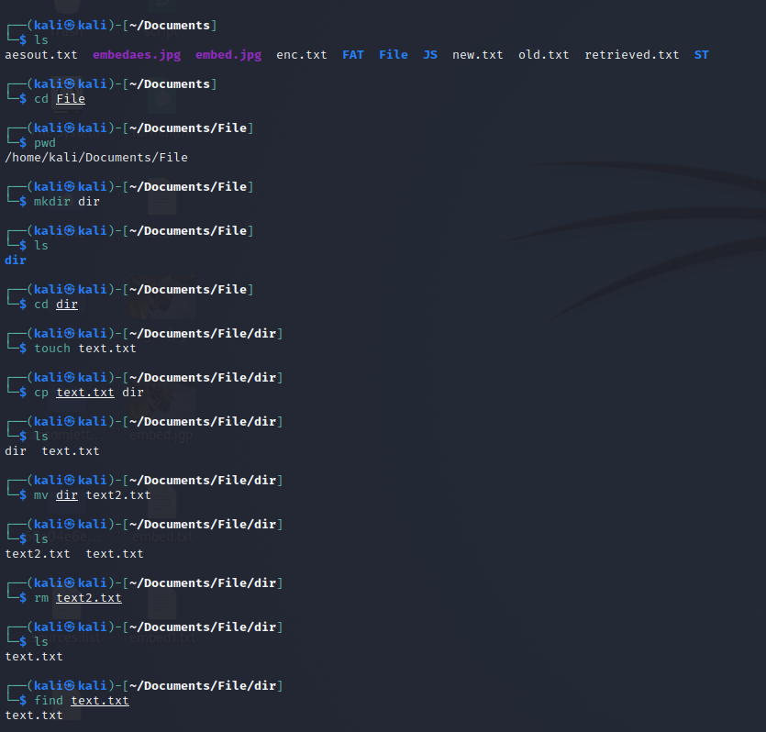

**File Viewing and Editing:**

cat: Concatenate and display file content

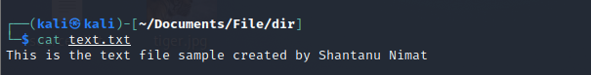

less: View file content with pagination

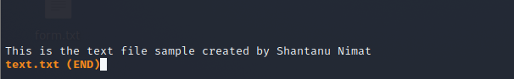

head: Display the beginning of a file



tail: Display the end of a file

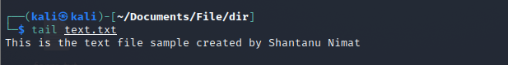

nano: Text editor for creating and editing files

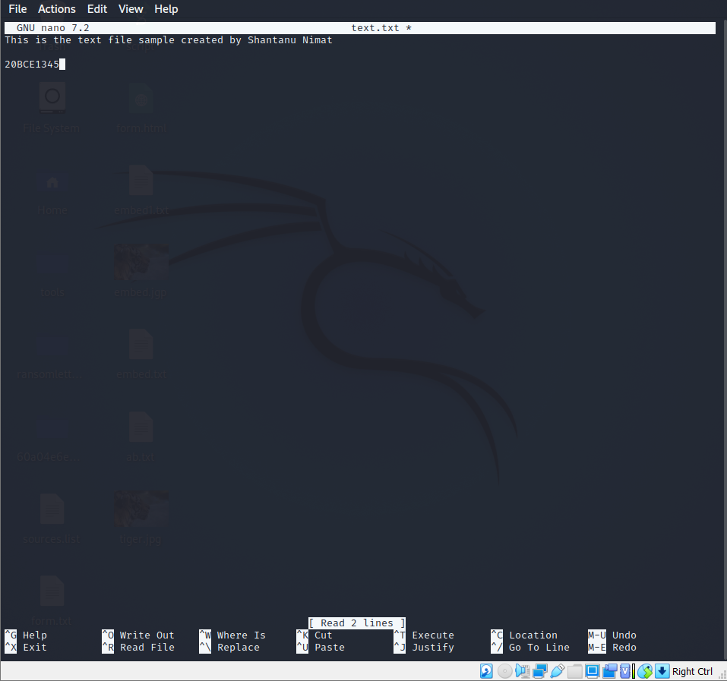

vi/vim: Powerful text editor for experienced users

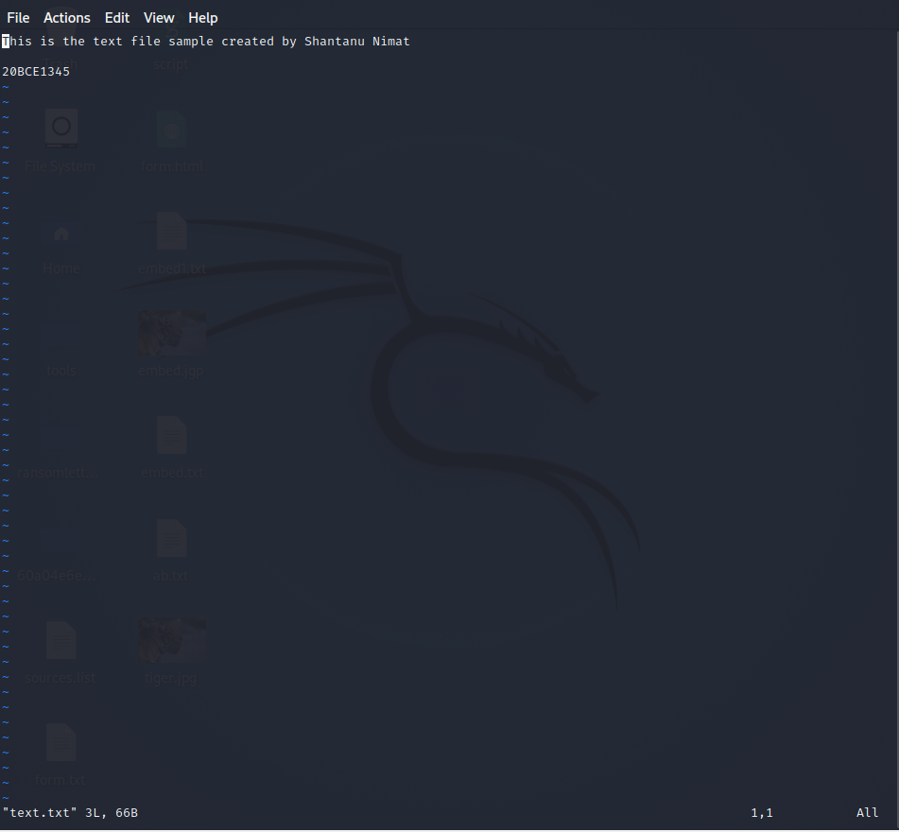

**File Permissions:**

chmod: Change file permissions

It will set the read and write permission for other users of the text files

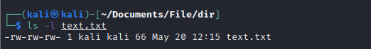

chown: Change file owner

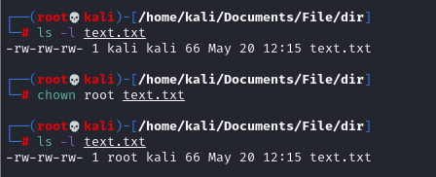

chgrp: Change file group

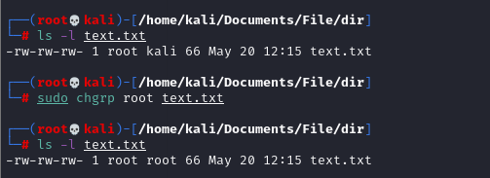

**File Compression and Archiving:**

tar: Archive files

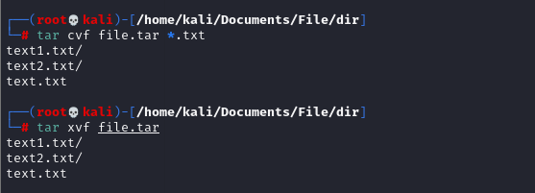

Compressed

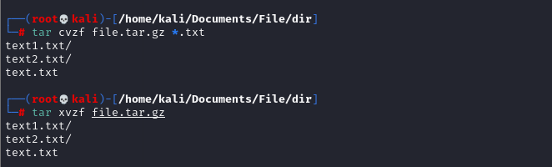

gzip: Compress files

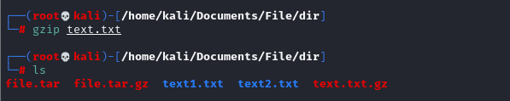

Unzip gzip

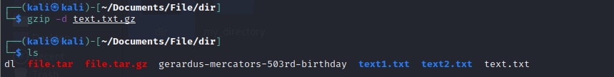

Zip and unzip: Extract files from a ZIP archive

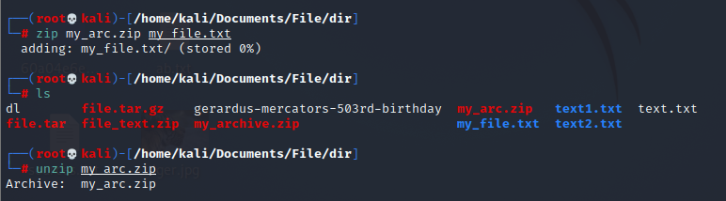

**Process Management:**

ps: List running processes

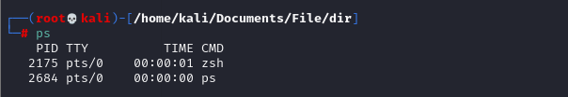

top: Display real-time system information and processes

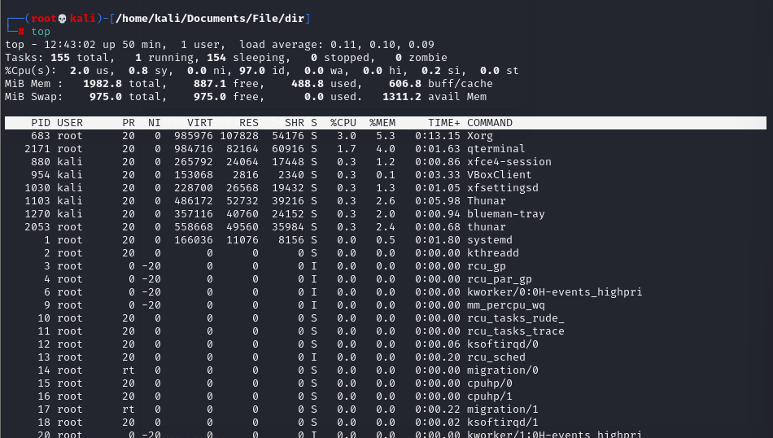

kill: Terminate processes



bg: Run processes in the background

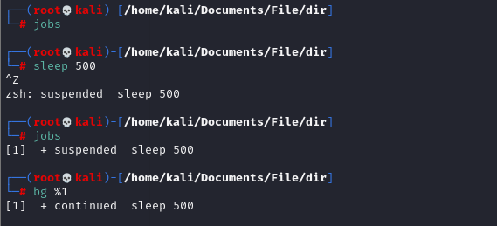

fg: Bring background processes to the foreground

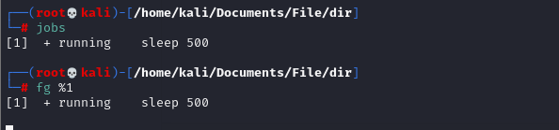

**System Information:**

uname: Print system information

df: Display disk space usage

free: Display memory usage

uptime: Show system uptime

who: Display logged-in users

w: Display logged-in users and their activities

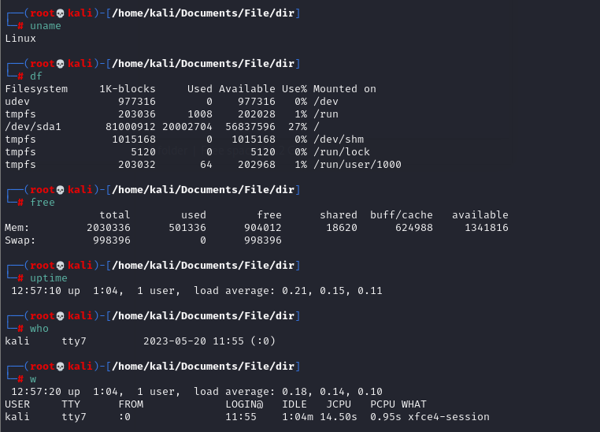

**Networking:**

ifconfig: Configure network interfaces

ping: Send ICMP echo requests to a network host

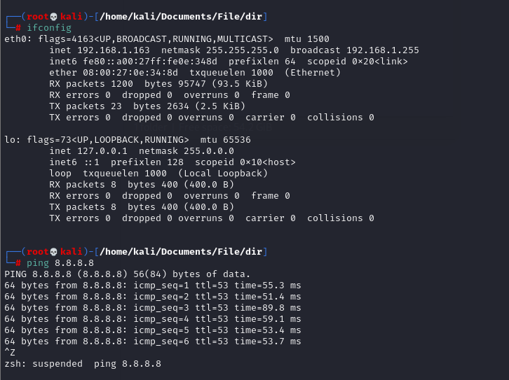

ssh: Securely connect to a remote system

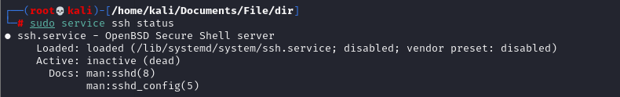

connecting to Metasploitable 2 using ssh

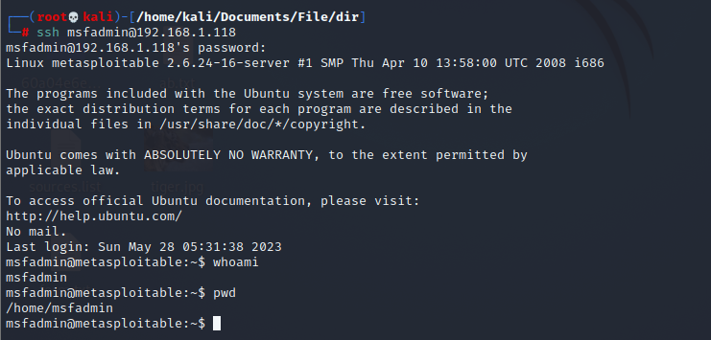

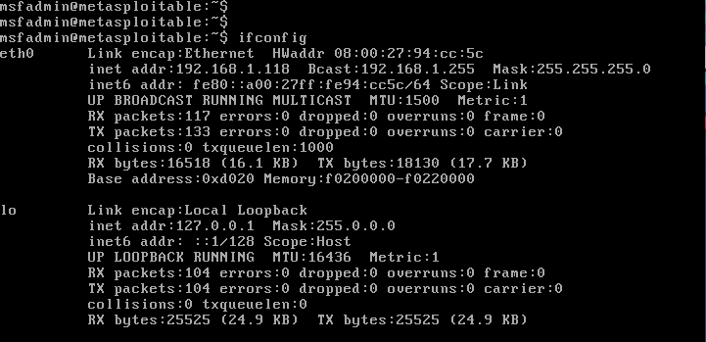

scp: Securely copy files between systems

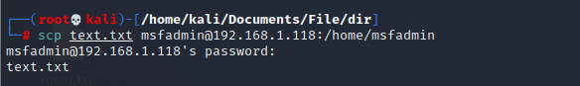

wget: Download files from the web

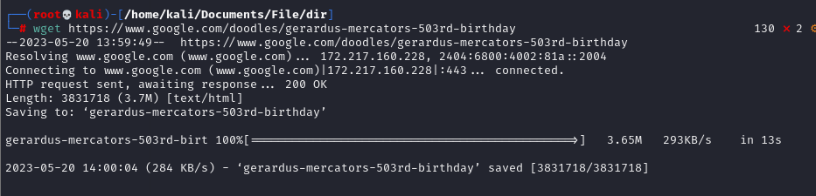

**System Administration:**

sudo: Execute commands with superuser privileges

apt-get: Package management for Debian-based distributions

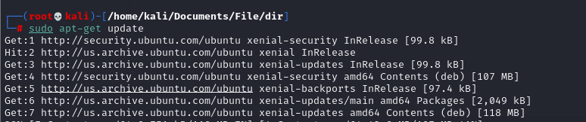

yum: Package management for Red Hat-based distributions

It is used for installing, updating, and managing software packages on the system. Here are some commonly used commands with yum:

Install a package:

sudo yum install <package_name>

Update all installed packages:

sudo yum update

Search for a package:

yum search <keyword>

List installed packages:

yum list installed

Remove a package:

sudo yum remove <package_name>

Clean the cache and free up disk space:

sudo yum clean all

Enable a repository:

sudo yum-config-manager --enable <repository_name>

Disable a repository:

sudo yum-config-manager --disable <repository_name>

systemctl: Manage system services

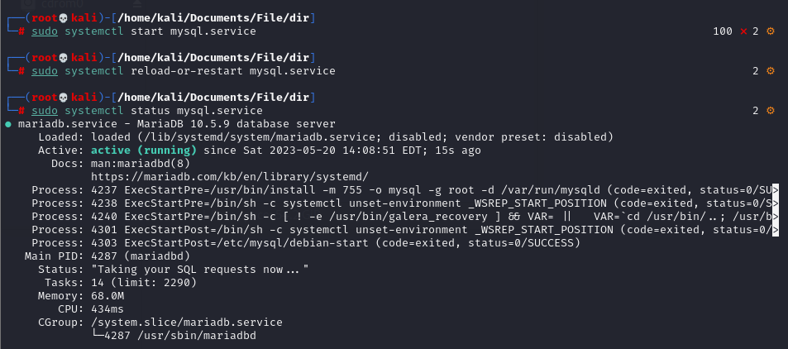

crontab: Schedule recurring tasks

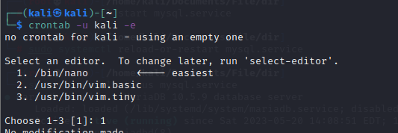

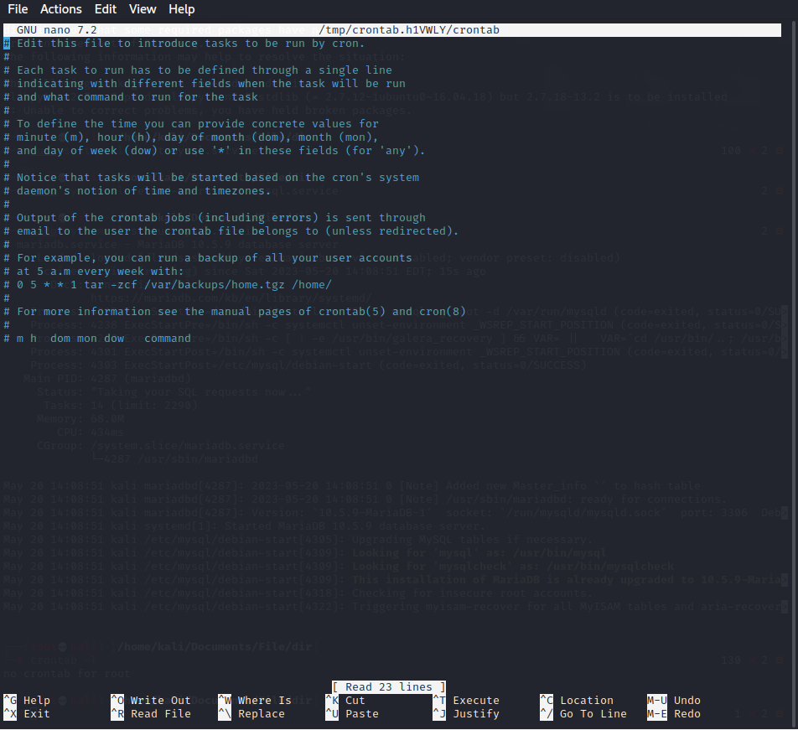

useradd: Add a new user

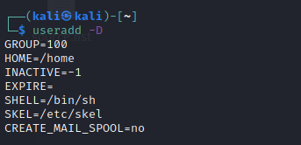

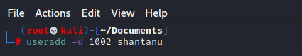

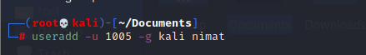

passwd: Change user password

