**Title: Linux Command List Assessment**

**Assignment 1**

***NAME: E VARUN SAI  
REG.NO:20BCD7179***

***CAMPUS: VIT-AP***

**Instructions:-**

The following assessment aims to test your understanding and practical knowledge of various Linux commands. Perform the tasks given below using the appropriate commands. Write down the command(s) used to complete each task. You can use any Linux distribution or command-line interface of your choice. Ensure that you provide the correct output or results for each task.

Note: It is recommended to perform this assessment on a Linux machine or virtual environment.

**File and Directory Operations:**

ls: List files and directories

cd: Change directory

pwd: Print working directory

mkdir: Make directory

touch: Create an empty file

cp: Copy files and directories

mv: Move or rename files and directories

rm: Remove files and directories

find: Search for files and directories

**File Viewing and Editing:**

cat: Concatenate and display file content

less: View file content with pagination



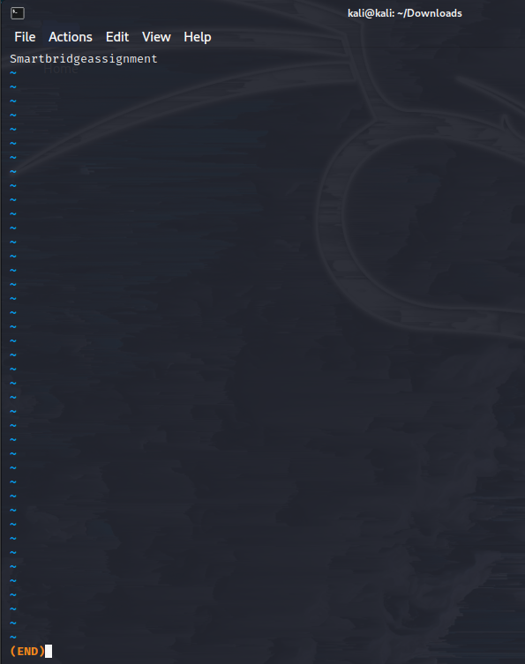

head: Display the beginning of a file

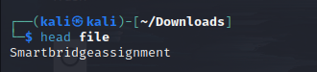

tail: Display the end of a file

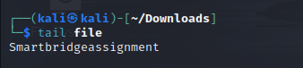

nano: Text editor for creating and editing files

vi/vim: Powerful text editor for experienced users

**File Permissions:**

chmod: Change file permissions

chown: Change file owner

chgrp: Change file group

**File Compression and Archiving:**

tar: Archive files

gzip: Compress files

unzip: Extract files from a ZIP archive

**Process Management:**

ps: List running processes

top: Display real-time system information and processes

kill: Terminate processes

bg: Run processes in the background

fg: Bring background processes to the foreground

**System Information:**

uname: Print system information



df: Display disk space usage

free: Display memory usage

uptime: Show system uptime

who: Display logged-in users

w: Display logged-in users and their activities

**Networking:**

ifconfig: Configure network interfaces

ping: Send ICMP echo requests to a network host

ssh: Securely connect to a remote system

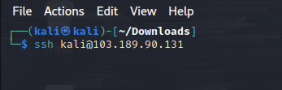

scp: Securely copy files between systems

wget: Download files from the web

**System Administration:**

sudo: Execute commands with superuser privileges

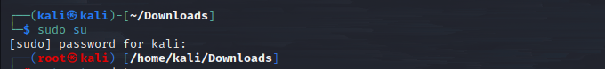

apt-get: Package management for Debian-based distributions

yum: Package management for Red Hat-based distributions



systemctl: Manage system services

crontab: Schedule recurring tasks

useradd: Add a new user

passwd: Change user password

