**Title: Linux Command List Assessment**

**Instructions:-**

The following assessment aims to test your understanding and practical knowledge of various Linux commands. Perform the tasks given below using the appropriate commands. Write down the command(s) used to complete each task. You can use any Linux distribution or command-line interface of your choice. Ensure that you provide the correct output or results for each task.

Note: It is recommended to perform this assessment on a Linux machine or virtual environment.

**File and Directory Operations:**

ls: List files and directories

cd: Change directory

pwd: Print working directory

mkdir: Make directory

touch: Create an empty file

cp: Copy files and directories

mv: Move or rename files and directories

rm: Remove files and directories

find: Search for files and directories

Commands Executed:

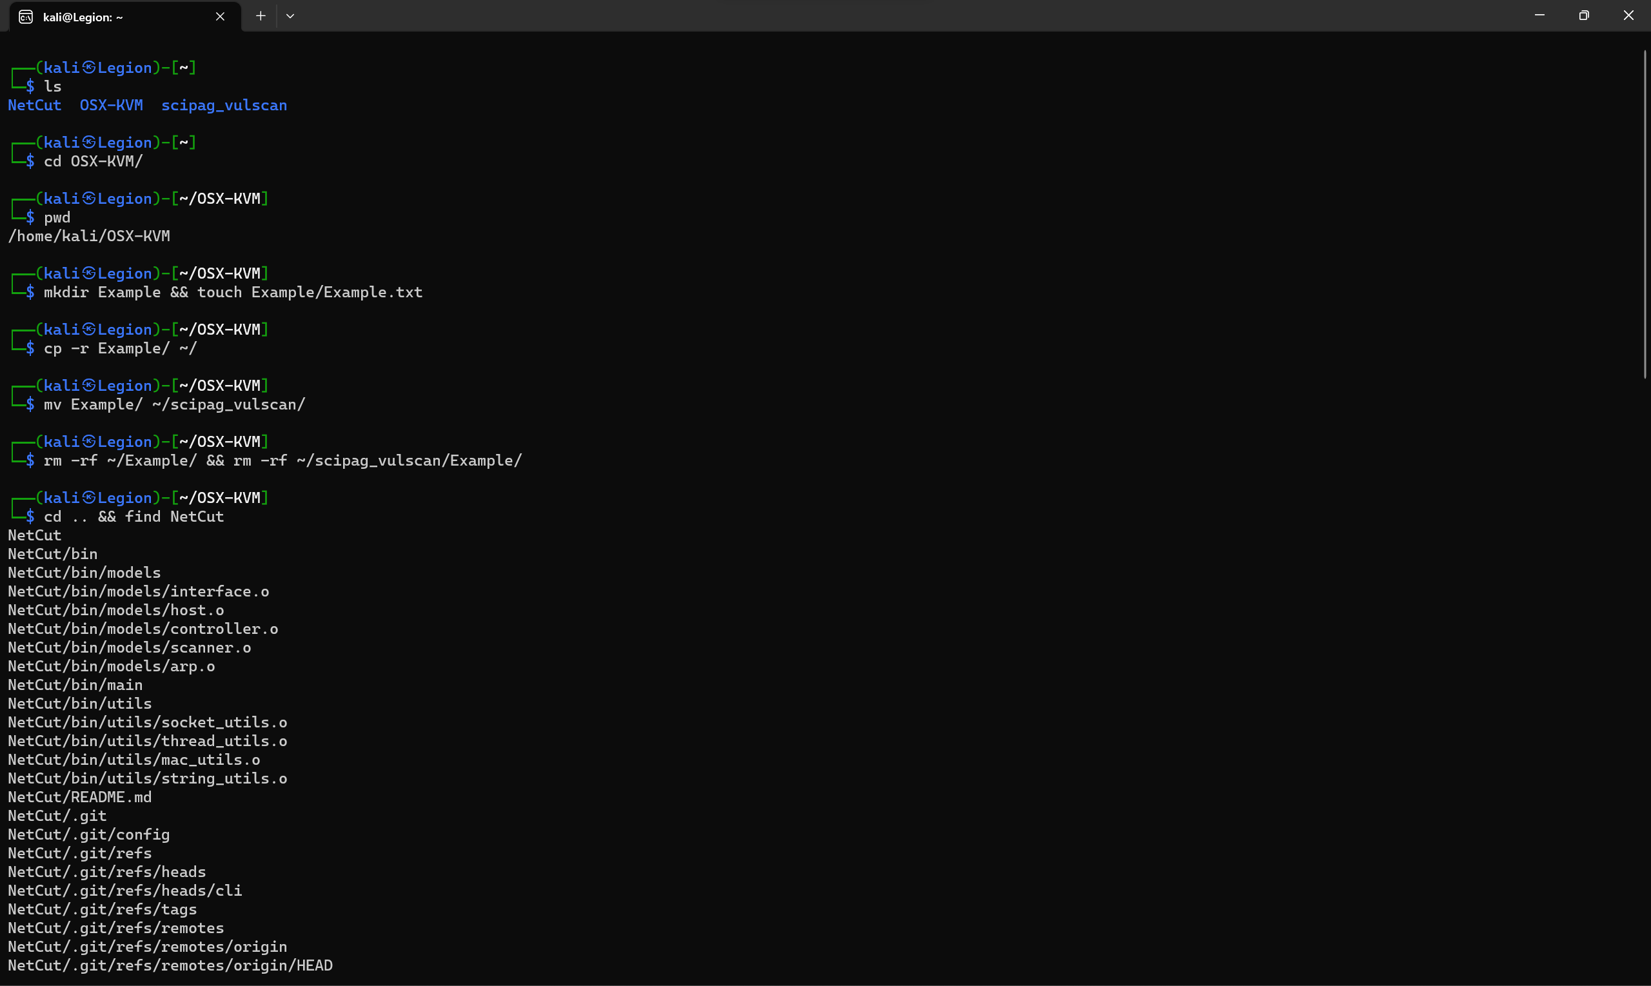

**File Viewing and Editing:**

cat: Concatenate and display file content

less: View file content with pagination

head: Display the beginning of a file

tail: Display the end of a file

nano: Text editor for creating and editing files

vi/vim: Powerful text editor for experienced users

Commands Executed:

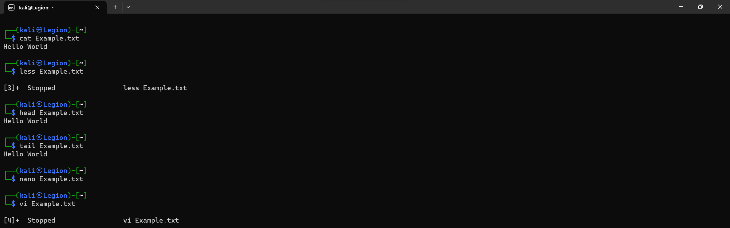

Less CommandNano Editor command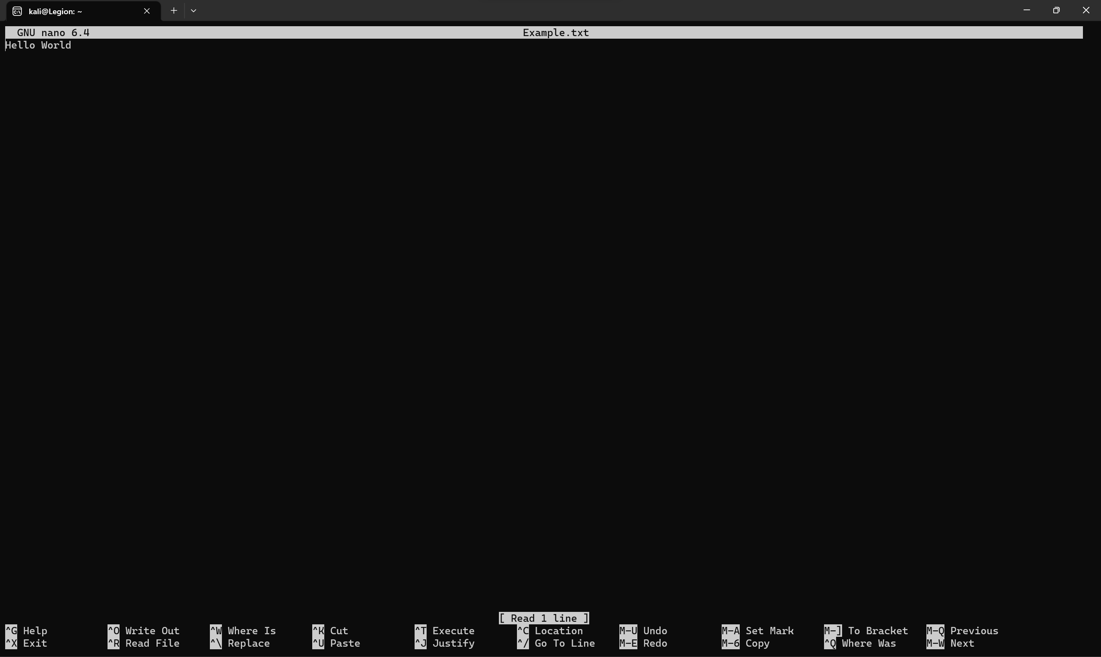

Vim Editor Command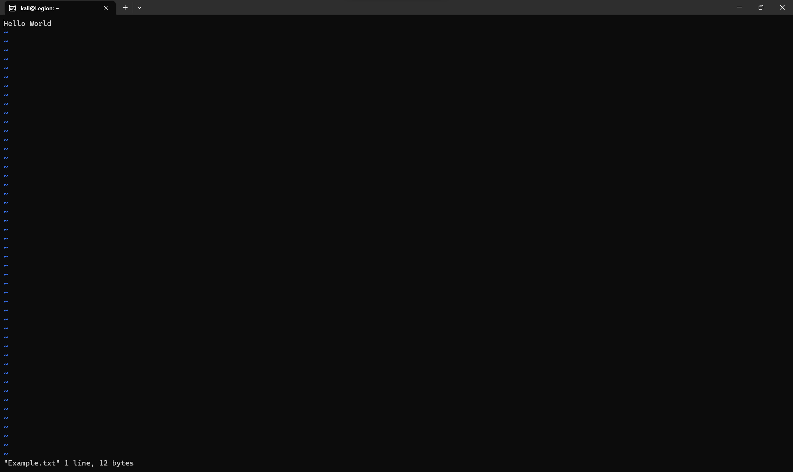

**File Permissions:**

chmod: Change file permissions

chown: Change file owner

chgrp: Change file group

Commands Executed:

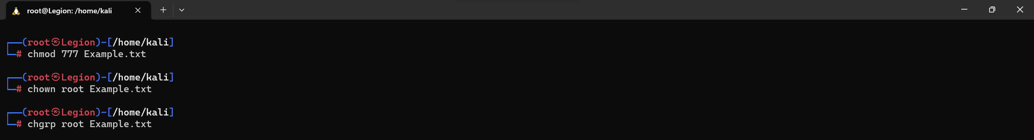

**File Compression and Archiving:**

tar: Archive files

gzip: Compress files

unzip: Extract files from a ZIP archive

Commands Executed:

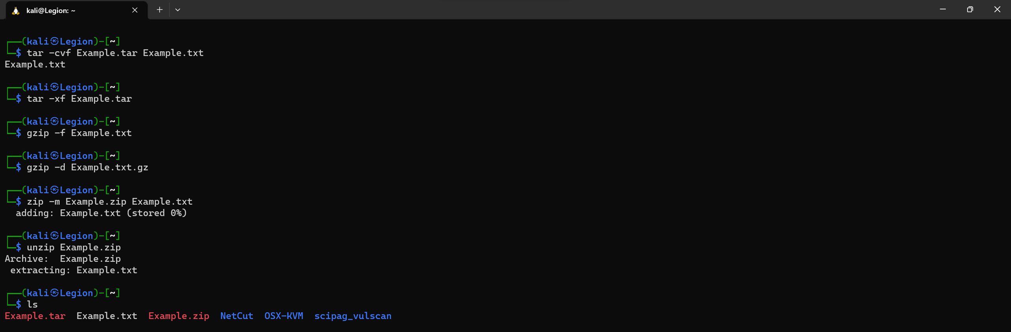

**Process Management:**

ps: List running processes

top: Display real-time system information and processes

kill: Terminate processes

bg: Run processes in the background

fg: Bring background processes to the foreground

Commands Executed:

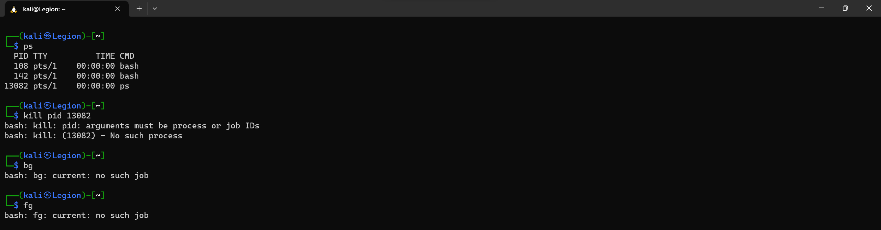

Top Command:

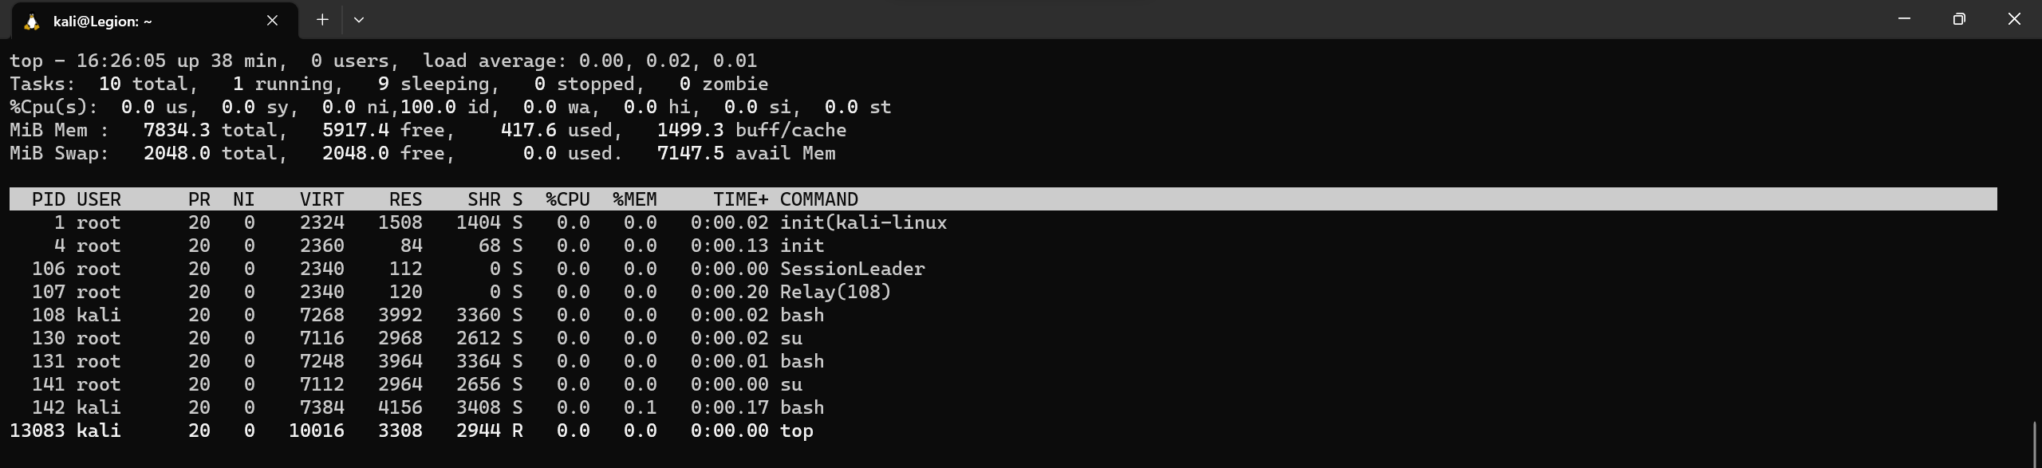

**System Information:**

uname: Print system information

df: Display disk space usage

free: Display memory usage

uptime: Show system uptime

who: Display logged-in users

w: Display logged-in users and their activities

Commands Executed:

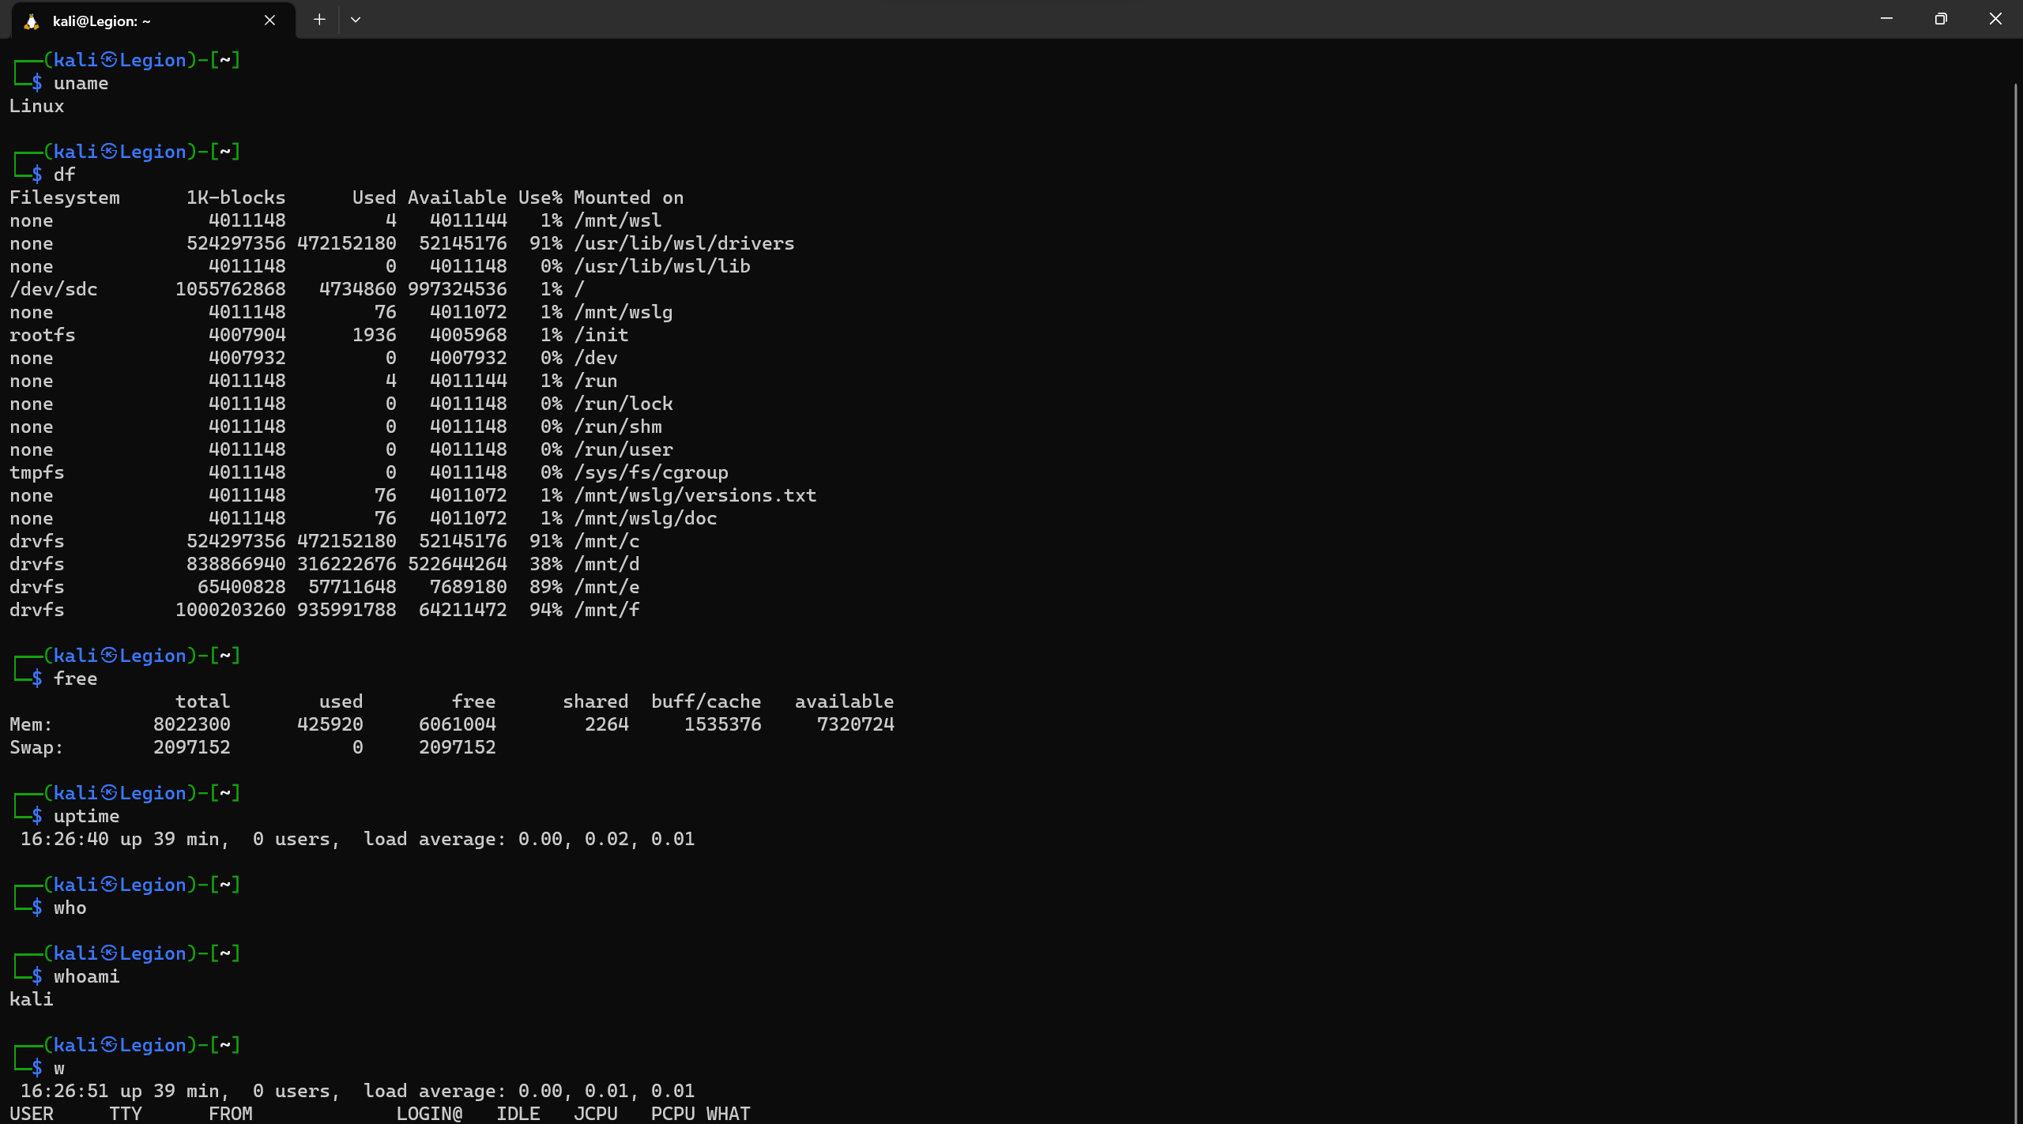

**Networking:**

ifconfig: Configure network interfaces

ping: Send ICMP echo requests to a network host

ssh: Securely connect to a remote system

scp: Securely copy files between systems

wget: Download files from the web

Commands Executed:

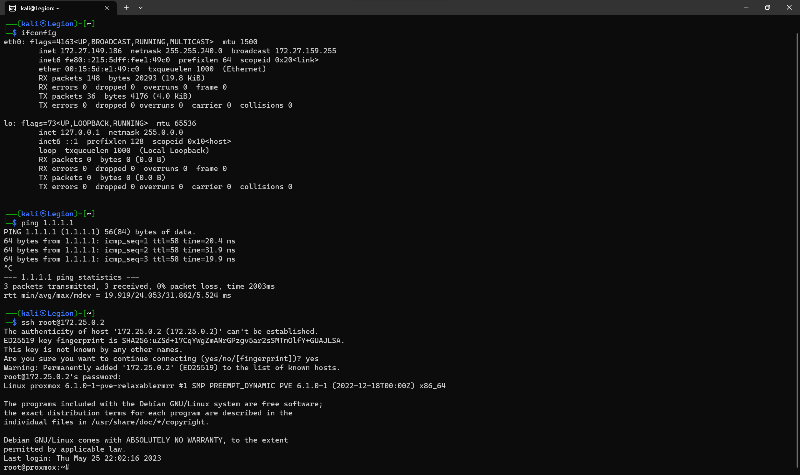

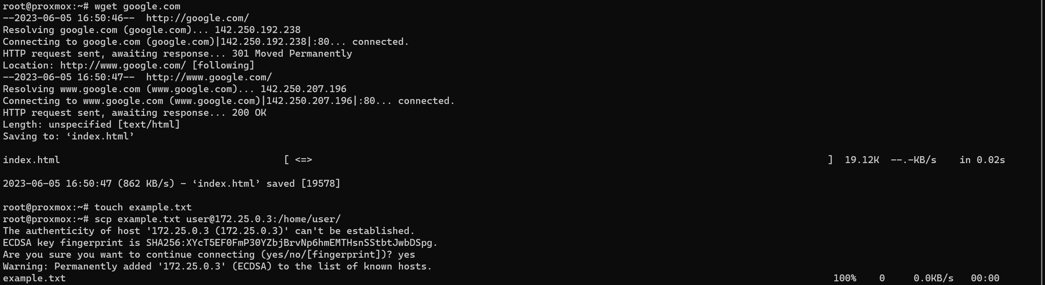

**System Administration:**

sudo: Execute commands with superuser privileges

apt-get: Package management for Debian-based distributions

yum: Package management for Red Hat-based distributions

systemctl: Manage system services

crontab: Schedule recurring tasks

useradd: Add a new user

passwd: Change user password

Commands Executed:

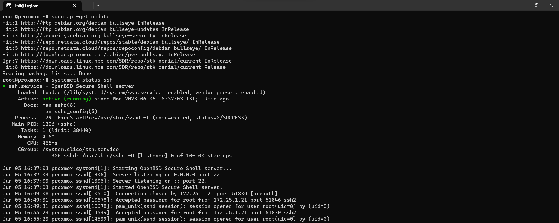 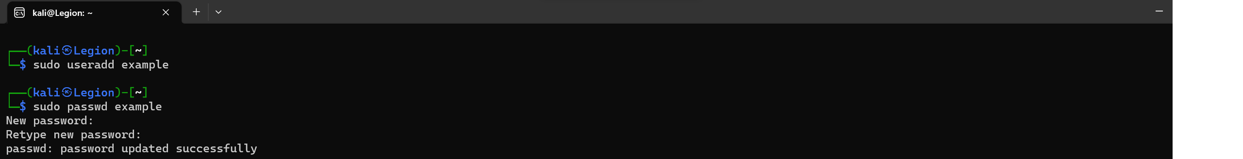

Ensure that you provide the correct command(s) used to accomplish each task. Write your answers below each task.

Once you have completed the assessment, review your answers and verify that the output or results are correct.

Make this in doucement format and send them with images