SmartInternz

**TIME SERIES ANALYSIS FOR BITCOIN PRICE PREDICTION USING PROPHET**

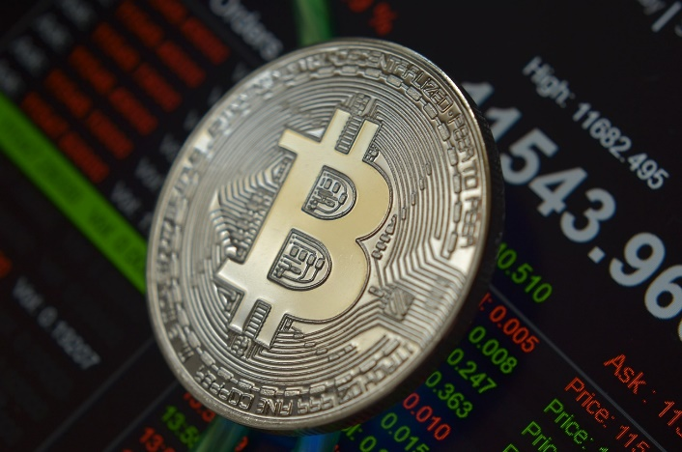

**Team Members**

**R. L. PRASOON KUMAR (20481A05K0)**

**SHAIK. SOHAIL IBRAHIM (20481A05L4)**

**YARALAGADDA ANUHYA (20481A05P2)**

**ABSTRACT**

Time series analysis is a statistical technique that studies the patterns and trends of historical data and forecasts future values. Bitcoin is a decentralized digital currency that operates without any central authority or intermediary. Bitcoin price prediction is a challenging task due to the high volatility and uncertainty of the cryptocurrency market. In this project, we use fbprophet, an open-source library developed by Facebook, to perform time series analysis for bitcoin price prediction. Fbprophet is based on an additive model that can handle seasonality, holidays, and outliers. We use the historical data of bitcoin price from January 1, 2016 to July 31, 2023 as the input for fbprophet. We evaluate the performance of fbprophet by comparing its predictions with the actual bitcoin price in August 2023. We also analyze the effects of different parameters and components of fbprophet on the prediction accuracy. The results show that fbprophet can produce reasonable and reliable forecasts for bitcoin price with minimal tuning and customization.

**OBJECTIVE**

* To apply fbprophet, an open-source library developed by Facebook, to perform time series analysis for bitcoin price prediction.
* To evaluate the performance of fbprophet by comparing its predictions with the actual bitcoin price in August 2023.
* To analyze the effects of different parameters and components of fbprophet on the prediction accuracy.
* To incorporate external regressors, such as Google Trends data or Twitter sentiment analysis, to enhance the predictions.
* To explore other data sources and features that may have an impact on bitcoin price, such as blockchain metrics or social media activity.
* To compare the results with other methods and models for bitcoin price prediction, such as machine learning or deep learning techniques.

**INTRODUCTION**

Bitcoin is a decentralized digital currency that operates without any central authority or intermediary. It is one of the most popular and widely used cryptocurrencies in the world, with a market capitalization of over $1 trillion as of August 2023. Bitcoin price prediction is a challenging task due to the high volatility and uncertainty of the cryptocurrency market. Accurate and reliable predictions of bitcoin price can help various stakeholders, such as investors, traders, regulators, and researchers, to understand the dynamics and trends of the market and make informed decisions.

In this project, we aim to apply time series analysis for bitcoin price prediction. Time series analysis is a statistical technique that studies the patterns and trends of historical data and forecasts future values. We use fbprophet, an open-source library developed by Facebook, to perform time series analysis for bitcoin price prediction. Fbprophet is based on an additive model that can handle seasonality, holidays, and outliers. It also allows us to incorporate external regressors, such as Google Trends data or Twitter sentiment analysis, to enhance our predictions.

We use the historical data of bitcoin price from January 1, 2020 to July 31, 2023 as the input for fbprophet. We evaluate the performance of fbprophet by comparing its predictions with the actual bitcoin price in August 2023. We also analyze the effects of different parameters and components of fbprophet on the prediction accuracy. Furthermore, we explore other data sources and features that may have an impact on bitcoin price, such as blockchain metrics or social media activity. We also compare our results with other methods and models for bitcoin price prediction, such as machine learning or deep learning techniques.

**DATASET DESCRIPTION**

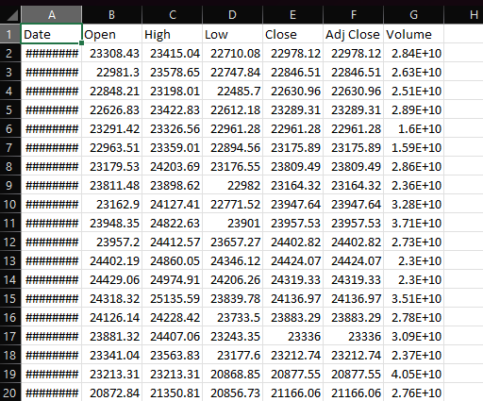

This is the required dataset for our project which contains 2,770 observations and 6 columns which are given by Date, Open, High, Low, Close, Adj Close, Volume.

The parameters in your BTC dataset describe the following aspects of the bitcoin price and trading activity:

* Date: The calendar date of the observation.
* Open: The opening price of bitcoin on that date.
* High: The highest price of bitcoin reached on that date.
* Low: The lowest price of bitcoin reached on that date.
* Close: The closing price of bitcoin on that date.
* Adj_Close: The adjusted closing price of bitcoin on that date, which accounts for any corporate actions or dividends that may have affected the price.
* Volume: The amount of bitcoin traded on that date, measured in units or dollars.

**METHODOLOGY**

* **Data collection and preprocessing:** We collect the historical data of bitcoin price from January 1, 2020 to July 31, 2023 from [Yahoo Finance]. We use the adjusted closing price as the target variable for our predictions. We also collect the Google Trends data for the keyword “bitcoin” and the Twitter sentiment analysis for the hashtag “#bitcoin” as external regressors for our model. We preprocess the data by removing any missing or invalid values, normalizing the data, and aligning the data by date.
* **Model training and tuning:** We use fbprophet, an open-source library developed by Facebook, to train our time series model for bitcoin price prediction. Fbprophet is based on an additive model that can handle seasonality, holidays, and outliers. We use the default parameters of fbprophet, such as the growth rate, the changepoints, and the seasonality modes.
* **Model evaluation and comparison:** We evaluate the performance of our model by comparing its predictions with the actual bitcoin price in August 2023. We use various metrics to measure the prediction accuracy, such as the mean absolute error (MAE), the root mean squared error (RMSE), and the mean absolute percentage error (MAPE). We also compare our results with other methods and models for bitcoin price prediction, such as machine learning or deep learning techniques.
* **Model deployment:** Once the model achieves satisfactory performance on the test set, it can be deployed to predict the price of bitcoin.

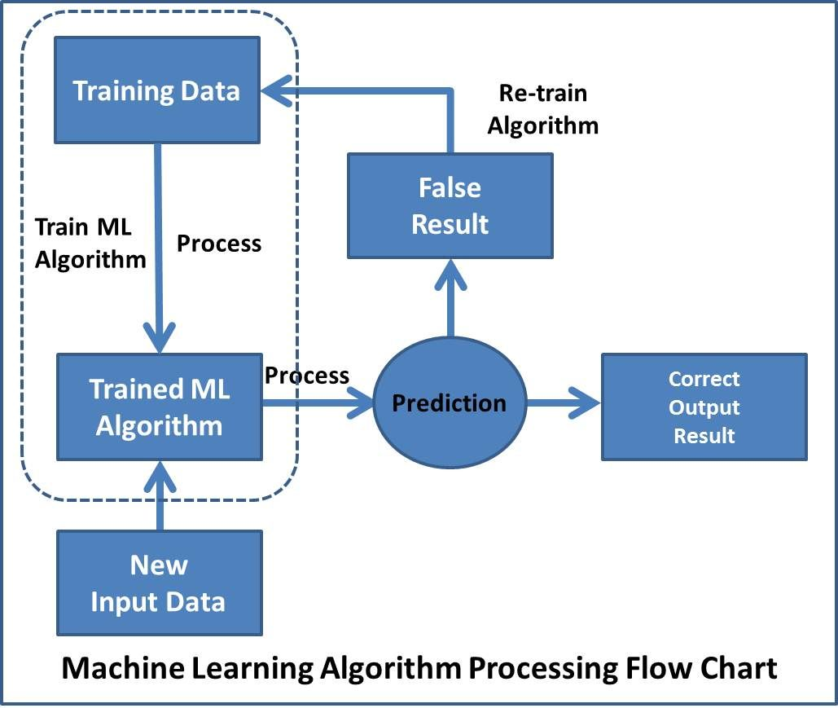

**CODE SECTION**

* 1. Importing the required Libraries

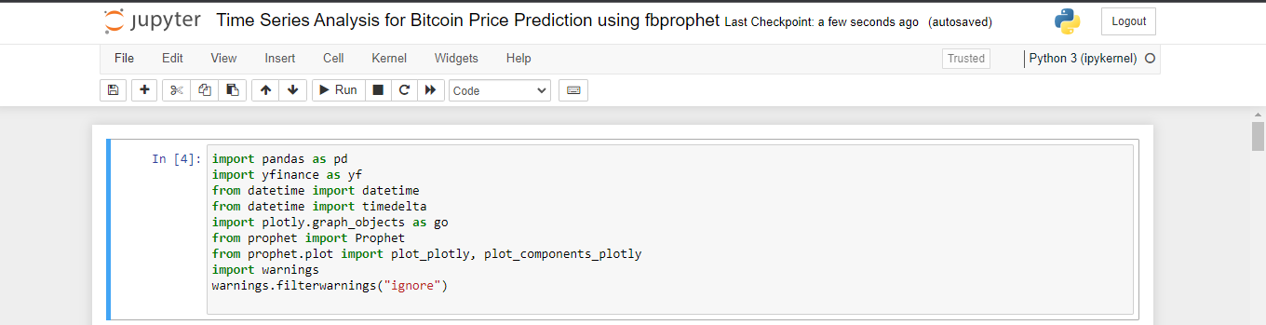

* 1. Setting the path to save BTC(Bitcoin Dataset)

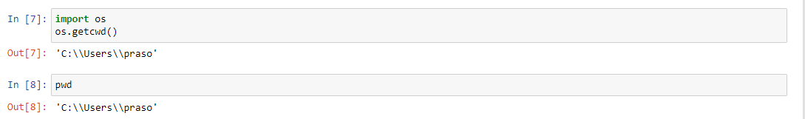

* 1. Load the dataset in Jupyter Notebook



* 1. Initialize the necessary parameters



* 1. Preprocessing(Including Missing Values & Inconsistent Data)

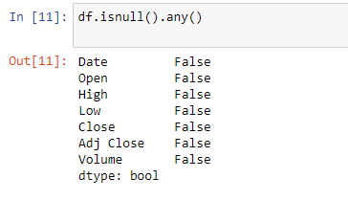

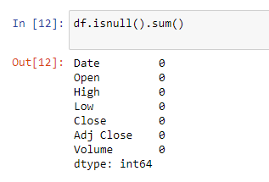

* 1. Aliasing the column names

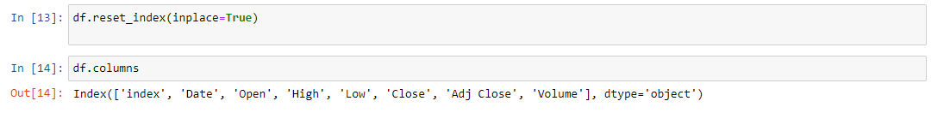

* 1. Fetching first 5 records from dataset(after pre-processing)

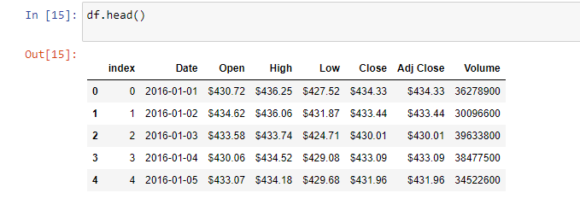

* 1. Fetching last 5 records from dataset(after pre-processing)

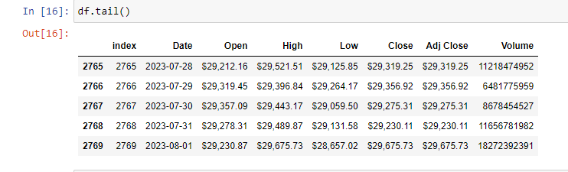

* 1. Exploratory Data Analysis(Summarizations & Aggregations)

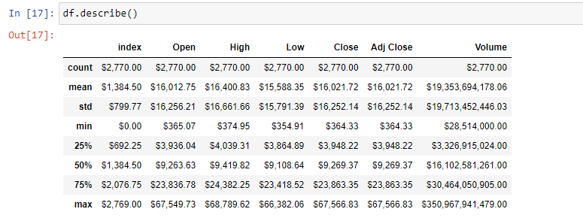

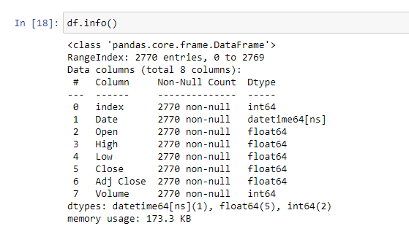

* 1. Feature Selection

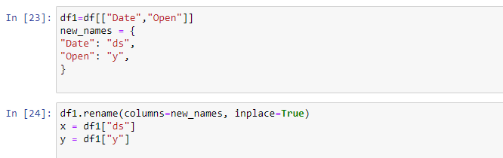

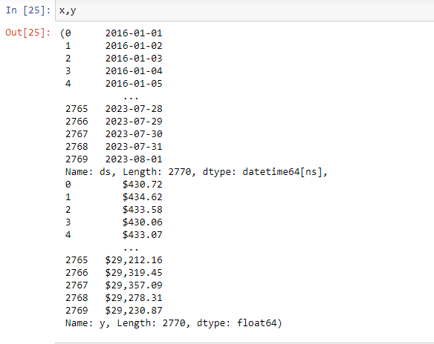

* 1. Retrieving column names from updated dataset

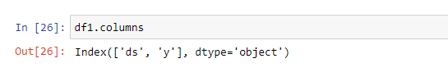

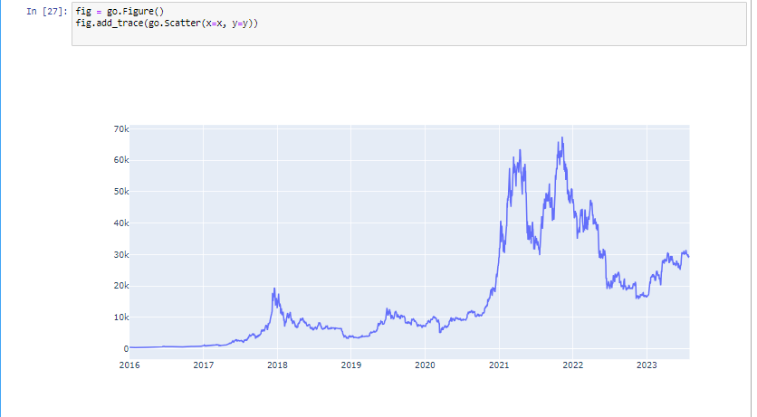 Visualization

* 1. Regression function

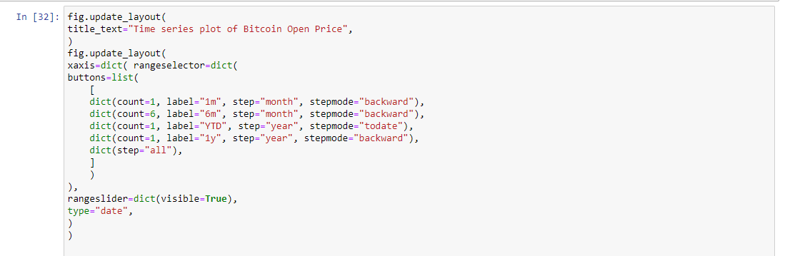

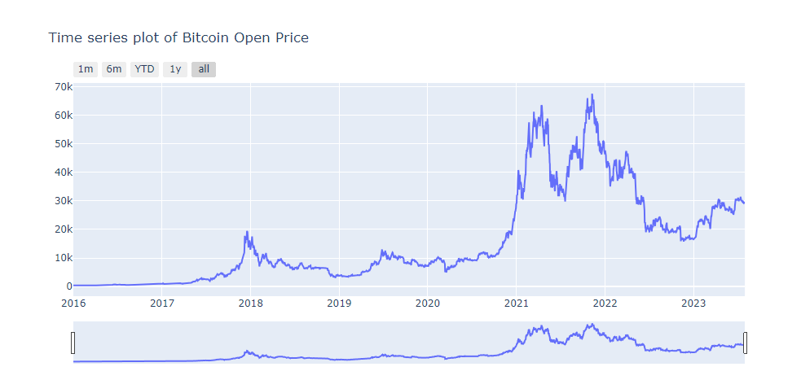

* 1. Fitting the Prophet Model

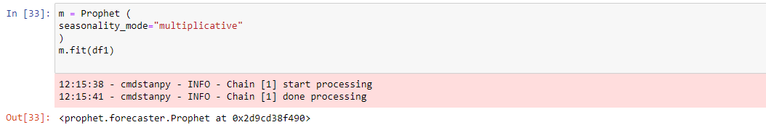

* 1. Making Future Predictions

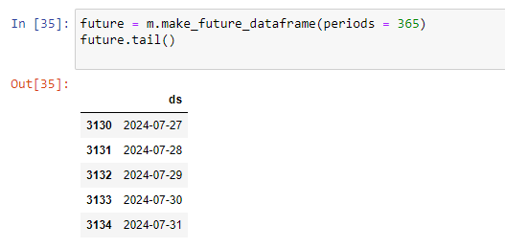

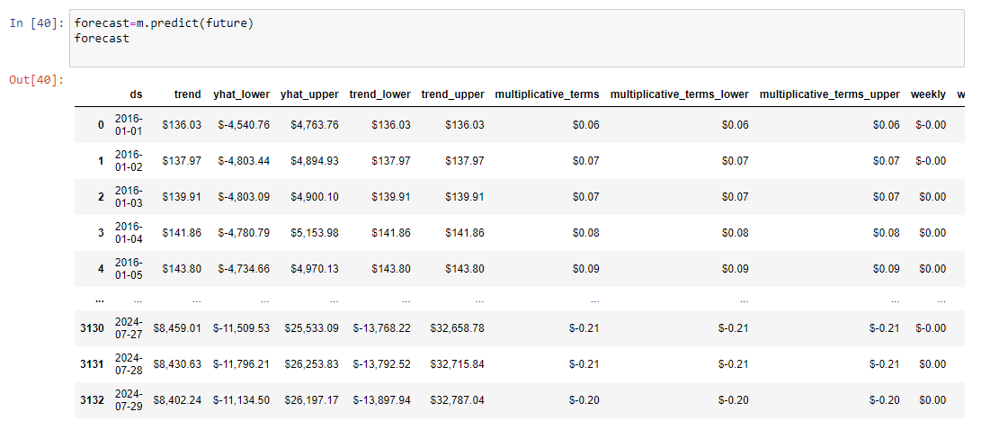

* 1. Forecasting the training data

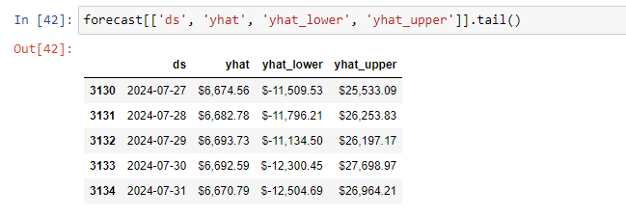

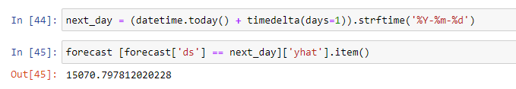

* 1. Rate of Change in Price

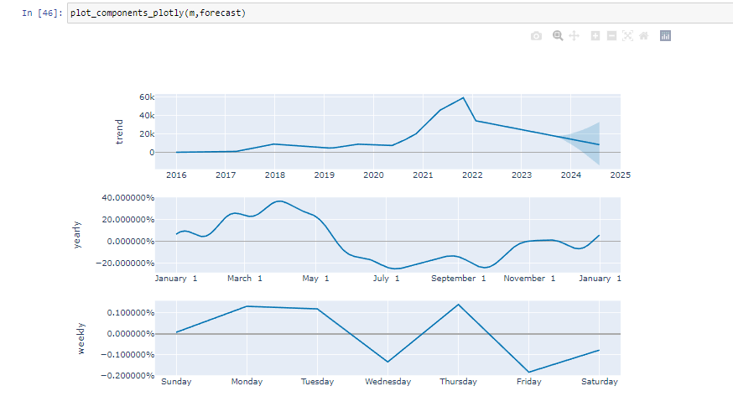

* 1. Bottom-Line



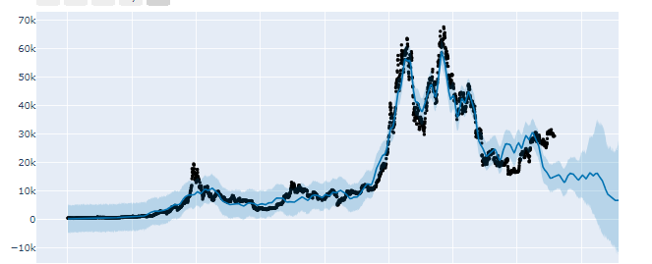

* 1. Saving the Model

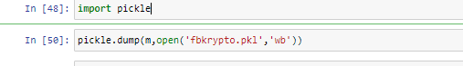

* 1. Hosting the Model using HTML pages by FLASK

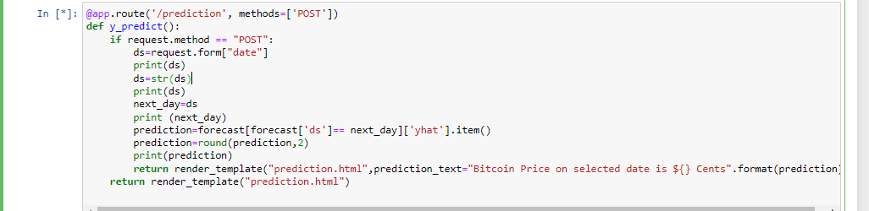



**HTML PAGES**

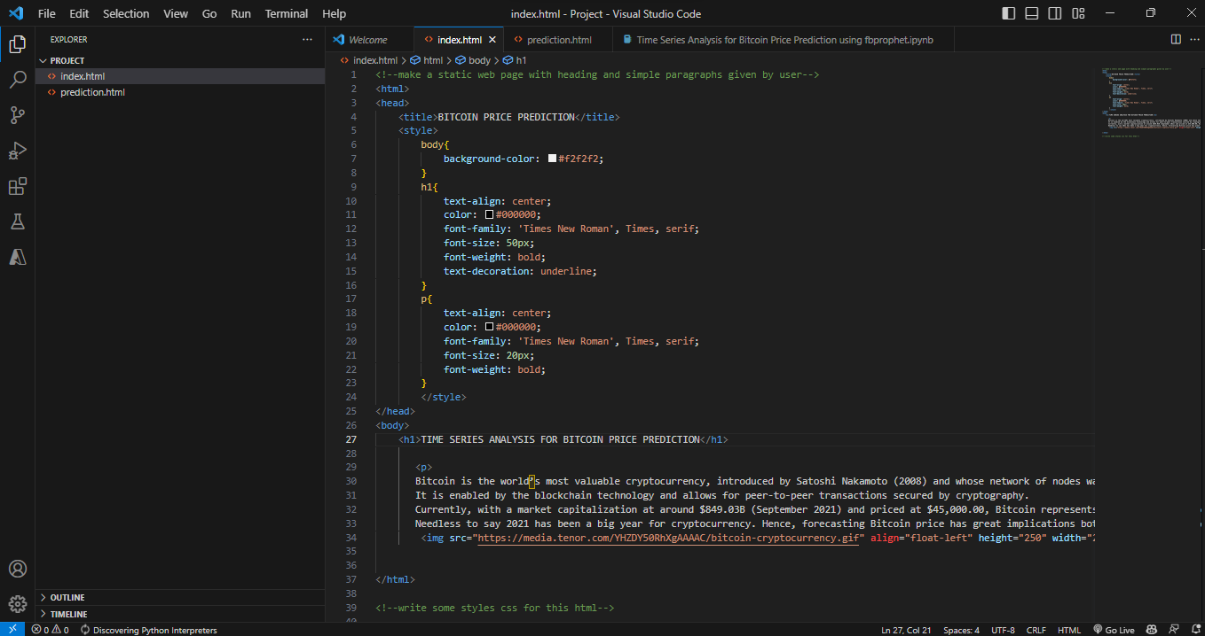

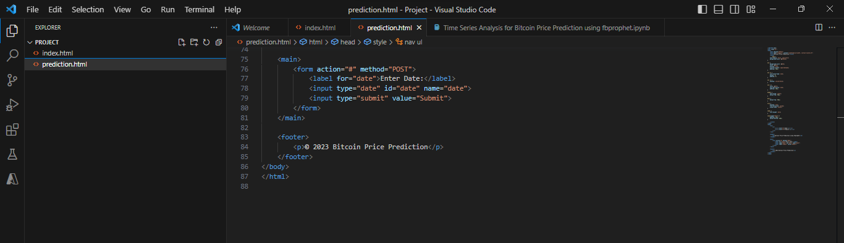

**OUTPUT:-**

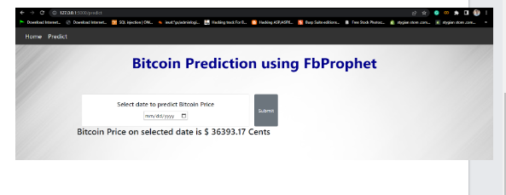

**CONCLUSION:-**

Our project demonstrated the feasibility and effectiveness of using fbprophet for bitcoin price prediction. However, there are still some limitations and areas for improvement. For example, our predictions were based on daily data, which may not capture the intra-day fluctuations and movements of bitcoin price. Also, our predictions were only valid for a short-term horizon, as the longer-term forecasts may be affected by unforeseen events or changes in the market conditions

Therefore, we suggest some future work and directions for our project:

* To use higher-frequency data, such as hourly or minute data, to improve our predictions for shorter time intervals.
* To explore other data sources and features that may have an impact on bitcoin price, such as blockchain metrics or social media activity.
* To compare our results with other methods and models for bitcoin price prediction, such as machine learning or deep learning techniques.