\*\*\* Deploying the application on the server\*\*\*

EC2

The plasma application can be runned on EC2 instance.

\*\*\*we need to add key pair in order to matain a secure connection between Local computer and the cloud server\*\*\*

Creating a UBUNTU server

1.



2.



3.

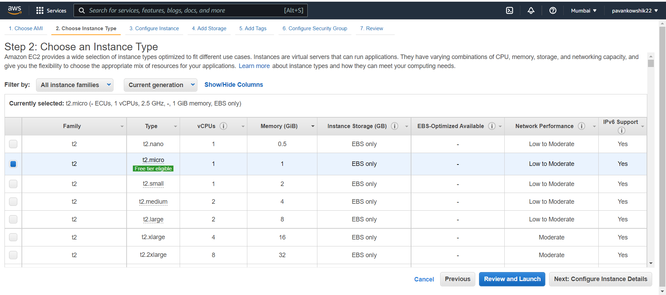

4.

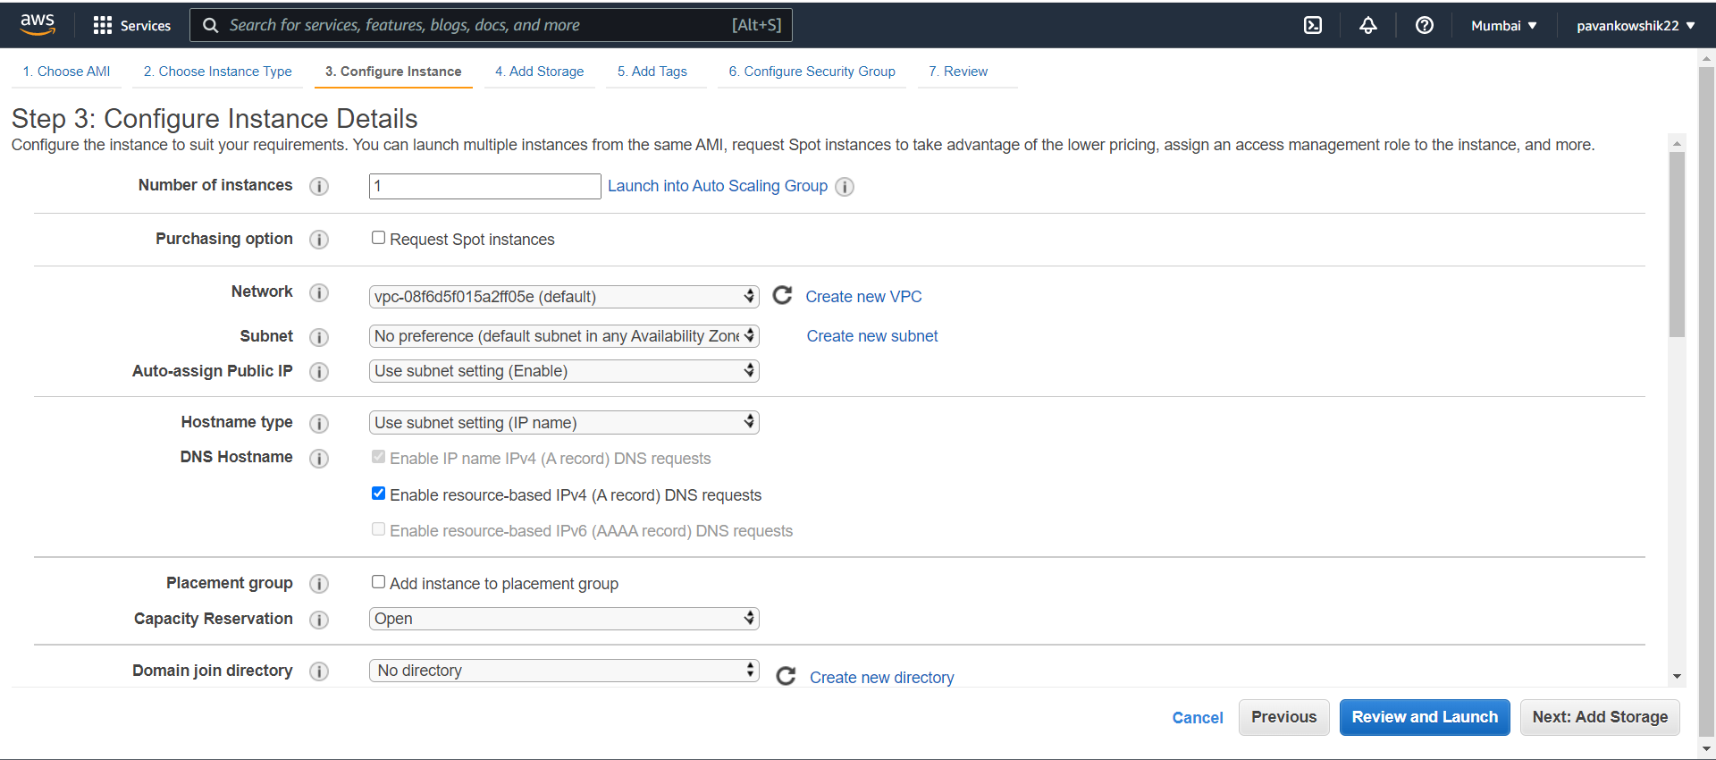

5.

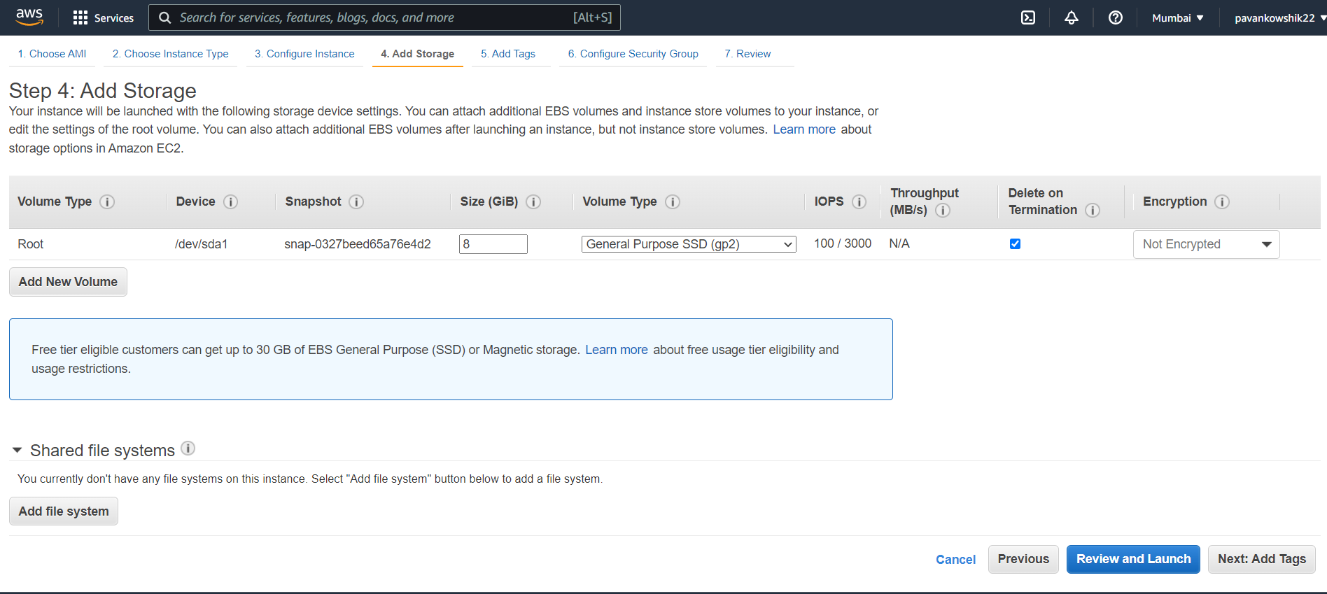

6.

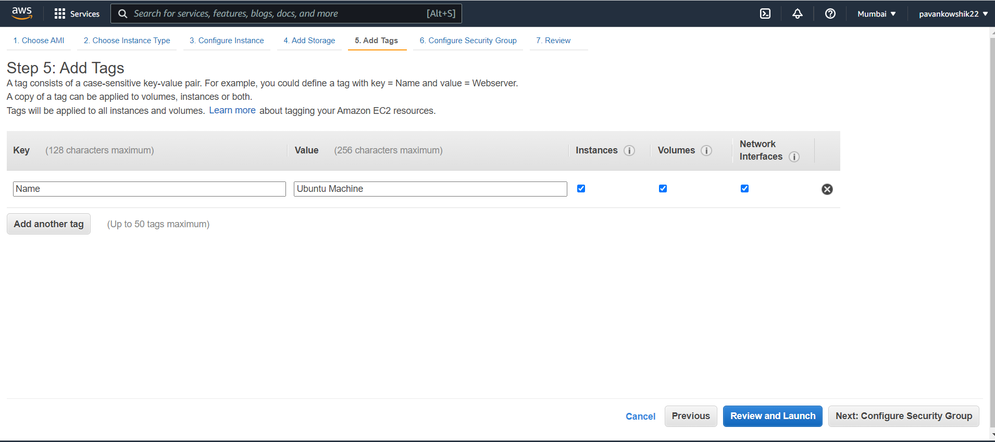

7.Now we need to enable the port for docker 8080

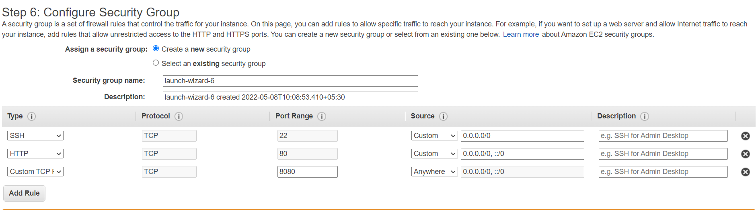

8.

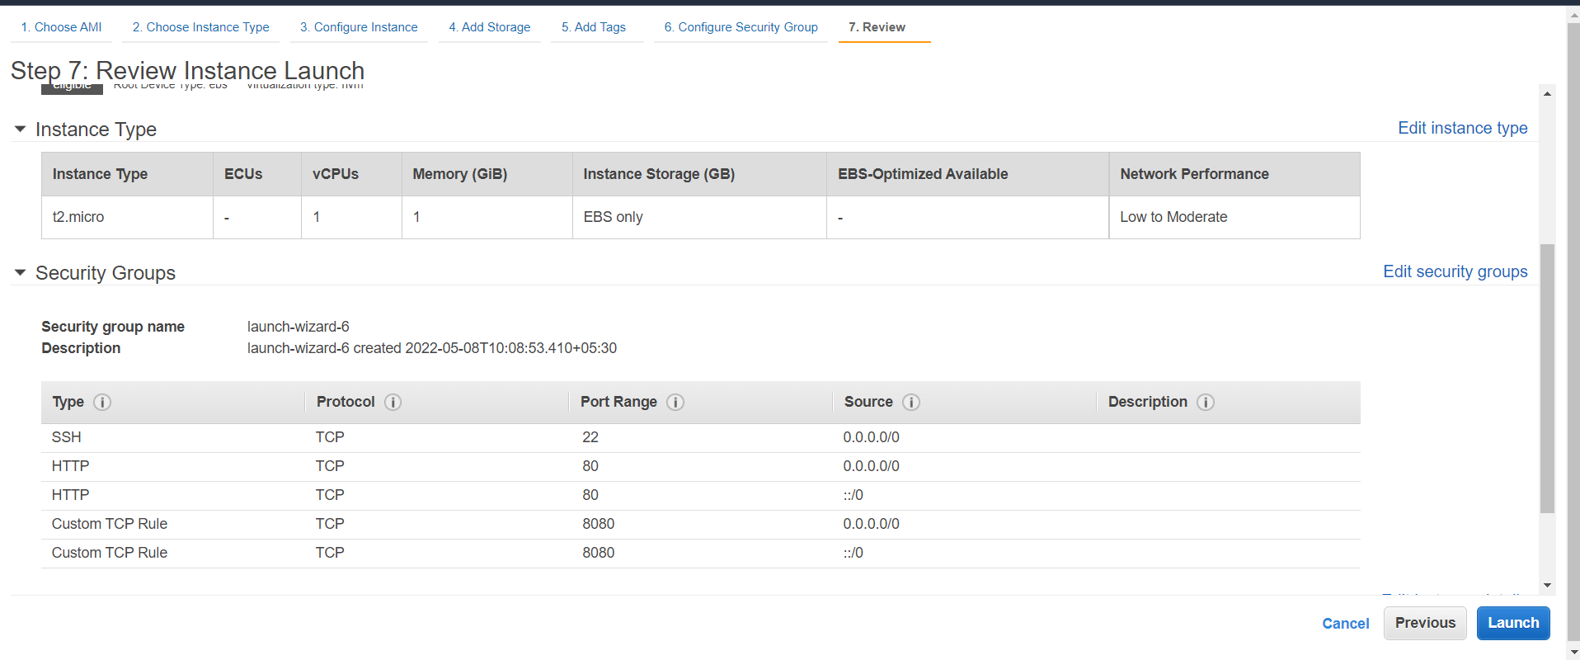

9.No need to create a new key pair as we created on previously

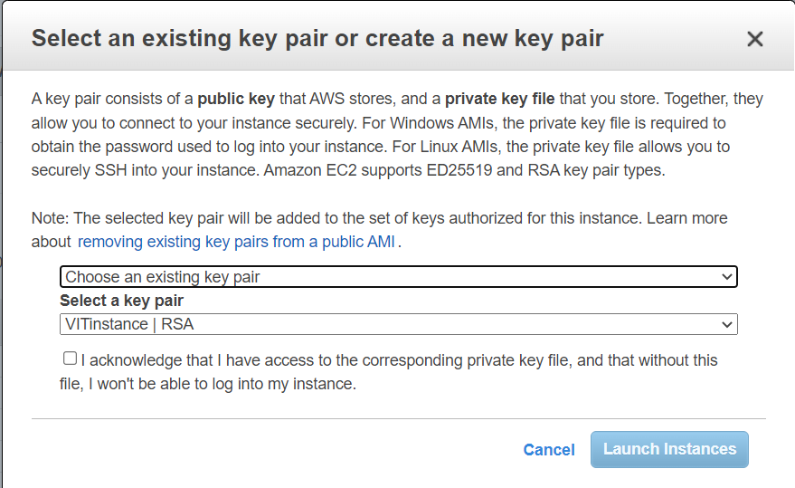

10.After launching the instance , open the command prompt and paste the key pair downloded file in the following path: C:\Users\pavan>

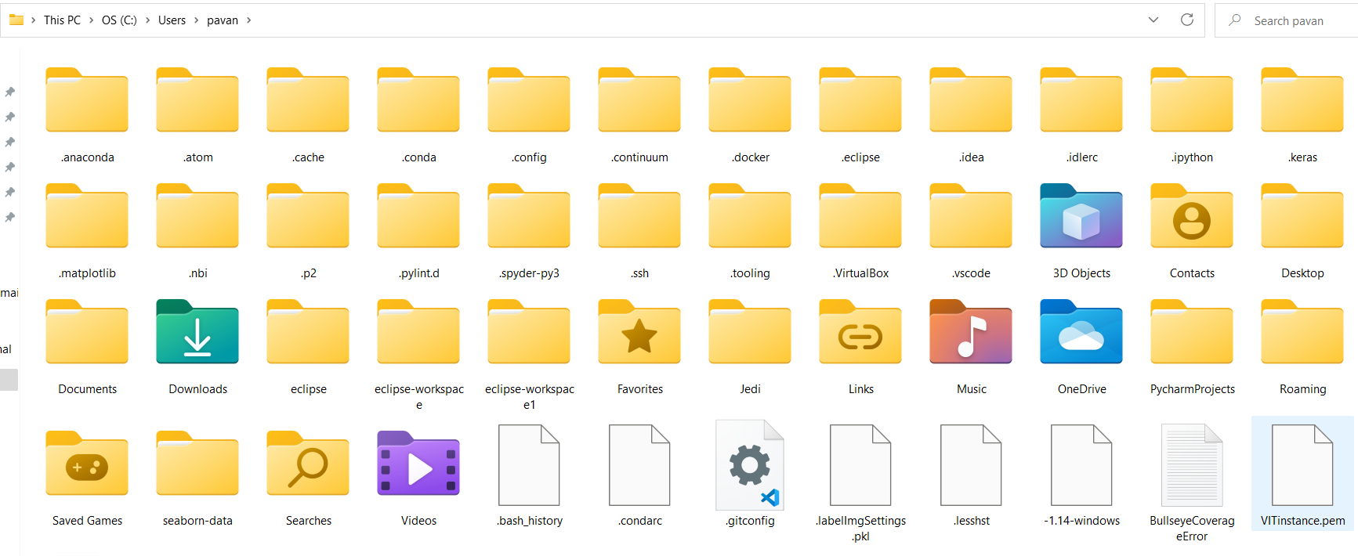

11.copy the command and paste to the command prompt

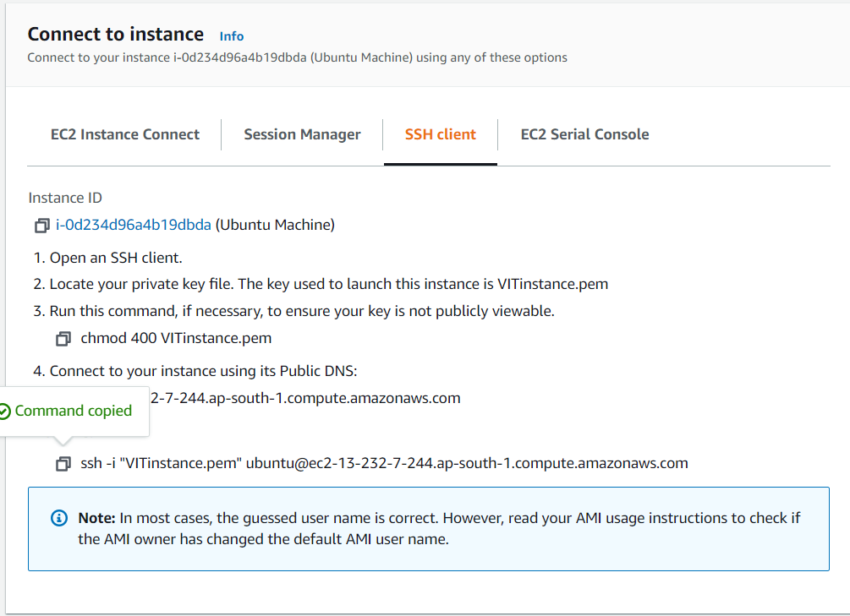

12. 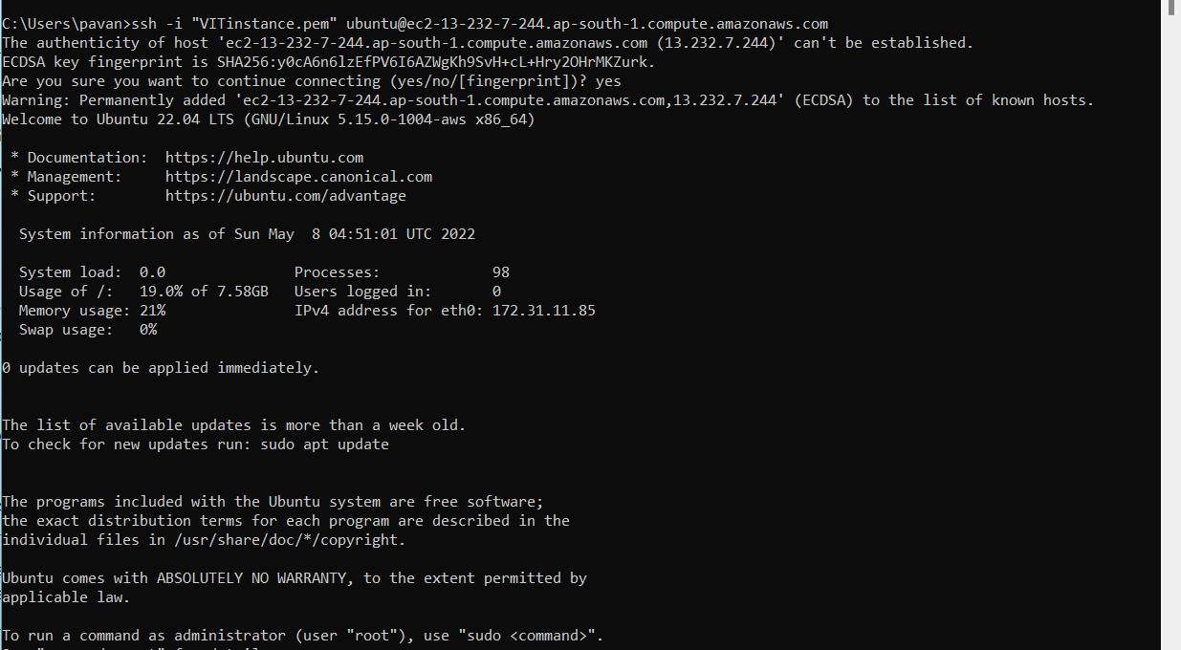

Use the following command:-

$ sudo apt-get update

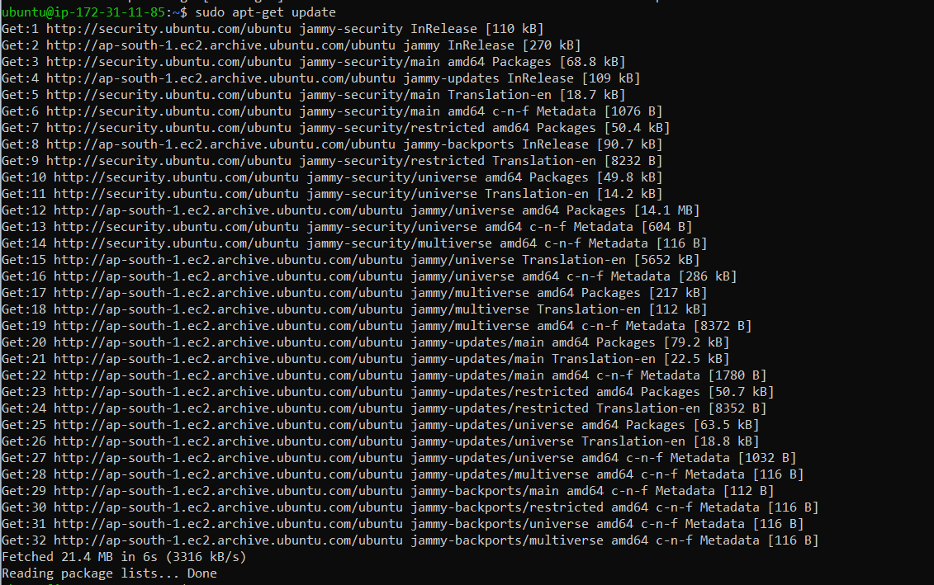

$ sudo apt install docker.io //installing the docker in Ubuntu

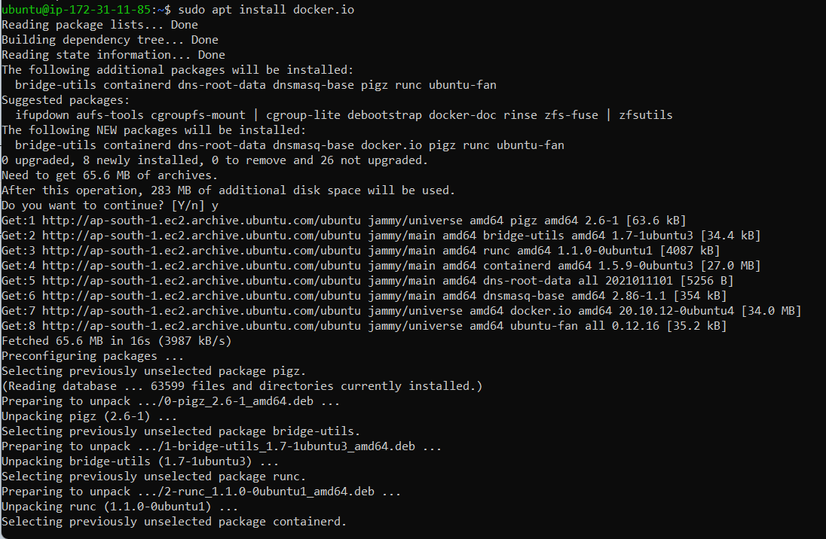

$ docker

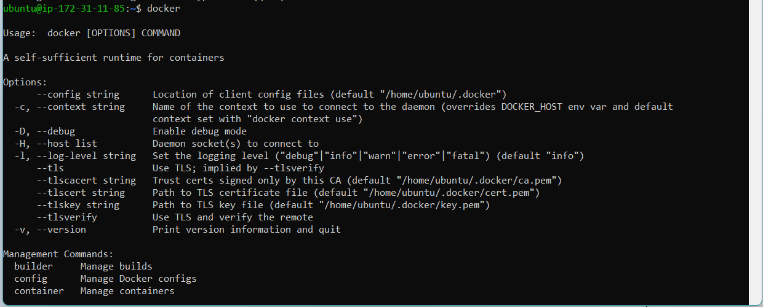

13. Now we are pulling the image from the docker hub to the Ubuntu machine

$ sudo docker pull uifd/ui-for-docker //Pulling image from the docker hub

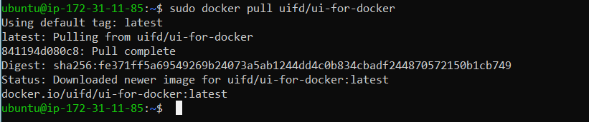

$ sudo docker images

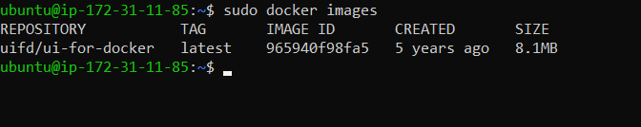

$ sudo docker run -p 8080:8080 sandeepdoodigani/vitplasma

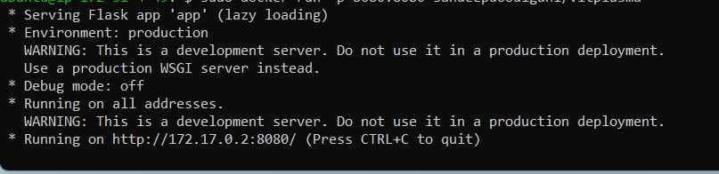

Copy the public Ipv4 address and add port 8080 at the last

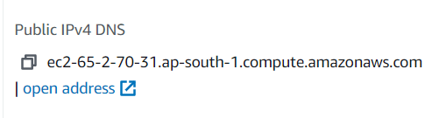

14. http://ec2-65-2-70-31.ap-south-1.compute.amazonaws.com:8080/

