**NUMBER OF VISUALIZATIONS**

1. **Column Chart: Age(Years) by Your level of satisfaction in Online Education**

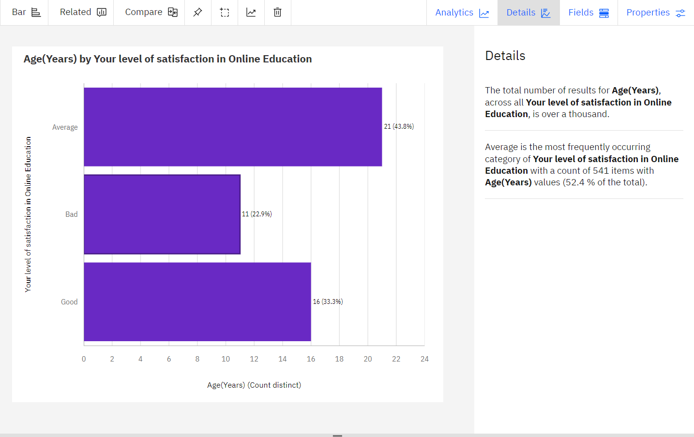

1. **Bar Chart: Internet facility in your locality by Your level of satisfaction in online Education**

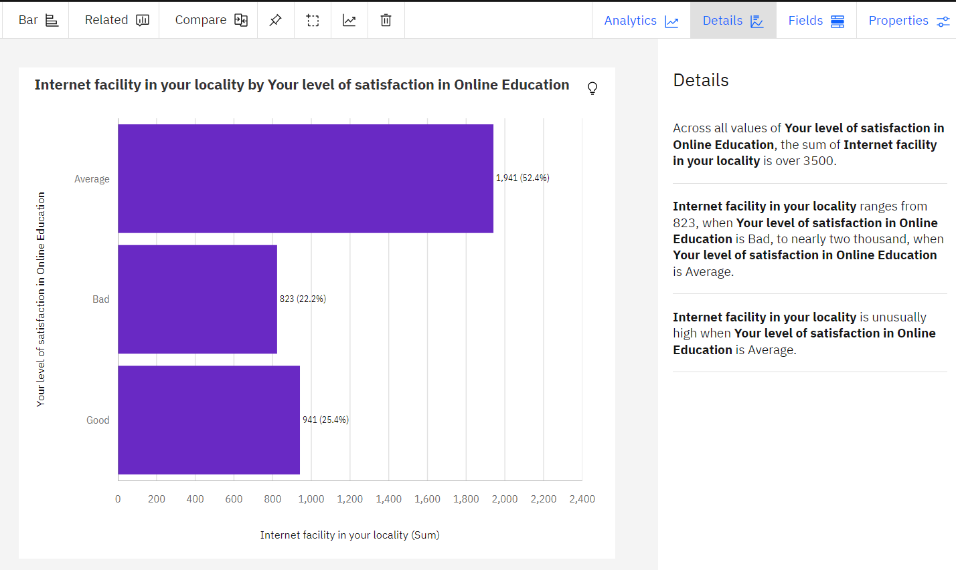

1. **Bar chart: Performance in online by Level of Education**

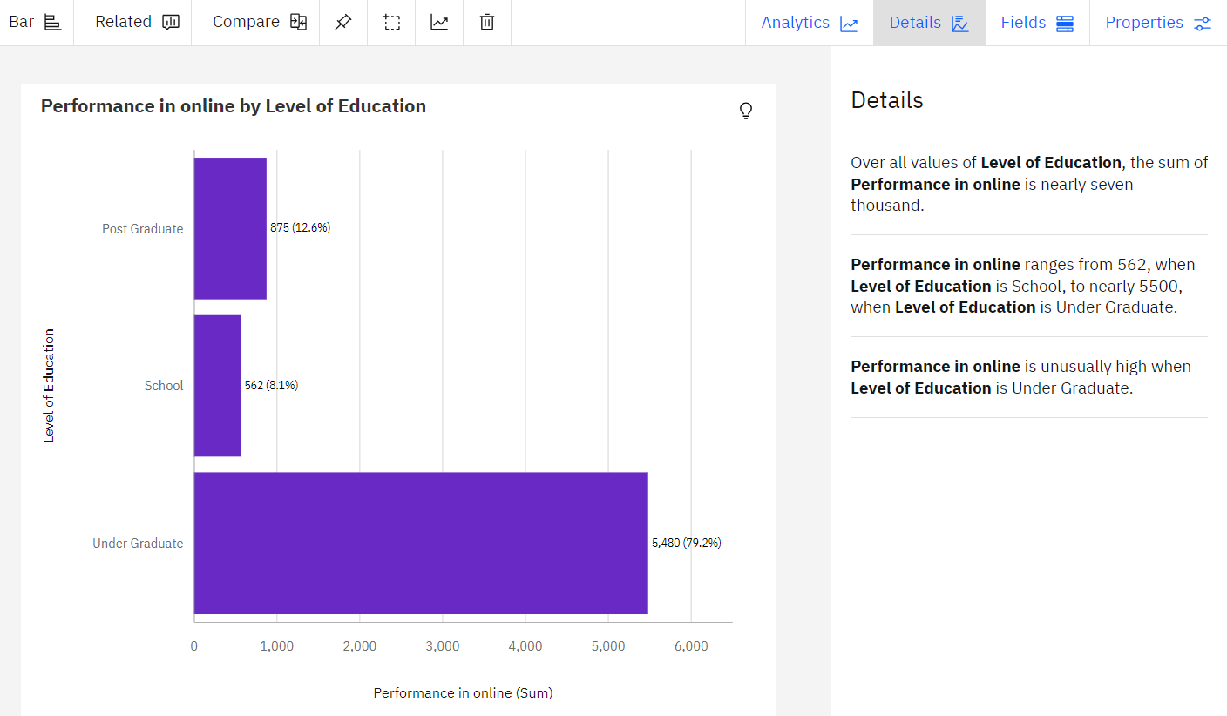

1. **Pie Chart: Time spent on social media (Hours) by Device type used to attend classes**

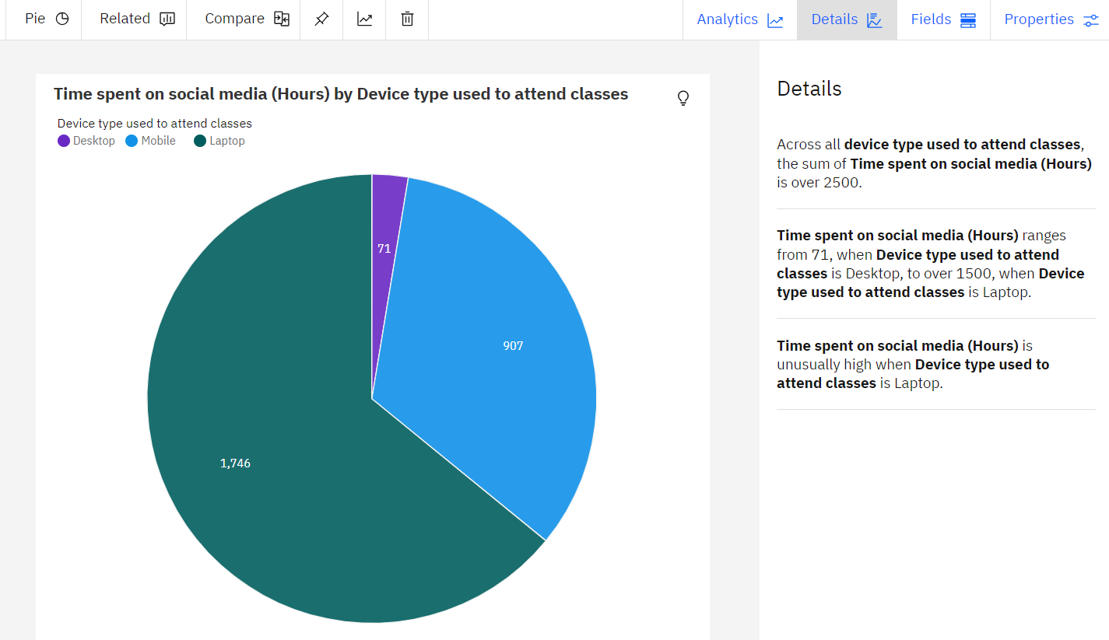

1. **Packed bubbles: Engaged in group studies? colored by Engaged in group studies? sized by Performance in online**

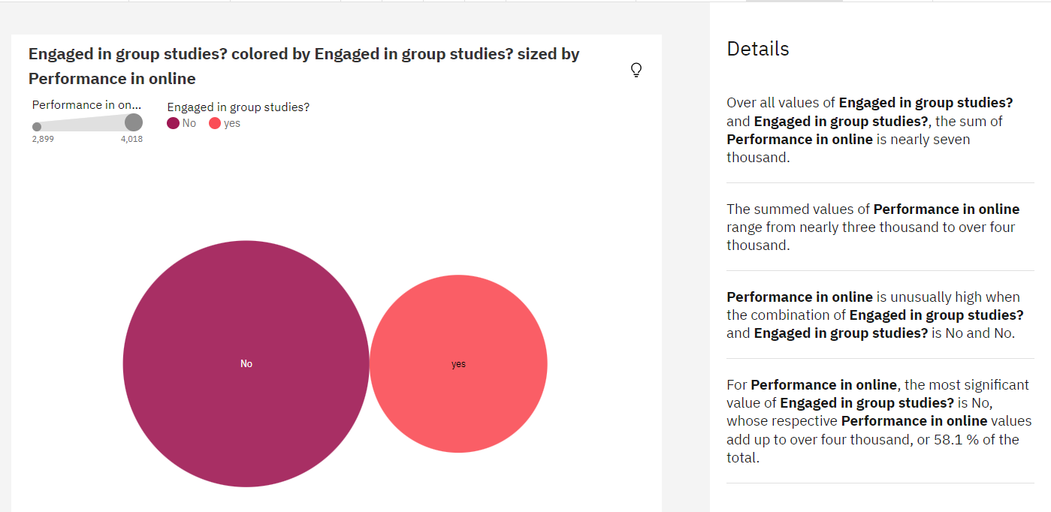

1. **Wordcloud: Average marks scored before pandemic in traditional classroom**

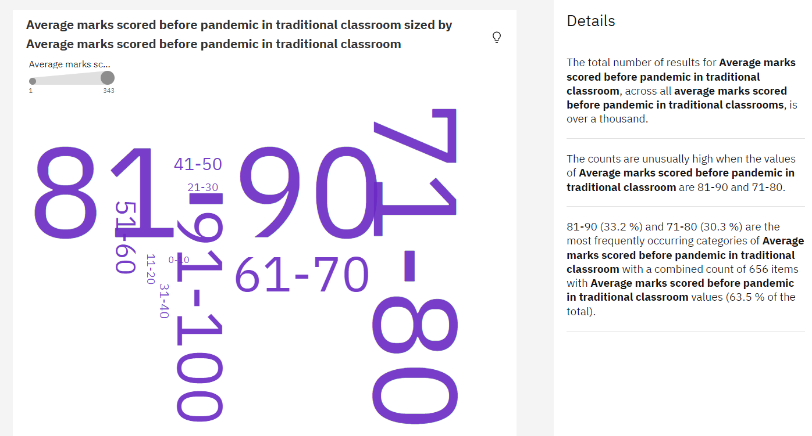

1. **Table: Economic status, Home Location and Performance in online**

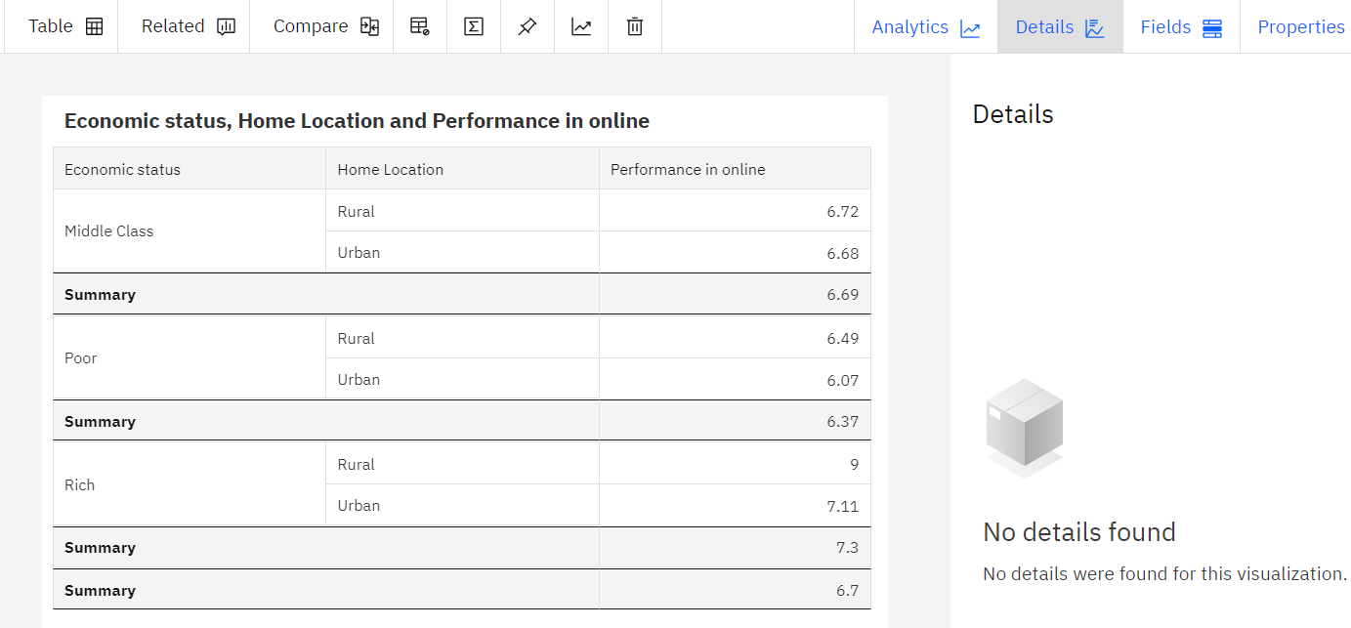

1. **Age(Years) by Study time (Hours) colored by Age(Years)**

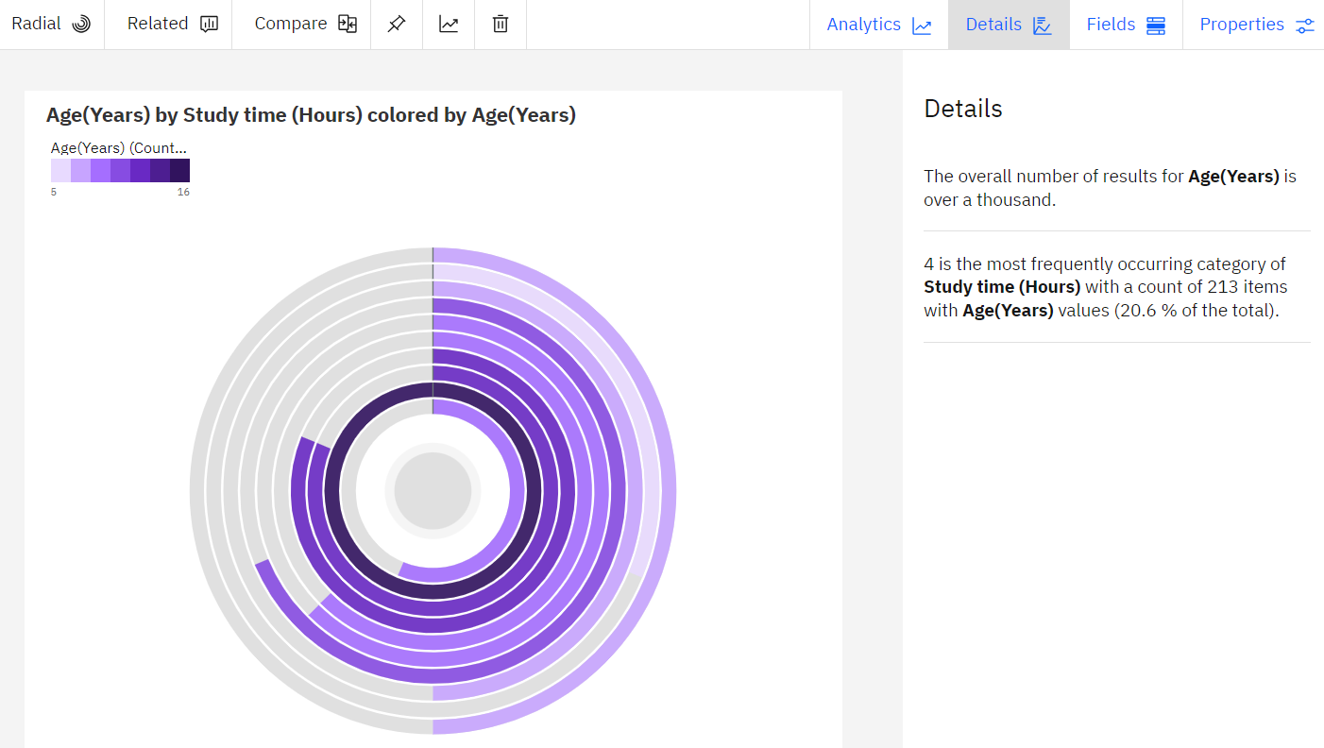

1. **Line Chart: Performance in online by study time(hours)**

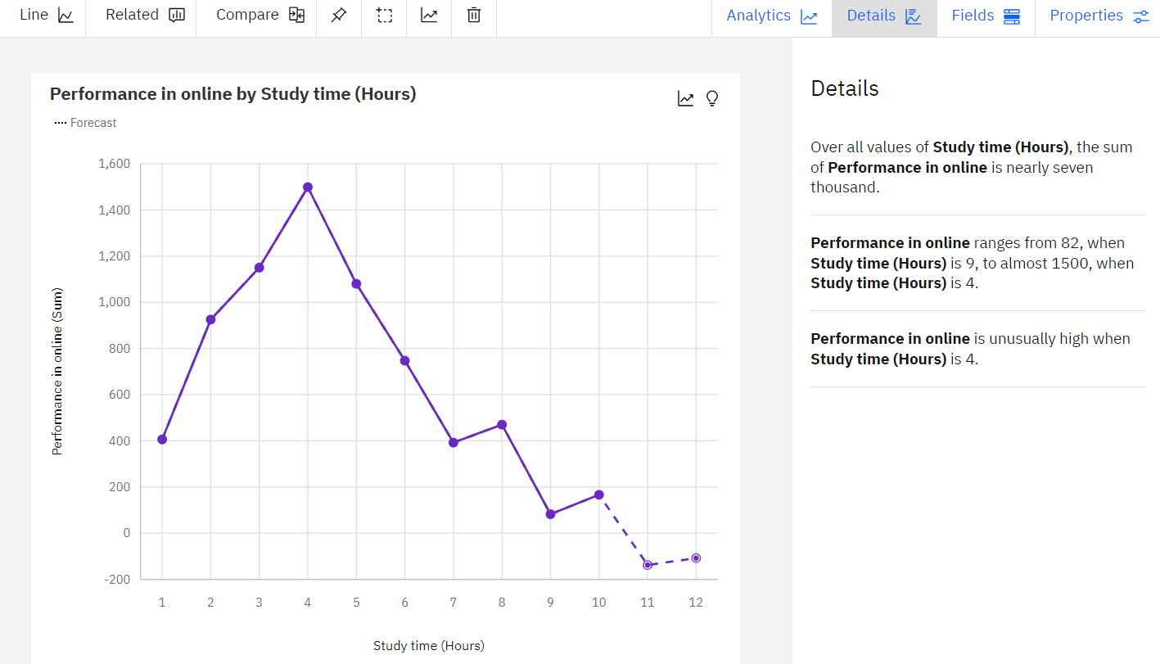

1. **Line Chart: Performance in online by sleep time(hours)**

