UNVEILING THE VIRTUAL CLASSROOM: AN IN-DEPTH ANALYSIS OF THE ONLINE EDUCATION SYSTEM

1 INTRODUCTION
1.1 Overview
Education is a crucial factor in the upliftment of a society. Education should be reachable to all to benefit the society. Online education system helps in attaining the reachability by providing a study from your place environment at a pace comfortable to the learner. It also fosters continuous learning environment whereby people can upgrade their qualifications, skillsets while working. When imparted effectively it could become a game changer in the education scenario. We could also see it’s reach when people were made to be in house during the lockdown imposed due to the corona outbreak. It facilitated the continuity of the education of the children from their home. This showcased to the world how online education system catered to the continuity of the education at adverse times.

1.2 Purpose
This project will help us in better understanding the system and come with strategies and mechanisms that could improve the effectiveness of the online educational system. The results of this review can provide insights at various levels and could guide and support the various stakeholders such as Govt. bodies to formulate suitable policies for the support of online education, educators to define strategies to improve the system and edutech companies to come with suitable design to improve the delivery, reach and effectiveness of online education.

2 LITERATURE SURVEY
2.1 Existing problem
A form of online education system imparted earlier and followed still is telecasting educational programs over radio and television. The first of this kind using radio was introduced by University of Wisconsin in 1919 (Engel, 1936). Though telecast of lectures happened but mostly it was one way with no interaction with the learners. The first distance education system through television was introduced by University of Iowa in 1932 (Koenig & Hill, 1967). The first online education system in the formal sense was introduced by University of Phoenix (The University of Phoenix, n. d.). With advent and usage of ICT technologies many forms of online education are practised today – short term courses, value added courses and complete courses leading to degrees to name a few.
On extensive research in this field, three important characteristics have been identified - (1) well-designed course material, compelling teacher-student interaction, well-prepared and wholeheartedly teachers; (2) fostering a feeling of community among online learners; and (3) fast technological innovation. (Sun & Chen, 2016).

2.2 Proposed solution
Perform a detailed analysis of the online education system to identify the primary factors affecting the system. The analysis could be carried out using data analytics tools such as IBM Cognos Analytics. Device strategies to enhance the system by looking into the primary factors contributing to the system.

3 THEORITICAL ANALYSIS
3.1 Block diagram

Survey Data
Preprocessing Data
Feature extraction
Analysing the data to identify patterns using visualization
Device strategies to improve the system

3.2 Hardware / Software designing
Hardwar requirement: Basic system with internet connectivity.
Software requirement: Access to IBM Cognos Analytics.

4 EXPERIMENTAL INVESTIGATIONS
The dataset used for this survey is ONLINE EDUCATION SYSTEM REVIEW.csv. The dataset contains 1033 records. Each record contains 23 features reviewing the online education. The details of the features are listed below.

S.No | Feature Name | Values
 | Gender | Male/Female
 | Home Location | Urban/Rural
 | Level of Education | School/Under Graduate/Post Graduate
 | Age (Years) | Age in years
 | Number of Subjects | Number of subjects taken online
 | Device type used to attend classes | Laptop/Mobile/Desktop
 | Economic status | Middle Class/Poor/Rich
 | Family size | Number of members in family
 | Internet facility in your locality | Ratings from 1 – 5
 | Are you involved in any sports? | Yes/No
 | Do elderly people monitor you? | Yes/No
 | Study time (Hours) | Study time in hours
 | Sleep time (Hours) | Sleep time in hours
 | Time spent on social media (Hours) | Time spent on social media in hours
 | Interested in Gaming? | Yes/No
 | Have separate room for studying? | Yes/No
 | Engaged in group studies? | Yes/No
 | Average marks scored before pandemic in traditional classroom | In ranges 0-10, 11-20, 21-30, 31-40, 41-50, 51-60, 61-70, 71-80, 81-90, 91-100.
 | Your interaction in online mode | Ratings from 1 – 5
 | Clearing doubts with faculties in online mode | Ratings from 1 – 5
 | Interested in? | Practical/Theory/Both
 | Performance in online | Ratings from 2 – 10
 | Your level of satisfaction in Online Education | Bad/Average/Good

Initially the features were pre-processed – a few renaming of features and changing the default aggregation behaviour to count and average was carried out. Then the correlation between the features were identified. The features that primarily affected the satisfaction level of online education is listed below.

S.No. | Features exhibiting high correlation with the satisfaction level of online education
 | Performance in online
 | Interaction in online mode
 | Clearing doubts with faculty in online mode
 | Device used

In order to understand how these features affected the satisfaction level, several visualizations were generated correlating the said features with the satisfaction level and analysed.

5 FLOWCHART
Diagram showing the control flow of the solution
Survey Data
Preprocessing:
Renaming the features
Changing the aggregate property
Identifying features highly correlated
With the satisfaction level
Building Visualizations to identify
The relationships between the features and
The satisfaction levels
Presenting the results through Dashboards,
Story and Reports.
Insights
6 RESULTS
The outcome of the review is shared below:
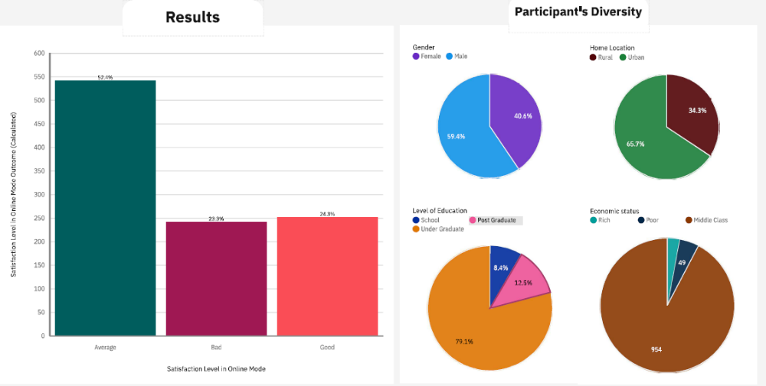

As can be seen from the above graph, most of the surveyed people (52.4%) have expressed satisfaction on online mode of education. Around 23.3% of people felt bad about online education 24.3% felt online education to be good. The diversity of the sample population surveyed is shown in the below graph.

The following graphs show the relationships between the primary features and the satisfaction level. Performance in online is unusually high when satisfaction level is good.

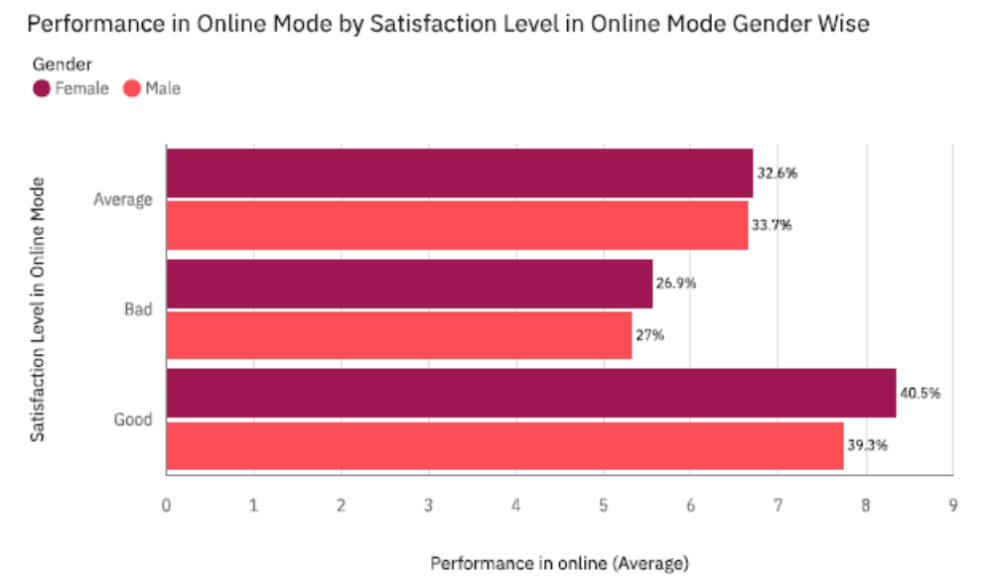
Performance in online is unusually high when the learners were able to clear their doubts with faculty members in online mode.

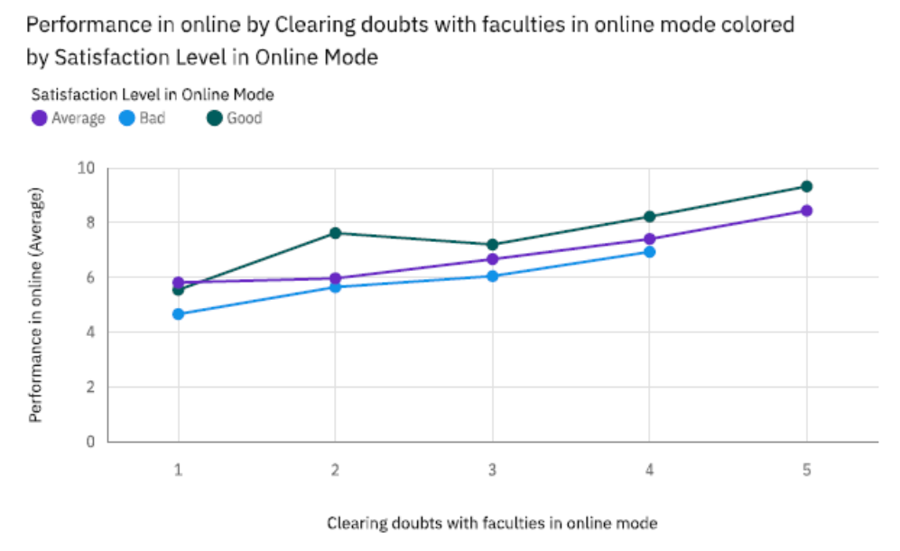

Performance in online is most unusual when interaction in online mode rating is five and satisfaction level is good, when interaction in online mode rating is 1 and satisfaction level is bad and when interaction in online mode rating is 5 and satisfaction level is average.

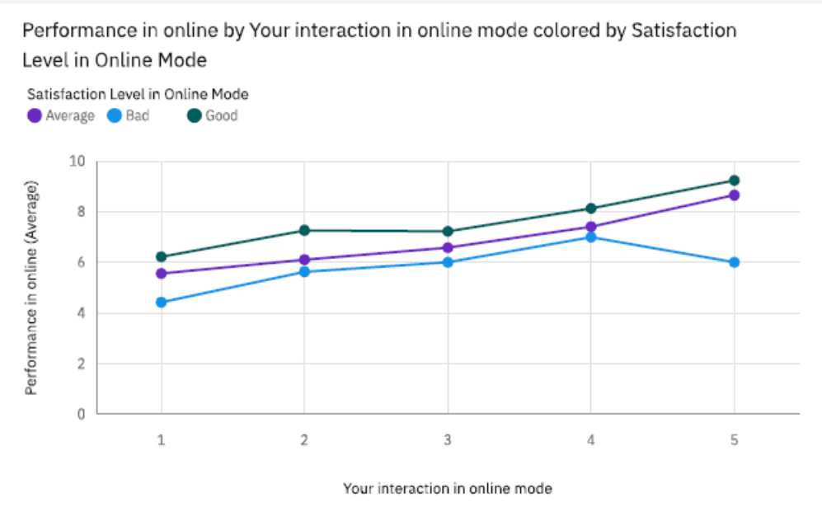

The age of the people who feel good about online education is on an average higher than people who feel bad about it.

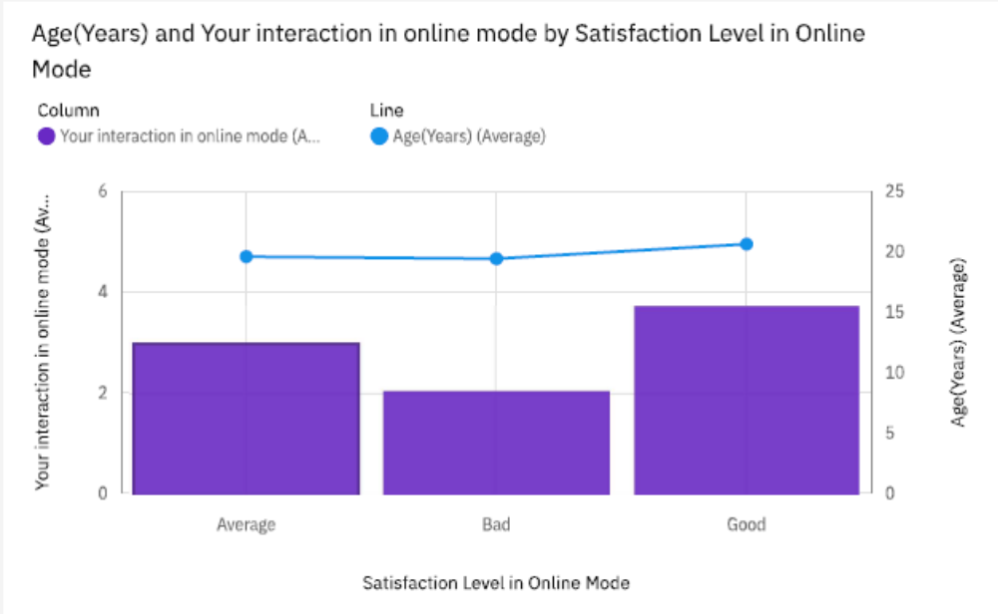

7 ADVANTAGES & DISADVANTAGES
The proposed survey and analysis give us insights into the dynamics of online education. It highlights which factors contribute to the betterment of online education and in which factors we need to focus to improve online education. Still, we find some unusual patterns in features which may be due the characteristics of the data used. Also, we can look for secondary correlations among attributes to see if more insights could be obtained.

8 APPLICATIONS
The findings could be applied to fine tune and improvise online education and tutoring systems. It could be used to design an effective and high-quality online education system.

9 CONCLUSIONS
To summarize the results of the survey:
- Good performance in online mode leads to high satisfaction in online education.
- Ability to clear doubts with faculty in online mode leads to increased satisfaction level in online education.
- Good interactivity in online mode leads to high satisfaction level in online education.
- On average the higher the age of a person the better his/her satisfaction level in online education.

10 FUTURE SCOPE
Apart from the primary correlations, some secondary correlations were also identified during the analysis. These secondary correlations can be explored further to gain insights into the factors that enhance the learning experience of an online education system.

11 BIBILOGRAPHY
Engel, H. A. (1936). WHA, Wisconsin’s pioneer. Unpublished manuscript. Wisconsin State Historical Society.
Koenig, A. E., & Hill, R. B. (1967). The farther vision: Educational television today. The University of Wisconsin Press.
The University of Phoenix (n. d.) The University of Phoenix history. Retrieved from http://www.distancelearninghq.com/learningresources-universityofphoenix.htm
Sun, A., & Chen, X. (2016). Online education and its effective practice: A research review. Journal of Information Technology Education: Research, 15, 157–190. Retrieved from http://www.informingscience.org/Publications/3502

