## **ONLINE EDUCATION SYSTEM**

## **Introduction**

Online education is a flexible instructional delivery system that encompasses any kind of learning that takes place via the [Internet](https://www.encyclopedia.com/science-and-technology/computers-and-electrical-engineering/computers-and-computing/internet). Online learning gives educators an opportunity to reach students who may not be able to enroll in a traditional classroom course and supports students who need to work on their own schedule and at their own pace.

**1.1 Overview**

Online education is a procedure of gaining skills and knowledge through electronic devices like computers, mobiles, laptops, etc using the internet. Online education makes it possible for tutors or mentors to reach all the students more flexibly and teach them the relevant skills more efficiently.

**1.2 Purpose**

Online education makes it possible for tutors or mentors to reach all the students more flexibly and teach them the relevant skills more efficiently. The students who can not attend traditional regular classes now can also learn anything from anywhere using the internet.

1. **Literature Survey**

**Online Learnings or E-Learnings**

Quick improvement in hardware have finished space training simple “(McBrien et al., 2009)”. “A large portion of the connections (web based learning, open instruction, net-based schooling PC learning, consolidated training, m-learning, for ex.) have in responded the ability to utilize a PC related with a net, that settlements the probability to discover from some place, whenever, in any beat, with any methods”. Internet learning are frequently named as a device which will scratch Learning measured more alternate engrossed, imaginative and surprisingly versatile. Network based learning is fluctuated as "learning proficiencies in coordinated or offbeat airs that is related with courses utilizing various gadgets (‘e.g. cell phones, workstations, and so forth’) with network induction”. “In these conditions, understudies are frequently anyplace (autonomous) to discover and coordinate with instructors and different deputies” “(Singh and Thurman, 2019)”. It simultaneous erudition climate organized classified the rationale deputies show up live talks, there are constant associations among teachers and disciples, and it is a criticism, with the help of bizarre learning exospheres not well controlled. “In such a learning area, erudition satisfied is not reachable esoteric the kind of live talks or periods; it's predominant at changed culture characterizations and deliberations. Instant input and instant answer are not plausible in such a environment “(Littlefield, 2018)”. Matched learning could give huge loads of events to societal association “(McBrien et al., 2009)”. “In the focus of this terminal contagion spread such online platform are essential where (a) video conferencing with at least 40 to 50 deputies is achievable,

(b) reflections with deputies are regularly done to remain classes invigorate,

(c) network associations are acceptable,

(d) discourses are open in cell headsets additionally and not simply workstations,

(e) viewpoint of assessing effectively itemized talks, and

(f) rapid response from deputies are frequently refined and responsibilities are often taken “(Basilaia et al., 2020)”

**2.1 Existing problem**

### **1. Lack of Motivation in Students**

It was thought that online learning would be the new interactive and immersive method to teach the new generation of students. Though, the results speak on the contrary. Endless oceans of texts, quizzes, frequent learning assignments, and MCQs have led to students losing motivation to keep revisiting the learning portal.

### **2. Infrastructural Problems**

Though online learning doesn’t require huge buildings, big classrooms, chairs, tables, blackboards, or chalk doesn’t mean there are no infrastructural requirements. The need for a computer, adequate software, constant electricity, and high-bandwidth internet is quite a big demand.

### **3. Lack of In-person Interaction**

Humans are social animals. The growth of the internet hinged on the principle that humans will always be curious to interact and know more about one another. That said, on a psychological level, virtual interaction cannot mimic that of a physical one.

**2.2 Proposed solution**

**-**> Introduce rewards and recognition for students who actively participate in the online learning platform. This could be done by providing them with certificates or other rewards such as discounts on course fees.

-> Break up long lectures and sessions with interactive activities such as quizzes and polls to keep students engaged.

-> Incorporate discussion boards and forums in the online learning platform to encourage students to interact and engage with each other.

-> Governments in developing countries should invest in providing free access to computers and the Internet in public libraries and schools.

-> Private businesses should be encouraged to support online learning initiatives by providing free or discounted access to computers and the Internet.

-> Private funding organizations should establish grants and scholarships for individuals to access computers and the Internet.

-> One possible solution to the lack of in-person interaction in virtual classrooms is to create smaller groups of students for virtual sessions. This would enable students to interact with one another as well as with the instructor, creating a more engaging atmosphere.

**3 THEORETICAL ANALYSIS**

**3.1 Block diagram**

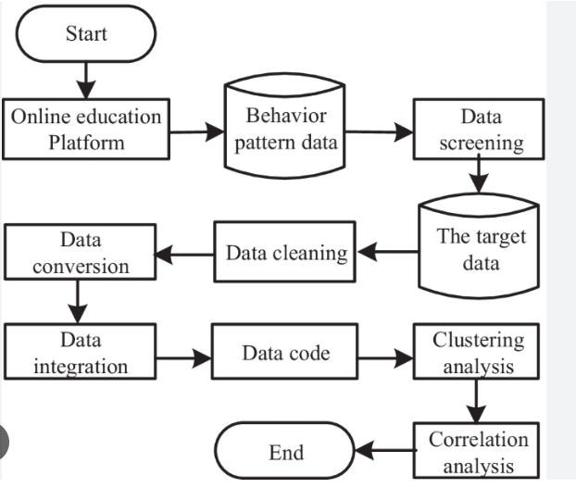

**3.2 Hardware / Software designing**

Computer:

* Windows 7, Windows 8.1, or later
* 2.5 GHz or faster processor
* 4 or more gigabytes (GB) of RAM
* Sound card and speakers
* DVD drive
* Word processing
* Spreadsheet
* Microsoft Office 2010 Enterprise Edition, or better

**4 EXPERIMENTAL INVESTIGATIONS**

It focuses on the use of data to leverage training outcomes. With the usage of effective tools such as predictive analysis, multi-source knowledge mapping, and machine learning, it is possible to design a system that caters to individual Learning Analytics needs.

**5. FlowChart**

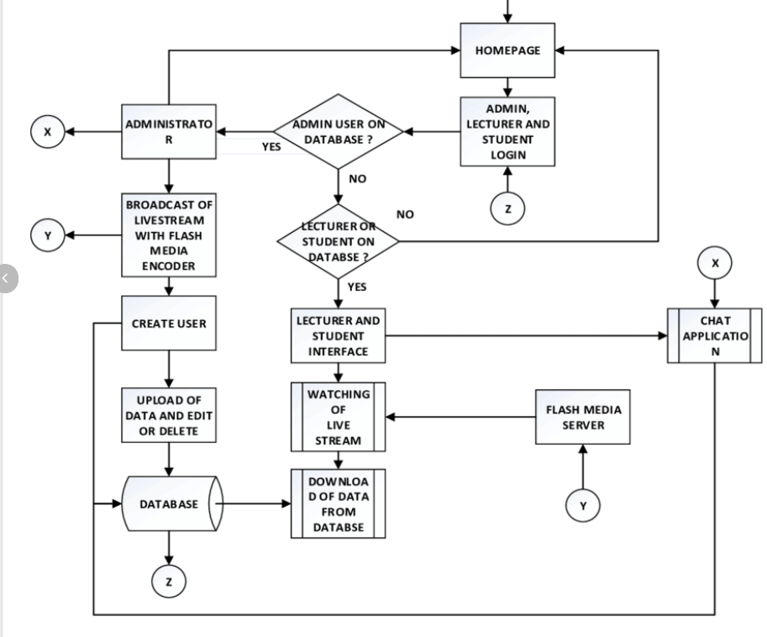

## **RESULT**

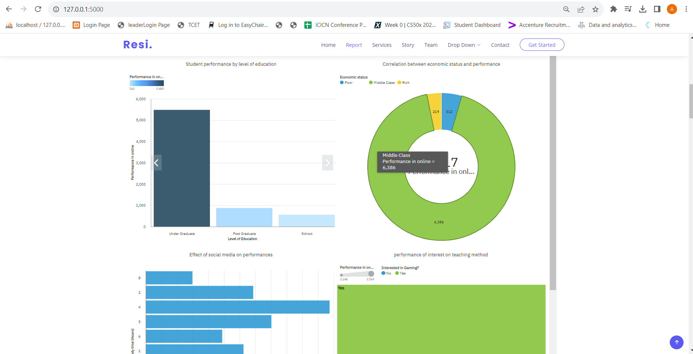

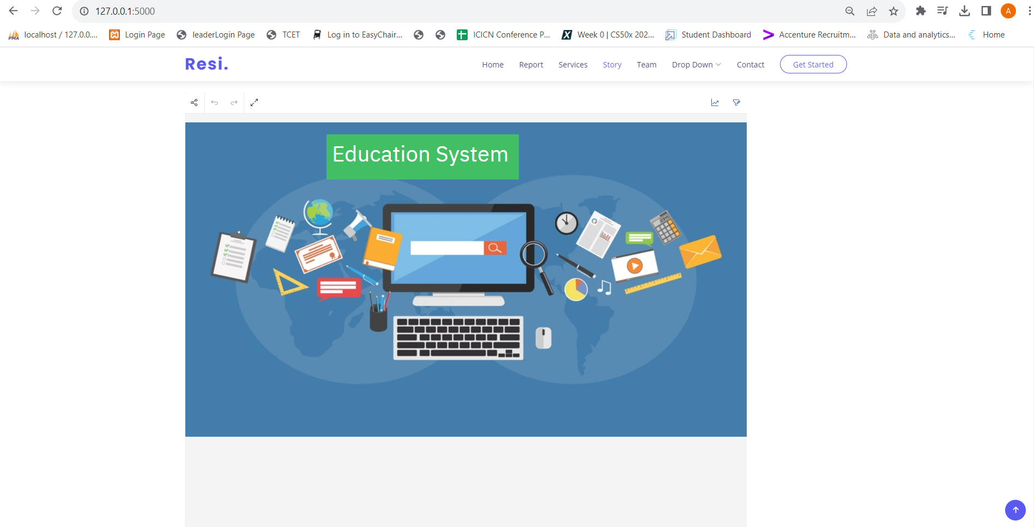

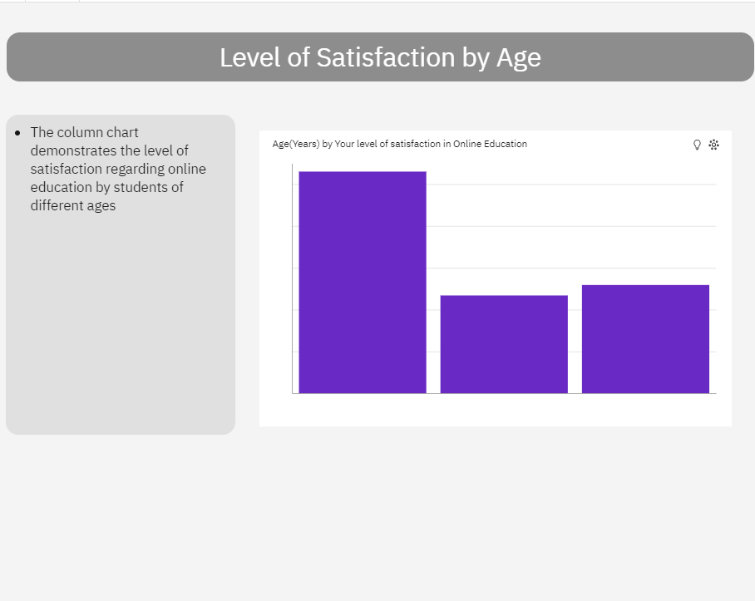

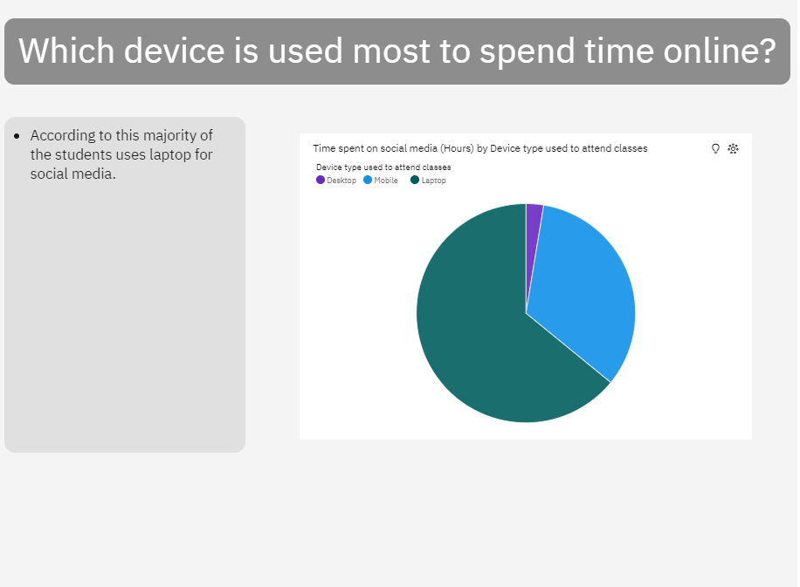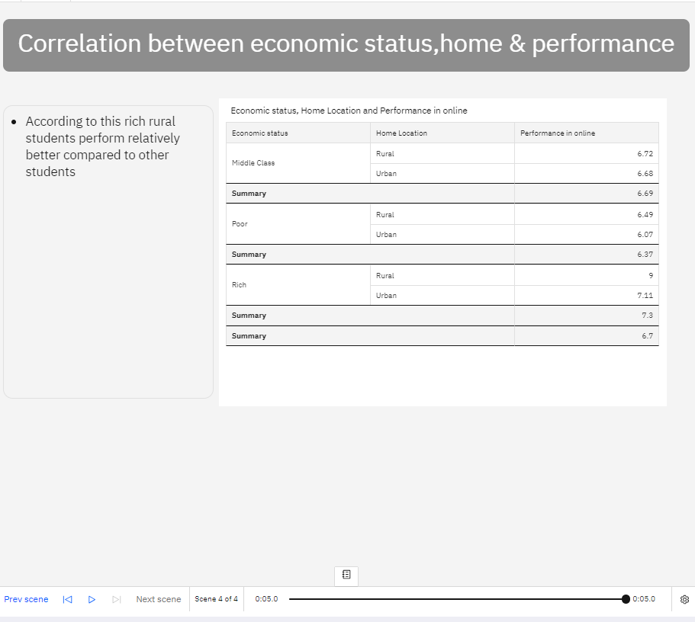

## 

## **Advantages of Online Education**

1. **Easy accessible and convenient from any place**

You can enrol in an online course from the comfort of your home and learn anything that you want at any time convenient to you, no matter where you live or what hours are available for these classes. You also have the freedom to take up courses from institutions in another country and not be restricted by geographical boundaries.

1. **Flexible hours and Saves time**

Another advantage of online learning is that you can attend classes at any time. You no longer have to worry about whether the course takes place during your typical work hours. It gives students more flexibility in their lives, so they don't need to change their schedules for a class. Online courses also save time because it usually does not require physically going into an institution from one's home location on campus.

1. **Fast and easy sharing of resources**

One of the advantages of online learning is the ease of sharing obtained information through online platforms. Online classes provided soft copy resources, which are easy to maintain as well as economical.

## **Disadvantages of Online Education**

## **Struggle to focus on a screen**

Online learning can be a struggle for many students, as the screen is often difficult to focus on. A huge problem with online classes is that it's easy to get distracted by social media or other sites and lose track of what the teacher said in class. Teachers need to keep their lessons engaging and crisp in addressing this concern, so they don't have any distractions.

1. **Network and other technological problems**

Perhaps the biggest drawback of online learning is that it is so prevalent. Although the nations have made great strides in creating a reliable internet infrastructure, many smaller towns and communities still struggle to maintain a steady connection with enough speed. A child's ability to learn continuously may be disrupted by an internet connection problem or a bad internet signal. This might make students less likely to show up to class frequently and learn the material.

1. **Lack of interpersonal communication**

Students benefit much from learning from their peers while they are in school. They develop their patience, their ability to deal with disappointment, and their ability to compete while they are with friends. Taking part in group study and engaging in group discussions is a common practice among students who want to improve their learning. Conversely, in an online course, there is little to no face-to-face interaction between the students and the professors. As a result, the pupils can feel very alone, which could hurt their academic performance.

## **Applications**

### **1. BYJU’s Learning**

BYJU’s Learning is an India-based online learning app. The app provides students with a huge variety of learning modules and content.

### **2. Udemy**

Currently, in the online educational apps market, Udemy is definitely in the top 2 due to its variety of courses. In 2010 Eren Bali, Oktay Cagler, and Gagan Biyani launched the currently successful Udemy app.

### **3. Khan Academy**

Khan Academy is bringing a revolution in the educational app sector. The app has taken a huge step in its business model as all of its content is free for everyone. Sal Khan is the founder of the educational platform as he launched the app back in 2008.

**Conclusion**

Increased educational access, high-quality learning opportunities, improved student outcomes and abilities, and more educational options are some of the possible benefits of online education.

**Future Scope**

* The main purpose of education is to achieve upward mobility. Online courses certification programs have been able to provide inexpensive education to the masses and also save time, energy and money.
* Electronic-learning through certified online courses provides a wide range of courses that caters to the core interests of the student, thus creating a fertile arena for future advancement.
* There is a misplaced notion, that employers prefer students with traditional brick and mortar college degrees. On the contrary, corporate organizations in India are recognizing the high skill levels of students who have undergone online courses certification programs from highly acclaimed educational institutions.

**11. BIBILOGRAPHY**

1. Evaluation of Evidence-Based Practices in Online Learning A Meta-Analysis and Review of Online Learning Studies.
2. https://www.educationworld.in/impact-of-online-learning-on-school-education/

**APPENDIX**

**Source code**

**Index.html**

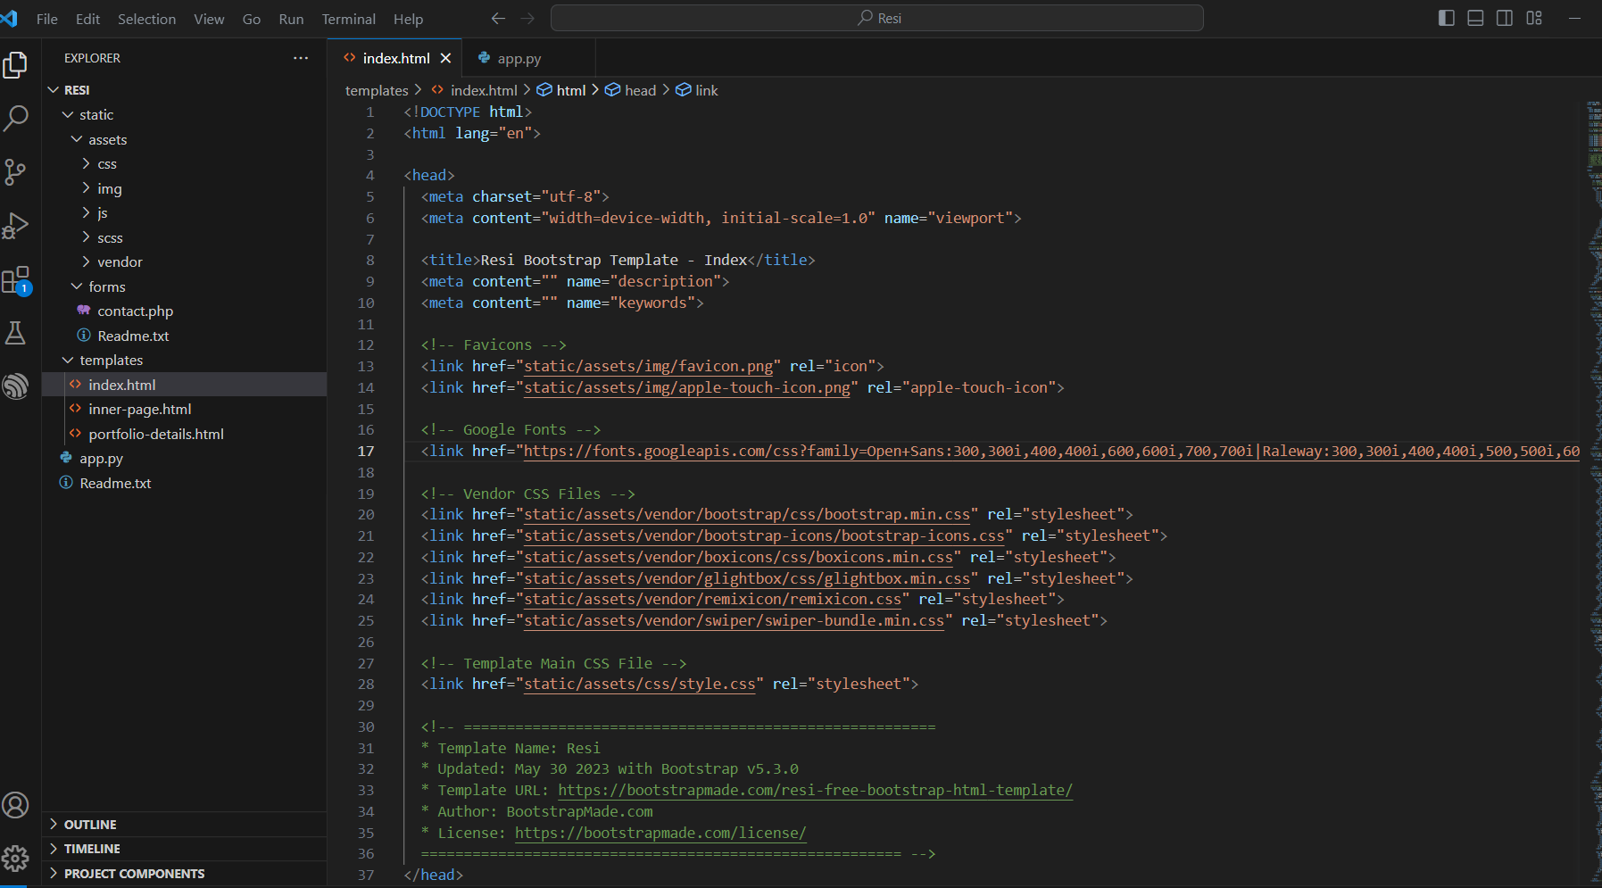

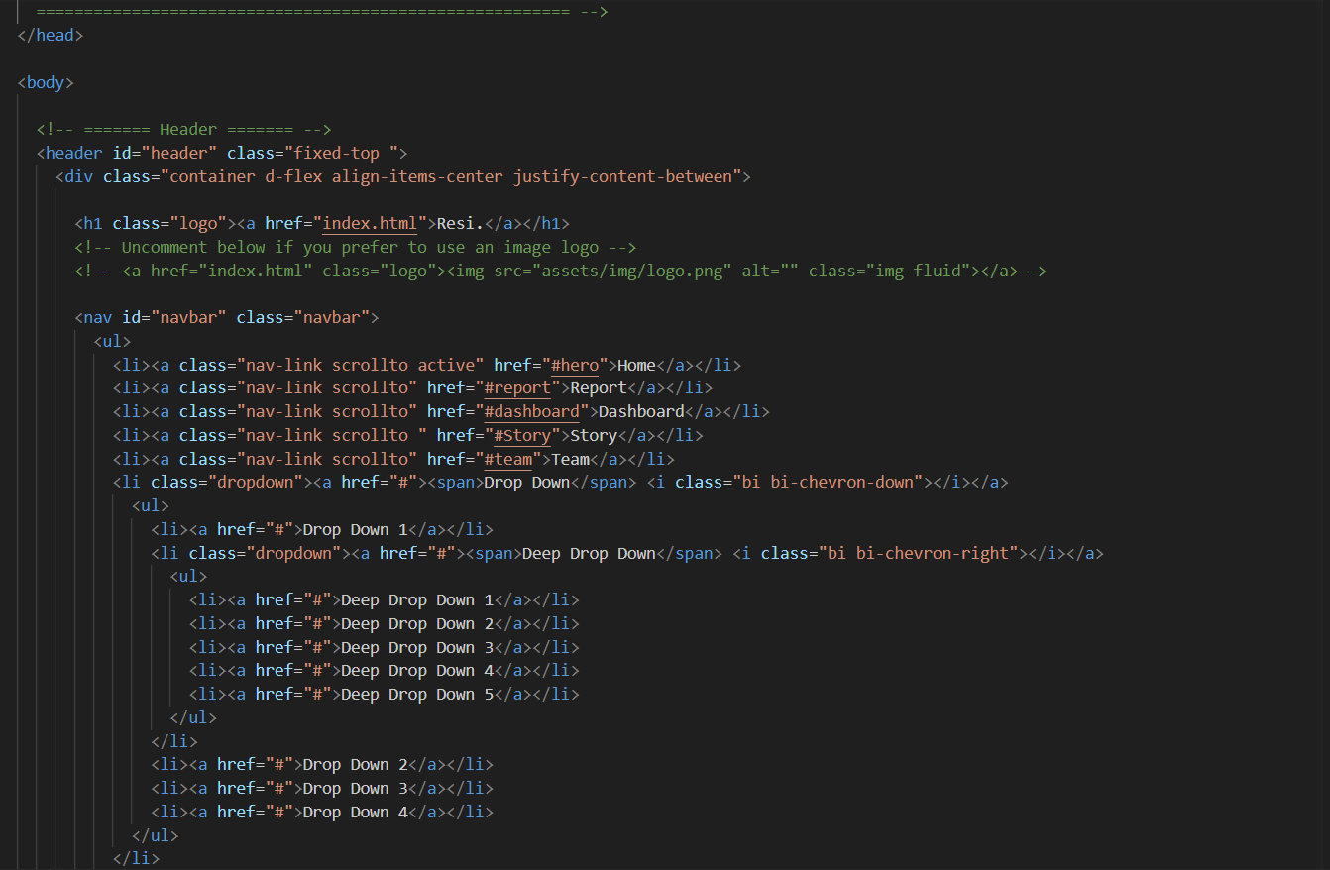

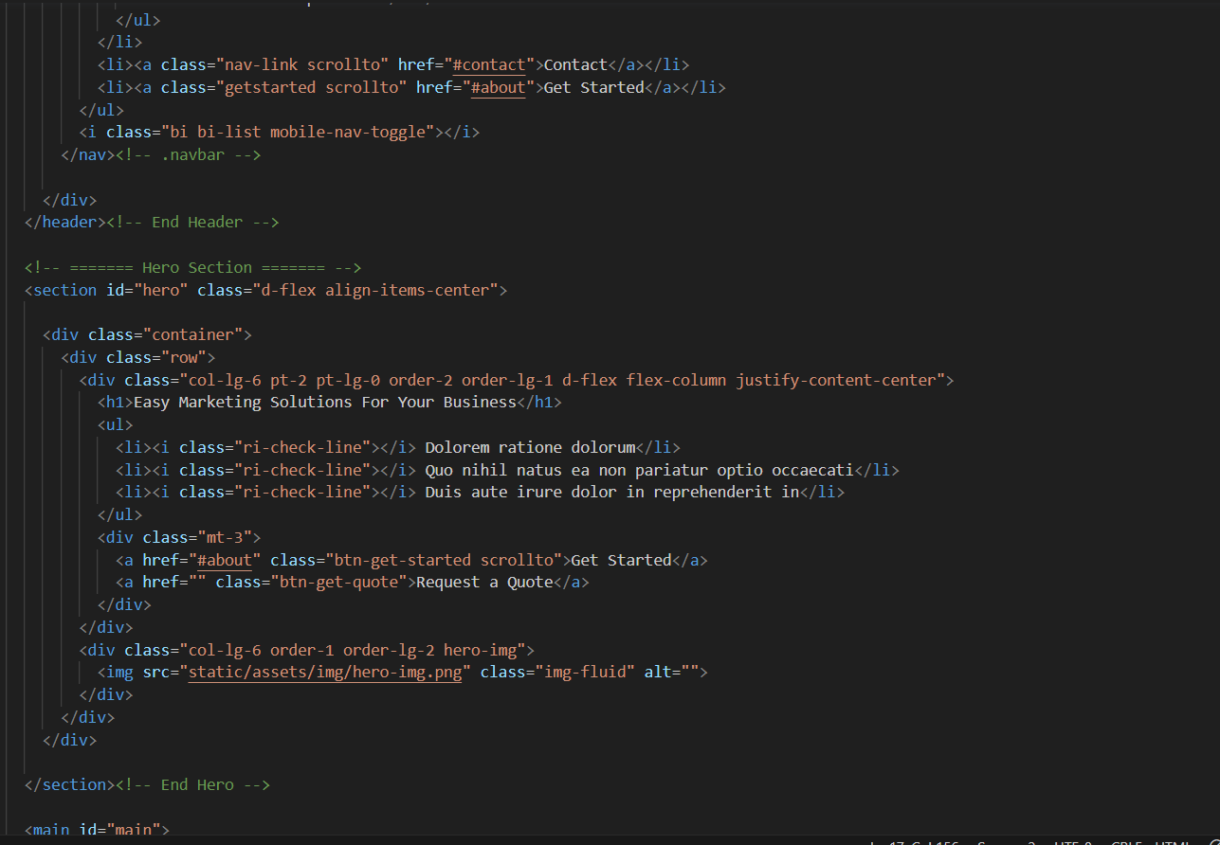

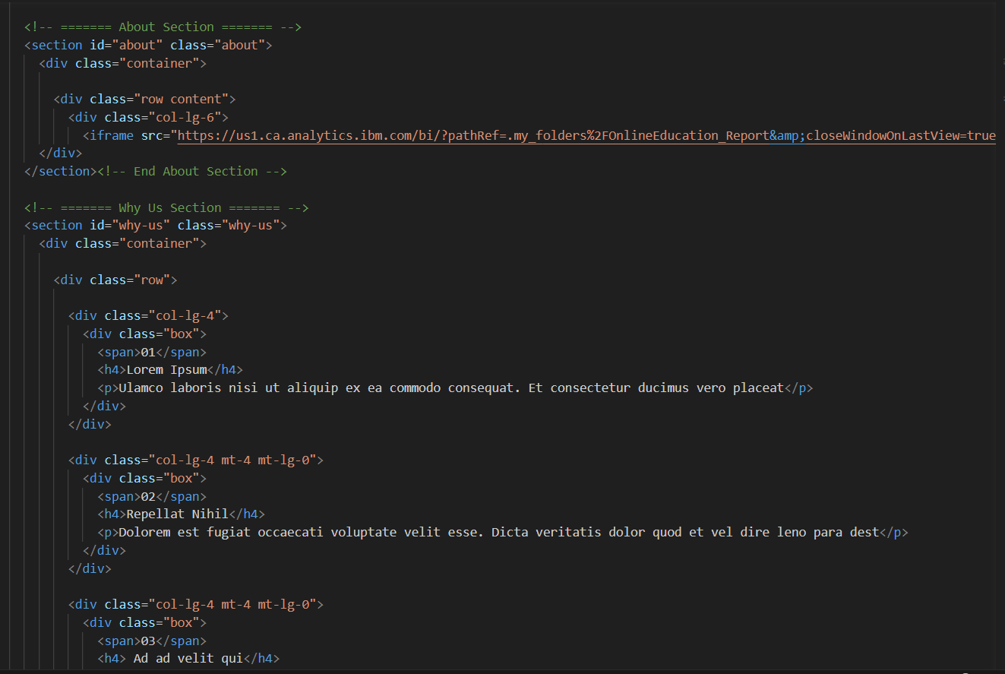

**App.py**

