# INTRODUCTION

* 1. **Overview**

The methodology of traditional learning has been greatly modified during the last couple of years. Online education enables the learners to study from anywhere in the world. Online classes and technology have emerged as a boon during the lockdown days. We have all been under house arrest but are still connected with the world of education. Due to the lockdown, students have not been able to stay connected with the outer world and the lack of exposure is evident. The only reprieve for the students’ mental well-being has been the transition to online classes. Teachers made sure that the learning for students was not compromised, so they took a great leap forward to find solutions and create new learning environments for their students to ensure that learning never stops. With the rapid advancements in technology and the widespread availability of internet access, online education has gained significant popularity in recent years.

* 1. **Purpose**

This project aims to analyze the various aspects of online education, examining its strengths, weaknesses, opportunities, and challenges. The outcomes of this project will provide valuable insights for educational institutions, policymakers, and online learning platforms to enhance the effectiveness and accessibility of online education. The analysis of the online education system performed in this project aims to contribute to the ongoing dialogue on the future of education and help shape a more inclusive, engaging, and effective learning environment in the digital age.

# LITERATURE SURVEY

* 1. **Existing problem**

Educational institutes across the world have closed due to the COVID-19 pandemic jeopardizing the academic calendars. Most educational institutes have shifted to online learning platforms to keep the academic activities going. However, the questions about the preparedness, designing and effectiveness of e-learning is still not clearly understood, particularly for a developing country like India, where the technical constraints like suitability of devices and bandwidth availability poses a serious challenge. The online learning was found to be advantageous as it provided flexibility and convenience for the learners. Students preferred well-structured content and also indicated the need for interactive sessions with quizzes and assignments at the end of each class to optimise the learning experience. However, most students also reported that online classes could be more challenging than traditional classroom because of the technological constraints, delayed feedback and inability of the instructor to handle effectively the Information and Communication Technologies. Therefore, all these factors should be considered while developing an online course to make it more effective and productive for the learner.

The usage and effectiveness of the Online Education System need to be analyzed thoroughly. Based on the analysis, the education system has to be enhanced to meet the requirements of the learners. The analysis will help the teachers to plan their teaching process effectively to match in par with the learners. The procedure to perform this analysis is tedious and the interpretation will also be difficult to perform.

* 1. **Proposed solution**

Data collection is the process of gathering and measuring information on variables of interest, in an established systematic fashion that enables one to answer stated research questions, test hypotheses, and evaluate outcomes and generate insights from the data.

|  |  |  |
| --- | --- | --- |
| **S.NO** | **PARAMETER** | **VARIABLES** |
|  | GENDER | MALE , FEMALE |
|  | HOME LOCATION | URBAN, RURAL |
|  | LEVEL OF EDUCATION | SCHOOL, UG, PG |
|  | AGE | Years |
|  | NUMBER OF SUBJECTS | 1-20 |
|  | DEVICE TYPE USED TO ATTEND CLASSES | DESKTOP, LAPTOP, MOBILE |
|  | ECONOMIC STATUS | MIDDLE CLASS, POOR  RICH |
|  | FAMILY SIZE | 2-10 |
|  | INTERNET FACILITY IN YOUR LOCALITY | 1-5 |
|  | ARE YOU INVOLVED IN ANY SPORTS? | YES , NO |
|  | DO ELDERLY PEOPLE MONITOR YOU? | YES ,NO |
|  | STUDY TIME (HOURS) | 1-10 |
|  | SLEEP TIME (HOURS) | 1-10 |
|  | TIME SPENT ON SOCIAL MEDIA (HOURS) | 1-10 |
|  | INTERESTED IN GAMING? | YES , NO |
|  | HAVE SEPARATE ROOM FOR STUDYING? | YES , NO |
|  | ENGAGED IN GROUP STUDIES? | YES , NO |
|  | AVERAGE MARKS SCORED BEFORE PANDEMIC IN TRADITIONAL CLASSROOM | 0-10 , 11-20, … 91-100 |
|  | YOUR INTERACTION IN ONLINE MODE | 1-5 |
|  | CLEARING DOUBTS WITH FACULTIES IN ONLINE MODE | 1-5 |
|  | INTERESTED IN? | PRACTICAL, THEORY  BOTH |
|  | PERFORMANCE IN ONLINE | 1-10 |
|  | YOUR LEVEL OF SATISFACTION IN ONLINE EDUCATION | AVERAGE, BAD , GOOD |

The data set involving the above-mentioned parameters are collected. The detailed analysis is performed using IBM Cognos Analytics. It is a web-based report authoring tool that professional report authors and developers use to build sophisticated, multiple-page, multiple-query reports against multiple databases.

IBM Cognos Business intelligence is a webbased reporting and analytic tool. It is used to perform data aggregation and create user friendly detailed reports. IBM Cognos provides a wide range of features and can be considered as an enterprise software to provide flexible reporting environment and can be used for large and medium enterprise. The reports generated using the IBM Cognos Analytics helps to provide an in -depth analysis of online education system.

# THEORITICAL ANALYSIS

* 1. **Block diagram**

The in-depth analysis of Online Education System includes the following stages,

**Data Collection** - The dataset involving the necessary parameters are collected and stored as a csv file. The collected dataset is connected with IBM Cognos

**Data Preparation** - Preparing the data for visualization involves cleaning the data to remove irrelevant or missing data, transforming the data into a format that can be easily visualized, exploring the data to identify patterns and trends, filtering the data to focus on specific subsets of data, preparing the data for visualization software, and ensuring the data is accurate and complete. This process helps to make the data easily understandable and ready for creating visualizations to gain insights into the performance and efficiency.

Data visualization is the process of creating graphical representations of data in order to help people understand and explore the information. The goal of data visualization is to make complex data sets more accessible, intuitive, and easier to interpret. By using visual elements such as charts, graphs, and maps, data visualizations can help people quickly identify patterns, trends, and outliers in the data.

**Data Visualizations -** The number of unique visualizations that can be created with a given dataset. Some common types of visualizations that can be used to analyze the online education data include bar charts, line charts, heat maps, scatter plots, pie charts, Maps etc. These visualizations can be used to compare performance, track changes over time, show distribution, and relationships between variables, breakdown of revenue and customer demographics, workload, resource allocation and location of hotels.

**Dashboard** - A dashboard is a graphical user interface (GUI) that displays information and data in an organized, easy-to-read format. Dashboards are often used to provide real-time monitoring and analysis of data, and are typically designed for a specific purpose or use case. Dashboards can be used in a variety of settings, such as business, finance, manufacturing, healthcare, and many other industries. They can be used to track key performance indicators (KPIs), monitor performance metrics, and display data in the form of charts, graphs, and tables.

The responsiveness and design of a dashboard for online education review data  is crucial to ensure that the information is easily understandable and actionable. Key considerations for designing a responsive and effective dashboard include user-centered design, clear and concise information, interactivity, data-driven approach, accessibility, customization, and security. The goal is to create a dashboard that is user-friendly, interactive, and data-driven.

**Story** - A data story is a way of presenting data and analysis in a narrative format, with the goal of making the information more engaging and easier to understand. A data story typically includes a clear introduction that sets the stage and explains the context for the data, a body that presents the data and analysis in a logical and systematic way, and a conclusion that summarizes the key findings and highlights their implications. Data stories can be told using a variety of mediums, such as reports, presentations, interactive visualizations, and videos.

The number of scenes in a storyboard for a data visualization analysis of the performance and efficiency of online education will depend on the complexity of the analysis and the specific insights that are trying to be conveyed. A storyboard is a visual representation of the data analysis process and it breaks down the analysis into a series of steps or scenes.

**Report** - A report is a document that presents information in a specific format and layout, usually based on data from a database or other data source. A report in IBM Cognos can contain various elements, such as tables, charts, graphs, and images, as well as text and data elements, and it is designed to be used by business users to help them better understand their data and make informed decisions.

There are several different types of reports available in IBM Cognos, including list reports, crosstab reports, chart reports, and report studio reports, among others. The type of report that you choose will depend on the specific needs and requirements of your organization, as well as the data that you need to present.

**Web Integration** - Publishing helps us to track and monitor key performance metrics, to communicate results and progress. help a publisher stay informed, make better decisions, and communicate their performance to others.

Dashboard , Reports and Story can be embedded with UI With Flask.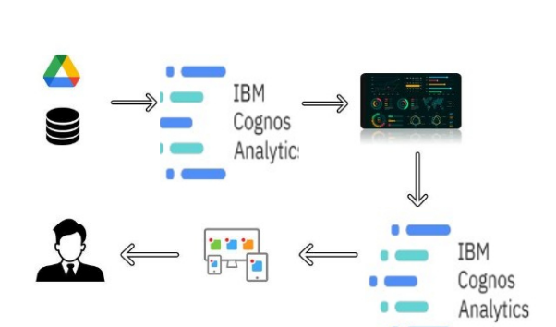

**Diagrammatic overview of the project**

* 1. **Hardware / Software designing**

Software requirements of the project – IBM Cognos Analytics , Visual Studio, Python IDE

# EXPERIMENTAL INVESTIGATIONS

* 1. **Data Collection**

Data collection is the process of gathering and measuring information on variables of interest, in an established systematic fashion that enables one to answer stated research questions, test hypotheses, and evaluate outcomes and generate insights from the data Analysis or the investigation made while working on the solution. The data related to the in-depth analysis of Online Education System is collected and stored in a file as ONLINE EDUCATION SYSTEM REVIEW.csv

* 1. **Data Preparation**

Preparing the data for visualization involves cleaning the data to remove irrelevant or missing data, transforming the data into a format that can be easily visualized, exploring the data to identify patterns and trends, filtering the data to focus on specific subsets of data, preparing the data for visualization software, and ensuring the data is accurate and complete. This process helps to make the data easily understandable and ready for creating visualizations to gain insights into the performance and efficiency.  
Data preprocessing is done by removing the redundant data and converting the parameters to the required format.

* 1. **Data Visualization**

Data visualization is the process of creating graphical representations of data in order to help people understand and explore the information. The goal of data visualization is to make complex data sets more accessible, intuitive, and easier to interpret. By using visual elements such as charts, graphs, and maps, data visualizations can help people quickly identify patterns, trends, and outliers in the data.

The number of unique visualizations that can be created with a given dataset. Some common types of visualizations that can be used to analyze the online education data include bar charts, line charts, heat maps, scatter plots, pie charts, Maps etc.

* 1. **Dashboard**

A dashboard is a graphical user interface (GUI) that displays information and data in an organized, easy-to-read format. Dashboards are often used to provide real-time monitoring and analysis of data, and are typically designed for a specific purpose or use case. Dashboards can be used in a variety of settings, such as business, finance, manufacturing, healthcare, and many other industries. They can be used to track key performance indicators (KPIs), monitor performance metrics, and display data in the form of charts, graphs, and tables.

Nearly 15 explorations are generated for this dashboard, involving word cloud, pie chart, column chart, stacked column, table, packed bubble, line chart etc.

* 1. **Story**

A data story is a way of presenting data and analysis in a narrative format, with the goal of making the information more engaging and easier to understand. A data story typically includes a clear introduction that sets the stage and explains the context for the data, a body that presents the data and analysis in a logical and systematic way, and a conclusion that summarizes the key findings and highlights their implications. Totally 4 scenes are created for the story.

* 1. **Report**

A report is a document that presents information in a specific format and layout, usually based on data from a database or other data source. A report in IBM Cognos can contain various elements, such as tables, charts, graphs, and images, as well as text and data elements, and it is designed to be used by business users to help them better understand their data and make informed decisions. There are several different types of reports available in IBM Cognos, including list reports, crosstab reports, chart reports, and report studio reports, among others. The type of report that you choose will depend on the specific needs and requirements of your organization, as well as the data that you need to present.

* 1. **Web Integration**

Publishing helps us to track and monitor key performance metrics, to communicate results and progress. help a publisher stay informed, make better decisions, and communicate their performance to others. The in-depth analysis of Online Education System is depicted in the web page and it helps us to view the reports easily.

# FLOWCHART

GENERATE DASHBOARD, REPORT, STORY

DATA PREPARATION

DATA VISUALIZATION

DATA COLLECTION

ONLINE EDUCATION SYSTEM REVIEW.CSV

WEB INTEGRATION

**Process flow for Online Education System Analysis**

# RESULT

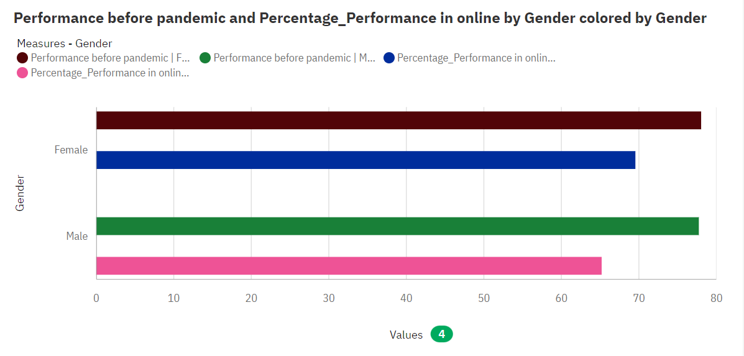

The average values of **Performance before pandemic**range from 77.73, occurring when **Gender** is Male, to 78.03, when **Gender** is Female. The average values of **Percentage_Performance in online**range from 65.2, occurring when **Gender** is Male, to 69.55, when **Gender** is Female.

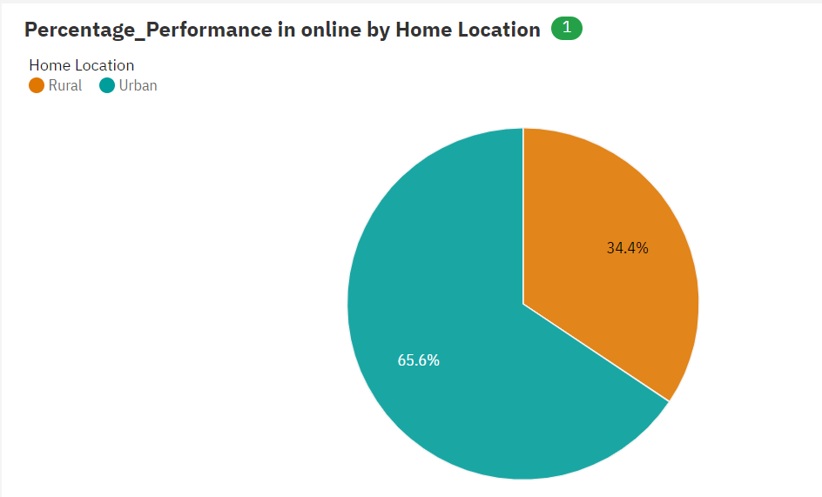

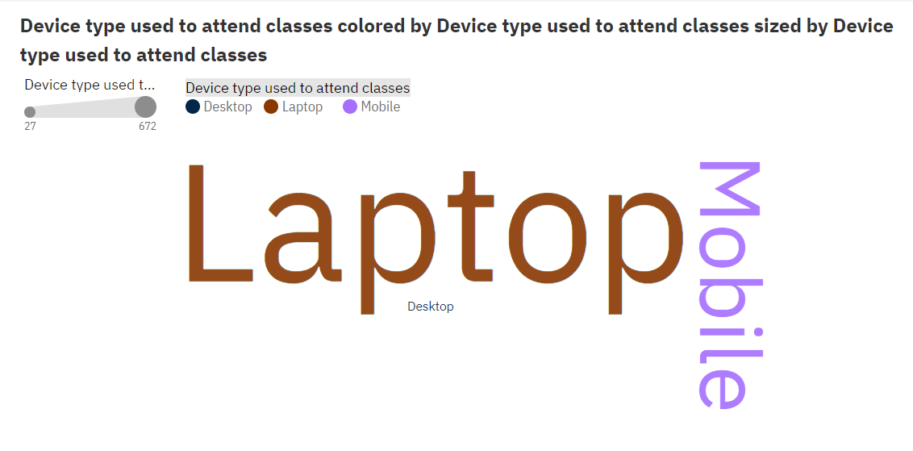Laptop is the most frequently occurring category of Device type used to attend classes with a count of 672 items with Device type used to attend classes values (65.1 % of the total).

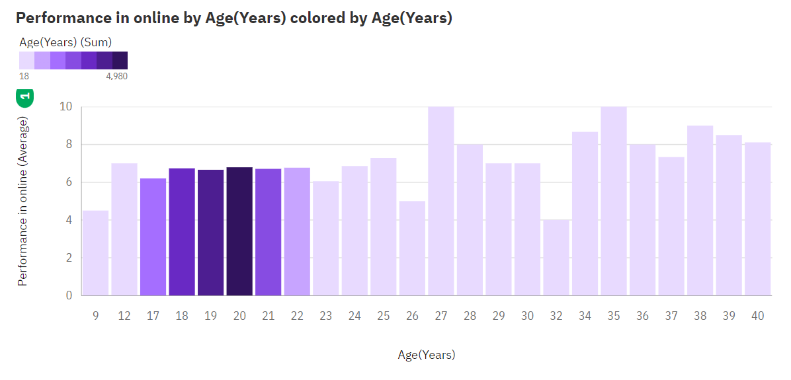

The average values of **Performance in online** range from 4, occurring when **Age(Years)** is 32, to 10, when **Age(Years)** is 27.

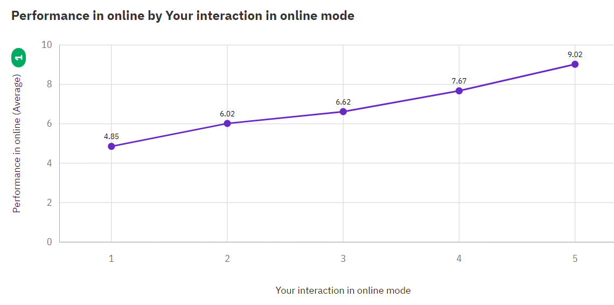

The average values of **Performance in online** range from 4.853, occurring when **Your interaction in online mode** is 1, to 9.022, when **Your interaction in online mode** is 5.

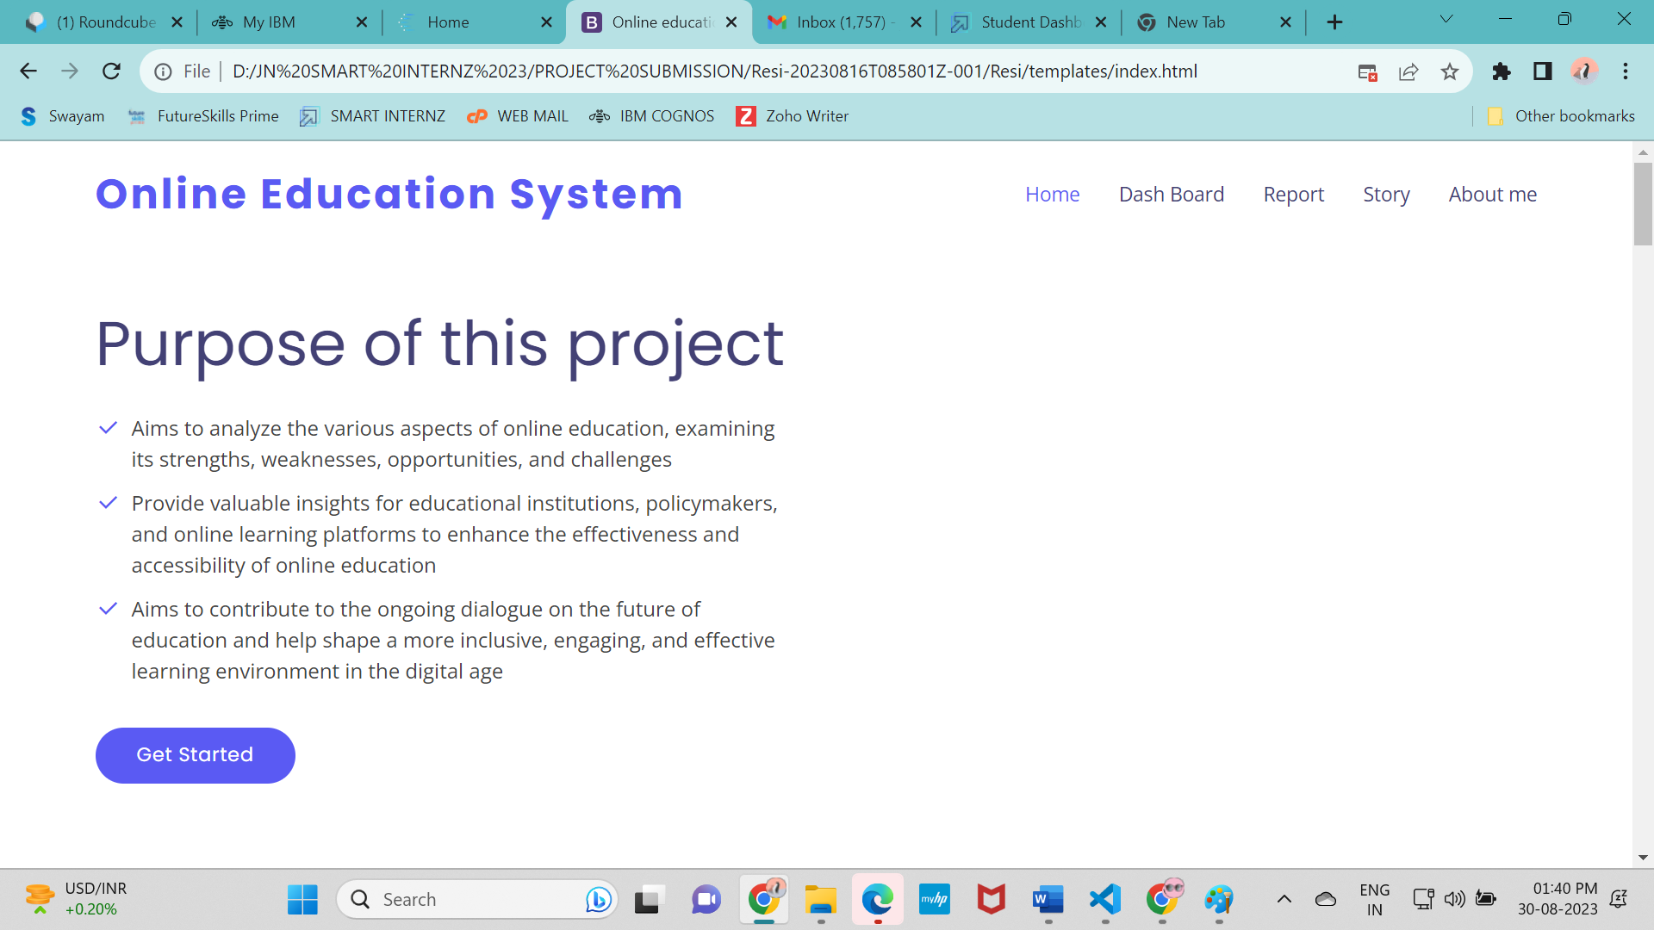

# ADVANTAGES & DISADVANTAGES

IBM Cognos is a business intelligence (BI) and performance management software suite developed by IBM. It is designed to enable organizations to access, analyze, and present their business data in a meaningful and effective manner. Cognos provides a range of tools and features to help users create reports, dashboards, and interactive visualizations that assist in decision-making and strategic planning.

It is a better tool for data analysis and visualization.

Its wide array of features can make it complex to set up and use, especially for users who are not familiar with business intelligence concepts. The learning curve can be steep for beginners.

# APPLICATIONS

Social Impact: Understanding the pros and cons of e-learning and making it better for future generations

Business Model/Impact: Ed-tech companies and other organizations can capitalize on this

# CONCLUSION

The data visualizations created using IBM Cognos Analytics provide an in-depth analysis of Online Education System and helps the educationists, teachers and the service providing community to plan their teaching methodology according to the needs of the learners. The learners from Urban background performs well and the device mostly used is Laptop. In addition, the under graduate female students perform well in online.

# FUTURE SCOPE

The data collection can be improved by collecting data from learners in different zones. Then, additional parameters such as e-learning materials usage can be included to enhance the analysis effectively.

# BIBILOGRAPHY

# <https://us1.ca.analytics.ibm.com/>

# [www.researchgate.net](http://www.researchgate.net)

# [www.ieee.org](http://www.ieee.org)

# APPENDIX

A. Source Code

<!DOCTYPE html>

<html lang="en">

<head>

  <meta charset="utf-8">

  <meta content="width=device-width, initial-scale=1.0" name="viewport">

  <title>Online education system analysis</title>

  <meta content="" name="description">

  <meta content="" name="keywords">

  <!-- Favicons -->

  <link href="D:/JN SMART INTERNZ 23/PROJECT SUBMISSION/Resi-20230816T085801Z-001/Resi/static/assets/img/favicon.png" rel="icon">

  <link href="D:/JN SMART INTERNZ 23/PROJECT SUBMISSION/Resi-20230816T085801Z-001/Resi/static/assets/img/apple-touch-icon.png" rel="apple-touch-icon">

  <!-- Google Fonts -->

  <link href="https://fonts.googleapis.com/css?family=Open+Sans:300,300i,400,400i,600,600i,700,700i|Raleway:300,300i,400,400i,500,500i,600,600i,700,700i|Poppins:300,300i,400,400i,500,500i,600,600i,700,700i" rel="stylesheet">

  <!-- Vendor CSS Files -->

  <link href="D:/JN SMART INTERNZ 23/PROJECT SUBMISSION/Resi-20230816T085801Z-001/Resi/static/assets/vendor/bootstrap/css/bootstrap.min.css" rel="stylesheet">

  <link href="D:/JN SMART INTERNZ 23/PROJECT SUBMISSION/Resi-20230816T085801Z-001/Resi/static/assets/vendor/bootstrap-icons/bootstrap-icons.css" rel="stylesheet">

  <link href="D:/JN SMART INTERNZ 23/PROJECT SUBMISSION/Resi-20230816T085801Z-001/Resi/static/assets/vendor/boxicons/css/boxicons.min.css" rel="stylesheet">

  <link href="D:/JN SMART INTERNZ 23/PROJECT SUBMISSION/Resi-20230816T085801Z-001/Resi/static/assets/vendor/glightbox/css/glightbox.min.css" rel="stylesheet">

  <link href="D:/JN SMART INTERNZ 23/PROJECT SUBMISSION/Resi-20230816T085801Z-001/Resi/static/assets/vendor/remixicon/remixicon.css" rel="stylesheet">

  <link href="D:/JN SMART INTERNZ 23/PROJECT SUBMISSION/Resi-20230816T085801Z-001/Resi/static/assets/vendor/swiper/swiper-bundle.min.css" rel="stylesheet">

  <!-- Template Main CSS File -->

  <link href="D:/JN SMART INTERNZ 23/PROJECT SUBMISSION/Resi-20230816T085801Z-001/Resi/static/assets/css/style.css" rel="stylesheet">

</head>

<body>

  <!-- ======= Header ======= -->

  <header id="header" class="fixed-top ">

    <div class="container d-flex align-items-center justify-content-between">

      <h1 class="logo"><a href="index.html">Online Education System</a></h1>

      <!-- Uncomment below if you prefer to use an image logo -->

      <!-- <a href="index.html" class="logo"><img src="assets/img/logo.png" alt="" class="img-fluid"></a>-->

      <nav id="navbar" class="navbar">

        <ul>

          <li><a class="nav-link scrollto active" href="#hero">Home</a></li>

          <li><a class="nav-link scrollto" href="#about">Dash Board</a></li>

          <li><a class="nav-link scrollto" href="#services">Report</a></li>

          <li><a class="nav-link scrollto " href="#portfolio">Story</a></li>

          <li><a class="nav-link scrollto" href="#contact">About me</a></li>

        </ul>

        <i class="bi bi-list mobile-nav-toggle"></i>

      </nav><!-- .navbar -->

    </div>

  </header><!-- End Header -->

  <!-- ======= Hero Section ======= -->

  <section id="hero" class="d-flex align-items-center">

    <div class="container">

      <div class="row">

        <div class="col-lg-6 pt-2 pt-lg-0 order-2 order-lg-1 d-flex flex-column justify-content-center">

          <h1>Purpose of this project</h1>

          <ul>

            <li><i class="ri-check-line"></i>Aims to analyze the various aspects of online education, examining its strengths, weaknesses, opportunities, and challenges</li>

            <li><i class="ri-check-line"></i>Provide valuable insights for educational institutions, policymakers, and online learning platforms to enhance the effectiveness and accessibility of online education</li>

            <li><i class="ri-check-line"></i>Aims to contribute to the ongoing dialogue on the future of education and help shape a more inclusive, engaging, and effective learning environment in the digital age</li>

          </ul>

          <div class="mt-3">

            <a href="#about" class="btn-get-started scrollto">Get Started</a>

          </div>

        </div>

        <div class="col-lg-6 order-1 order-lg-2 hero-img">

          <img src="static/assets/img/hero-img.png" class="img-fluid" alt="">

        </div>

      </div>

    </div>

  </section><!-- End Hero -->

  <main id="main">

    <!-- ======= About Section ======= -->

    <section id="about" class="about">

      <div class="container">

        <iframe src="https://us1.ca.analytics.ibm.com/bi/?perspective=dashboard&amp;pathRef=.my_folders%2FJN%2BPROJECT%2Bdashboard&amp;closeWindowOnLastView=true&amp;ui_appbar=false&amp;ui_navbar=false&amp;shareMode=embedded&amp;action=view&amp;mode=dashboard&amp;subView=model0000018a271dbae5_00000002" width="1100" height="1000" frameborder="0" gesture="media" allow="encrypted-media" allowfullscreen=""></iframe>

      </div>

    </section><!-- End About Section -->

       <hr>

    <!-- ======= Services Section ======= -->

    <section id="services" class="services">

      <div class="container">

        <iframe

    <!-- ======= Portfolio Section ======= -->

    <section id="portfolio" class="portfolio">

      <div class="container">

        <iframe src="https://us1.ca.analytics.ibm.com/bi/?perspective=story&amp;pathRef=.my_folders%2FJN%2BPROJECT%2Bstory&amp;closeWindowOnLastView=true&amp;ui_appbar=false&amp;ui_navbar=false&amp;shareMode=embedded&amp;action=view&amp;sceneId=model0000018a3a866f42_00000000&amp;sceneTime=0" width="1100" height="1000" frameborder="0" gesture="media" allow="encrypted-media" allowfullscreen=""></iframe>

    <!-- ======= Contact Section ======= -->

    <section id="contact" class="contact section-bg">

      <div class="container">

        <div class="section-title">

          <h2>Contact</h2>

          <p>Nithya Jayakumar         an           Enthusiastic learner</p>

        </div>

        <div class="row">

          <div class="col-lg-6">

            <div class="row">

              <div class="col-md-12">

                <div class="info-box">

                  <i class="bx bx-map"></i>

                  <h3>Designation</h3>

                  <p>Professor @ KS Rangasamy College Of Technology , TamilNadu</p>

                </div>

              </div>

              <div class="col-md-6">

                <div class="info-box mt-4">

                  <i class="bx bx-envelope"></i>

                  <h3>Email Us</h3>

                  <p>jknithya@gmail.com</p>

                </div>

              </div>

            </div>

          </div>

        </div>

      </div>

    </section><!-- End Contact Section -->

</html>

**Prepared and Submitted by**

**Nithya Jayakumar**

**Professor, K.S.Rangasamy College of Technology, TamilNadu**

**jknithya@gmail.com**