**DIFFERENT TYPES OF VISUALIZATIONS**

BAR CHART

LINK: <https://us1.ca.analytics.ibm.com/bi/?perspective=explore&pathRef=.my_folders%2Fpie>

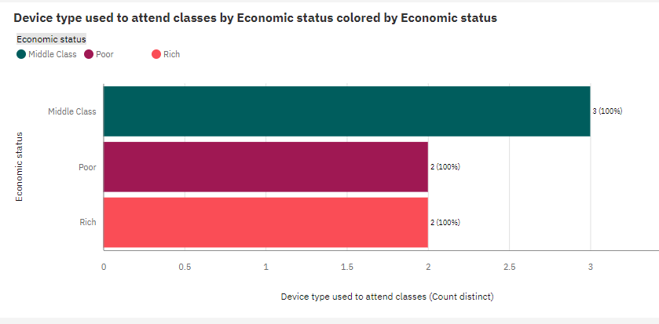

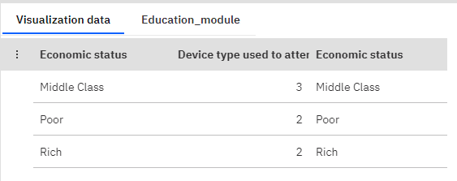

RADIAL PLOT

LINK:

<https://us1.ca.analytics.ibm.com/bi/?perspective=explore&pathRef=.my_folders%2Fpie&subView=model00000189f2601ea4_00000000>

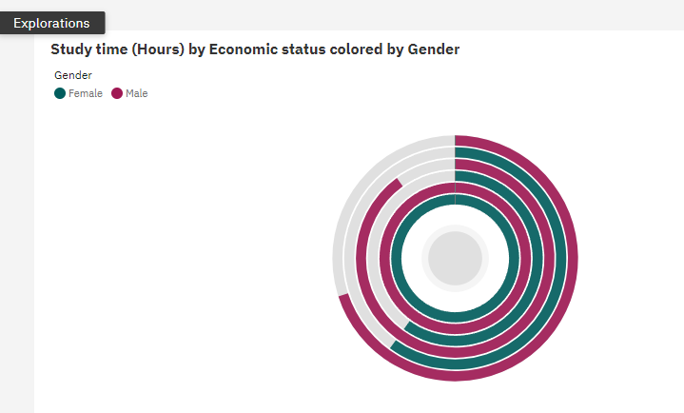

PIE CHART

LINK:

<https://us1.ca.analytics.ibm.com/bi/?perspective=explore&pathRef=.my_folders%2Fpie&subView=model00000189f27a348b_00000004>

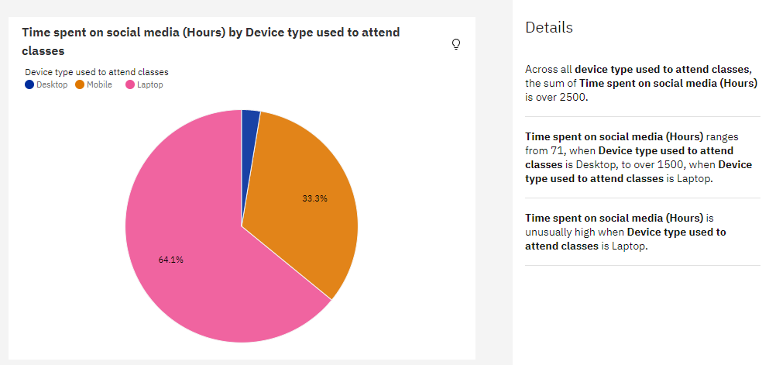

RELATION CHART

LINK:

<https://us1.ca.analytics.ibm.com/bi/?perspective=explore&pathRef=.my_folders%2Fpie&subView=model00000189f26fad6e_00000002>

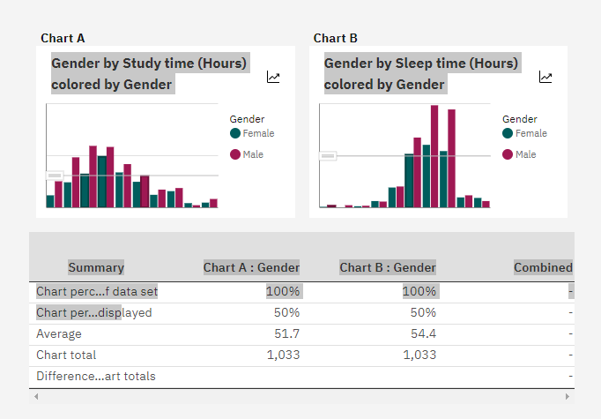

TABLE

LINK

https://us1.ca.analytics.ibm.com/bi/?perspective=explore&pathRef=.my_folders%2Fpie&subView=model00000189f4d0186d_00000005

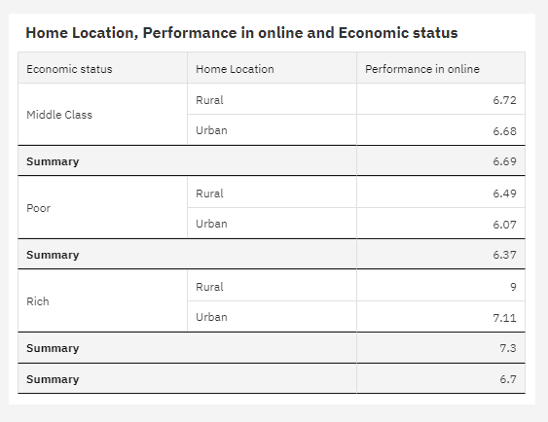

PACKED BUBBLE

LINK:

<https://us1.ca.analytics.ibm.com/bi/?perspective=explore&pathRef=.my_folders%2Ftable&subView=model00000189f27ea064_00000003>

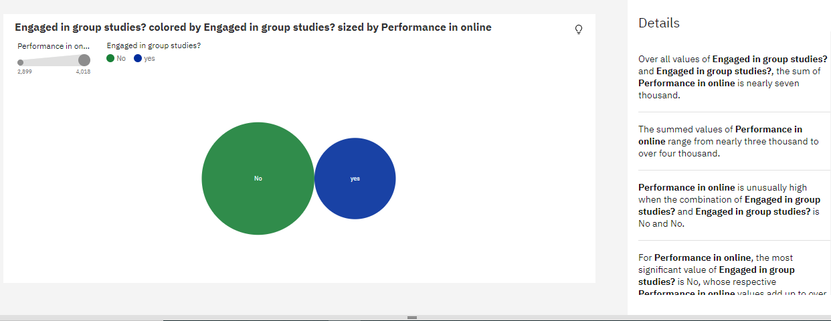

WORDCOUNT

LINK:

<https://us1.ca.analytics.ibm.com/bi/?perspective=explore&pathRef=.my_folders%2Ftable&subView=model00000189f280d80d_00000004>

