**No of Visualizations/ Graphs**

* **Column Chart: Age(Years) by Your level of satisfaction in Online Education**

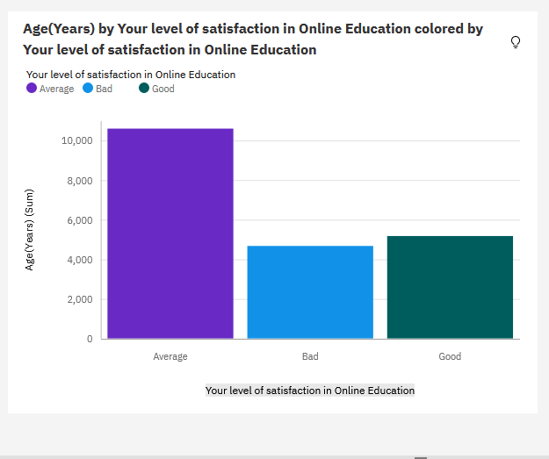

* Bar Chart: Internet facility in your locality by Your level of satisfaction in Online Education

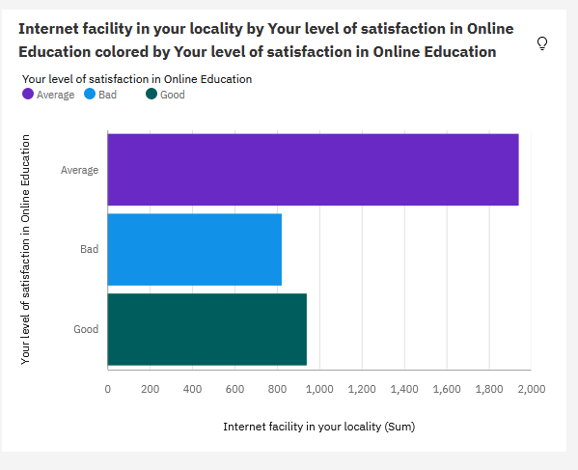

* Bar chart: Performance in online by Level of Education

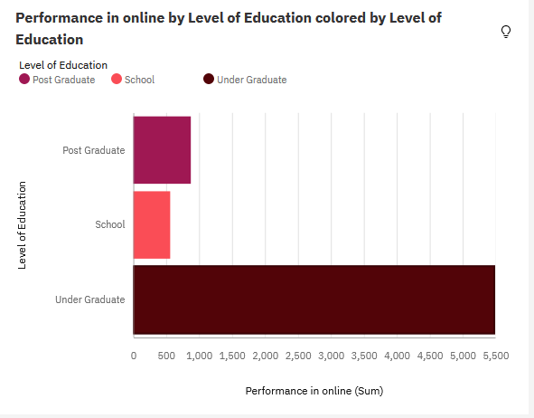

* Pie Chart: Time spent on social media (Hours) by Device type used to attend classes

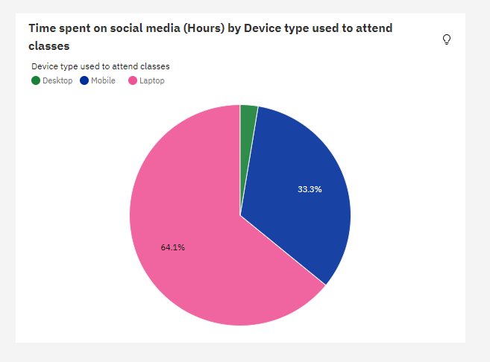

* Packed bubbles : Engaged in group studies? colored by Engaged in group studies? sized by Performance in online

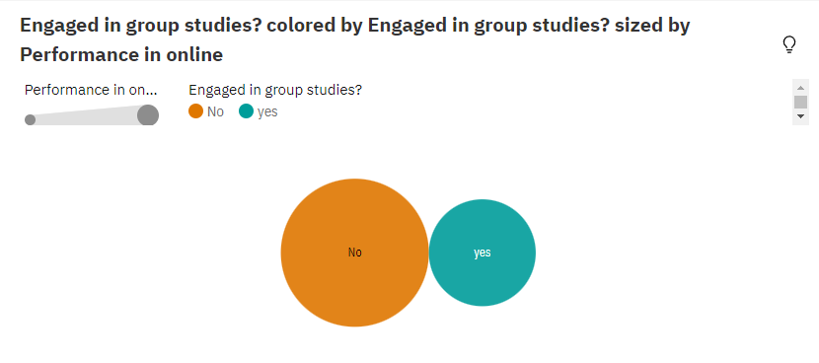

* Wordcloud: Average marks scored before pandemic in traditional classroom

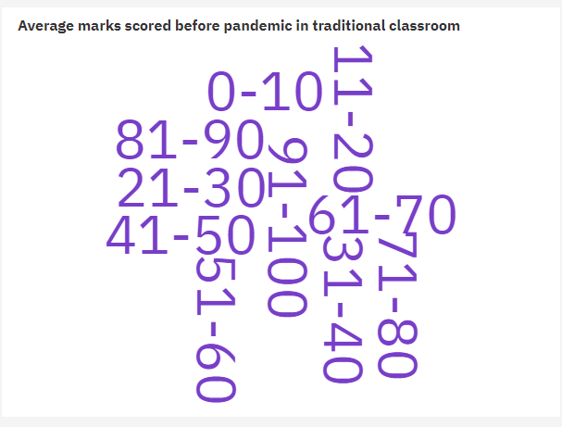

* Table: Economic status, Home Location and Performance in online

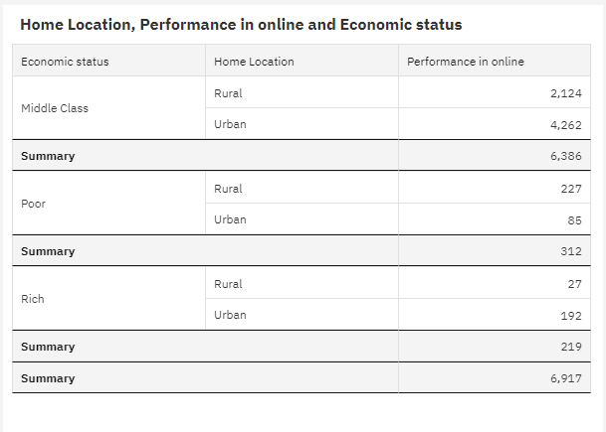

* Radial Chart:

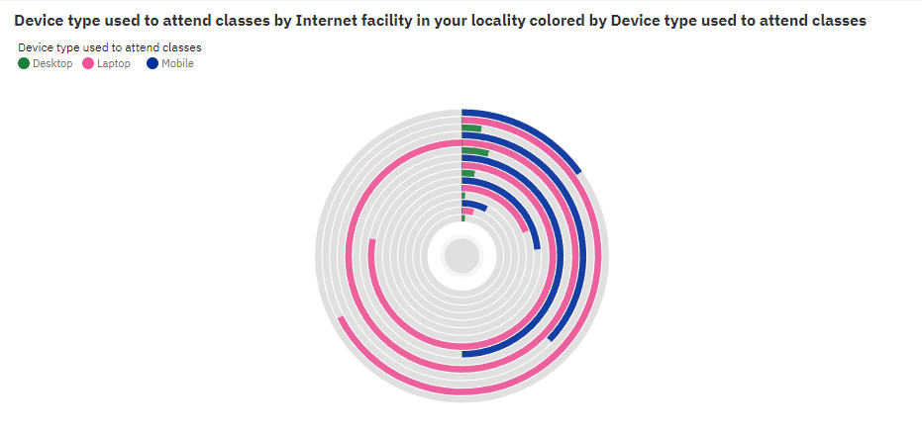

* Line Chart: Performance in online by study time(hours)

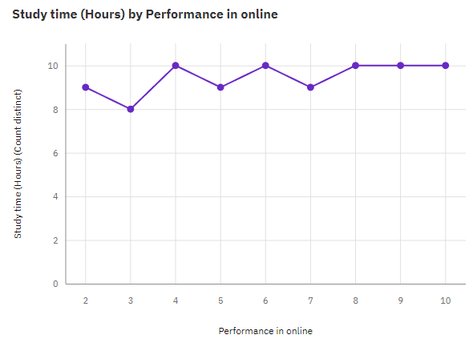

* Line Chart: Performance in online by sleep time(hours)

