**CALCULATION FIELDS**

1. **Calculating the maximum age of people who are learning through online education:**

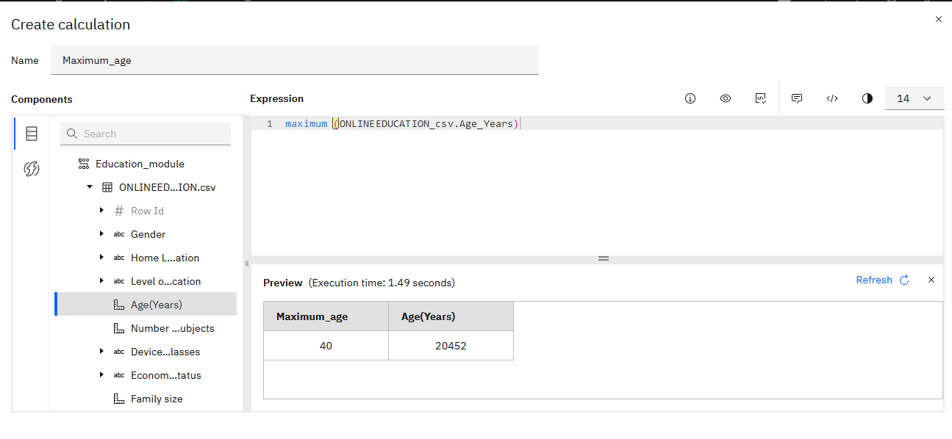

1. **Calculating the number of person interested in gaming:-**

