QRadar Community edition

Installation Steps and Screen shot

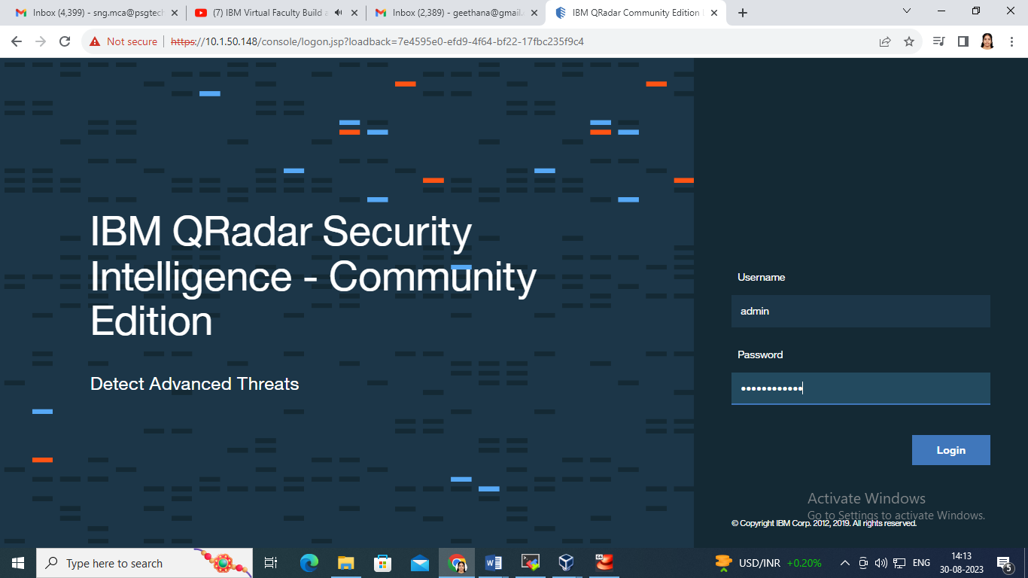

After providing credentials, the Qradar will move to License Agreement

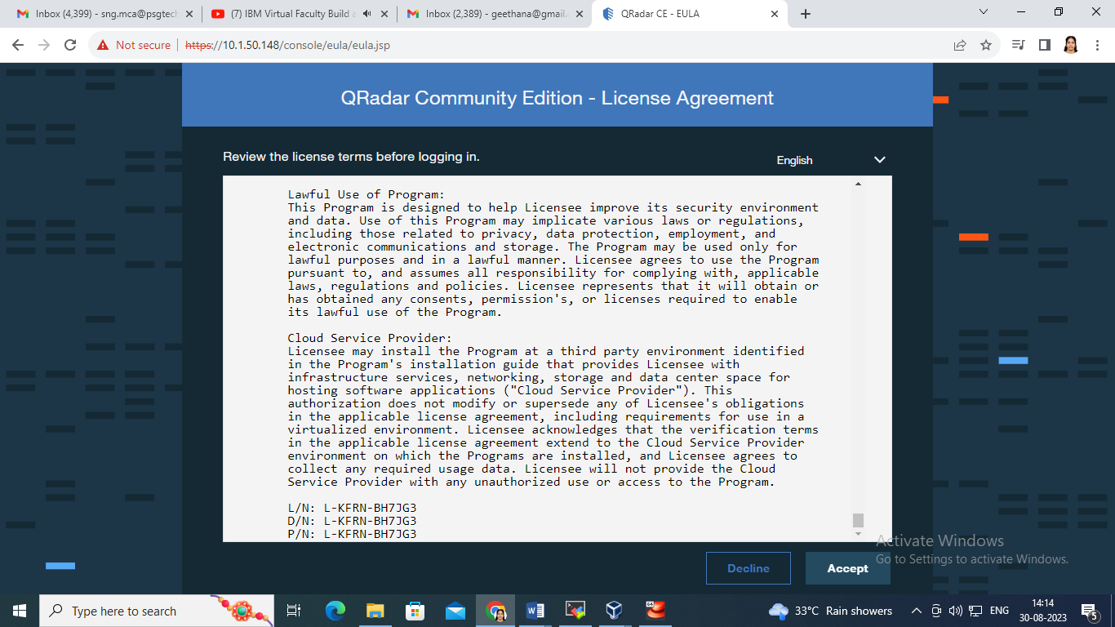

Once we click the Accept button, Dashboard will appear as shown below. This helps to view all log activity and reports

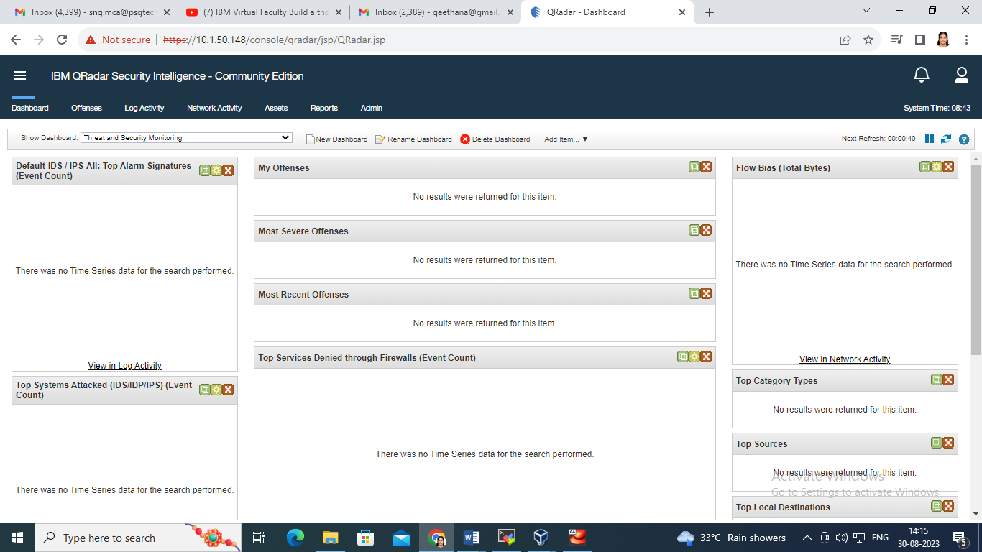

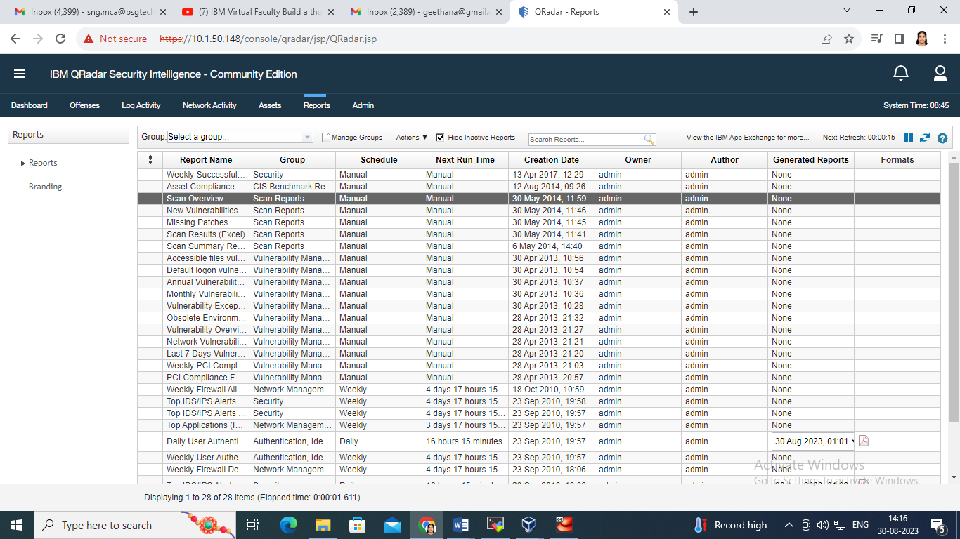

Log Activity

