PLUGGING INTO THE FUTURE -

***AN EXPLORATORY OF THE ELECTRICITY***

***CONSUMPTION***

# Milestone 1 : Defining the Problem /Problem Understanding

**Activity 1: Introduction:**

Plugging Into the Future – An Exploration of Electricity Consumption Patterns. This is exploratory data analytics project in which we have find any patterns or insights from the data. To perform exploratory data analytics, we use Tableau.

In an era marked by technological advancement and environmental concerns, the exploration of electricity consumption has gained paramount significance. Leveraging the power of the Tableau visualization tool, this study aims to delve into the intricate landscape of electricity consumption.

Using Tableau's visualization capabilities, this section will present a historical journey of electricity consumption. Line charts and time series visualizations will illustrate how consumption patterns have evolved over decades, offering insights into the key factors driving these changes.

Through Tableau's interactive maps and graphs, we will explore regional electricity usage trends. This section will allow users to filter and compare electricity consumption across different regions, highlighting variations influenced by factors such as population density, economic activity, and climate.

**Technical architecture:**

**Tableau Workflow:**

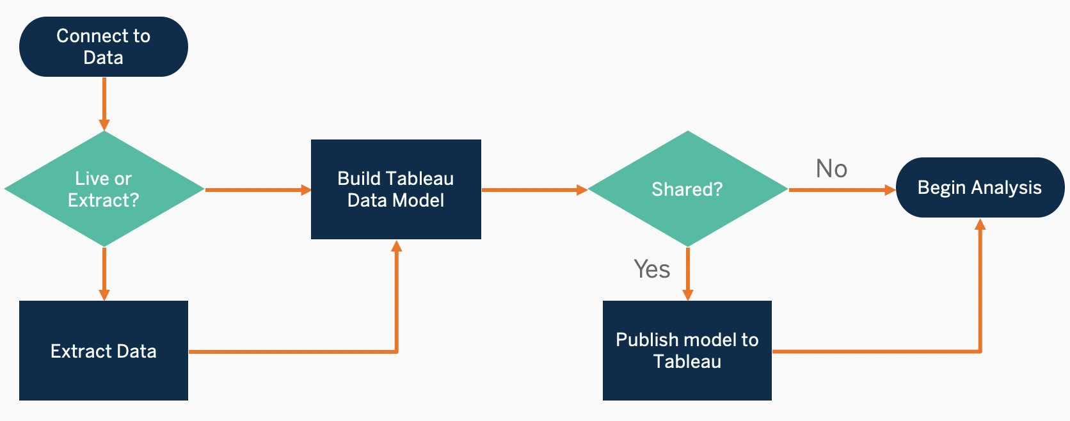

**Activity 2: Business Requirements:**

The project aims to identify the key drivers of electricity consumption in different sectors, develop a model to predict electricity consumption, identify opportunities for energy efficiency, and develop a communication plan to educate consumers about energy efficiency.

To identify the key drivers of electricity consumption, the project will collect data on electricity consumption from a variety of sources, such as smart meters, surveys, and weather data. The data will then be analyzed to identify the factors that are most correlated with electricity consumption.

To develop a model to predict electricity consumption, the project will use a variety of statistical techniques, such as regression analysis and machine learning. The model will be used to predict electricity consumption for different scenarios, such as changes in the climate or the adoption of new technologies.

To identify opportunities for energy efficiency, the project will analyze the data on electricity consumption to identify appliances and other equipment that are inefficient. The project will also identify policies and programs that could help to promote energy efficiency, such as rebates for energy-efficient appliances and tax breaks for renewable energy projects.

**Milestone 2 : Data Collection:**

**Activity 1: Data Collection.**

* I have collected this dataset from Kaggle Website.

**LINK:** https://www.kaggle.com/code/twinkle0705/aninteractive-eda-of-electricity-consumption

## Activity 2: Understanding the Data

## Here is the clear explanation video on the dataset <https://drive.google.com/file/d/1m1PVxYDWFVuOnwktZvpphUdDb1eq6ZLV/view?usp=sharing>

# MILESTONE 3: Data Visualization

## Activity 1: No of Unique Visualization

**Activity 1.1: From The given dataset (Electricity Consumption), How can we analyse only 2019 Electricity consumption?**

**<https://drive.google.com/file/d/14RdiwtpiS2EtODVx5mC8mFVAHdaXTHiD/view?usp=sharing>**

**Activity 1.2: From The given dataset (Electricity Consumption), How can we analyse only 2020 Electricity consumption?**

[**https://drive.google.com/file/d/187HE9gZ7zA0EXrAZQQ6AE0eYsg06rpxD/view?usp=sharing**](https://drive.google.com/file/d/187HE9gZ7zA0EXrAZQQ6AE0eYsg06rpxD/view?usp=sharing)

**Activity 1.3: How to find the total energy consumption using a Bar Chart?**

[**https://drive.google.com/file/d/15aZ5UjNSIShIPuSun37dtb5uGXsc_EU_/view?usp=sharing**](https://drive.google.com/file/d/15aZ5UjNSIShIPuSun37dtb5uGXsc_EU_/view?usp=sharing)

**Activity 1.4: What are all the Top 5 consumers of electricity(in states)?** [**https://drive.google.com/file/d/1w2YA203Jyor9pRG5NKeilGyg2qF8BaHB/view?usp=sharing**](https://drive.google.com/file/d/1w2YA203Jyor9pRG5NKeilGyg2qF8BaHB/view?usp=sharing)

**Activity 1.5: What are all the Bottom 5 consumers of electricity (in states)?**

[**https://drive.google.com/file/d/11fYQVp3chgUqJTiY01TKHDE-gXELhVtI/view?usp=sharing**](https://drive.google.com/file/d/11fYQVp3chgUqJTiY01TKHDE-gXELhVtI/view?usp=sharing)

**Activity 1.6: Can we compare the usage of electricity Before and After the Lockdown?**

[**https://drive.google.com/file/d/118U59KzsRiBA3gVH6zKrPsHR3PB9AUro/view?usp=sharing**](https://drive.google.com/file/d/118U59KzsRiBA3gVH6zKrPsHR3PB9AUro/view?usp=sharing)

**Activity 1.7: Do certain locations exhibit different consumption patterns?**

**<https://drive.google.com/file/d/1iYpIuK1VfBLjFaIqYtLlA9lSWJy_X1rr/view?usp=sharing>**

**Activity 1.8: Are there any noticeable spikes or drops in consumption that correlate with external factors (e.g., holidays, weather changes)?**

[**https://drive.google.com/file/d/1C9phcwyCZJmyugSnJMrreaJvqGjjODfn/view?usp=sharing**](https://drive.google.com/file/d/1C9phcwyCZJmyugSnJMrreaJvqGjjODfn/view?usp=sharing)

**Activity 1.9: How much electricity consumption in metro cities?**

[**https://drive.google.com/file/d/1S8Dmly4J39xzB8iusNbsCnIWA8jTznxE/view?usp=sharing**](https://drive.google.com/file/d/1S8Dmly4J39xzB8iusNbsCnIWA8jTznxE/view?usp=sharing)

**Activity 1.10: How much daily electricity has been consumed all over India?**

[**https://drive.google.com/file/d/1yEeI8lg_CvNLpjItRWB4V6ysuZjMmdtY/view?usp=sharing**](https://drive.google.com/file/d/1yEeI8lg_CvNLpjItRWB4V6ysuZjMmdtY/view?usp=sharing)

# Milestone 3: Story in Tableau

In Tableau, a story is a sequence of visualizations that work together to convey information. You can create stories to tell a data narrative, provide context, demonstrate how decisions relate to outcomes, or to simply make a compelling case.

A story is a sheet, so the methods you use to create, name, and manage worksheets and dashboards also apply to stories (for more details, see Workbooks and Sheets). At the same time, a story is also a collection of sheets, arranged in a sequence. Each individual sheet in a story is called a story point.

**Tableau Story Link:** <https://public.tableau.com/app/profile/ragavaa.m/viz/IBMProject_16893860193820/StoriesOfElectricityConsumption2019-2020?publish=yes>

**1.Story of the electricity consumption in 2019:**

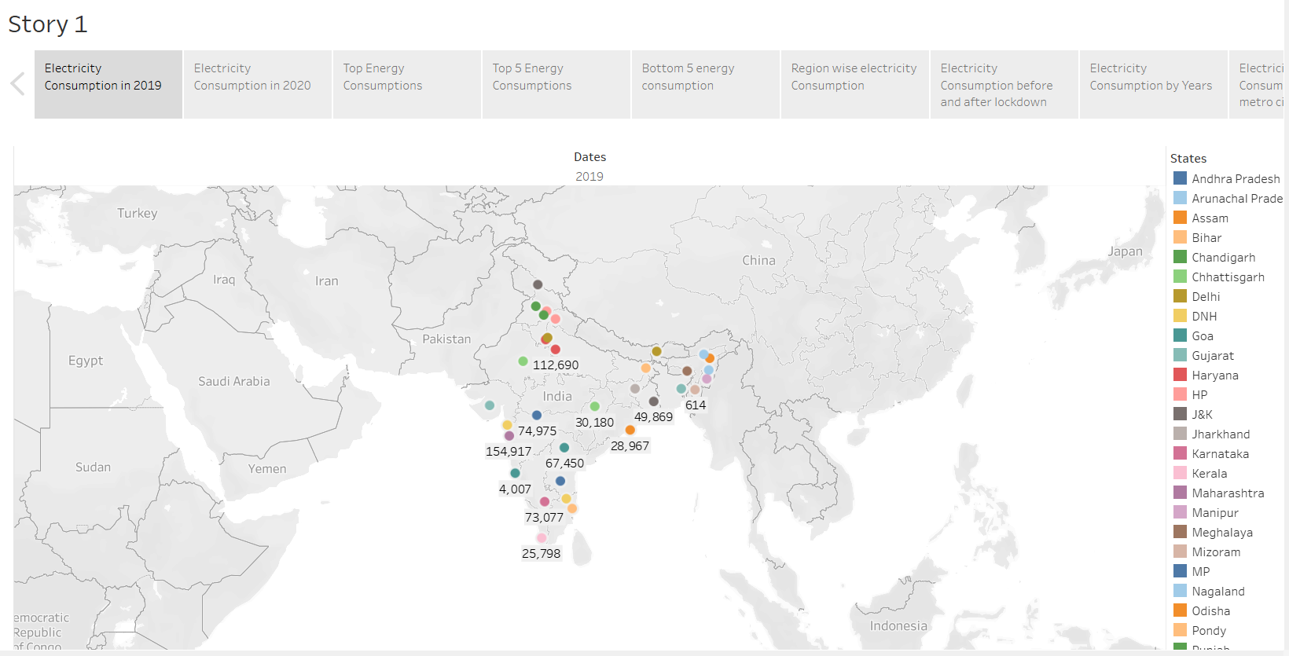

[**https://drive.google.com/file/d/14RdiwtpiS2EtODVx5mC8mFVAHdaXTHiD/view?usp=sharing**](https://drive.google.com/file/d/14RdiwtpiS2EtODVx5mC8mFVAHdaXTHiD/view?usp=sharing)

**2.Story of the Electricity Consumption in 2020:**

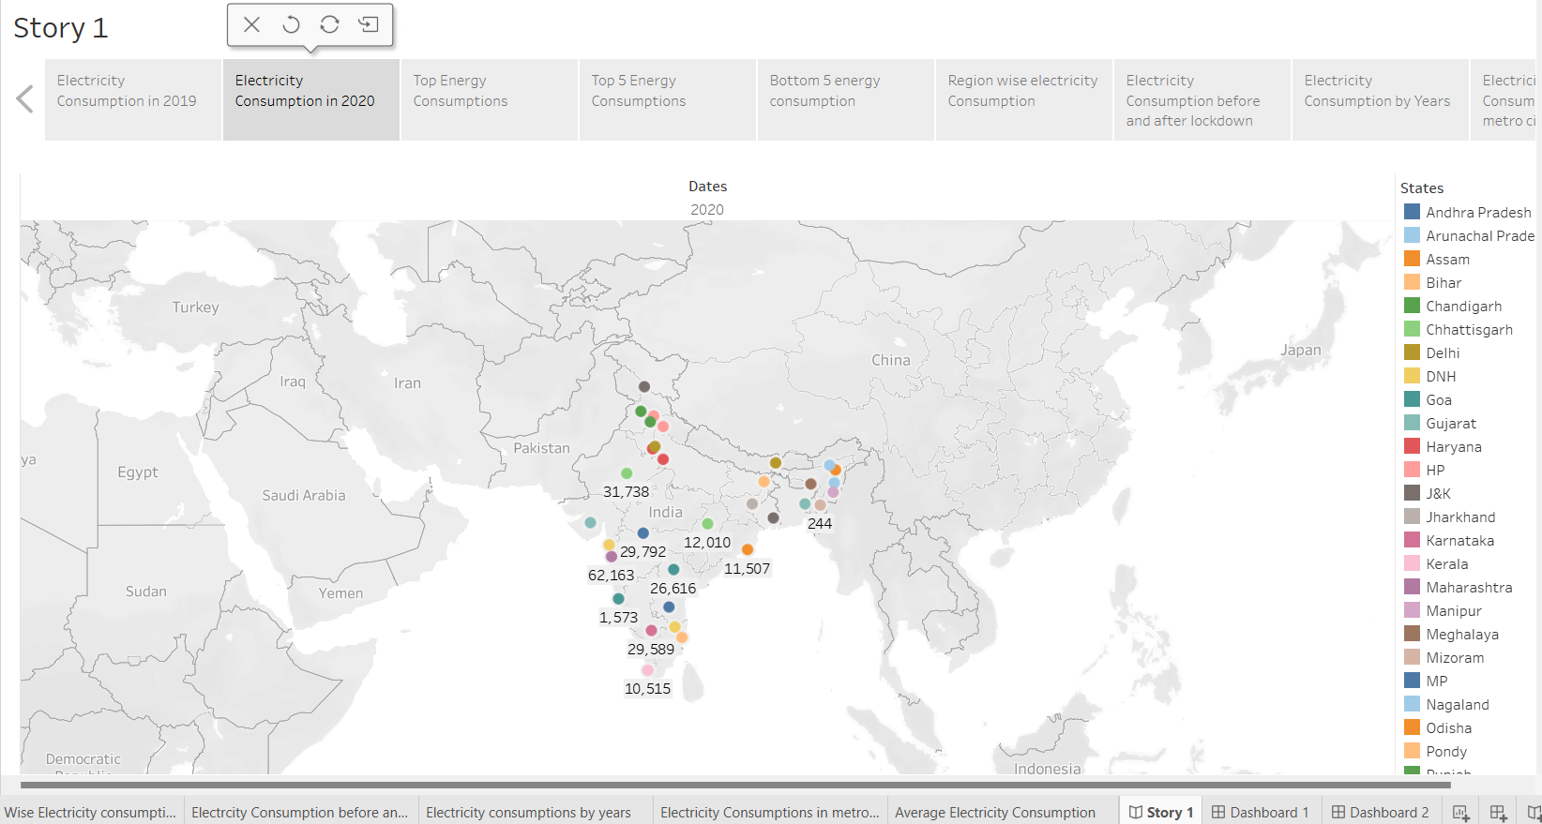

[**https://drive.google.com/file/d/187HE9gZ7zA0EXrAZQQ6AE0eYsg06rpxD/view?usp=sharing**](https://drive.google.com/file/d/187HE9gZ7zA0EXrAZQQ6AE0eYsg06rpxD/view?usp=sharing)

**3.Story of the Energy Consumption by States.**

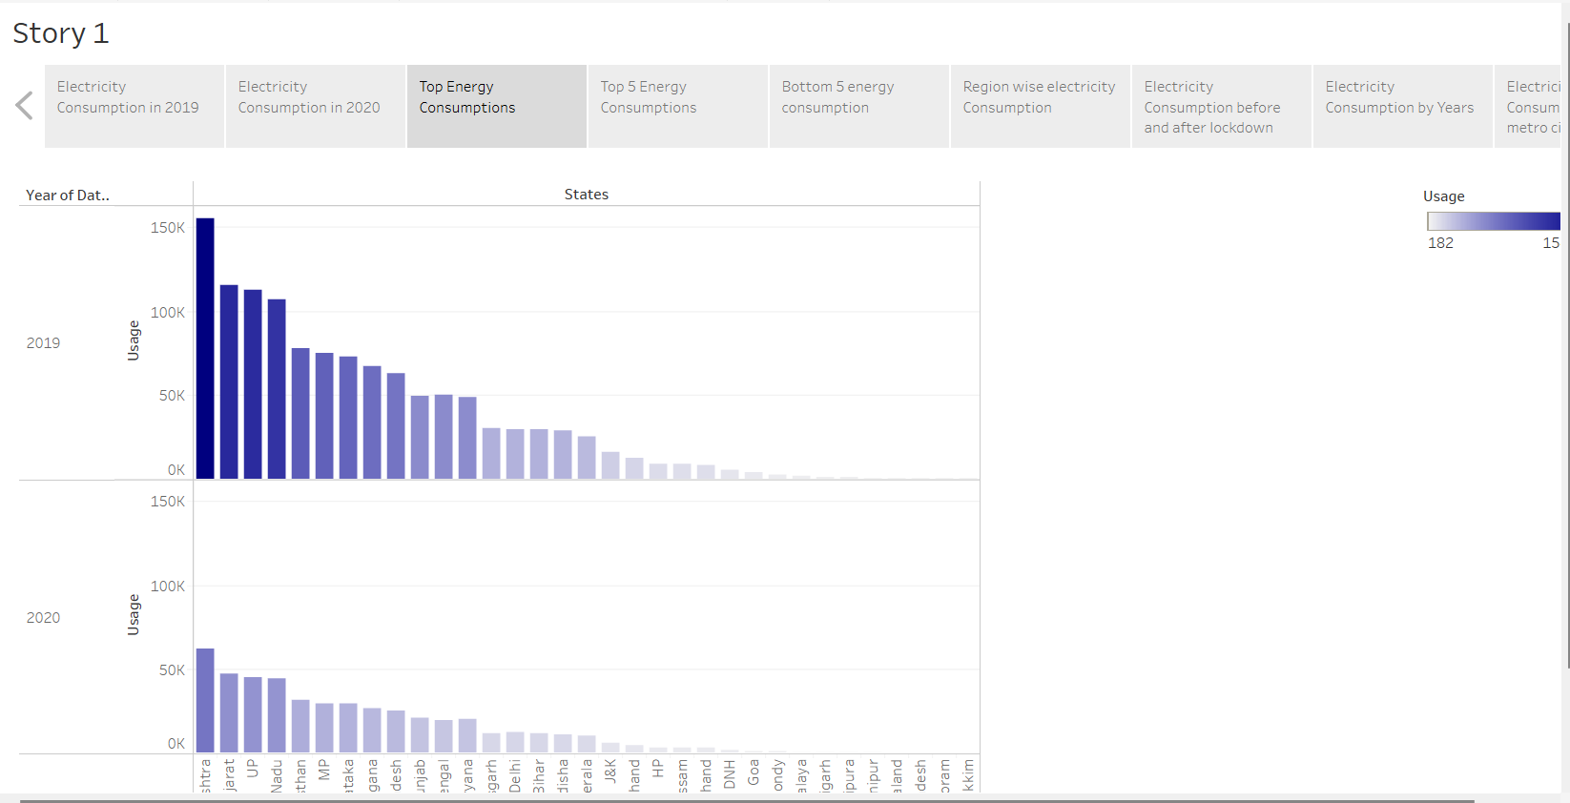

[**https://drive.google.com/file/d/15aZ5UjNSIShIPuSun37dtb5uGXsc_EU_/view?usp=sharing**](https://drive.google.com/file/d/15aZ5UjNSIShIPuSun37dtb5uGXsc_EU_/view?usp=sharing)

**4.Story of the Top 5 Energy consumptions:**

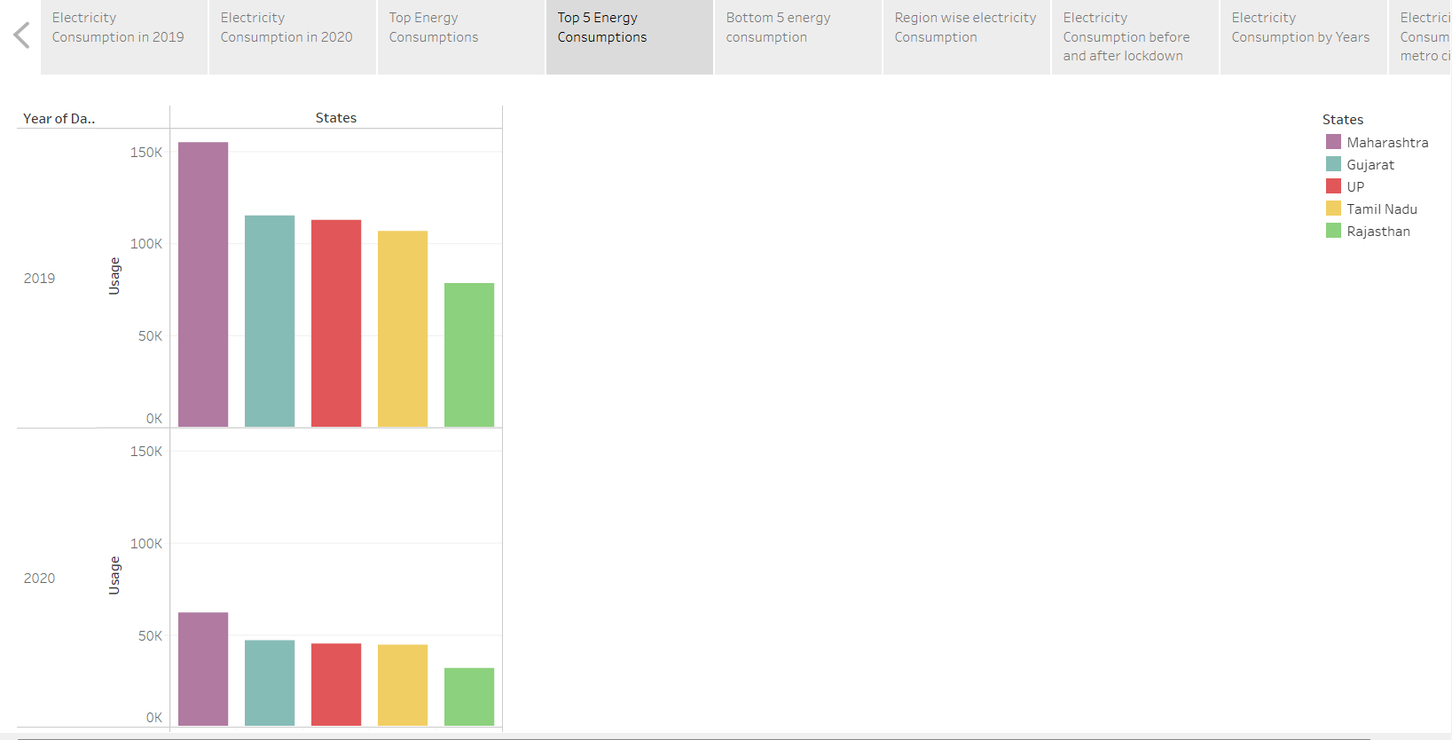

[**https://drive.google.com/file/d/1w2YA203Jyor9pRG5NKeilGyg2qF8BaHB/view?usp=sharing**](https://drive.google.com/file/d/1w2YA203Jyor9pRG5NKeilGyg2qF8BaHB/view?usp=sharing)

**5. Story of the Bottom 5 Energy consumptions:**

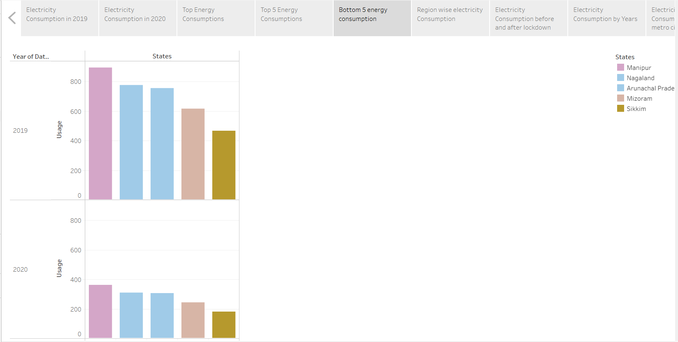

[**https://drive.google.com/file/d/11fYQVp3chgUqJTiY01TKHDE-gXELhVtI/view?usp=sharing**](https://drive.google.com/file/d/11fYQVp3chgUqJTiY01TKHDE-gXELhVtI/view?usp=sharing)

**6.Story of the region wise Electricity consumption.**

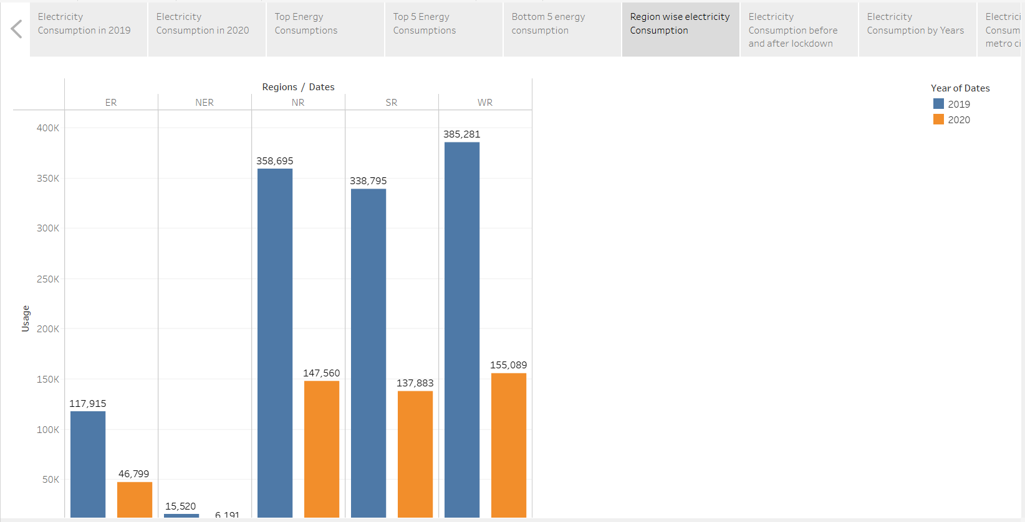

[**https://drive.google.com/file/d/118U59KzsRiBA3gVH6zKrPsHR3PB9AUro/view?usp=sharing**](https://drive.google.com/file/d/118U59KzsRiBA3gVH6zKrPsHR3PB9AUro/view?usp=sharing)

**7.Story of the comparison of the Electricity Consumption before and after the Lockdown:**

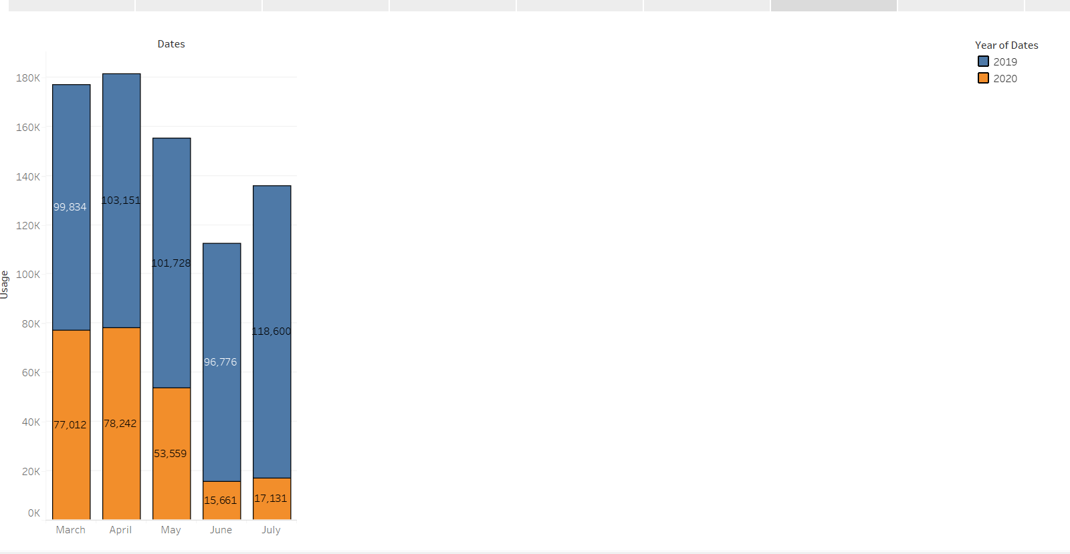

[**https://drive.google.com/file/d/1iYpIuK1VfBLjFaIqYtLlA9lSWJy_X1rr/view?usp=sharing**](https://drive.google.com/file/d/1iYpIuK1VfBLjFaIqYtLlA9lSWJy_X1rr/view?usp=sharing)

**8. Electricity Consumption by years using line graphs.**

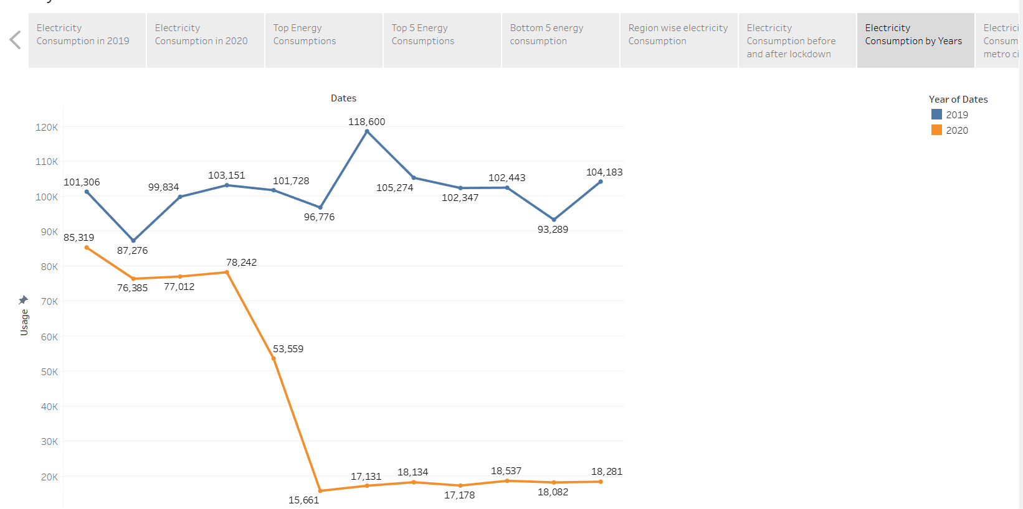

[**https://drive.google.com/file/d/1C9phcwyCZJmyugSnJMrreaJvqGjjODfn/view?usp=sharing**](https://drive.google.com/file/d/1C9phcwyCZJmyugSnJMrreaJvqGjjODfn/view?usp=sharing)

**9.Electricity consumption by metro cities:**

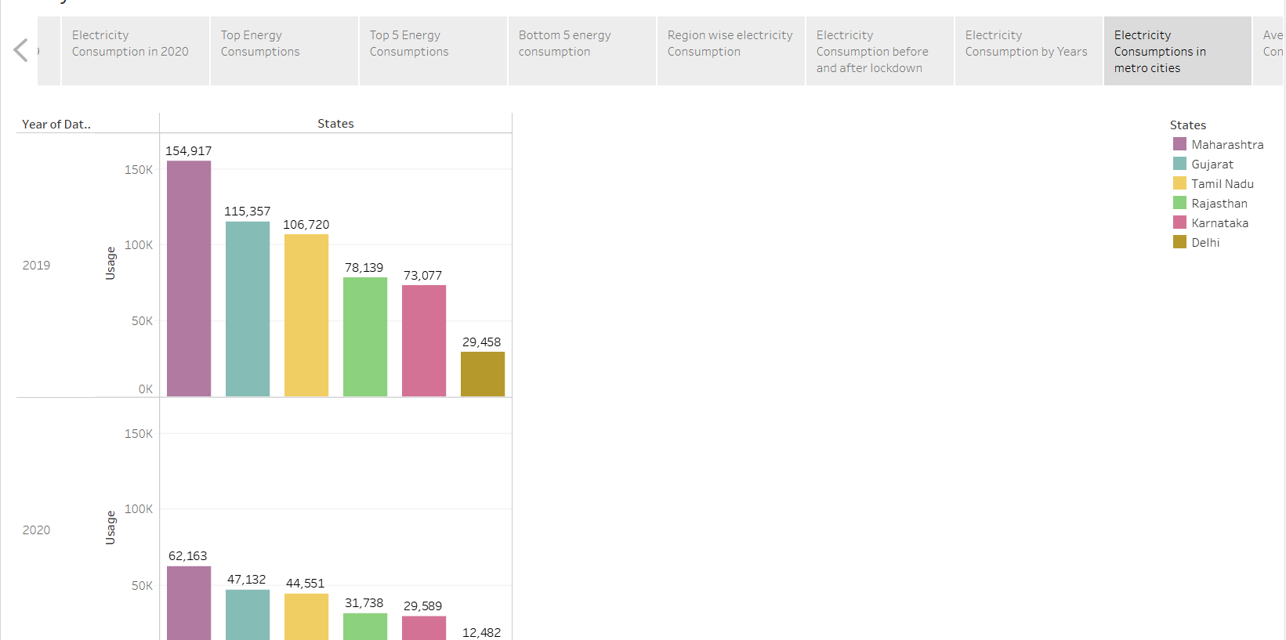

[**https://drive.google.com/file/d/1S8Dmly4J39xzB8iusNbsCnIWA8jTznxE/view?usp=sharing**](https://drive.google.com/file/d/1S8Dmly4J39xzB8iusNbsCnIWA8jTznxE/view?usp=sharing)

**10.Story of the daily average electricity consumption in India.**

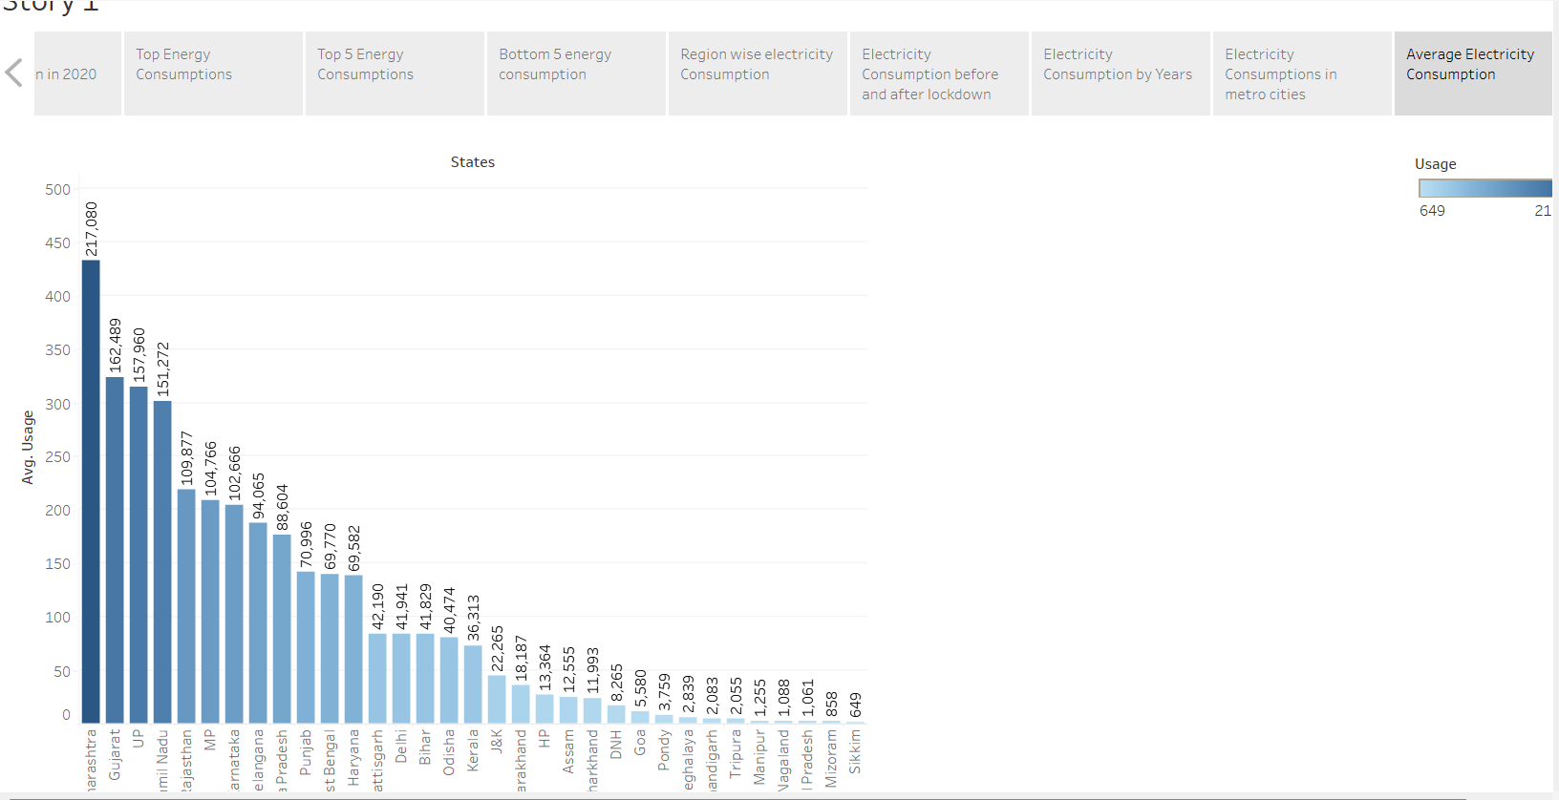

[**https://drive.google.com/file/d/1yEeI8lg_CvNLpjItRWB4V6ysuZjMmdtY/view?usp=sharing**](https://drive.google.com/file/d/1yEeI8lg_CvNLpjItRWB4V6ysuZjMmdtY/view?usp=sharing)

# Milestone 4: Tableau Dashboard

A dashboard is a way of displaying various types of visual data in one place. Usually, a dashboard is intended to convey different, but related information in an easy-to-digest form. And oftentimes, this includes things like key performance indicators (KPI)s or other important business metrics that stakeholders need to see and understand at a glance.

In my Project, there are two dashboards in it.

**DASHBOARD 1:**

<https://drive.google.com/file/d/1J5tbLAoNdH-JYXbbL8qVwwQzD1FS9FG9/view?usp=sharing>

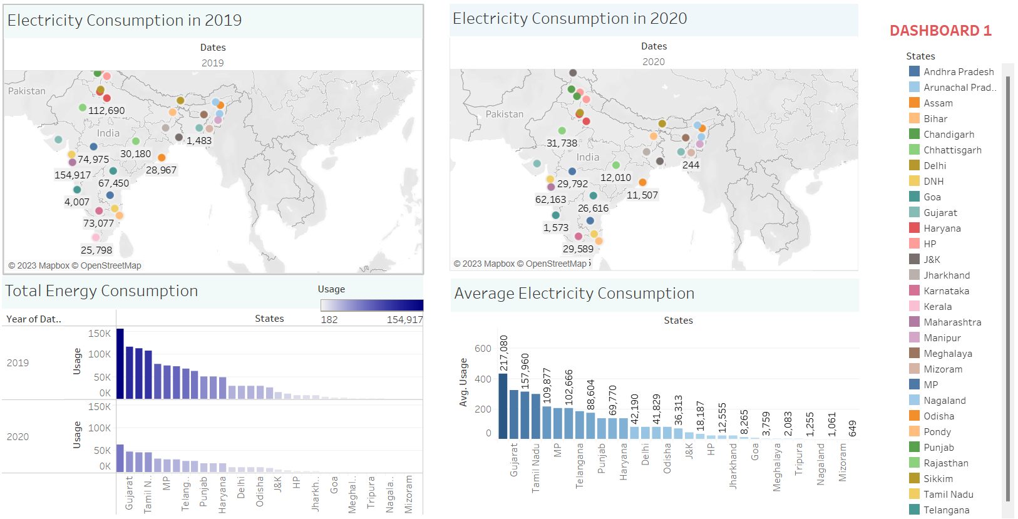

**DASHBOARD 2:**

<https://drive.google.com/file/d/1J5tbLAoNdH-JYXbbL8qVwwQzD1FS9FG9/view?usp=sharing>

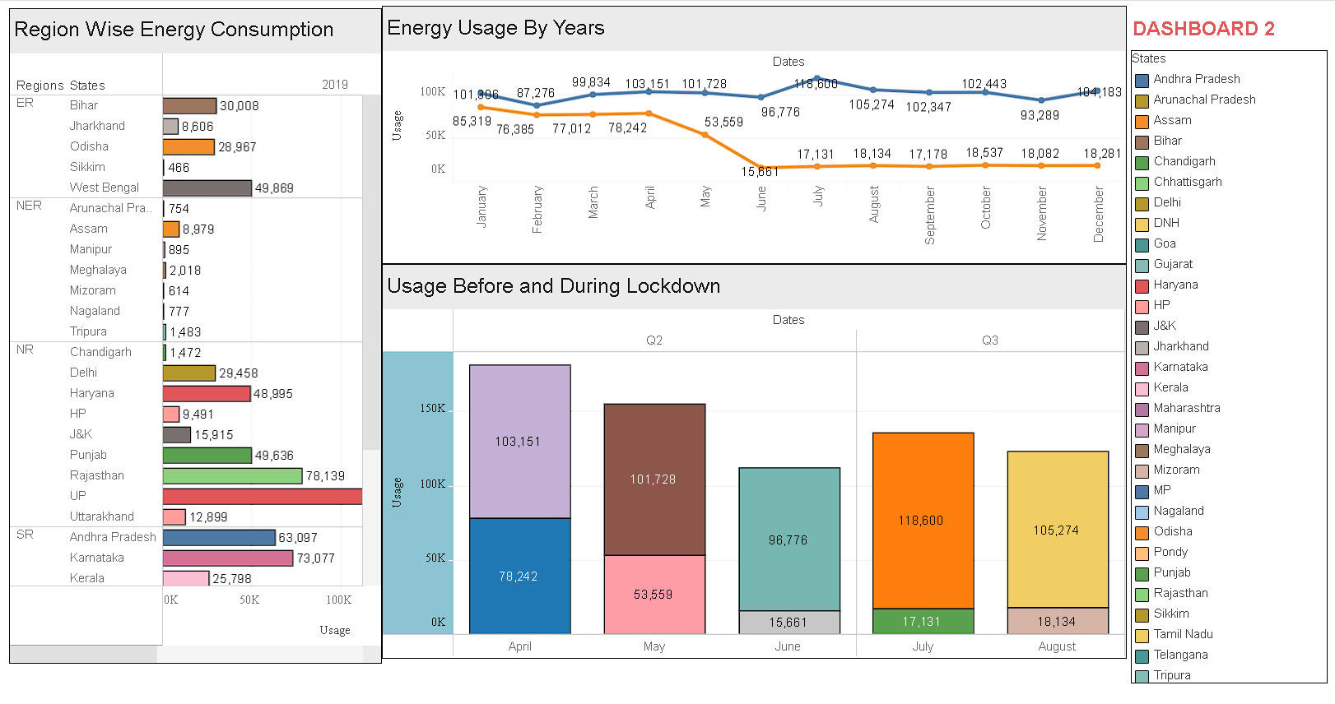

**Milestone 5: Web Integration:**

Web Integration Link:

<https://drive.google.com/file/d/1y13AZ_52NjPvo34TyrtWXXOXM4_A-gPT/view?usp=sharing>

**Screenshots:**

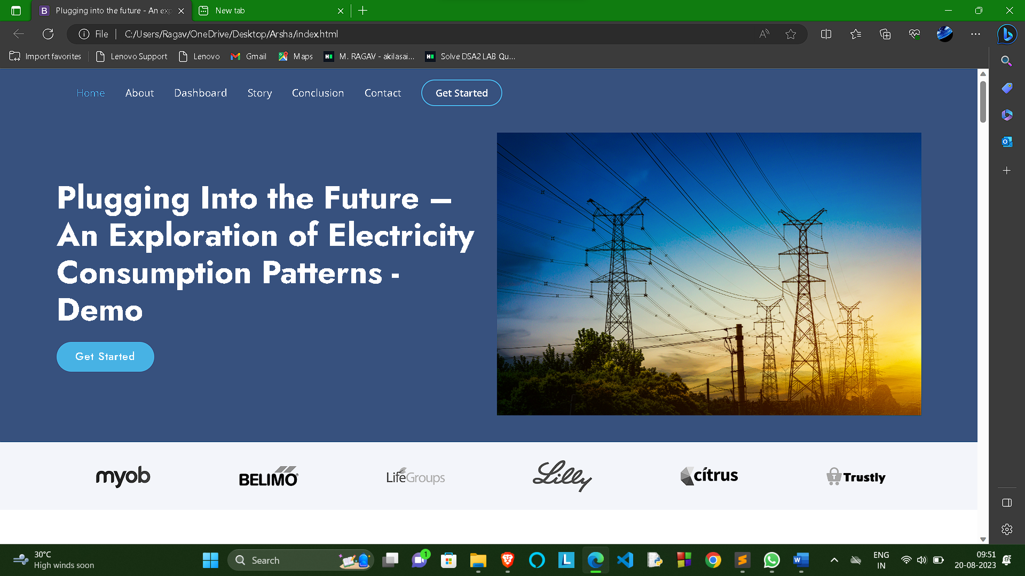

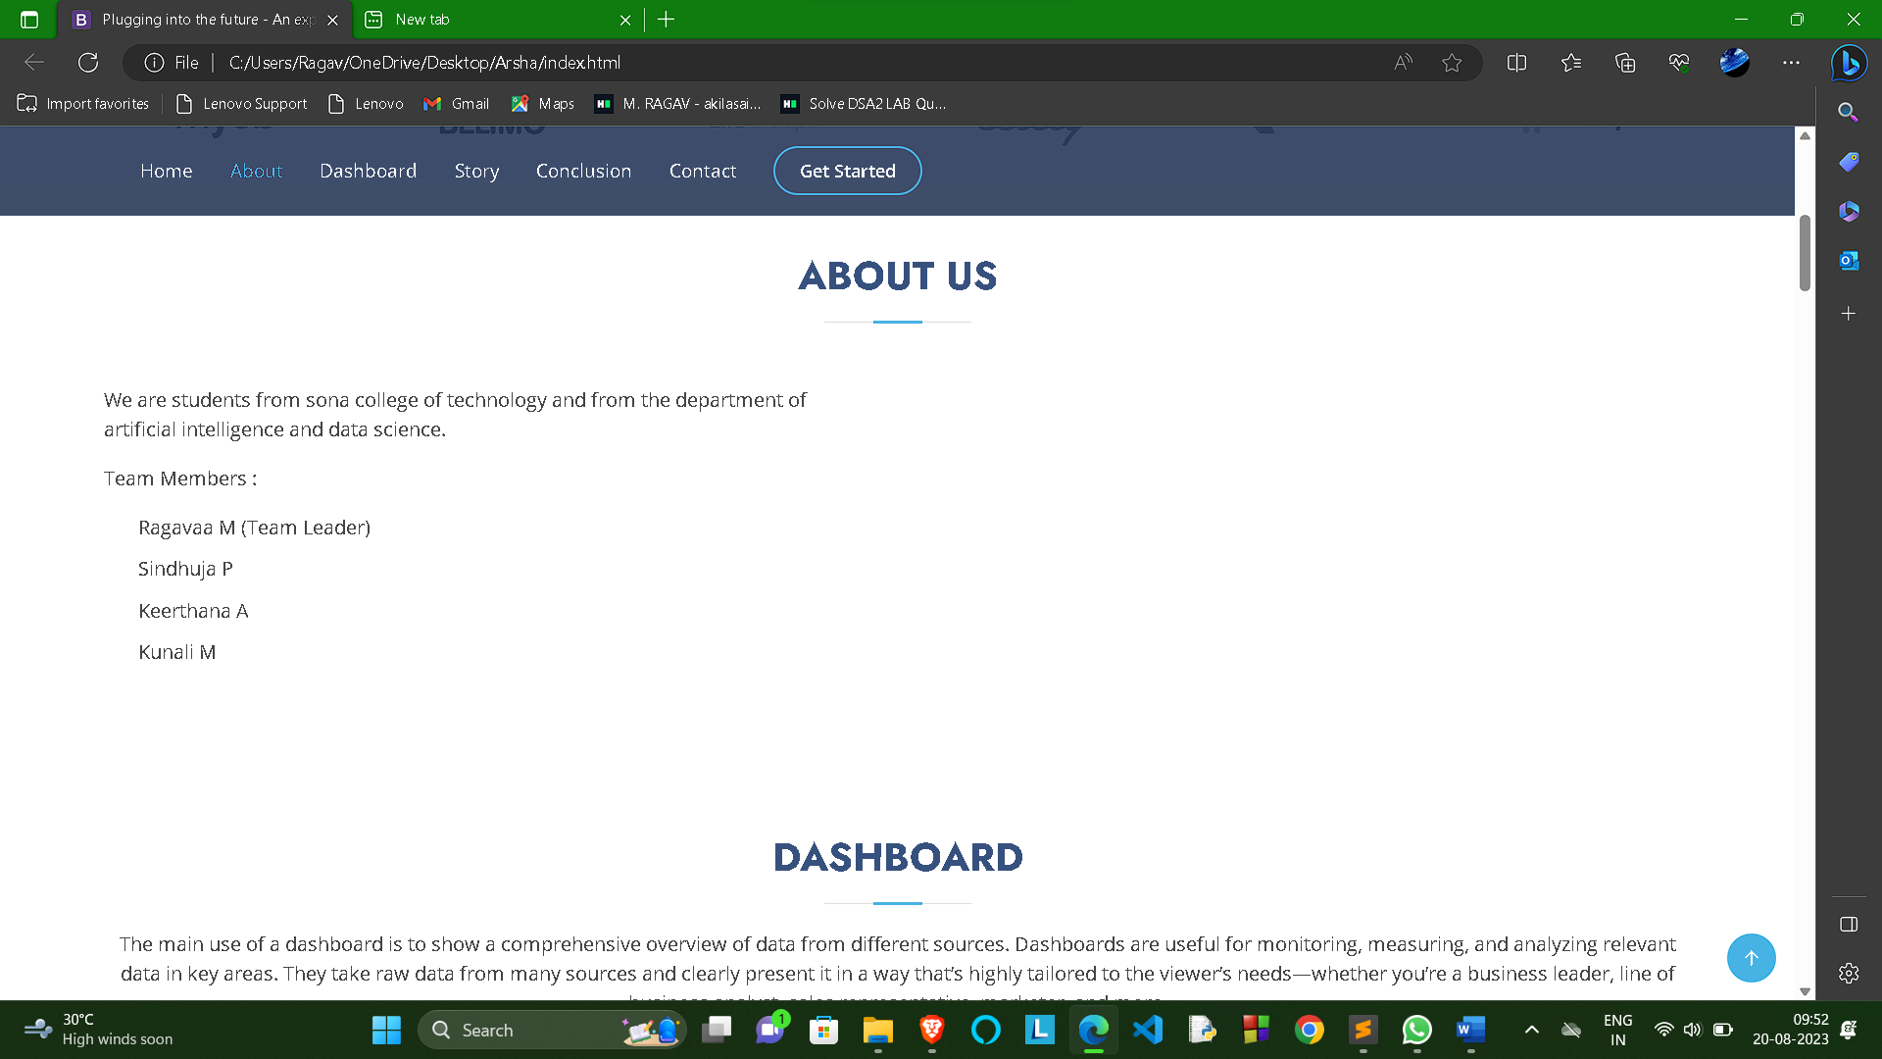

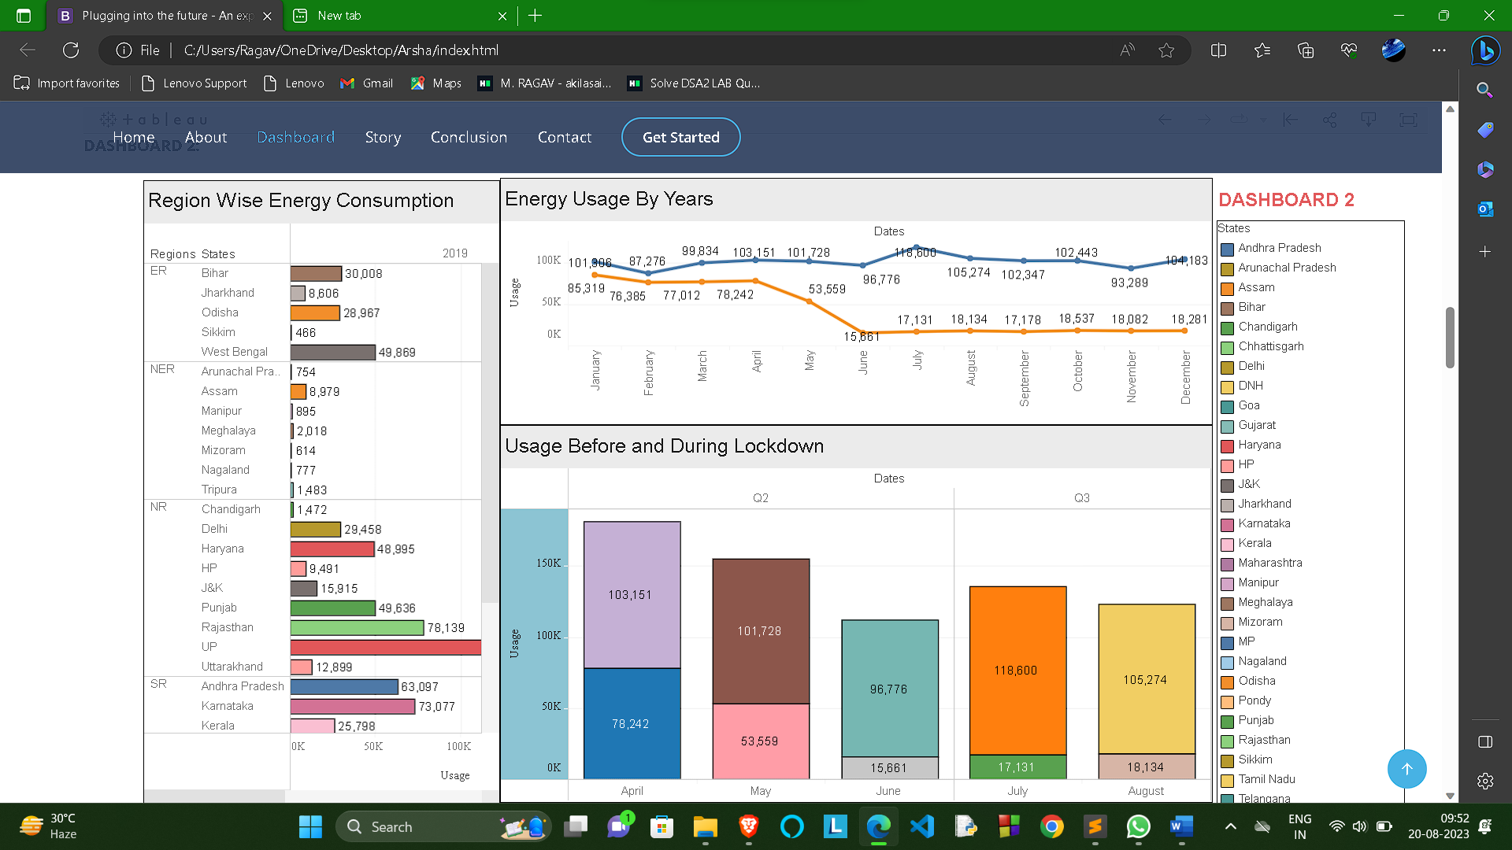

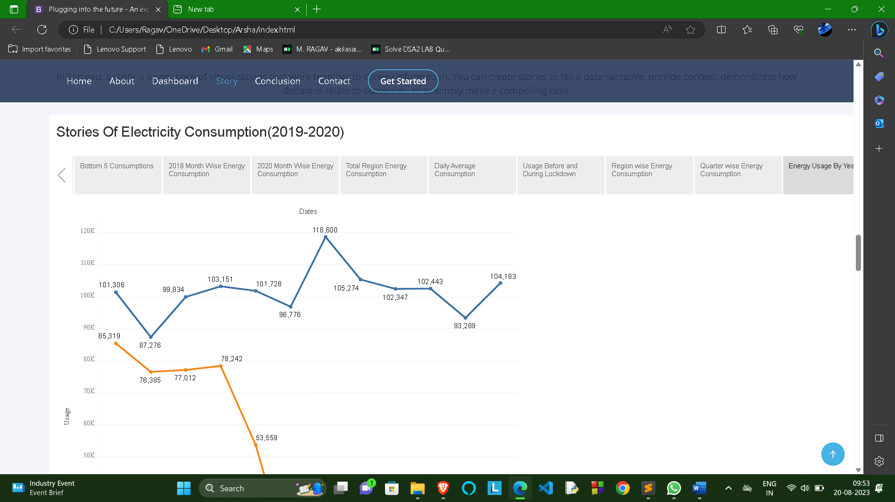

**Milestone 6: Conclusion:**

**Electricity Consumption Stats.**

* Maharashtra is the Highest Electricity consumption user

of India.

* Sikkim is the Lowest Electricity Consumption user of

India .

**Electricity Consumption before and during Lockdown in India**

* Electricity consumption was more in 2019 in month of March-June before Lockdown
* Electricity Consumption was less in 2020 in month of March-June during the Lockdown

**Electricity Consumption in Quarters**

* Electricity Consumption in 2019 for Quarter 3 was Highest.
* Electricity Consumption in 2019 for Quarter 1 was Lowest.
* Electricity Consumption in 2020 for Quarter 3 was Lowest.
* Electricity Consumption in 2020 for Quarter 1 was Highest.

**Electricity Consumption in Regions**

* Total Electricity consumption in Western Region is Highest.
* Total Electricity consumption in North Eastern Region is Lowest.