**WILD PLANTS EDIBILITY PREDICT USING IBM WATSON STUDIO**

**Mini Project**

Submitted By

**MUPPALA KEERTHANA 18UK1A0534**

**BOURISHETTY SWETHA 18UK1A0556**

**KALERU NARESH 18UK1A0538**

**BHUKYA SANTHOSH 18UK1A0507**

**ABSTRACT**

The rural communities of developing countries depend on wild edible plants to meet their food requirements during periods of food shortage. Wild edible plants are mostly serving as supplementary foods in different parts of the world because they are nutritionally rich and can supplement especially vitamins and micronutrients. The main objective of this project is to build Convolutional neural networks are a deep model to detect and classify the edibility of the wild plant. The model also suggests the effects of non-edible wild plant produce.

We are creating a web application where the user selects the image which is to be classified. The image is fed into the model that is trained and the predicted class will be displayed on the webpage.

**1.INTRODUCTION**:

**1.1 Overview:**

The rural communities of developing countries depend on wild edible plants to meet their food requirements during periods of food shortage. Wild edible plants are mostly serving as supplementary foods in different parts of the world because they are nutritionally rich and can supplement especially vitamins and micronutrients. The main objective of this project is to build Convolution neural networks are a deep model to detect and classify the edibility of the wild plant. The model also suggests the effects of non-edible wild plant produce.

We are creating a web application where the user selects the image which is to be classified. The image is fed into the model that is trained and the predicted class will be displayed on the webpage.

**1.2 PURPOSE:**

By using wild plants eligibility prediction using IBM Watson studio we will:

1. We know the concepts and can work on IBM Watson studio.
2. Wild edible plants are mostly serving as supplementary foods in different parts of the world because of the nutritionally rich and can supply the vitamins and micronutrients
3. The main objective of this project is about the model suggests of non-edible wild plant production.

**2.PROBLEMSTATEMENT:-**

1. Wild plant food often has the vegetable kingdom suitable by nature for use of food, especially by human beings .
2. Not all parts of any given plants have been know the people.

**3.LITERATURE SURVEY:-**

**3.1 EXISTING SYSTEM:**

Prediction of edibility of wild plants by classifying the input image of various wild plants on organization of wild plants is stems are one part of plants that are eaten by humans .Most plants are made up of roots ,stem ,leaves. The most commonly edible parts of plants are fruits ,usually sweet ,fleshy and sufficient. The most cultivated for their value and referred to as vegetables. Wild plants are nutrionally rich and can supplement especially vitamins and micronutrients.

**3.2 PROPOSED SOLUTION:**

We are creating a web application where the user selects the image which is to be classified. The image is fed into the model that is trained and the predicted class will be displayed on the webpage.

our method employs the IBM Watson studio prediction modelfor accurate identification of edibility of wild plants to detect the plants belongs to appropriate class.

|  |  |
| --- | --- |
|  | **Figure 1: Training and Testing using Histopathological images with CNN** |
|  |  |

These filters scan the image by a sliding window on the image, while learning the recurrent patterns which arise in any area of the image. The interval between filters is known as the stride. The convolution is extended to overlapping windows if the stride hyper parameter is smaller than the filter dimension. Convolutional layers bring out the features of images with precise positions. If the positions change, even a small amount for any reason, the feature maps will be different. To overcome this problem, the down sampling process must be done at the output of every convolutional layer. With convolutional layers, down sampling can be done by changing the convolution’s phase across the image. A more acceptable and common method is to use a pooling layer. Using this process, outputs will be more accurate.

**4. THEORTICAL ANALYSIS**

**4.1 Block Diagram:**

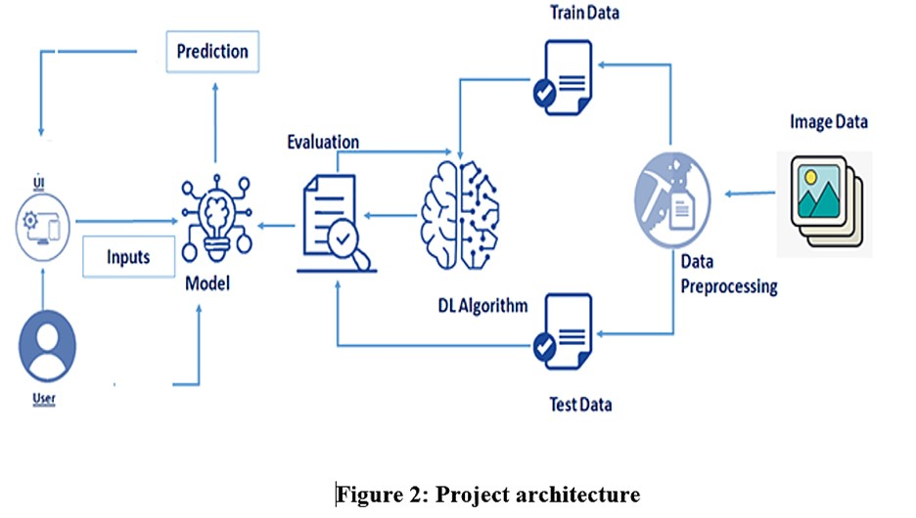

**4.2 USECASE DIAGRAM**

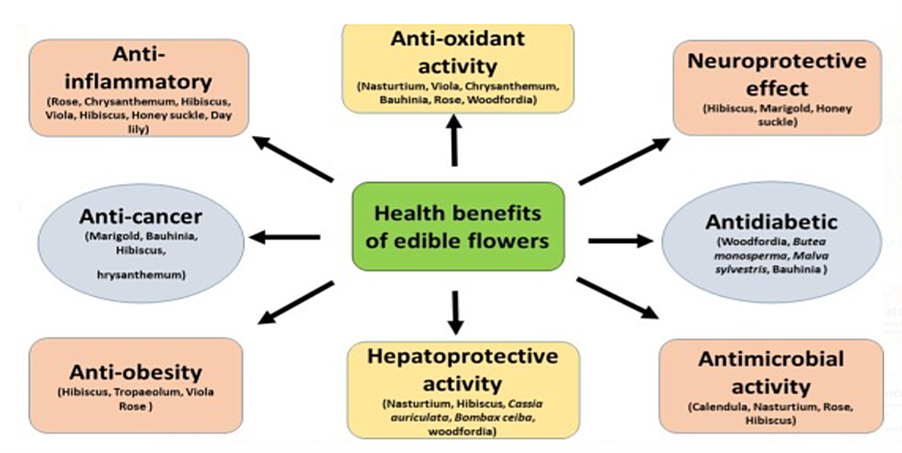

**Figure 3:Use case diagram**

**4.3 SOFTWARE SPECIFICATIONS:**

|  |  |
| --- | --- |
| **REQUIREMENT** | **SPECIFICATION** |
| Anaconda Navigator | You must have anaconda installed in your device prior to begin. |
| Spyder, Jupyter Notebook, Flask  Framework, deep learning software tools like keras,tensorflow | 1. One should have Spyder and Jupyter notebook. 2. One should install flask framework through anaconda prompt for running their web application 3. We need to build the model using jupyter notebook with all the imported packages. |
| Web browser | For all Web browsers, the following must be enabled:   1. cookies 2. HTML 3. Java script |

**4.4 HARDWARE SPECIFICATIONS:**

|  |  |
| --- | --- |
| **REQUIREMENT** | **SPECIFICATIONS** |
| Operating system | Microsoft Windows  UNIX  Linux® |
| Processing | Minimum: 2 CPU cores for one user. For each deployment, a sizing exercise is highly recommended. |
| RAM | Minimum 8 GB. |
| Operating system specifications | File descriptor limit set to 8192 on UNIX and Linux |
| Disk space | A minimum of 7 GB of free space is required to install the software. |

**5.EXPERIMENTALANALYSIS:-**

Analysis or the investigation made while working on the solution:

While working on the solution we investigated on prediction of edibility of wild plants, IBM cloud, IBM Watson studio ,Convolution Neural Network(CNN) model, Cloud Object Storage. The key role on investigation is collection of datasets.

**IBM Cloud Account**:

IBM Acquired soft layer, a public cloud platform, to serve as the foundation for its IaaS offering. In October 2016, IBM rolled the soft layer brand under its Blue mix brand of PaaS offerings, giving users to access both IaaS and PaaS resources from a single console. IBM cloud provides a full-stack, public cloud platform with various products in the catalog, including options for compute, storage, networking, end to end developer solutions for app development, testing and deployment, security databases, and cloud native services.

Creating the IBM cloud account by going to the IBM cloud login page and click create on IBM cloud account. Enter our IBM id and an ID is created based on the email that we enter. Completing the remaining fields with our information and click create account by this the account is created.

**Dataset Pre-processing:**

The data pre-processing on images of wild plants is done by following steps:

1. Import the Image Data Generator library
2. Configure Image Data Generator class
3. Apply Image Data Generator functionality to Train set and Test set

**Model Building:**

1. Import the model building Libraries
2. Initializing the model
3. Adding Input Layer
4. Adding Hidden Layer

**6.FLOW CHART:**

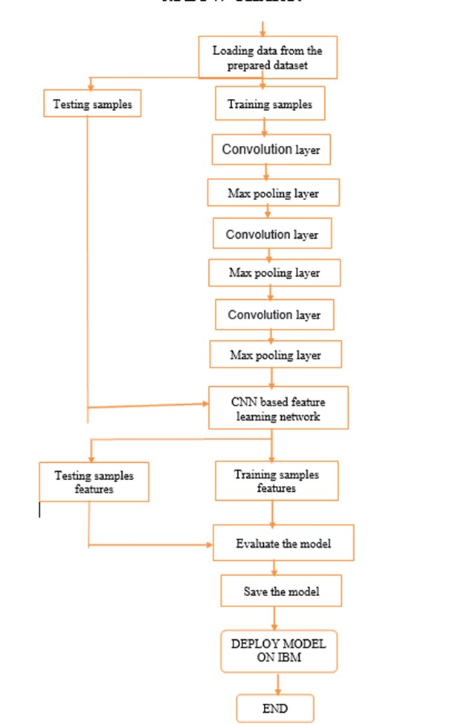

**7.CODE SNIPPETS:-**

**7.1 MODELCODE:-**

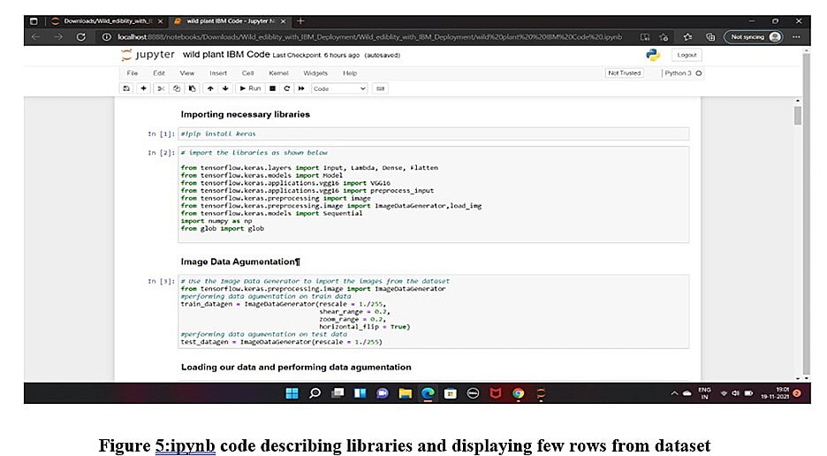

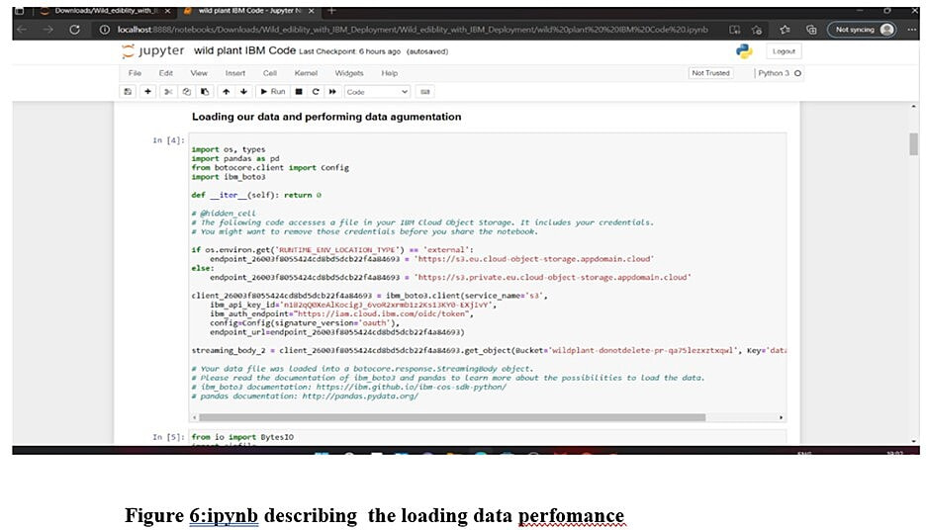

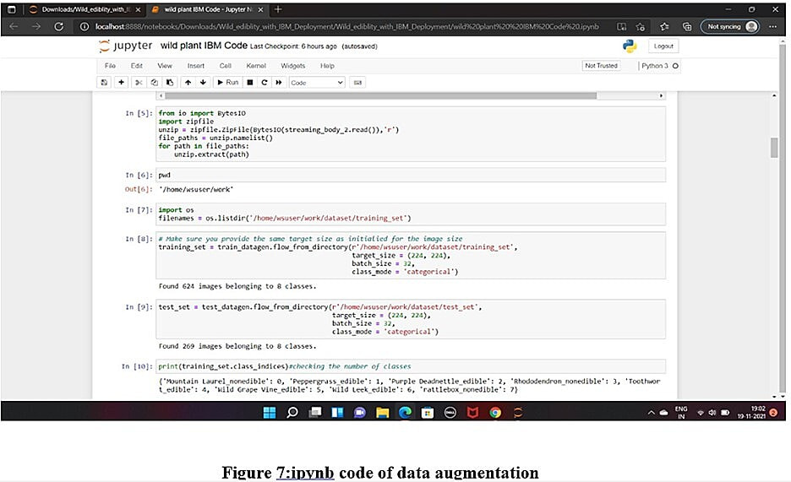

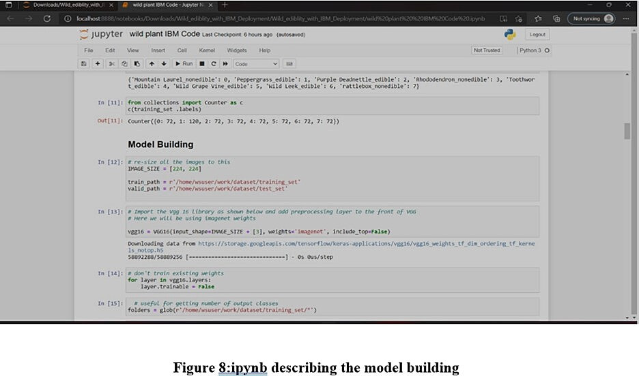

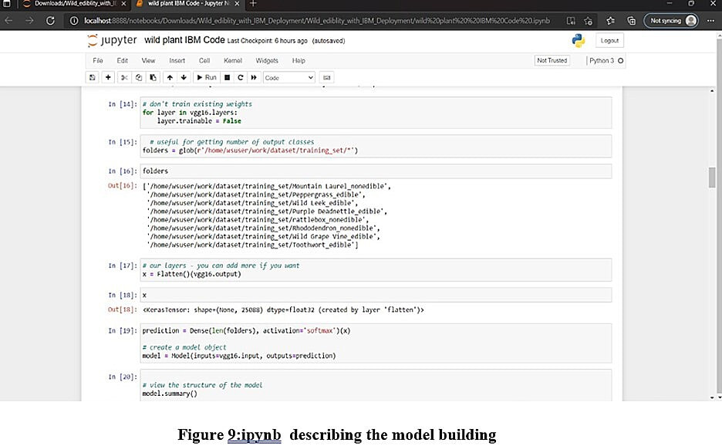

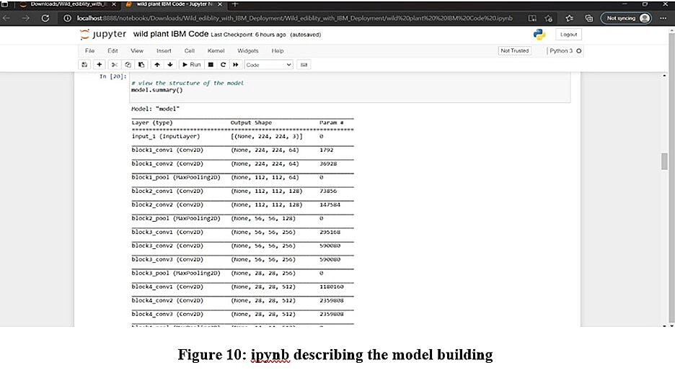

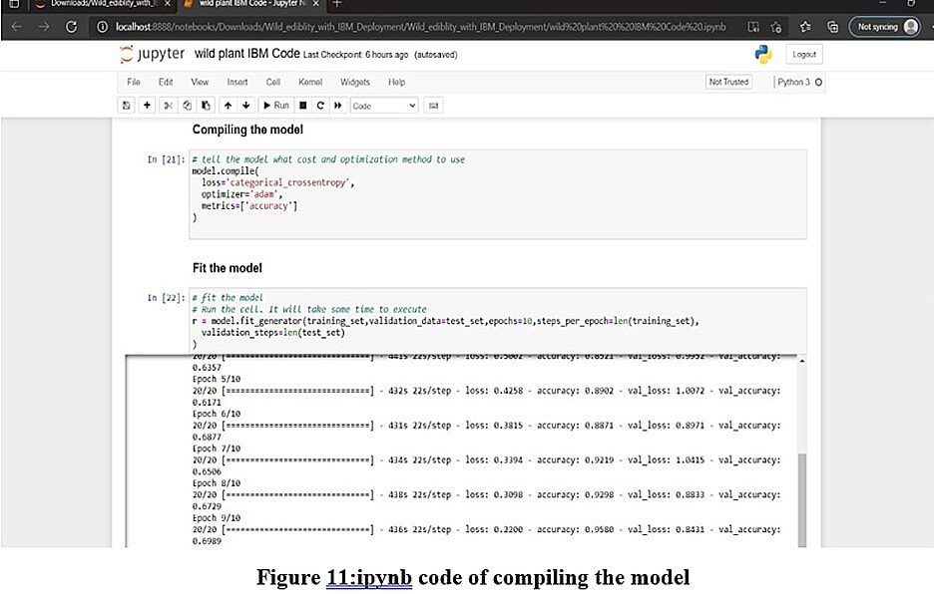

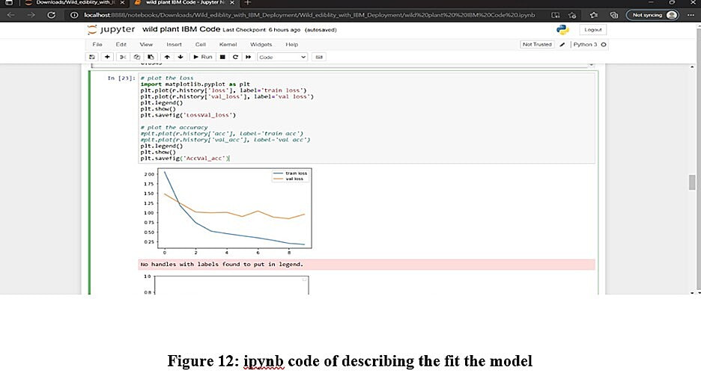

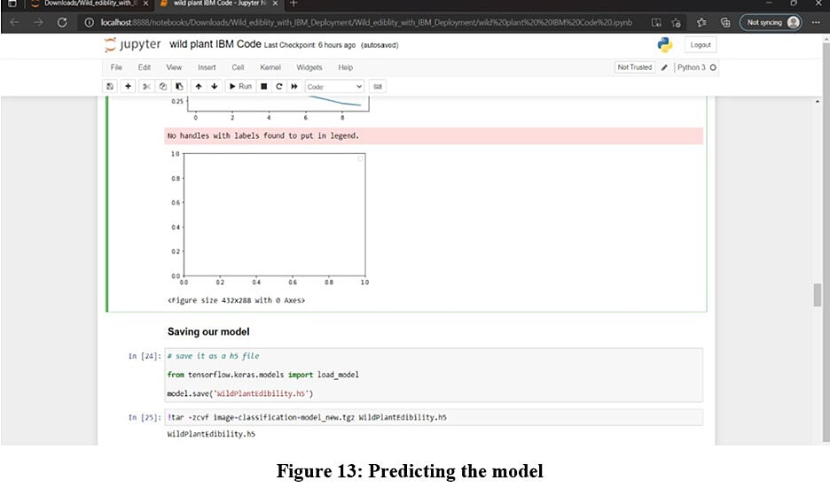

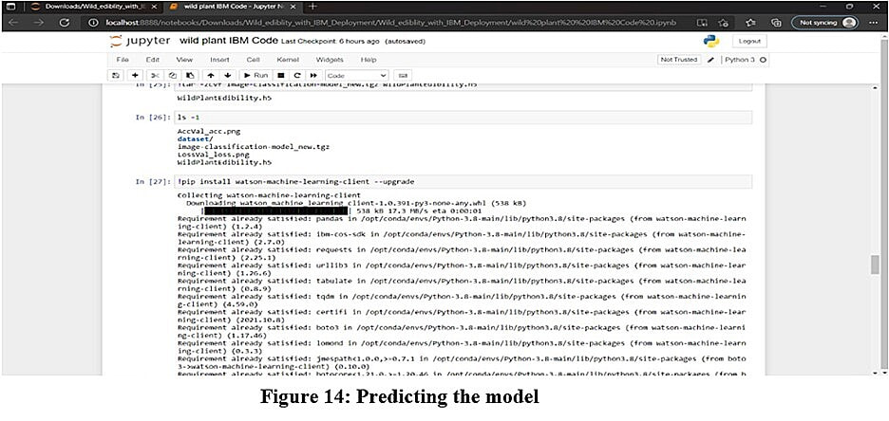

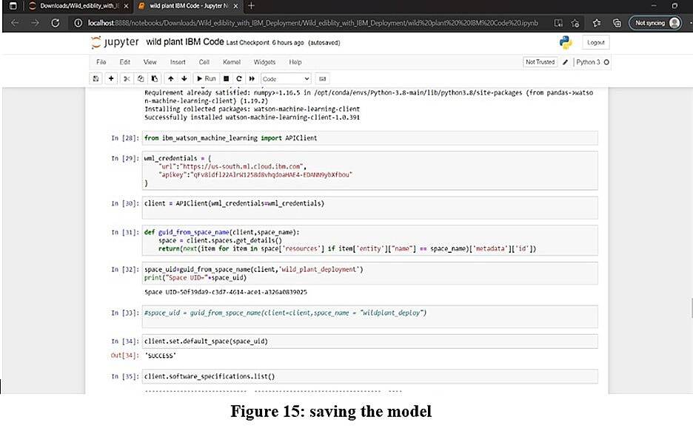

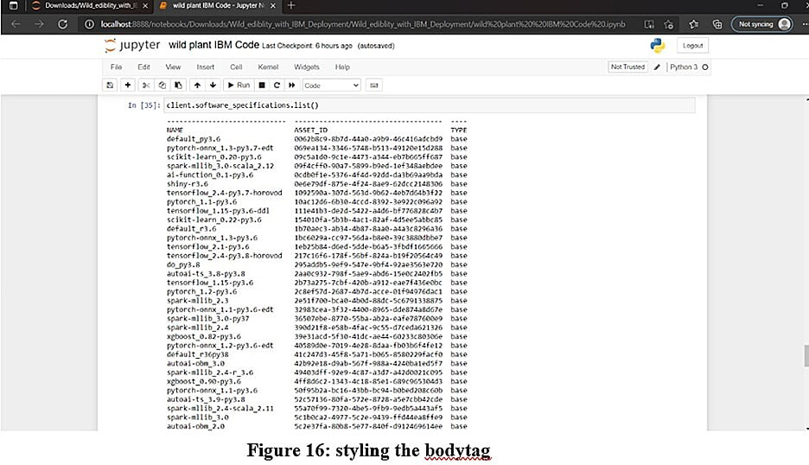

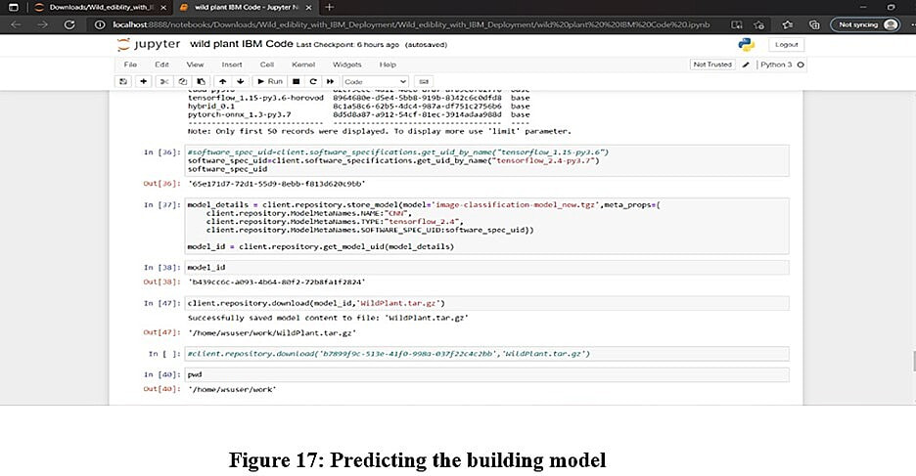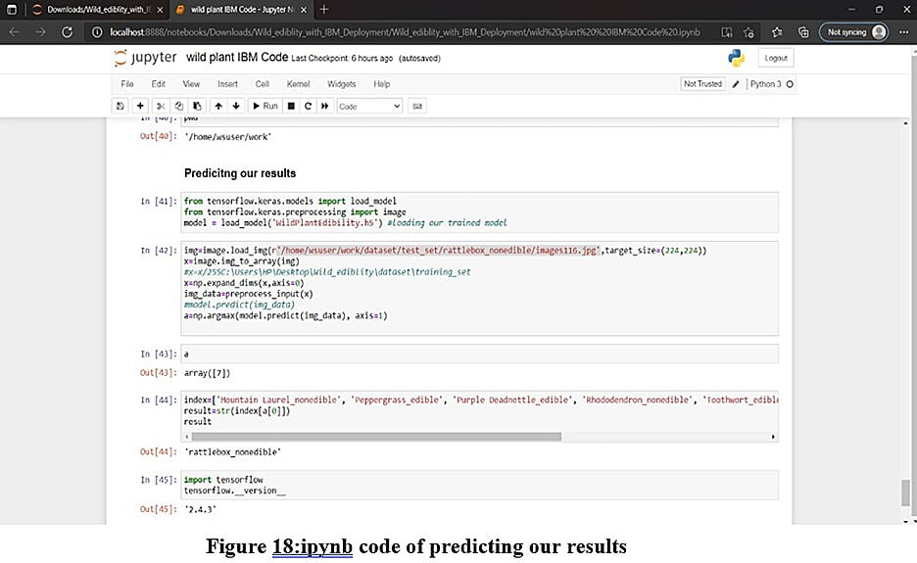**HTML CODE OF INDEX:-**

1. **INDEX.HTML**

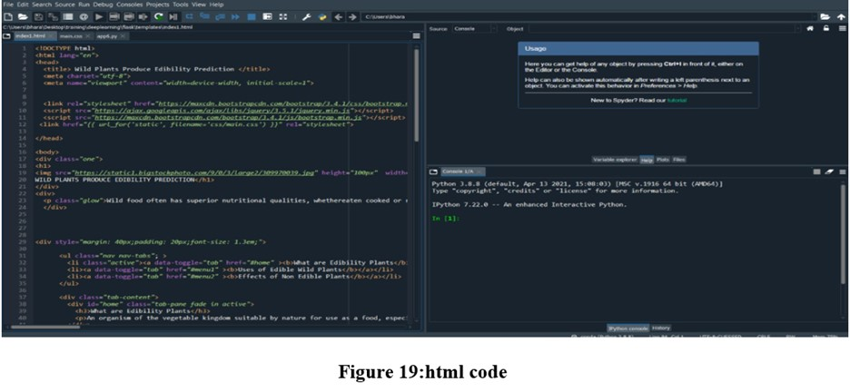

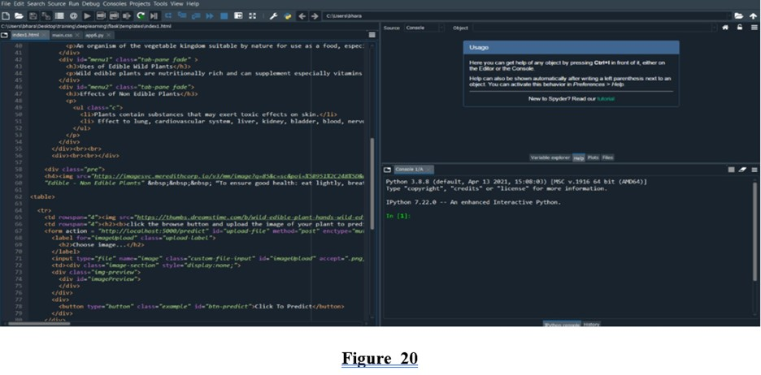

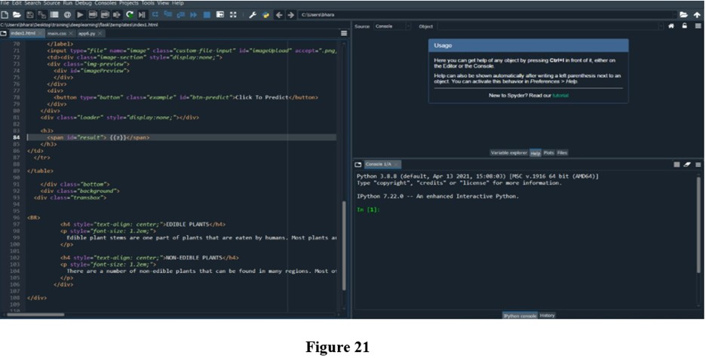

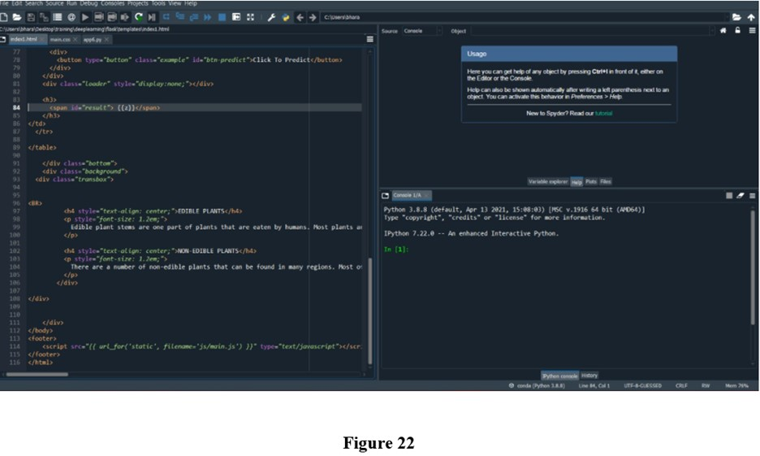

**CONCLUSION:-**

**From this entire finding we know fundamental concepts and can work on IBM Watson and machine learning.**

1. In this project we have presented the Wild Plants Edibility Prediction
2. We have done the Prediction using Deep Learning Techniques.
3. For the better results we applied CNN layer and proved with 97% accuracy.

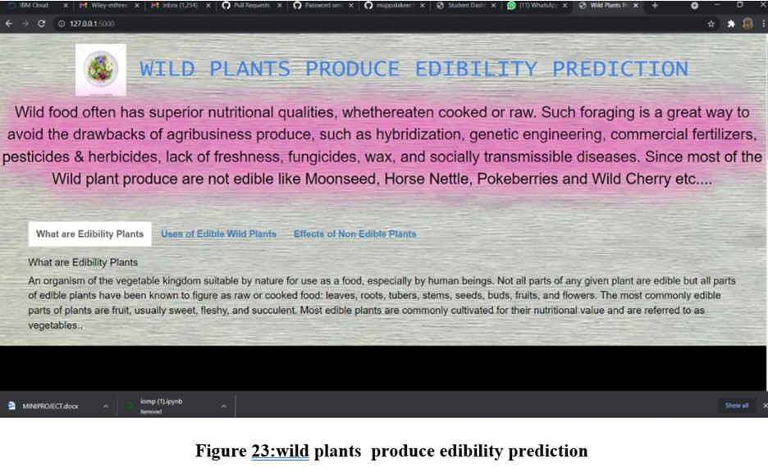

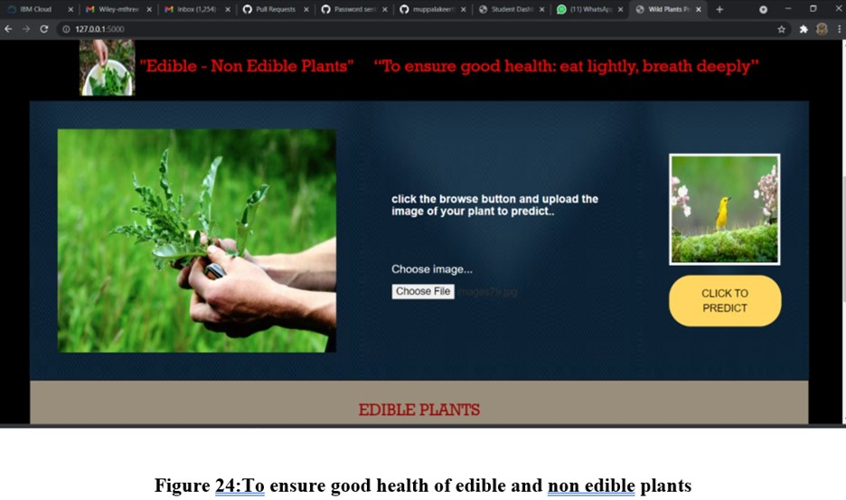

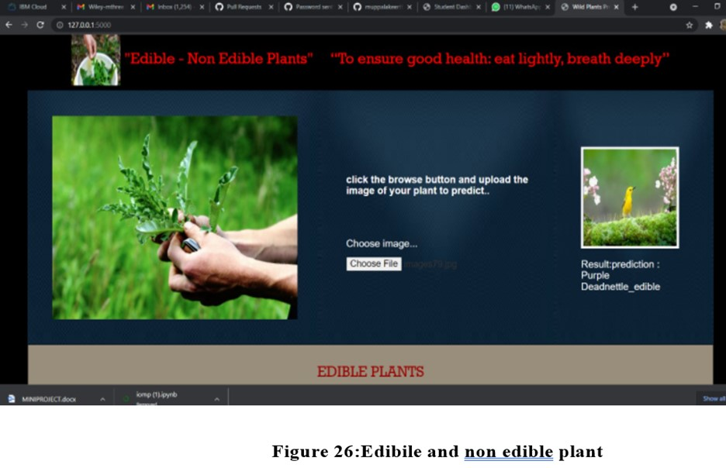

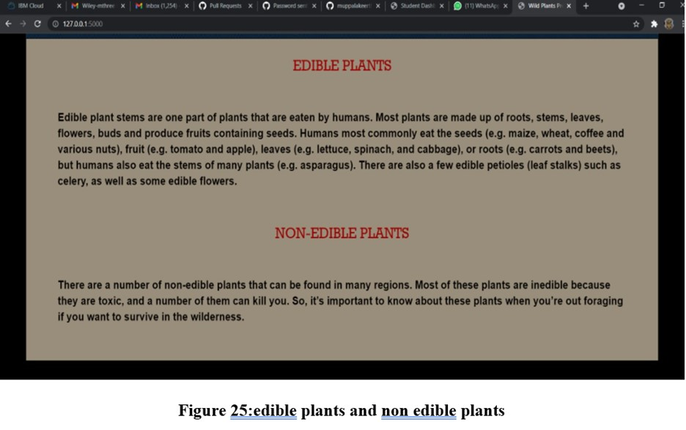

**9.APPLICATION**

Wild plants food often has superior nutritional qualities, such as wild edible plants are nutrionally rich and can supplement especially vitamins and micronutrients .These shows that the wild plants are essential components of many cities diets ,especially in periods of seasonal food shortage.

**10. ADVANTAGES**

1. An organization of the vegetable kingdom suitable by nature for use as a food, especially by human beings.
2. The most commonly edible plants are fruits,usually sweet, fleshy and sufficient.
3. Most edible palnts are commonly collect from their nutritional value and reffered to as vegetables.

**11.DISADVANTAGES**

1. There are no.of non-edible plants that can be found in many regions.
2. Effect of lungs ,kidneys and etc,

**12.FUTURE SCOPE:-**

**Enhancements that can be made in the future:**

1. Wild plants are serving as supplementary foods for various rural communities.
2. The model built with convolution neural networks detect and classifying edibility of wild plants.
3. Our model also suggests the effects of non-edible wild plant procedure.

**13.BIBLIOGRAPHY:-**

1. <https://smartinternz.com/Student/guided_projects>
2. <https://www.kaggle.com/paultimothymooney/breast-histopathology-images>