**AGRICULTURE DATA ANALYTICS IN CROP YEILD ESTIMATION USING  
IBM COGNOS**

**ABSTRACT**

Agriculture is important for human survival because it serves the basic need. A well-known fact that the majority of population (≥55%) in India is into agriculture. Due to variations in climatic conditions, there exist bottlenecks for increasing the crop production in India. It has become challenging task to achieve desired targets in Agri based crop yield. Various factors are to be considered which have direct impact on the production, productivity of the crops. Crop yield prediction is one of the important factors in agriculture practices. Farmers need information regarding crop yield before sowing seeds in their fields to achieve enhanced crop yield. The use of technology in agriculture has increased in recent year and data analytics is one such trend that has penetrated into the agriculture field. The main challenge in using big data in agriculture is identification of effectiveness of big data analytics. Efforts are going on to understand how big data analytics can agriculture productivity. The present study gives insights on various data analytics methods applied to crop yield prediction and also signifies the important lacunae points in the proposed area of research.

**INTRODUCTION**

Crop production in India is one of the important sources of income and India is one of the top countries to produce crops. As per this project we will be analyzing some important visualization, creating a dashboard and by going through these we will get most of the insights of Crop production in India. Agriculture forms the basis for food security and hence it is important. In India, majority of the population i.e., above 55% is dependent on agriculture as per the recent information. Agriculture is the field that enables the farmers to grow ideal crops in accordance with the environmental balance. In India, wheat and rice are the major grown crops along with sugarcane, potatoes, oil seeds etc. Farmers also grow non-food items like rubber, cotton, jute etc. More than 70% of the household in the rural area dependon agriculture. This domain provides employment to more than 60% of the total population and has a contribution to GDP also (about 17%). In the farm output, India ranks second considering the world wide scenario. This is the widest economic sector and has an important role regarding the framework of socio-economic fabric of India. Farming depends on various factors like climate and economic factors like temperature, irrigation, cultivation, soil, rain fall, pesticide and fertilizers. Historical information regarding crop yield provides major input for companies engaged in this domain. These companies make use of agriculture products as raw materials, animal feed, paper production and so on. The estimation of production of crop helps these companies in planning supply chain decision like production scheduling.

**OVER VIEW**

1.In this project we have to collect dataset related to the title.

2.We have to create an IBM account select IBM Cognos Analytics.

3.Upload the dataset into IBM Cognos Analytics Dashboard.

4.Find the Relationships in the uploaded dataset.

5.Visulazing the data set with different selected fields.

**PURPOSE**

The purpose or the use of this project is to estimate the crop yield/production in India. In which states or in which districts the particular crop is cultivated in which seasons and to what extent the yield/production will be.? The answers to all these questions can be achieved by this project with IBM Cognos analytics.

**LITERATURE SURVEY**

**Existing Problem:**

Agriculture sector is struggling to increase the productivity of crop in India. Smart agriculture driven by Information Technology is the emerging trend in the research in this area in recent days. One of the areas being explored is the problem of yield prediction which is a major concern.

**Proposed Solution:**

Crop Yield Estimation using IBM Cognos.

With this we can come to know in how area the crops can be cultivated so that the required productivity will be acquired using visualizations in IBM Cognos Analyticsacross India. Crop yield/production estimation helps the farmers in various ways by providing the record of previous crop yield/production.

**THEORITICAL ANALYSIS**

**IBM**

**COGNOOS**

DATA

**Hardware & Software**

**Software Specification:**

|  |  |
| --- | --- |
| REQUIREMENT | SPECIFICATION |
| IBM Account | You Must have an account in IBM prior  To begin |
| IBM cognos analytics dashboard | 1.Contains Different Visualization  2.One should launch the cognos analytics dasboard |
| Web browser | For all web browser, the following must  Be enabled:   * Cookies * Java script |

**Hardware Specification:**

|  |  |
| --- | --- |
| REQUIREMENTS | SPECIFICATIONS |
| Operating System | Microsoft Windows  Unix  Linux |
| Processing | Minimum: 4 CPU for onr user. For each  Deployment, a sizing exercise is highly recommended. |
| RAM | Minimum 8GB |

**Experimental Investigations**

While analyzing the datasets we have observed that there is a noisy data and mostly null values are present, by using IBM Cognos tool we have overcome the problems faced in the dataset (Null values, noisy data). On further proceeding we have seen various visualization tools out of those we have selected few best of them and the visuals are presented in the results slide.

**FLOW CHART**

‘



Understand the dataset and Explore

Visualize the Data

Create Dashboard

Create IBM account

Upload the dataset

**RESULT**

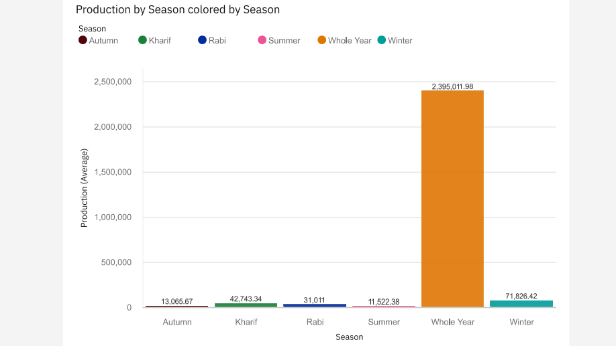

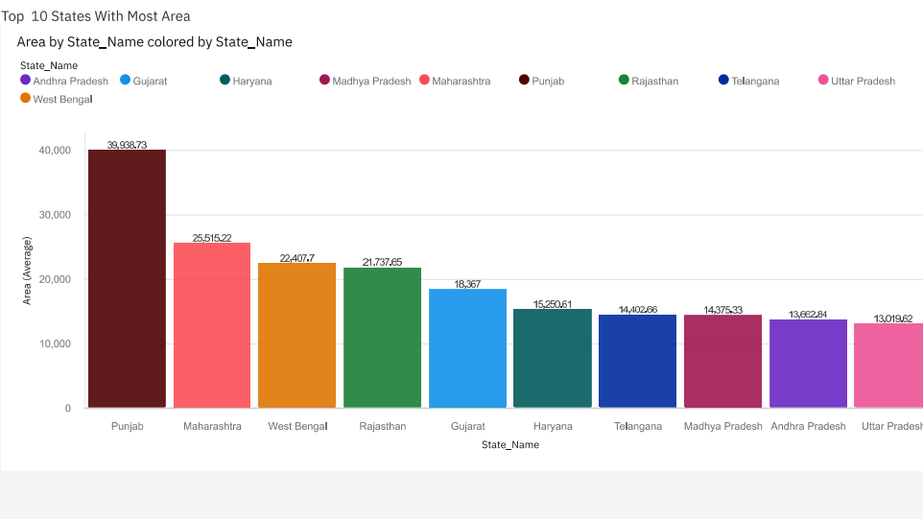

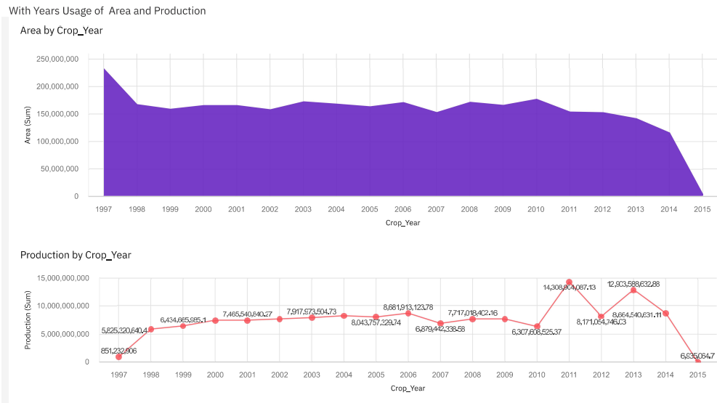

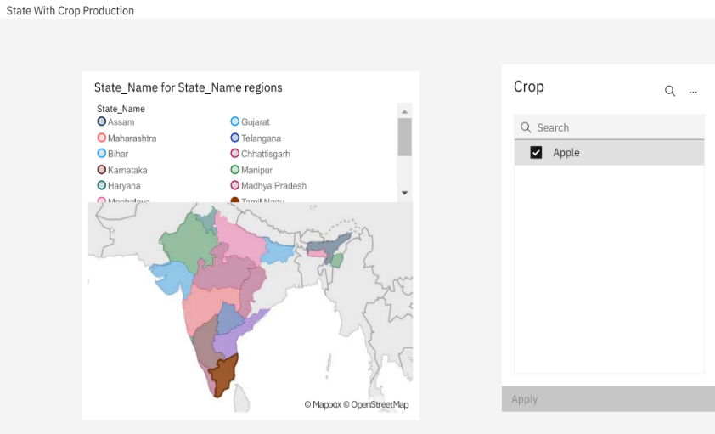

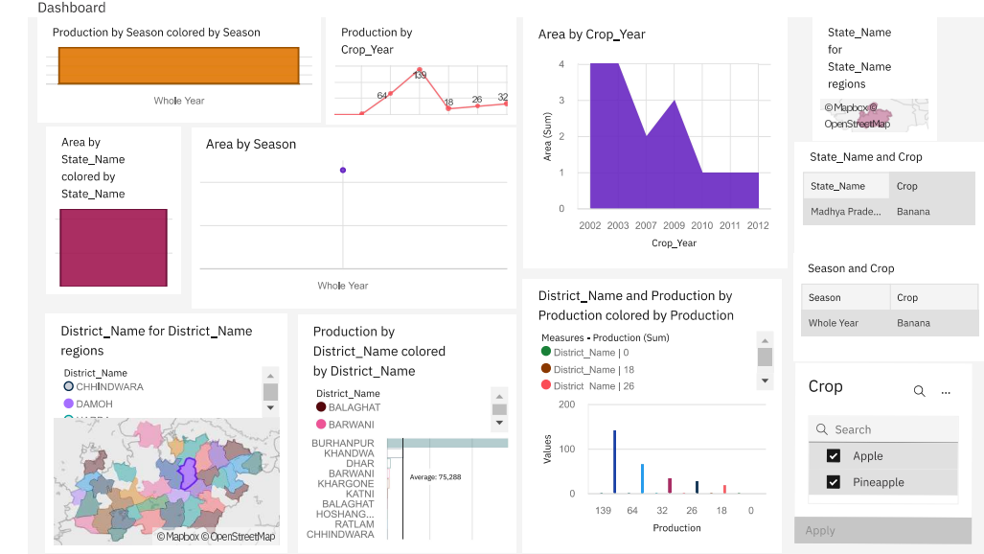

**ADVANTAGES**

Advantages of using IBM Cognos analytics:

* Automates reporting
* Enables precise reporting from database
* Enables users to share reports easily
* Creating Dashboards.
* Drill Throughout from one report or Dashboard to a Detailed report.
* Add Extension to new reporting possibilities to the product.
* Lower costs—reduces maintenance due to complete report coverage and a zero-footprint environment.
* Faster results—shortens reporting time due to seamless integration and adaptive authoring.
* Improved decision making—reports and dashboards present data in easily-understood formats.
* Adaptive authoring automatically adjusts report layout when objects are added, moved, or removed.
* Ability to work with data using familiar business terms.
* Ability to use a variety of charts—crosstabs, bar or 3D bar, pie or doughnut, line, gauge, funnel, scatter, dot density, waterfall, and so forth.
* Ability to create complex, multi-page layouts using different data sources.
* High performance data access across all sources.
* Complete connectivity regardless of environment.
* Open architecture that leverages XML, SOAP, and WSDL.
* Multiple export formats—Excel, Portable Document Format (PDF), Extensible Markup Language (XML), Hypertext Markup Language (HTML), and Comma Separated Value (CSV).
* Multilingual capabilities automatically deliver reports in the users' working language.
* Ability to integrate seamlessly with the Selling and Fulfillment Foundation, without the user having to log in to the application again.

**DISADVANTAGES**

Disadvantages of using IBM Cognos analytics:

* Advanced reporting need experienced user.
* Dashboards are difficult to be correctly sized into a page.
* Can’t replace a data table in a visualization.
* String values in a column in your source CSV file can be only 128 characters long. If your CSV file has string columns with values that are longer, an error message is displayed.

The following functionality from IBM Cognos Analytics is not supported in dashboards:

* Data grouping
* Custom color palettes
* Custom visualizations
* Assistant
* Forecasting
* Insights in visualization
* Jupyter notebook visualization
* Advanced data analytics

**APLICATIONS**

* IBM Cognos provides quick relationships among pairs of fields that focuses on a single field of interest.
* IBM Cognos Analytics is a set of business intelligence tools available on cloud or on-premise.
* The primary focus is in the area of Descriptive Analytics, to help users see the information in your data through dashboards, professional reporting and self-service data exploration.
* Create and deliver personalized reports
* Data exploration and prediction.

**CONCLUSION**

As a result of penetration of technology into agriculture field, there is a marginal improvement in the productivity. The innovations have led to new concepts like digital agriculture, smart farming, precision agriculture etc. In the literature, it has been observed that analysis has been done on agriculture productivity, hidden patterns discovery using data set related to seasons and crop yields data. We have noticed and made analysis about different crops cultivated, area and productions in different states and districts using IBM Cognos some of them are 1) Seasons with average productions. In this analytics we come to know in which seasons the average production is more and in which seasons the production is less. 2)Production by crop year. In this analysis we come to know in which years the production is high and low. 3) Production by District. With this analytics we can aware of the districts with the selected crops cultivated and states too.4) Production by Area. From this we can know how much area should be cultivated and the production will be getting will be estimated. Finally created the dashboard and made analysis that in which state and in which year with crop area and to what extent the production will be are analyzed.

It can be concluded that as the food is the basic need of humans, the requirement of getting the maximum yields using optimal resource will become the necessity in near future as a result of growing population. The survey outcomes indicate the need for improved techniques in crop yield analytics. There exists a lot of research scope in this research area.

**Future Scope**

Cognos may be a leading Business software and performance management tool. It permits Organisation to become top performing and analytics-driven entities. it’s designed to assist everybody in your Organisation create the selections that win higher business outcomes, versatile preparation choices, and to enable you to simply scale your analytics to fulfil dynamic business desires.

**BIBILOGRAPHY**

**References:**

P. Vinciya “Agriculture Analysis for Next Generation High Tech Farming in Data Mining”, Anna University, Trichy, Tamilnadu, India, 5 May,2016.

M. A. Jayaram and Netra Marad,” Fuzzy Inference Systems for Crop Yield Prediction”, Journal of Intelligent Systems, 2012,21(4),pp.363-372.

http://agricoop.nic.in/sites/default/files/Annual_rpt_2016 17_E.pdf

[CRC Dictionary of Agricultural Sciences](http://prospero.murdoch.edu.au/record=b1616162)

[Encyclopedia of Agriculture and Food Systems](http://prospero.murdoch.edu.au/record=b2614997~S1)

[Global Plants](http://prospero.murdoch.edu.au/record=e1000740), IEEE Reference paper

**propagation, cultivation and use in landscaping / John W. Wrigley, Murray Fagg.**