DISEASE PREDICTION USING MACHINE LEARNING

1. INTRODUCTION

In the realm of healthcare, the ability to predict and prevent medical conditions plays a pivotal role in improving patient outcomes and overall public health. Two critical areas that have garnered
significant attention are the prediction of thyroid disorders and strokes. Thyroid disorders, encompassing a range of conditions affecting the thyroid gland's function, and strokes, a leading cause of disability and mortality globally, both necessitate early identification and intervention. In this exploration, we delve into the multifaceted landscape of predictive models, risk factors, and
emerging technologies that are revolutionizing our approach to foreseeing and mitigating the onset of thyroid disorders and strokes. By harnessing the power of medical data, technological
advancements, and clinical expertise, researchers and healthcare professionals strive to enhance our capacity to preemptively address these medical challenges and ultimately foster a healthier future.

1.1 OVERVIEW

The smart health prediction system focused for optimally reducing the healthcare costs. There are several functionalities remain untouched into health prediction system. So, by living in the edge of technology and still if we are not able to utilize it in efficient and proper manner then there is no use of it. To tackle this, research is carried out in health prediction system. There are several applications which use any one of the technologies. This project shows the merging of both technologies to achieve efficient result.

1.2 PURPOSE

The analysis accuracy is reduced when the quality of medical data incomplete.Moreover, different regions exhibit unique characteristics of certain regional diseases, which may weaken the prediction of disease outbreaks. However, those existing work mostly considered structured data. There are no proper methods to handle semi structured and unstructured.The proposed system will consider both structured and unstructured data.The analysis accuracy is increased by usingMachine Learning algorithm.

2.LITERATURE SURVEY

2.1 EXISTING PROBLEM

Machine can predict diseases but cannot predict the sub types of the diseases caused by occurrence of one disease. It fails to predict all possible conditions of the people. Existing system handles only structured data. The prediction system is broad and ambiguous. In current past, countless disease estimate classifications have been advanced and in procedure. The standing organizations arrange a blend of machine learning algorithms which are judiciously exact in envisaging diseases. However, the restraint with the prevailing systems is speckled. First, the prevailing systems are dearer only rich people could pay for to such calculation systems. And, when it comes to folks, it becomes even
higher. Second, the guess systems are non-specific and indefinite so far. So that, a machine can envisage a positive disease but cannot expect the sub types of the diseases and diseases caused by the existence of one bug. For occurrence, if a group of people are foreseen with Diabetes, doubtless some of them might have complex risk for Heart viruses due to the actuality of Diabetes. The remaining schemes fail to foretell all possible surroundings of the tolerant. The study has identified multiple risk factors for disease, including high blood pressure, high cholesterol, smoking, and diabetes. Based on these risk factors, a risk score can be calculated to predict an individual's likelihood of developing disease. Traditional statistical methods are used to identify risk factors and calculate a risk score, which can be used for disease prevention and management.

2.2 PROPOSED SOLUTION

The Proposed system of multiple disease prediction using machine learning is hat we have used algorithms and all other various tools to build a system which predicts the disease of the patient using the symptoms and by taking those symptoms we are comparing with the system's dataset that is previously available. By taking those datasets and comparing with the patient's disease we will predict the accurate percentage disease of the patient. The dataset and symptoms go to the prediction model of the system where the data is pre-processed for the future references and then the feature selection is done by the user where he will enter/select the various symptoms. Then the classification of those data is done with the help of machine learning algorithms such as Logistic regression, Random Forest and AdaBoost classifier. Then the data goes in the recommendation model, there it shows the risk analysis that is involved in the system and it also provides the probability estimation of the system such that it shows the various probability like how the system behaves when there are n number of predictions are done and it also does the recommendations for the patients from their final result and also from their symptoms like it can show what to use and what not to use from the given datasets and the final results. It predicts probable diseases by mining data sets such as stroke and thyroid disease. To the best of our knowledge in the area of medical big data analytics none of the existing work focused on both data types.

3.THEORITICAL ANALYSIS

3.1 BLOCK DIAGRAM
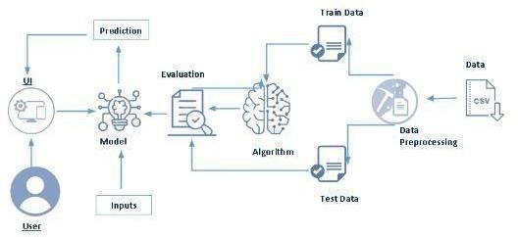

3.2 HARDWARE AND SOFTWARE DESIGNING

PYTHON

Python is an interpreted, object-oriented, high-level programming language with dynamic semantics. It was created by Guido van Rossum , and first released on February 20, 1991. Its high-level built in data structures, combined with dynamic typing and dynamic binding , make it very attractive for Rapid Application Development, as well as for use as a scripting or glue language to connect existing components together. Python's simple, easy to learn syntax emphasizes readability and therefore reduces the cost of program maintenance. Python supports modules and packages, which encourages program modularity and code reuse. The Python interpreter and the extensive standard library are available in source or binary form without charge for all major platforms, and can be freely distributed.

COLAB
Google Colaboratory, or "Colab" as most people call it, is a cloud-based Jupyter notebook environment. It runs in your web browser (you can even run it on your favorite chromabook) and lets anyone with internet access experiment with machine learning and coding for artificial intelligence. You can write and execute python code, share your code and edit it simultaneously with other team members, and document everything by combining it into a single notbookwith rich text, charts, images, HTML, and LaTeX.

VISUAL STUDIO CODE
Visual Studio Code (famously known as VS Code) is a free open source text editor by Microsoft. VS Code is available for Windows, Linux, and macOS. Although the editor is relatively lightweight, it includes some powerful features that have made VS Code one of the most popular development environment tools in recent times.VS Code supports a wide array of programming languages from Java, C++, and Python to CSS, Go, and Dockerfile. Moreover, VS Code allows you to add on and even creating new extensions including code linters, debuggers, and cloud and web development support.

FLASK
Webframework used for building. It is a web application framework written in python which will be running in local browser with a user interface. In this application, whenever the user interacts with UI and selects emoji, it will suggest the best and top movies of that genre to the user.

HARDWARE REQUIREMENTS
Operating system: window 7 and above with 64bit Processor Type -Intel Core i5 3220
RAM: 4Gb and above
Hard disk: min 100GB

4.EXPERIMENTAL INVESTIGATIONS

The text data need to be organized before proceeding with the project. The original dataset has a single folder. We will be using the city_day.csv file to fetch the text data of training data. The datas need to be unique and all fields need to be filled.The dataset images are to be pre-processed before giving to the model. We will create a function that uses the pre-trained model for predicting custom outputs. Then we have to test and train the model. After the model is build, we will be integrating it to a web application

5.FLOWCHART
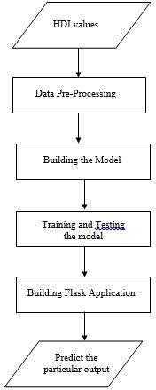

6.RESULT
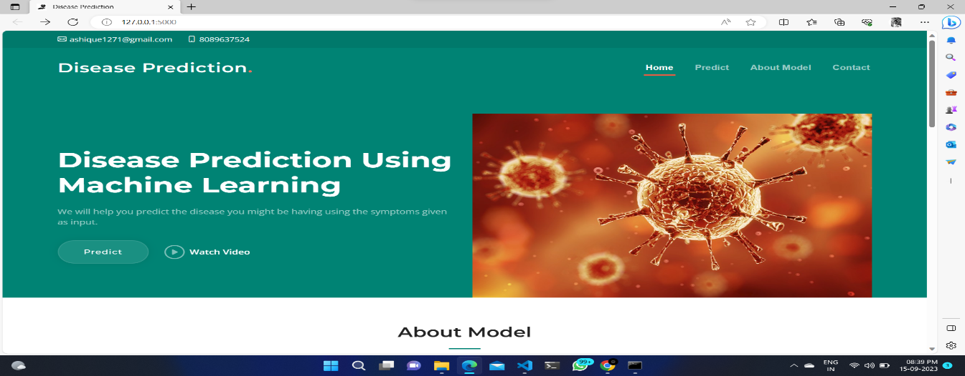

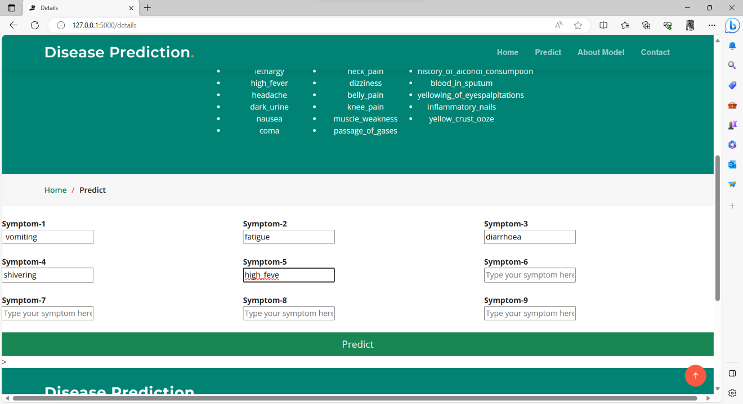

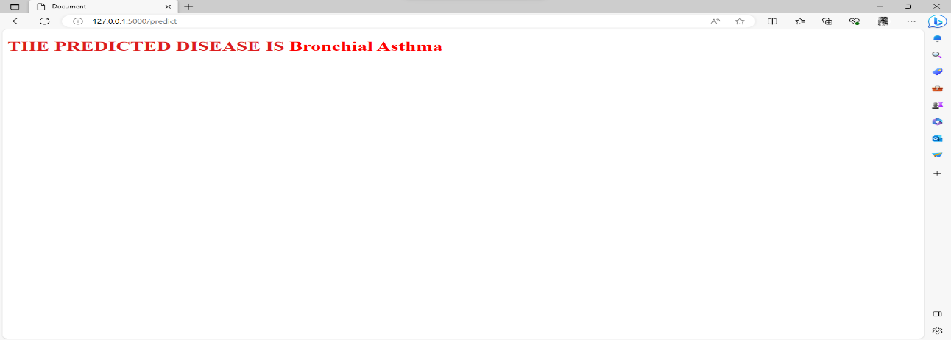

7.ADVANTAGES & DISADVANTAGES
ADVANTAGES
- Easy to use
- Cost efficient
- Time efficient
DISADVANTAGES
- Always prediction is not possible
- Not accurate always

8.APPLICATIONS
- Help improve healthcare by enabling early diagnosis and intervention.
- Analyse patient data to identify patterns and precict the likelihood of a disease or condition.
9.CONCLUSION
Disease prediction using machine learning has the potential to revolutionize healthcare by enabling diagnosis,personalized treatment ,and improved healthcare efficiency.With the increasing availability of patient data and advancements in machine learning algorithms ,disease prediction using machine learning is poised to become n essential tool in the fight againts diseases.

10.FUTURE SCOPE
In the future,the model can be used in various sectors and can enhance efficiency by considering more symptoms to predict diseases. The model can be used for providing an enhanced, more accurate framework that would lead to better human disease prediction model.

11.BIBILOGRAPHY
SOURCE CODE
1.app.py

from flask import Flask, render_template, request
import numpy as np
import pickle

# Load the model and initialize the Flask app
model = pickle.load(open('model.pkl', 'rb'))
app = Flask(__name__)

@app.route("/")
def home():
return render_template('index.html')

@app.route('/details')
def pred():
return render_template('details.html')

@app.route('/predict', methods=['POST', 'GET'])
def predict():

if request.method == 'POST':
# Define the list of symptoms
col = [
'itching', 'continuous_sneezing', 'shivering', 'joint_pain',
'stomach_pain', 'vomiting', 'fatigue', 'weight_loss', 'restlessness',
'lethargy', 'high_fever', 'headache', 'dark_urine', 'nausea',
'pain_behind_the_eyes', 'constipation', 'abdominal_pain', 'diarrhoea',
'mild_fever', 'yellowing_of_eyes', 'malaise', 'phlegm', 'congestion',
'chest_pain', 'fast_heart_rate', 'neck_pain', 'dizziness',
'puffy_face_and_eyes', 'knee_pain', 'muscle_weakness',
'passage_of_gases', 'irritability', 'muscle_pain', 'belly_pain',
'abnormal_menstruation', 'increased_appetite', 'lack_of_concentration',
'visual_disturbances', 'receiving_blood_transfusion', 'coma',
'history_of_alcohol_consumption', 'blood_in_sputum', 'palpitations',
'inflammatory_nails', 'yellow_crust_ooze'
]

# Get the selected symptoms from the form
selected_symptoms = [col[x] for x in range(0, 45) if col[x] in request.form]

# Create a binary array for symptoms
b = [1 if col[i] in selected_symptoms else 0 for i in range(0, 45)]
b = np.array(b).reshape(1, -1)

# Make the prediction using the model
prediction = model.predict(b)
predicted_disease = prediction[0]
print(f"Predicted Disease: {predicted_disease}")
return render_template('results.html', prediction_text='{}'.format(predicted_disease))

if __name__ == "__main__":
app.debug = True
app.run()

2.result.html
<!DOCTYPE html>
<html lang="en">
<head>
<meta charset="UTF-8">
<meta name="viewport" content="width=device-width, initial-scale=1.0">
<title>Document</title>
</head>
<body>
<h1 style="color:rgb(221, 28, 28)">THE PREDICTED DISEASE IS <span style="color:#ff0000;font-weight:bold;">{{prediction_text}}</span></h1>
</body>
</html>

3.details.html
<!DOCTYPE html>
<html lang="en">

<head>
<meta charset="utf-8">
<meta content="width=device-width, initial-scale=1.0" name="viewport">

<title>Details</title>
<style>
ul {
columns: 3;
-webkit-columns: 3;
-moz-columns: 3;
}
</style>
<meta content="" name="description">
<meta content="" name="keywords">

<!-- Favicons -->
<link href="https://static.vecteezy.com/system/resources/previews/000/355/283/non_2x/vector-health-icon.jpg" rel="icon">
<link href="https://static.vecteezy.com/system/resources/previews/000/355/283/non_2x/vector-health-icon.jpg" rel="apple-touch-icon">

<!-- Google Fonts -->
<link rel="preconnect" href="https://fonts.googleapis.com">
<link rel="preconnect" href="https://fonts.gstatic.com" crossorigin>
<link href=https://fonts.googleapis.com/css2?family=Open+Sans:ital,wght@0,300;0,400;0,500;0,600;0,700;1,300;1,400;1,600;1,
&family=Montserrat:ital,wght@0,300;0,400;0,500;0,600;0,700;1,300;1,400;1,500;1,600;1,700&family=Raleway:ital,wght@0,300;0,400;0,500;0,600;0,700;1,300;1,400;1,500;1,600;1,700&display=swap" rel="stylesheet">

<!-- Vendor CSS Files -->
<link href="static/vendor/bootstrap/css/bootstrap.min.css" rel="stylesheet">
<link href="static/vendor/bootstrap-icons/bootstrap-icons.css" rel="stylesheet">
<link href="static/vendor/aos/aos.css" rel="stylesheet">
<link href="static/vendor/glightbox/css/glightbox.min.css" rel="stylesheet">
<link href="static/vendor/swiper/swiper-bundle.min.css" rel="stylesheet">

<!-- Template Main CSS File -->
<link href="static/css/main.css" rel="stylesheet">

<!-- =======================================================
* Template Name: Impact
* Updated: Mar 10 2023 with Bootstrap v5.2.3
* Template URL: https://bootstrapmade.com/impact-bootstrap-business-website-template/
* Author: BootstrapMade.com
* License: https://bootstrapmade.com/license/
======================================================== -->
</head>

<body>

<!-- ======= Header ======= -->
<section id="topbar" class="topbar d-flex align-items-center">
<div class="container d-flex justify-content-center justify-content-md-between">
<div class="contact-info d-flex align-items-center">
<i class="bi bi-envelope d-flex align-items-center"><a href="mailto:contact@example.com">ashique1271@gmail.com</a></i>
<i class="bi bi-phone d-flex align-items-center ms-4"><span>1234567891</span></i>
</div>
</div>
</section><!-- End Top Bar -->

<header id="header" class="header d-flex align-items-center">

<div class="container-fluid container-xl d-flex align-items-center justify-content-between">
<a href="index.html" class="logo d-flex align-items-center">
<!-- Uncomment the line below if you also wish to use an image logo -->
<!-- <img src="static/img/logo.png" alt=""> -->
<h1>Disease Prediction<span>.</span></h1>
</a>
<nav id="navbar" class="navbar">
<ul style="color: white">
<li><a href="/">Home</a></li>
<li><a href = "/details">Predict</a></li>
<li><a href="/">About Model</a></li>
<li><a href="/">Contact</a></li>
</ul>
</nav><!-- .navbar -->
<i class="mobile-nav-toggle mobile-nav-show bi bi-list"></i>
<i class="mobile-nav-toggle mobile-nav-hide d-none bi bi-x"></i>

</div>
</header><!-- End Header -->
<!-- End Header -->

<main id="main">

<!-- ======= Breadcrumbs ======= -->
<div class="breadcrumbs">
<div class="page-header d-flex align-items-center" style="background-image: url('');">
<div class="container position-relative">
<div class="row d-flex justify-content-center">
<div class="col-lg-6 text-center">
<h2>Disease Prediction</h2>
<p>You will have the input box below where you can select your symptoms.</p>
<p>You can input the number of symptoms you have and leave others blank.</p>
<p>This is the list of the symptoms . If you have symptoms which are from this list please enter the symptom in the same form as shown below.</p>
<div class="container">
<ul class="list" style="color: white">
<li class="list-item">itching</li>
<li class="list-item">muscle_pain</li>
<li class="list-item">shivering</li>
<li class="list-item">joint_pain</li>
<li class="list-item">stomach_pain</li>
<li class="list-item">vomiting</li>
<li class="list-item">fatigue</li>
<li class="list-item">weight_loss</li>
<li class="list-item">restlessness</li>
<li class="list-item">lethargy</li>
<li class="list-item">high_fever</li>
<li class="list-item">headache</li>
<li class="list-item">dark_urine</li>
<li class="list-item">nausea</li>
<li class="list-item">coma</li>
<li class="list-item">constipation</li>
<li class="list-item">abdominal_pain</li>
<li class="list-item">diarrhoea</li>
<li class="list-item">mild_fever</li>
<li class="list-item">malaise</li>
<li class="list-item">phlegm</li>
<li class="list-item">congestion</li>
<li class="list-item">chest_pain</li>
<li class="list-item">fast_heart_rate</li>
<li class="list-item">neck_pain</li>
<li class="list-item">dizziness</li>
<li class="list-item">belly_pain</li>
<li class="list-item">knee_pain</li>
<li class="list-item">muscle_weakness</li>
<li class="list-item">passage_of_gases</li>
<li class="list-item">irritability</li>
<li class="list-item">continuous_sneezing</li>
<li class="list-item">puffy_face_and_eyes</li>
<li class="list-item">abnormal_menstruation</li>
<li class="list-item">increased_appetite</li>
<li class="list-item">lack_of_concentration</li>
<li class="list-item">visual_disturbances</li>
<li class="list-item">receiving_blood_transfusion</li>
<li class="list-item">pain_behind_the_eyes</li>
<li class="list-item">history_of_alcohol_consumption</li>
<li class="list-item">blood_in_sputum</li>
<li class="list-item">yellowing_of_eyespalpitations</li>
<li class="list-item">inflammatory_nails</li>
<li class="list-item">yellow_crust_ooze</li>
</ul>
</div>
</div>
</div>
</div>
</div>
<nav>
<div class="container">
<ol>
<li><a href="/">Home</a></li>
<li>Predict</li>
</ol>
</div>
</nav>
</div><!-- End Breadcrumbs -->

<div class="row">
<form action="/predict" method="post" class="col s12">

<br>
<div class="row">
<div class="input-field col s4">
<label for="s1"><b>Symptom-1</b></label>
<br>
<input id="s1" name="Symptom1" placeholder="Type your symptom here" type="text" class="validate">
</div>

<div class="input-field col s4">
<label for="s2"><b> Symptom-2</b></label>
<br>
<input id="s2" name="Symptom2" placeholder="Type your symptom here" type="text" class="validate">
</div>

<div class="input-field col s4">
<label for="s3"><b>Symptom-3</b></label>
<br>
<input id="s3" name="Symptom3" placeholder="Type your symptom here" type="text" class="validate">
</div>
</div>

<br>
<div class="row">
<div class="input-field col s4">
<label for="s4"><b>Symptom-4</b></label>
<br>
<input id="s4" name="Symptom4" placeholder="Type your symptom here" type="text" class="validate">
</div>

<div class="input-field col s4">
<label for="s5"><b> Symptom-5</b></label>
<br>
<input id="s5" name="Symptom5" placeholder="Type your symptom here" type="text" class="validate">
</div>

<div class="input-field col s4">
<label for="s6"><b>Symptom-6</b></label>
<br>
<input id="s6" name="Symptom6" placeholder="Type your symptom here" type="text" class="validate">
</div>
</div> <br>
<div class="row">
<div class="input-field col s4">
<label for="s7"><b>Symptom-7</b></label>
<br>
<input id="s7" name="Symptom7" placeholder="Type your symptom here" type="text" class="validate">
</div>

<div class="input-field col s4">
<label for="s8"><b> Symptom-8</b></label>
<br>
<input id="s8" name="Symptom8" placeholder="Type your symptom here" type="text" class="validate">
</div>

<div class="input-field col s4">
<label for="s9"><b>Symptom-9</b></label>
<br>
<input id="s9" name="Symptom9" placeholder="Type your symptom here" type="text" class="validate">
</div>
</div>

<br>
<div class="row center">
<button type="submit" class="btn btn-success btn-lg" style="color:rgb(237, 239, 241)">Predict</button>
</div>
</form>
</div>

</div>
</div>
</div>
</div>>
</main><!-- End #main -->
<!-- ======= Footer ======= -->
<footer id="footer" class="footer">

<div class="container">
<div class="row gy-4">
<div class="col-lg-5 col-md-12 footer-info">
<a href="index.html" class="logo d-flex align-items-center">
<span>Disease Prediction</span>
</a>
<p>Preventive Diagnosis at your convenience.</p>
</div>

<div class="col-lg-2 col-6 footer-links">

<div class="col-lg-3 col-md-12 footer-contact text-center text-md-start">
<h4>Contact Us</h4>
<p>
ALEENA<br>
AKHILAANA<br>
ROSS <br><br>
<strong>Phone:</strong> 8089637524<br>
<strong>Email:</strong> ashique1271@gmail.com<br>
</p>

</div>

</div>
</div>
<div class="container mt-4">
<div class="copyright">
&copy; Copyright <strong><span>Disease Prediction</span></strong>. All Rights Reserved!!!created by:aleena,akhilana,ross,ashique
</div>
<div class="credits">
<!-- All the links in the footer should remain intact. -->
<!-- You can delete the links only if you purchased the pro version. -->
<!-- Licensing information: https://bootstrapmade.com/license/ -->
<!-- Purchase the pro version with working PHP/AJAX contact form: https://bootstrapmade.com/impact-bootstrap-business-website-template/ -->
</div>
</div>

</footer><!-- End Footer -->
<!-- End Footer -->
<a href="#" class="scroll-top d-flex align-items-center justify-content-center"><i class="bi bi-arrow-up-short"></i></a>

<div id="preloader"></div>

<!-- Vendor JS Files -->
<script src="static/vendor/bootstrap/js/bootstrap.bundle.min.js"></script>
<script src="static/vendor/aos/aos.js"></script>
<script src="static/vendor/glightbox/js/glightbox.min.js"></script>
<script src="static/vendor/purecounter/purecounter_vanilla.js"></script>
<script src="static/vendor/swiper/swiper-bundle.min.js"></script>
<script src="static/vendor/isotope-layout/isotope.pkgd.min.js"></script>
<script src="static/vendor/php-email-form/validate.js"></script>

<!-- Template Main JS File -->
<script src="static/js/main.js"></script>

</body>

</html>

