

DA_Assignment 1



August 30, 2023

VIT-AP

ANDHRA PRADESH, AMARAVATHI

**NAME:** DERANGULA CHARAN KUMAR

**REG.NO:**21BCB7109

**CAMPUS:** VIT-AP

**COURSE:** Data Analytics with IBM cogon’s Analytics

**DATA MODULE:**

1.Unnecessary columns:

1. Invoice id (cause it’s like serial number)
2. Branch (For unique branch there is unique city)
3. Tax (its fixed for each and every product and also there is total so it’s not necessary)

2.split date as day, month, year and day of the week

**1.Bar graph:**

**Bars:** Day of the Week

**Length**: Quantity

**Colour**: Day of the week

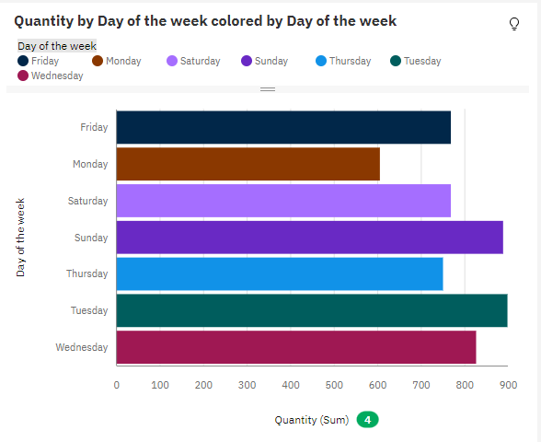

**2.Box plot:**

**x-axis:** product line

**y-axis:** total sales

**key:** day of the week

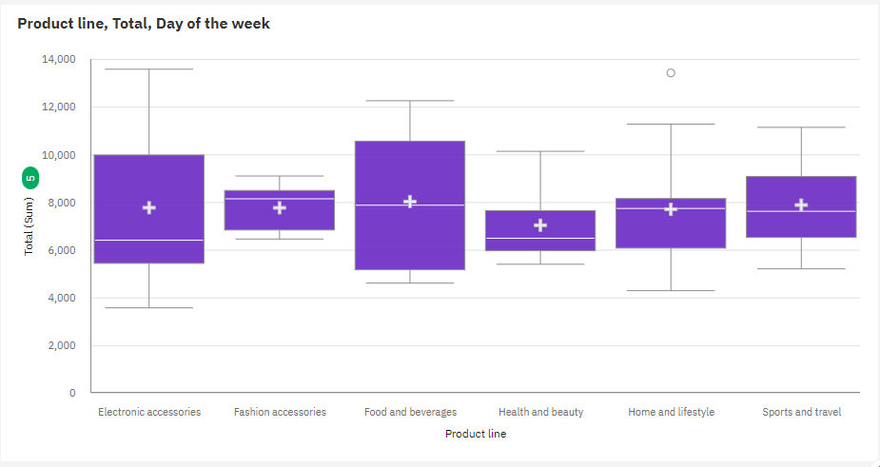

**3. line and column**

**Monthly Sales Trends and Product Line Comparison**

X-Axis: Month (from the "Date" column)

**Column Length:** Total Sales

**Column Colour**: Product Line

**Line Position:** Total Sales

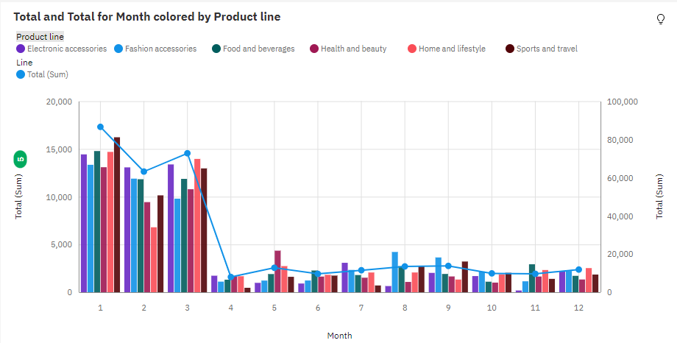

**Gender-based Sales and Rating Analysis**

* **X-Axis:** Gender
* **Column Length:** Total Sales
* **Column Colour:** Payment Method
* **Line Position:** Average Rating

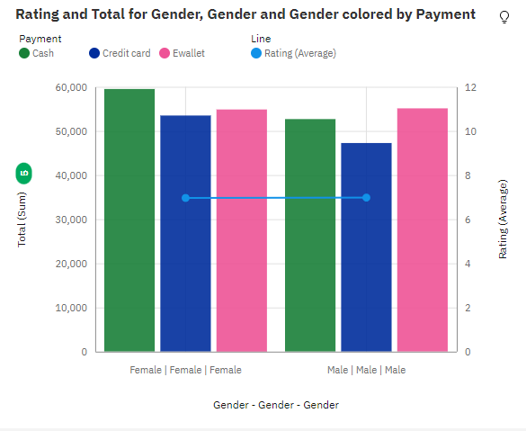

**4.Pi- chart**

**Size:** Total sales

**Segment:** product line

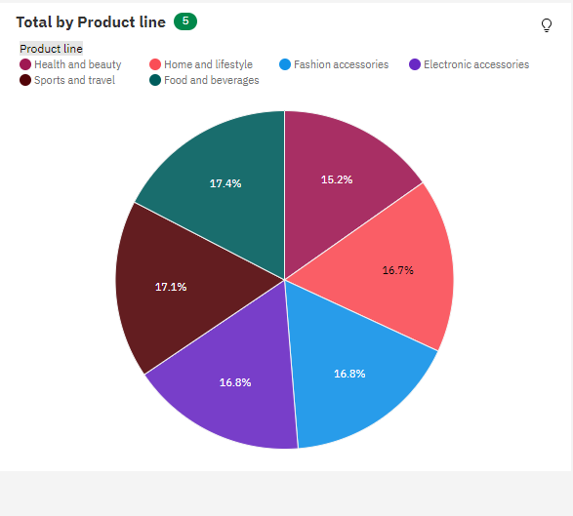

**5. radial**

**Bars:** product line

**Length:** product line   
**colour:** gender

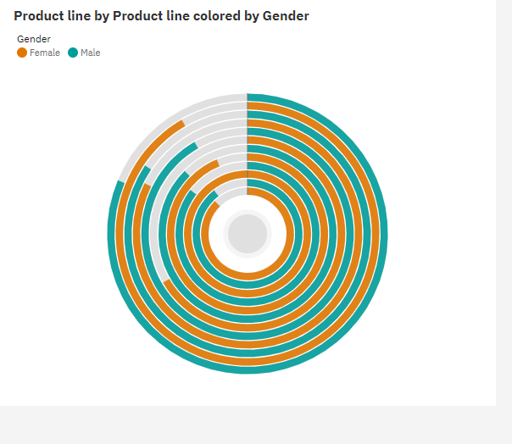

**6. Heat Map**

* **Rows:** Day of the Week
* **Columns:** Product Line
* **Heat:** Total Sales (Colour Intensity)
* **Size (Optional):** Quantity (for size differentiation)

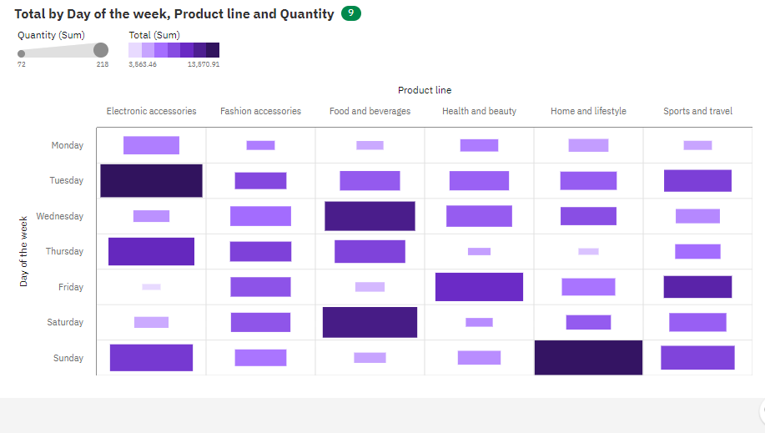

**6. Bubble packed:**

**Bubble:** product line

**Size:** Quantity   
**colour:** gross income

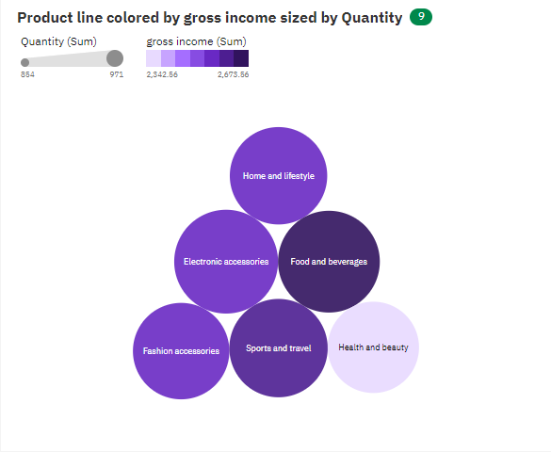

**7. Tree**

* **Hierarchy (Area):** City > Product Line
* **Size:** Total Sales
* **Heat (Colour Intensity):** Gross Income

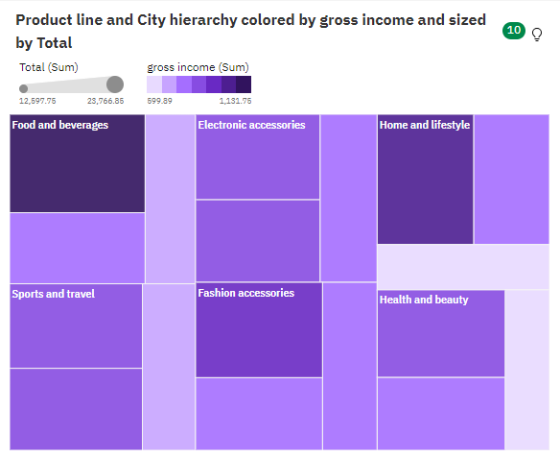

**8.Water fall**

**X-axis:** product line   
**y-axis:** total sales

