

DA_Assignment- 2



August 30, 2023

VIT-AP

ANDHRA PRADESH, AMARAVATHI

**NAME:** DERANGULA CHARAN KUMAR

**REG.NO:**21BCB7109

**CAMPUS:** VIT-AP

**COURSE:** Data Analytics with IBM cogon’s Analytics

**1. Dashboards**

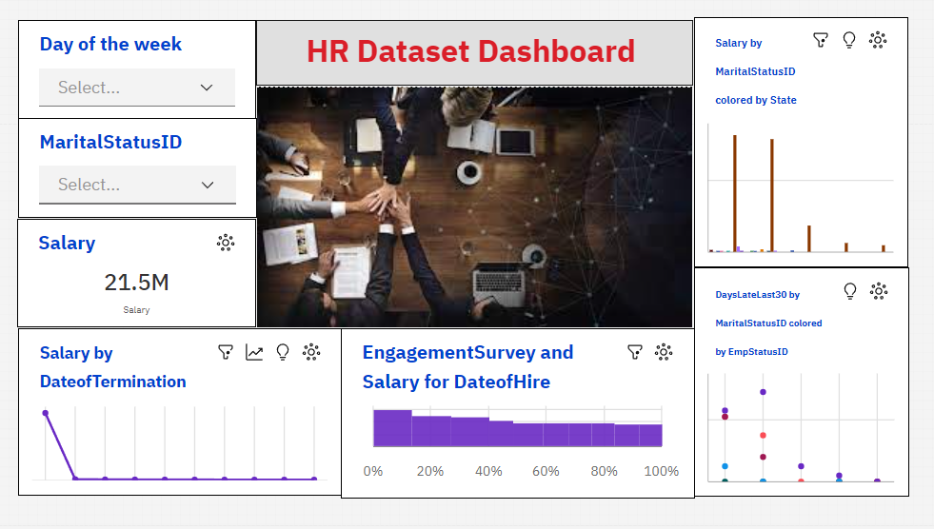

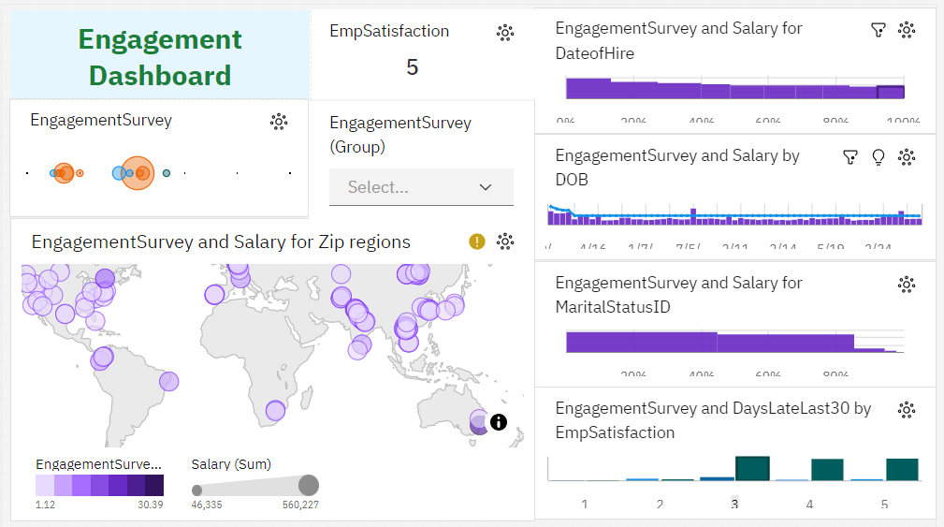

**2. Report**

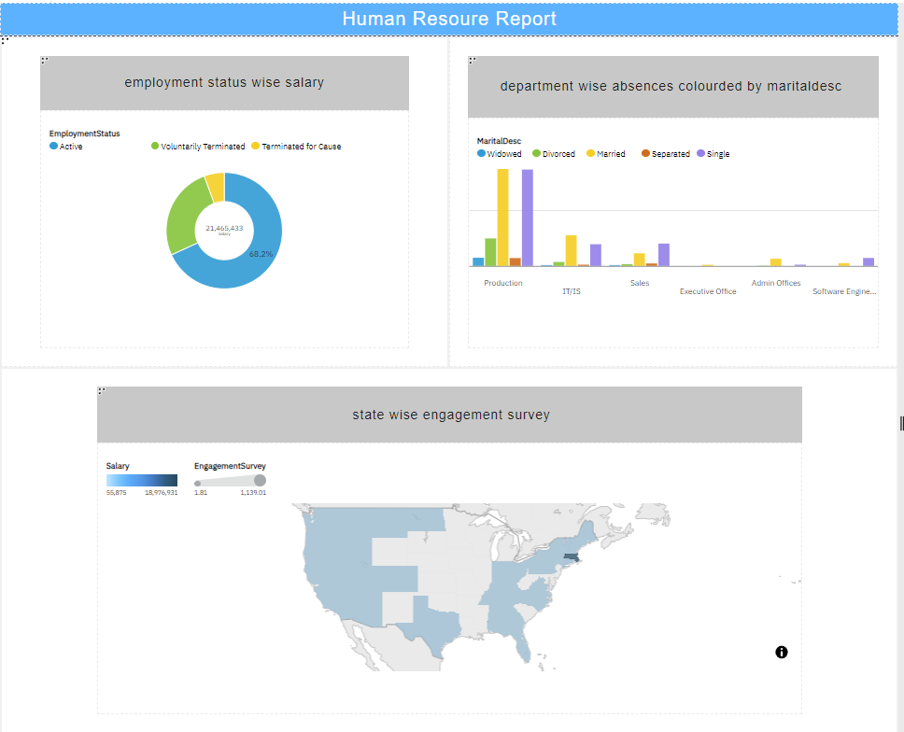

**3. Story**



