

ASSIGNMENT-3



September 14, 2023

VIT-AP

AMARAVATHI, ANDHRA PRADESH

Name: D. Charan Kumar

Reg.No.: 21BCB7109

Campus: VIT-AP

BRANCH: CSB

**1.Bar Graph:**

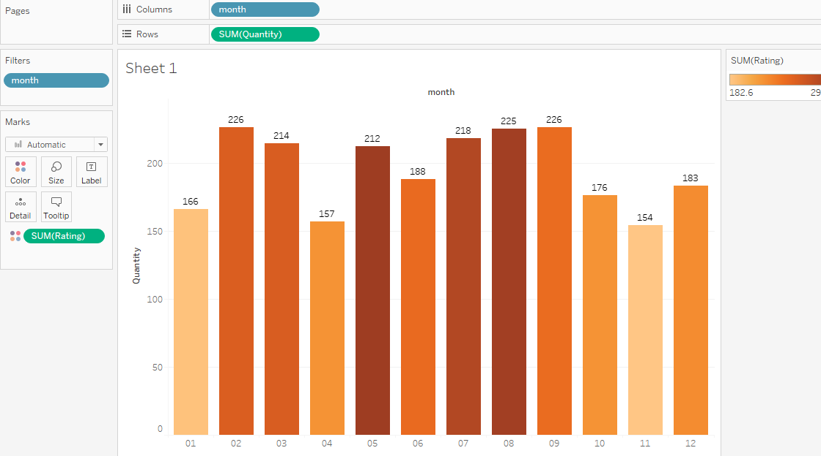

**2.line Graph:**

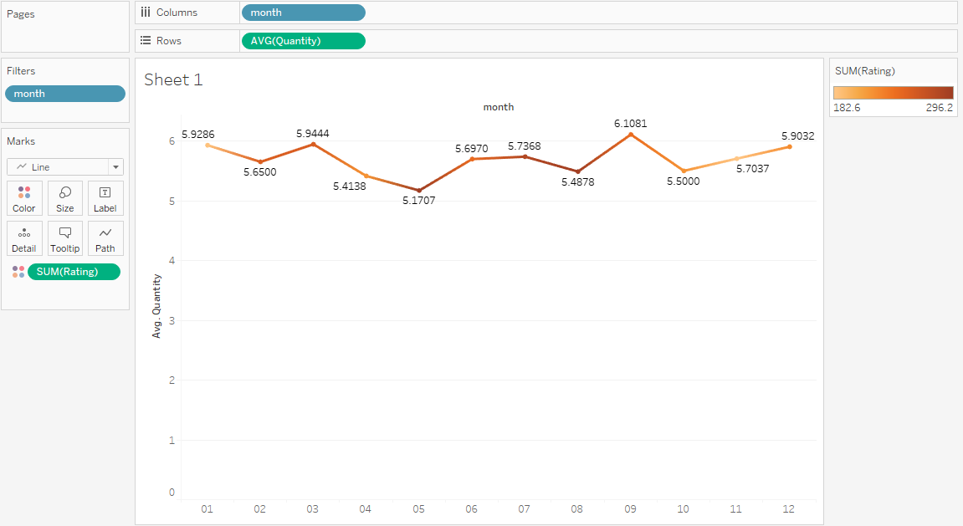

**3.Pi-Chart:**

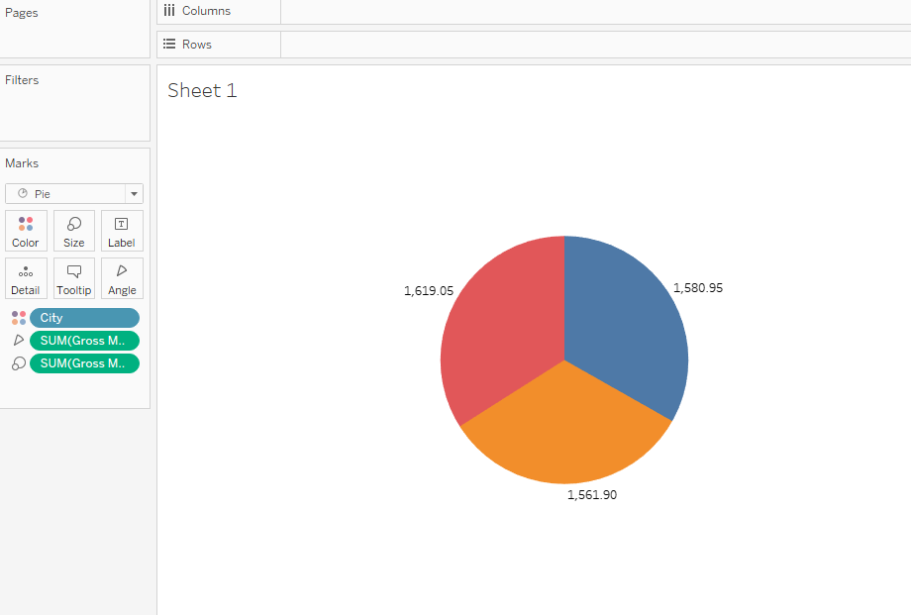

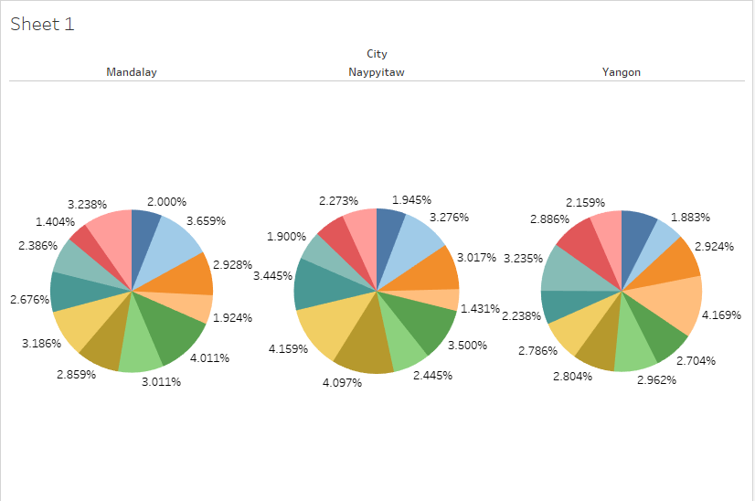

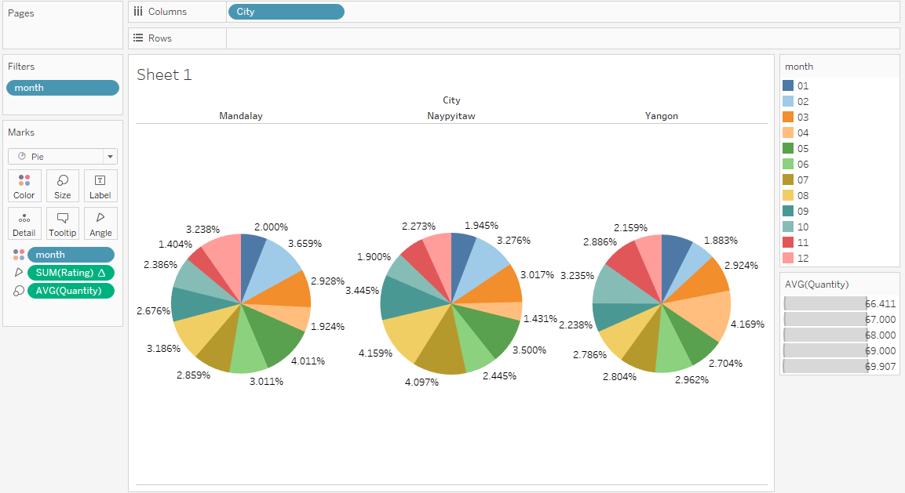

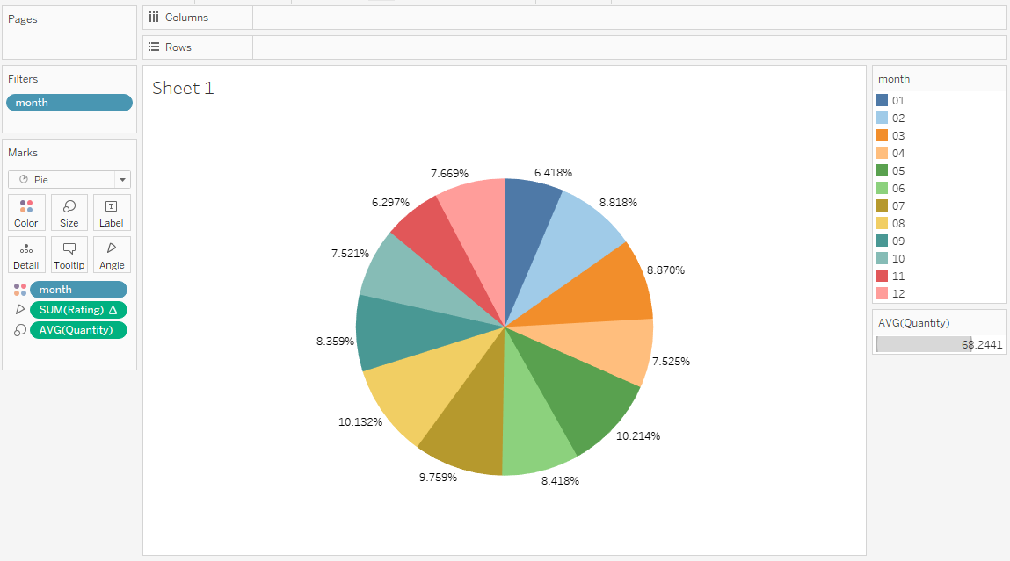

**4.Tree Map:**

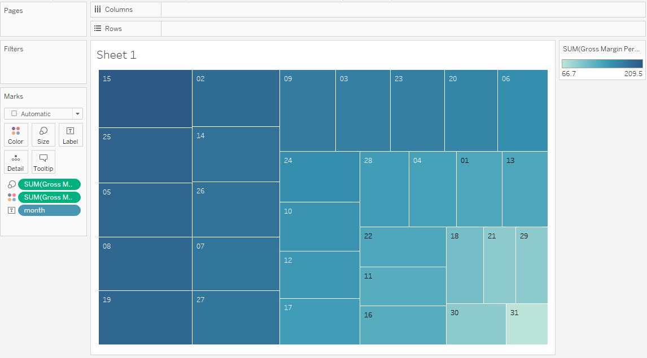

**5.Bubble Chart:**

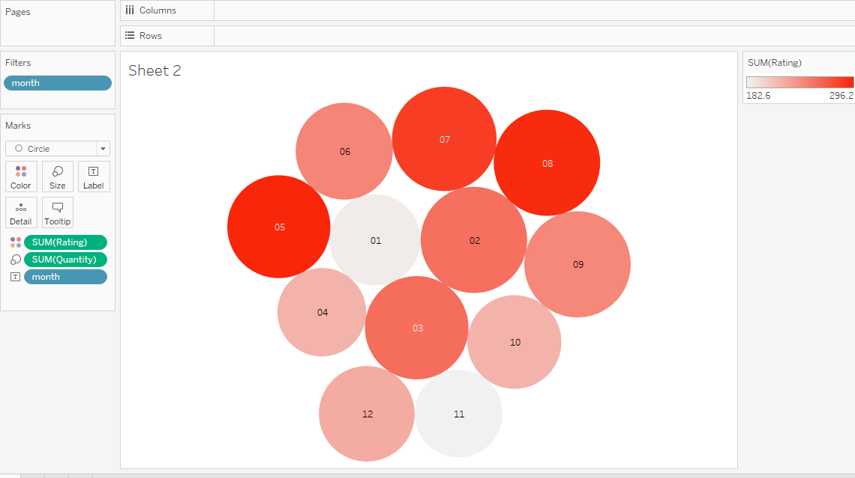

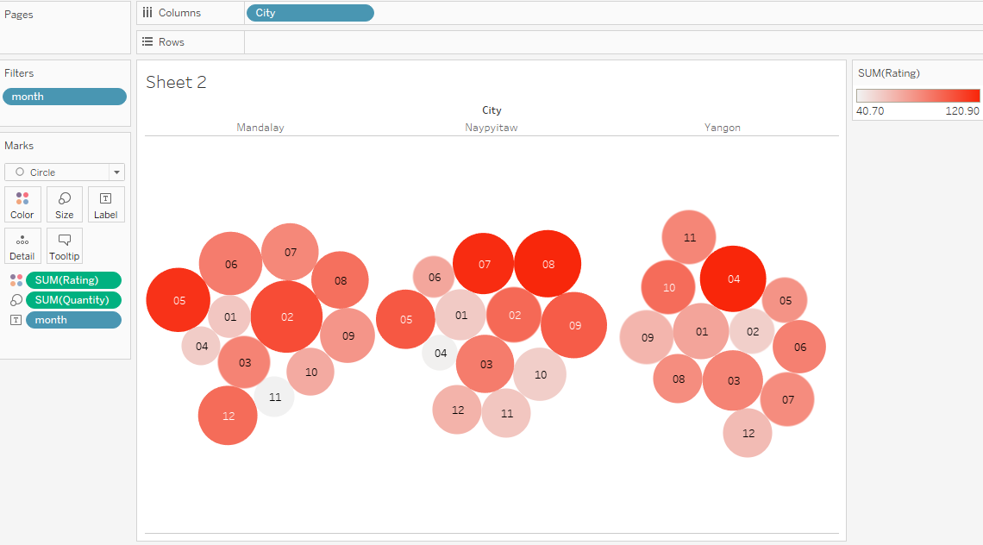

**6.Box Plot:**

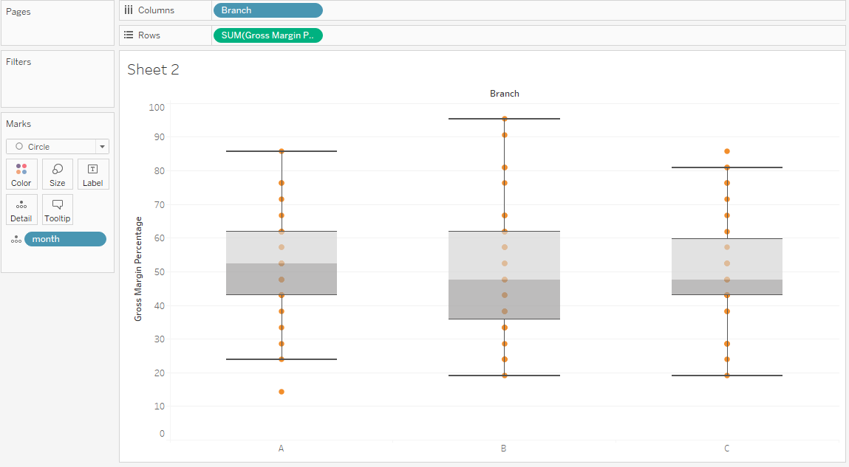

**7.Bullet Graph:**

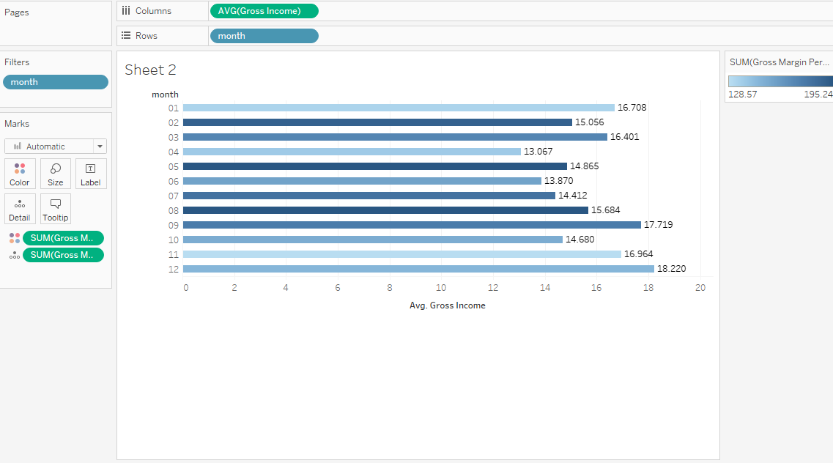

**8.Scatter plot:**

