

DA_Assignment- 4



September 20, 2023

VIT-AP

ANDHRA PRADESH, AMARAVATHI

**NAME:** DERANGULA CHARAN KUMAR

**REG.NO:**21BCB7109

**CAMPUS:** VIT-AP

**COURSE:** Data Analytics with IBM cogon’s Analytics

**Create basic and Lod calculations in Tableau**

**BASIC CALCULATIONS:**

1)Discount ratio

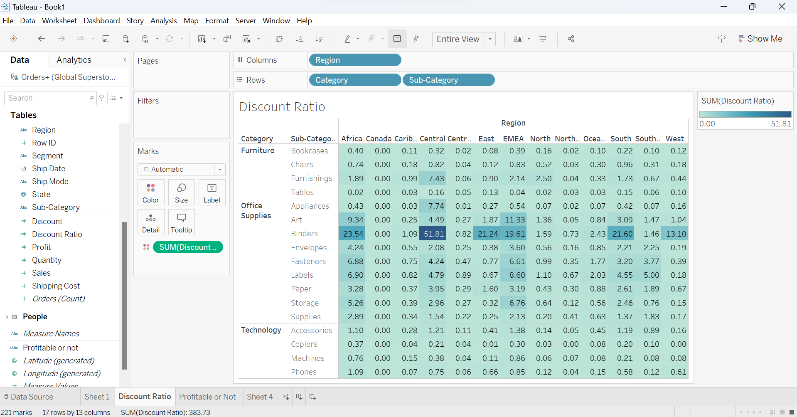

2)Profitable or not

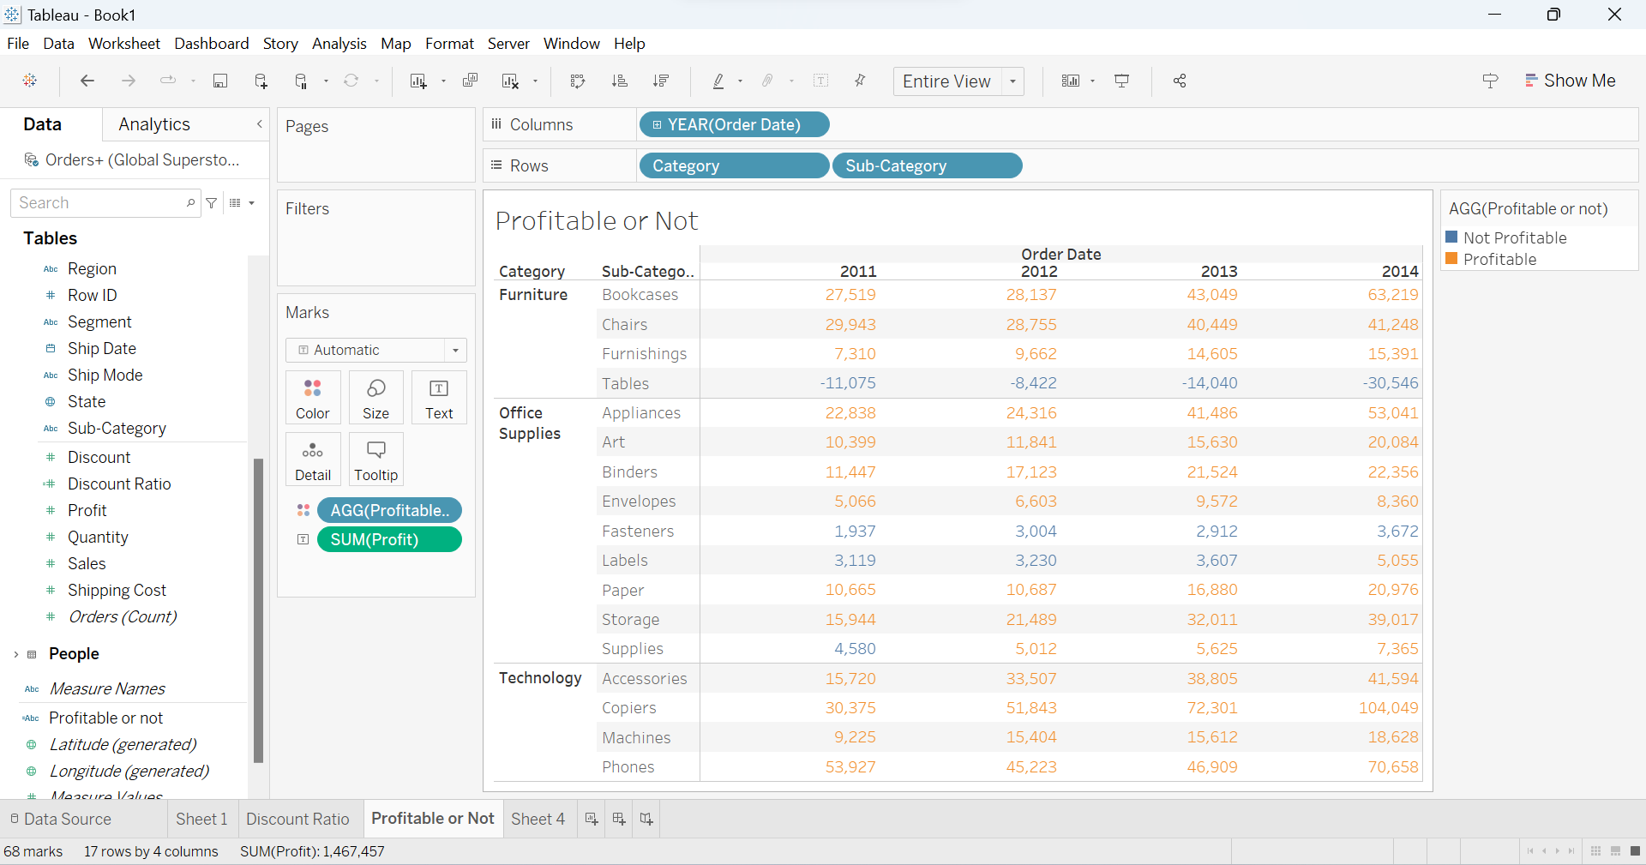

**LOD CALCULATIONS:**

1)Daily Profit KPI:

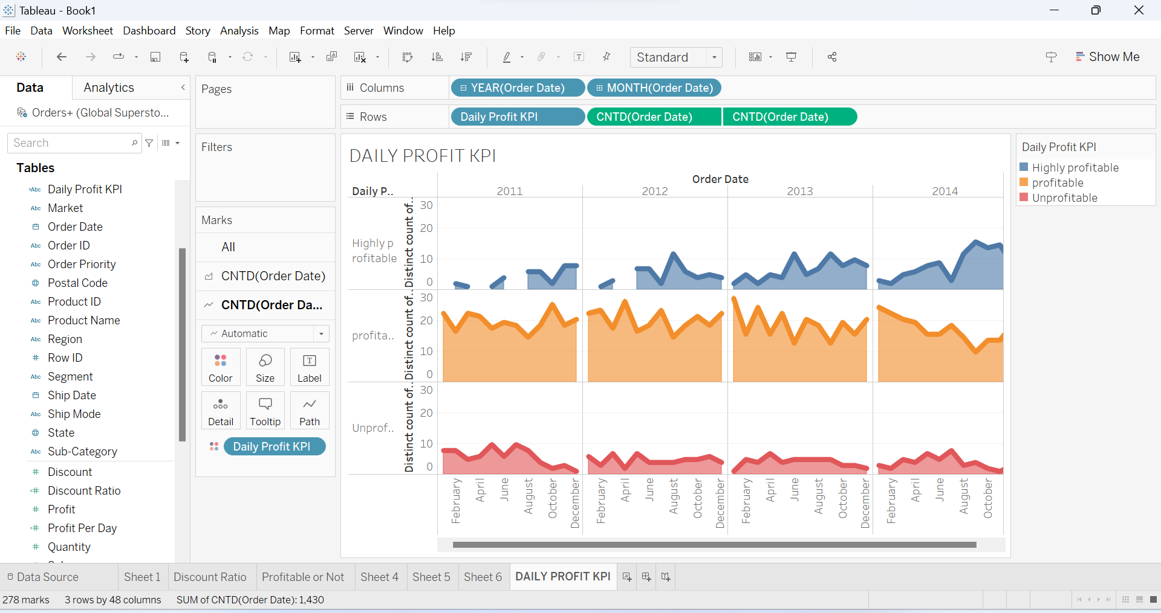

## 2)Customer order frequency

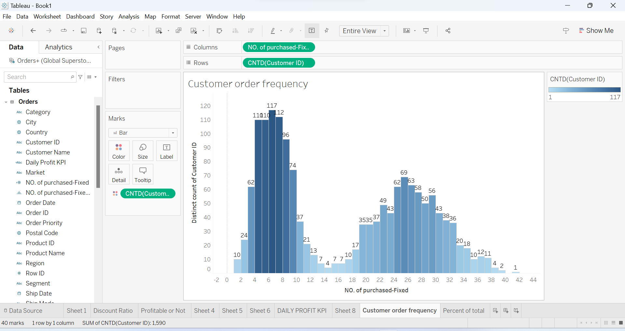

## 3)Percent of total

