ASSIGNMENT-3

**NAME: PEETHA SOMA TEJASWI**

**REG.NO.: 21BCB7133**

**CAMPUS: VIT-AP**

**BRANCH: CSB**

**1.Bar Chart:**

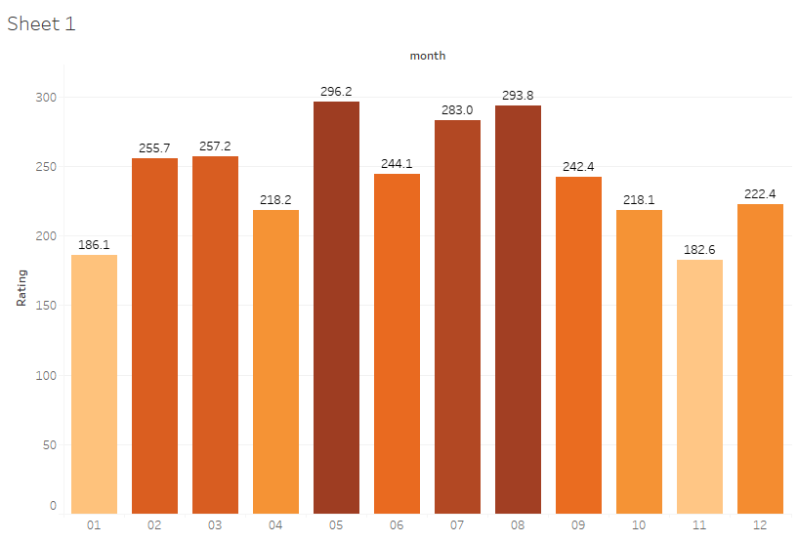

**2.Line graph:**

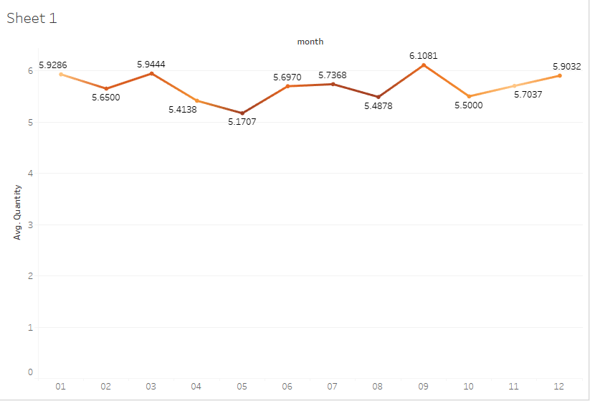

**3.Pi Chart:**

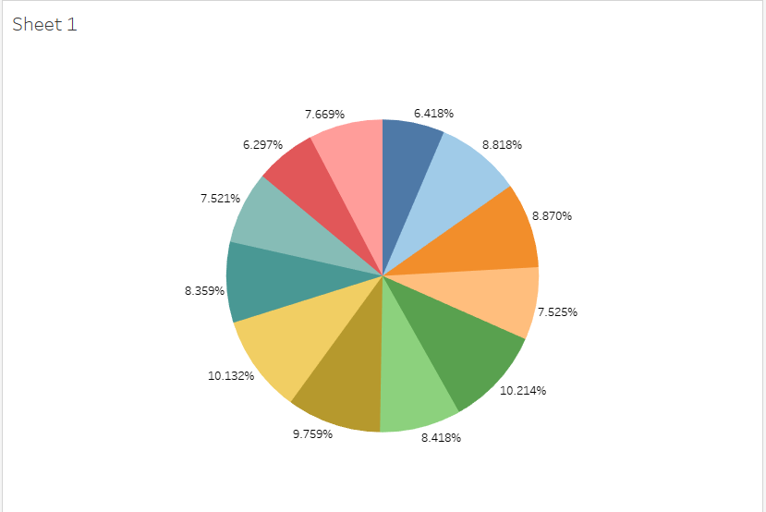

**4.Tree Map:**

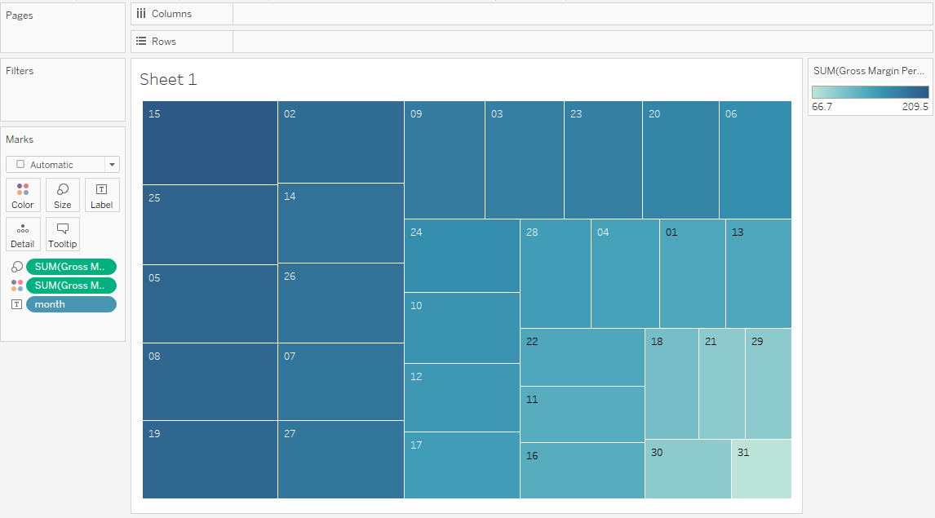

**5.Bubble chart:**

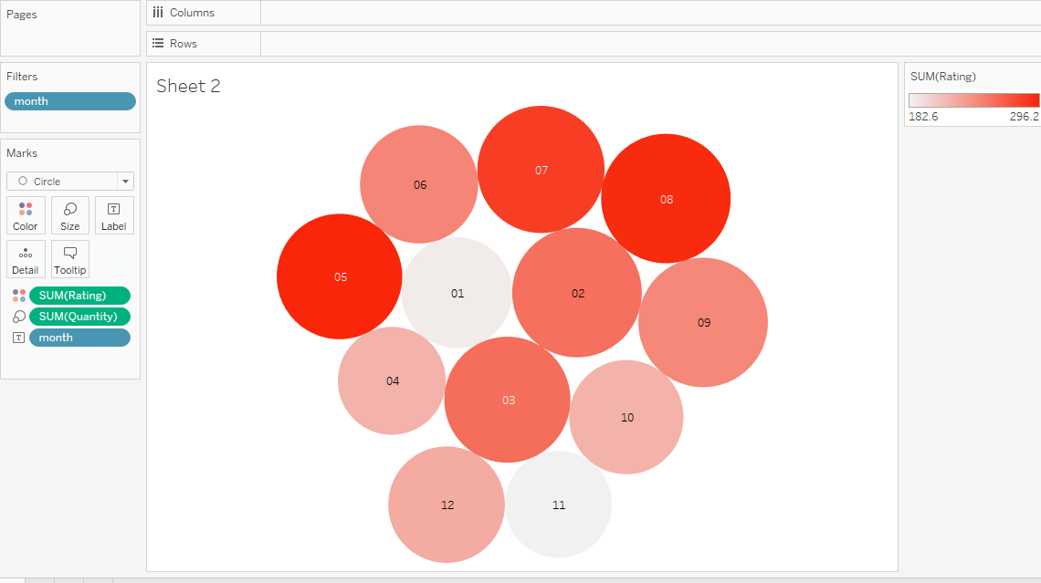

**6.Box plot:**

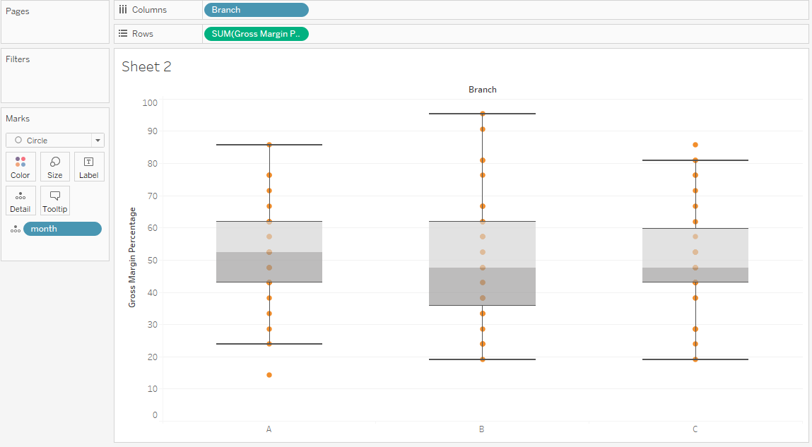

**7.Bullet Graph:**

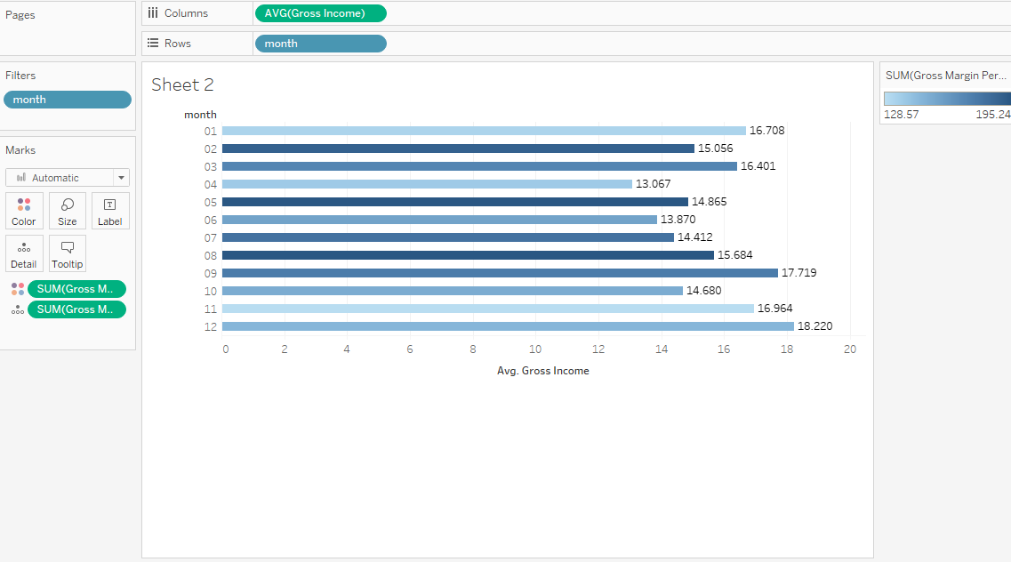

**8.Scatter plot:**

