# IBM WATSON STUDIO FOR BUILDING AN AUTOMATED ESSAY GRADING SYSTEM

MINI PROJECT REPORT

PREPARED BY:

18UK1A05D5 - GUNDAVARAM RAHUL

18UK1A05B3-THAMMISHETTY SOUMYA

18UK1A05D7-JAKKULA PAUSHA

18UK1A05A3-GUNDA ROHITH

## INTRODUCTION:

### OVERVIEW

Essays are crucial testing tools for assessing academic achievement, integration of ideas and ability to recall, but are expensive and time-consuming to grade manually. Manual grading of essays takes up an amount of instructors' valuable time and hence is an expensive process. Automated grading, if proven to match or exceed the reliability of human graders, will reduce costs.  Currently, automated grading is used instead of second graders in some high-stakes applications, and as the only grading scheme in low stakes evaluation. This application can have a high utility in many places. For instance, currently, evaluation of essay writing sections in exams like GRE, GMAT, and TOEFL is done manually. And, so automating such a system may prove to be highly useful.

An automated grading system is built with the magical powers of neural networks. Using automation reduces time and effort in evaluation. NLTK libraries for feature extraction and LSTM are used for the learning process.

### PURPOSE

The purpose of our project i.e. building an automated essay grading system is to allow instructors to quickly grade multiple complex computer literacy assignments. Key to the success of the system is the ability of the system to “learn” the correct and incorrect responses and store them for future use.

## 

## 2. LITERATURE SURVEY:

EXISTING PROBLEM:

Data collection was not a problem. A minor problem occurred during cleaning the data like for our model two steps cleaning is required one for converting essay into list of words and second for converting essay into list of sentences. In first case punctuations(like ., ?, !) were not needed in second case punctuations(like ., ?, !) were required to break into sentences. Feature extraction is complicated and lengthy but no problem occurred. So to grade the essay there will be a lot of complication like to check spellings, punctuations, sentence formations, and the essay in correct format and relevant to the question. So this is the existing problem and for this we have proposed a particular solution.

### PROPOSED SOLUTION:

We used tensor flow to build our model. We used the baseline model to predict scores for the given essays rather than giving feedback .we then feed these embeddings to the multi layered LSTM.Then we feed the output of the LSTM layer to the fully connected layer. An automated grading system is built with the magical powers of neural networks. Using automation reduces time and effort in evaluation. NLTK libraries for feature extraction and LSTM are used for the learning process.

## THEORITICAL ANALYSIS:

### BLOCK DIAGRAM

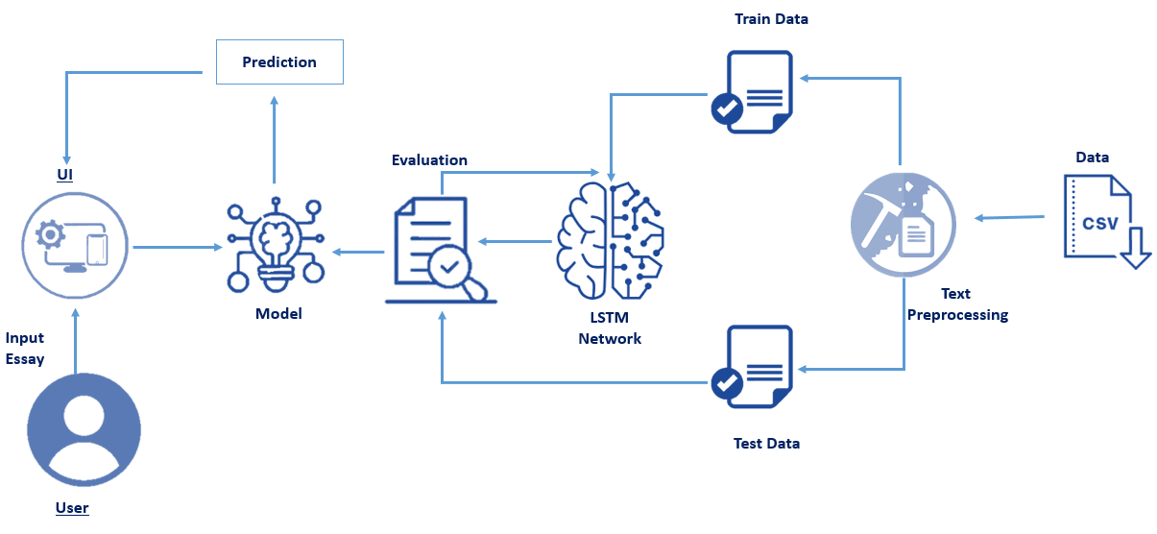

### HARDWARE AND SOFTWARE DESIGN:

For our project we used the python programming language in the jupyter note book and also we used NLP (natural language preprocessing) it is a branch of computer science which is concerned with giving computers the ability to understand text and spoken words in much the same way human beings can.  
Here we also used the libraries like tensorflow and keras utmost for our project.

Keras is a neural network library while Tensor Flow is the open-source library for a number of various tasks in machine learning. Tensor Flow provides both high-level and low-level APIs while Keras provides only high-level APIs. ... Both frameworks thus provide high-level APIs for building and training models with ease. And also here we used the deep learning and LSTM networks which are well-suited to classifying, processing and making predictions based on time series data.

## EXPERIMENTAL INVESTIGATIONS:

Our analysis on doing this project i.e. automated essay grading system is;

From this project we are capable of understanding the text given and how to process it and also to extract the important features from the text. So that the system is automatically giving the grading for the essay generated by user for the particular question and also from our project we can also analyze that we are preprocessing our data with the help of different data pre-processing techniques and also the web applications is built with the help of the flask framework. The below information gives us the idea about our project files folder

* The data folder contains the dataset (.tsv file) and the 8 question descriptions.
* Static folder contains the images which are needed for the flask application development. I can include the style sheets under the css folder.
* Templates folder contains the HTML required.
* App.py the scripting flask file.
* Essay training.ipynb and essay testing.ipynb are the training and testing files.
* .h5 contains the weights which are saved after model training is completed.
* .bin file has the vectors saved after vectorization is done.

## 

## FLOW CHART:

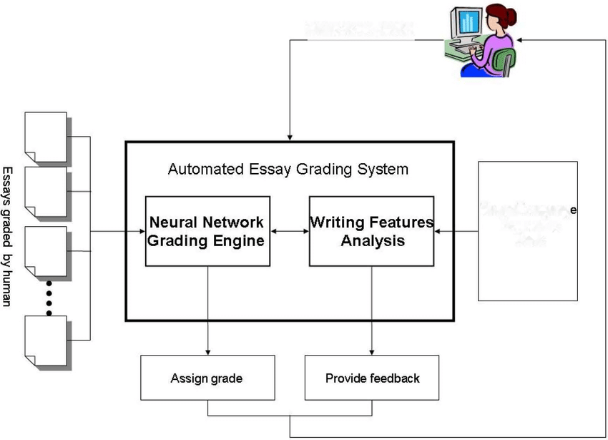

## RESULT:

The result of our project is

The blow is the home page of our project….

The below image is the question that we are given for the essay writing…..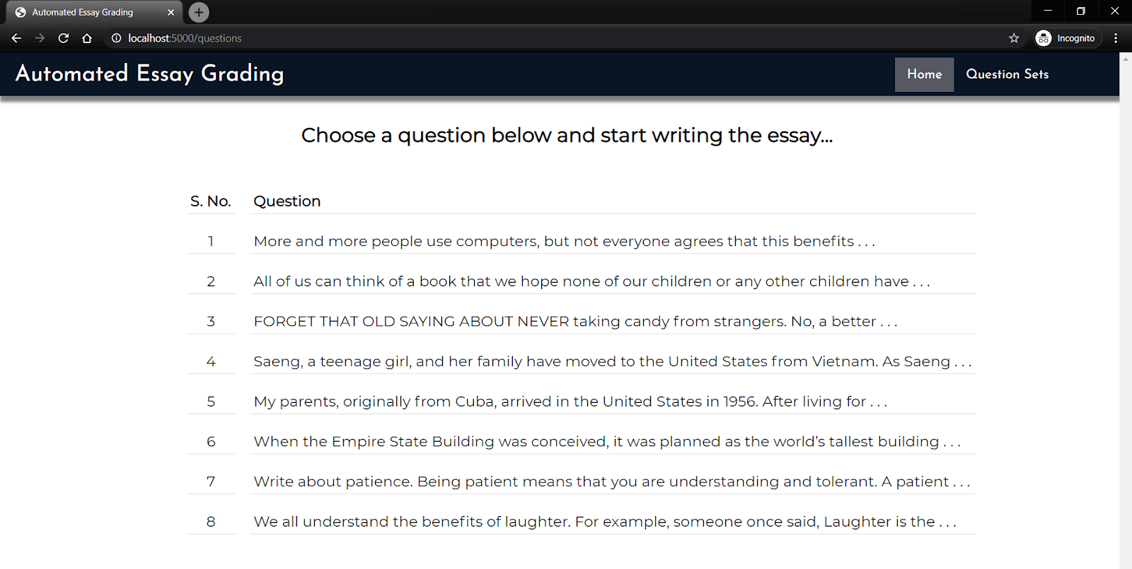

Here the below image shows where to write the essay….!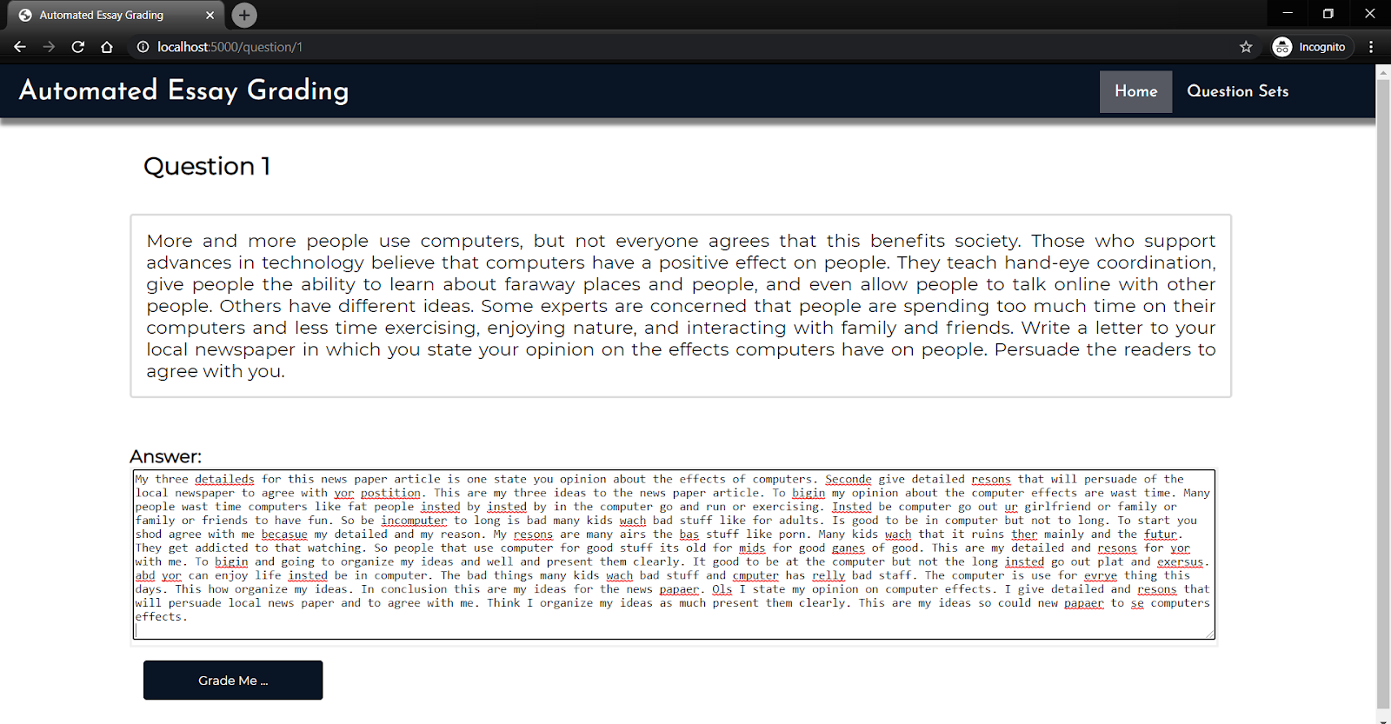

Here the below we can see that the graded has been given….!!!!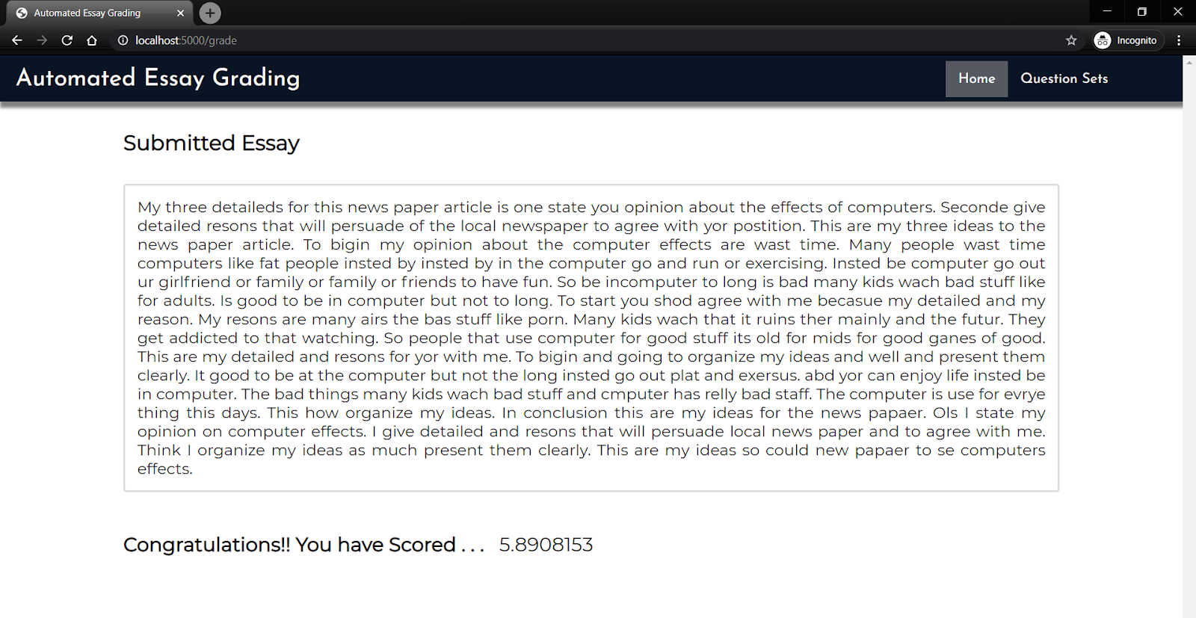

Therefore the above are the result of our project!

## ADVANTAGES AND DISADVANTAGES:

ADVANTAGES:

1. Cost-Efficient – Efficiency aspects include cost reduction and faster results when evaluating essays.
2. AES system is able to evaluate a large number of essays in an effective way as compared to human raters.
3. This automated grading system can work efficiently and can give results in less time for more no. of essays.

DISADVANTAGES:

1. It may not be accurate.
2. It will also give grading when the essay is not relevant to the topic.
3. For now it only checks the sentence formation and the grammar.
4. **CONCLUSION:**

Our model gives out good predictions on the basis of the features considered such as word count, sentence count, prevalence, parts of speech count. The performance on context and sentiment rich essays can be made better by better training our model with larger and more complex datasets and advanced NLP features. The average weighted kappa we have achieved by using this process is above 0.5 which is normally ideal.

1. **REFERENCES:**
2. Manvi Mahana, Mishel Johns, Ashwin Apte. Automated Essay Grading System using Machine Learning, CS229 Machine Learning-Autumn 2012.
3. Y.Harika, I.Sri Latha, V.Lohith Sai, P.Sai Krishna , M.Suneetha. Automated Essay Grading System using Feature Selection. p-ISSN: 2395-0072. Volume: 04 Issue: 03 | March -2017
4. Abhishek Suresh, Manuj Jha. Automated Essay Grading using Natural Language Processing and Support Vector Machine. IJCAT - International Journal of Computing and Technology, Volume 5, Issue 2, February 2018
5. Hassan, Samer and Mihalcea, Rada. “Semantic relatedness using Salient Semantic Analysis” 2012 http://www.cse.unt.edu/ rada/papers/hassan.aaai11.pdf (Accessed: 25 April 2012)
6. Kaggle. ”Develop an automated scoring algorithm for student-written essays.” (2012). <https://www.kaggle.com/c/asap-aes>
7. Drolia, S., et al., Automated Essay Rater using Natural Language Processing. International Journal of Computer Applications, 2017. 163(10).
8. **APPENDIX SOURCE CODE:**

<https://github.com/smartinternz02/SI-GuidedProject-4263-1626242521>

**----------THANK YOU----------**

.