21BCE0999 SAMEER CHAUHAN TASK-15

Aim-We have to perform exploitation using msf console framework in kalli linux on our Metasploitable 2 machine

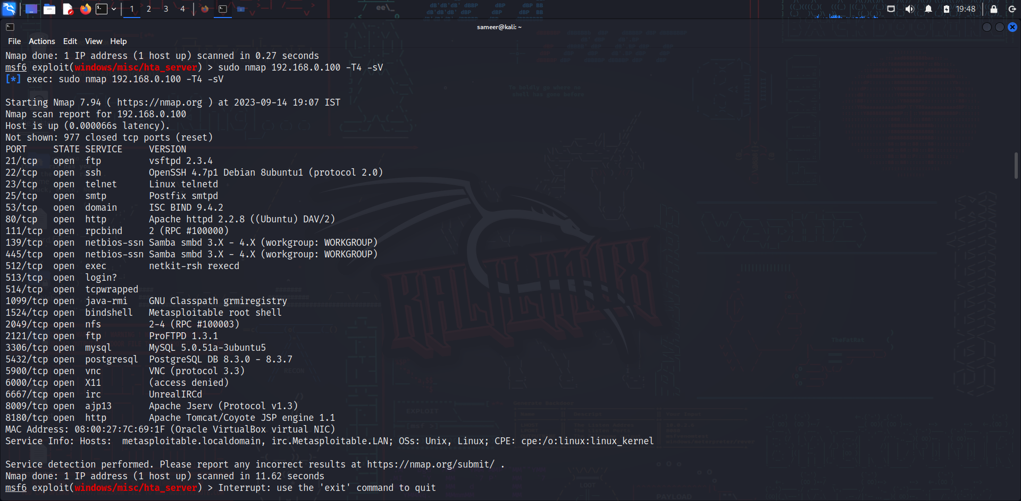

First we will perform nmap scan to scan all the open ports, services running on our meta2 machine

Nmap -A 192.168.0.100 -T4

Now we will take different service versions for exploitations using msf console framework

**1-vsftpd 2.3.4 backdoor command exploitation-**

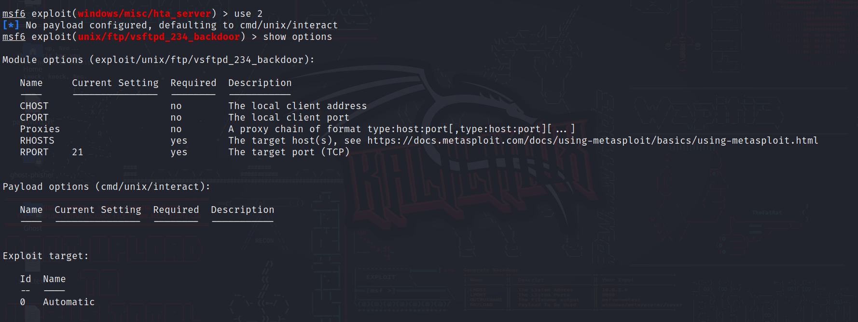

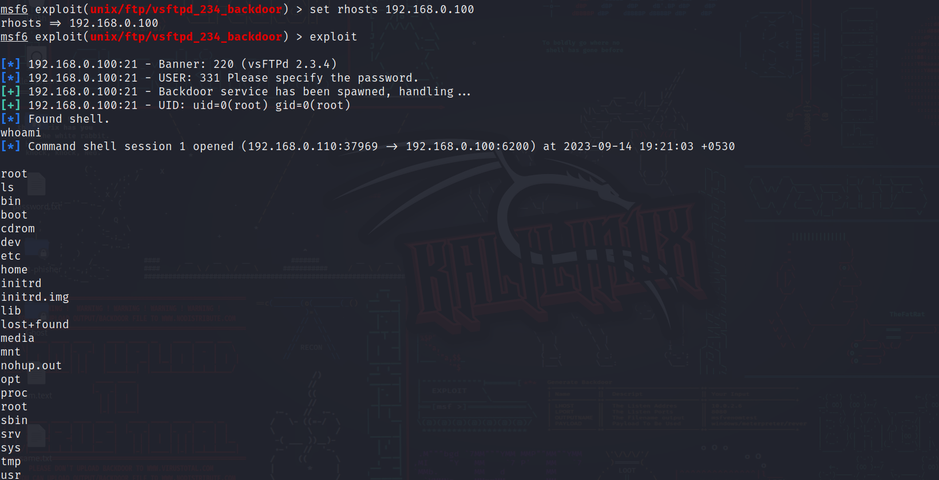

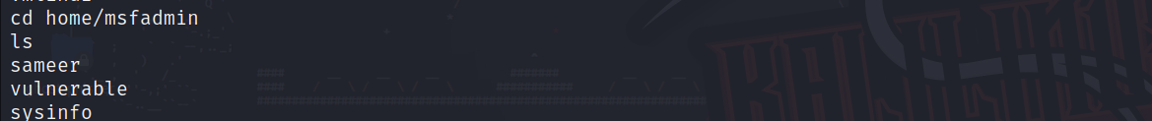

**Here we can see that by exploiting the above vulnerability we gained shell access and hack our meta2 machine**

**2- Samba 2.2x linux –**

**Here we use samba vulnerability and done the exploitation to gain interactive shell access**

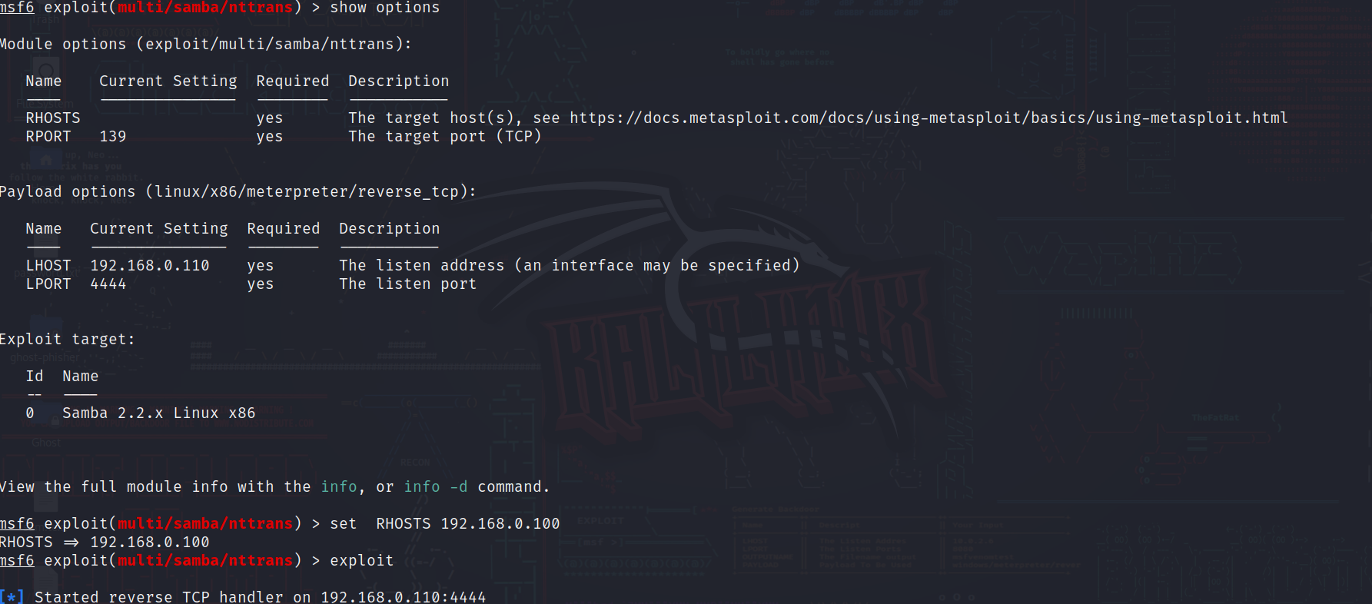

Here we can see in the screenshot we set LHOST,RPORT

And exploit and the reverse tcp handler listened and the we got shell access

3-Pro FTPD 1.3.1 exploitation

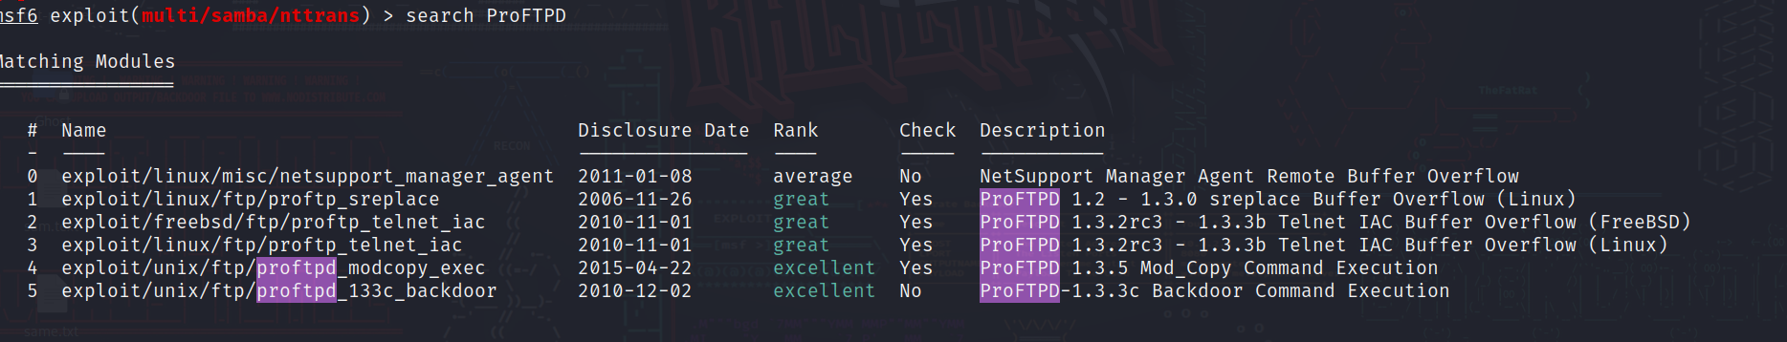

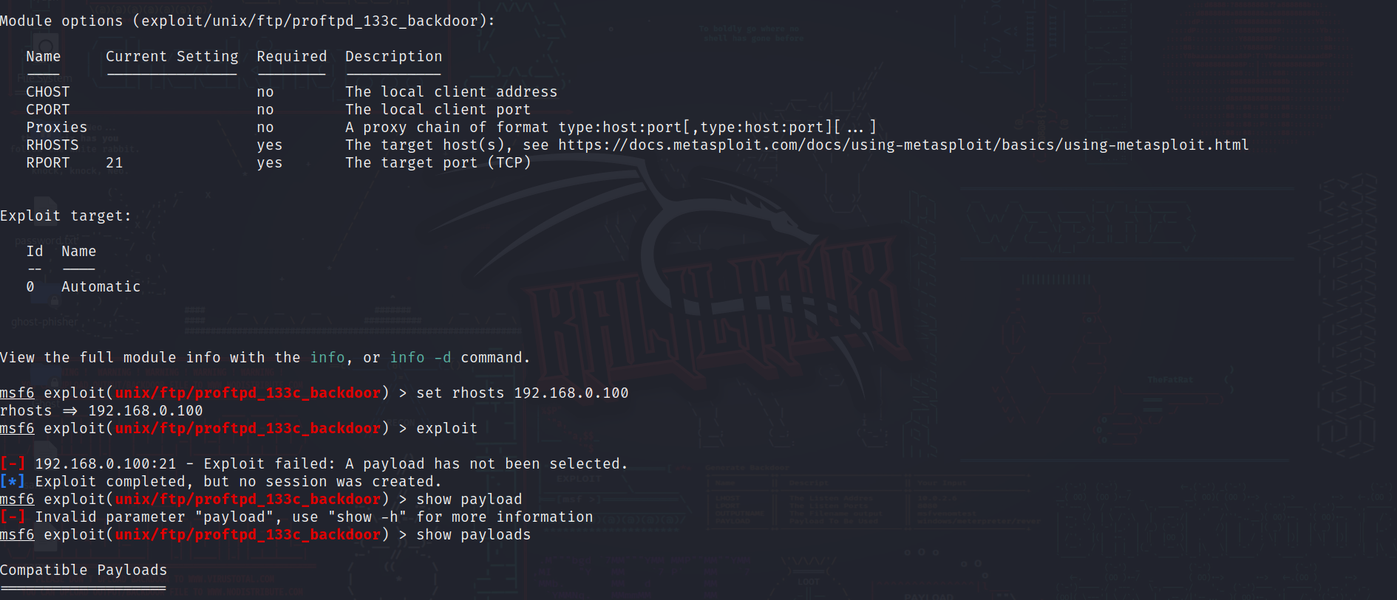

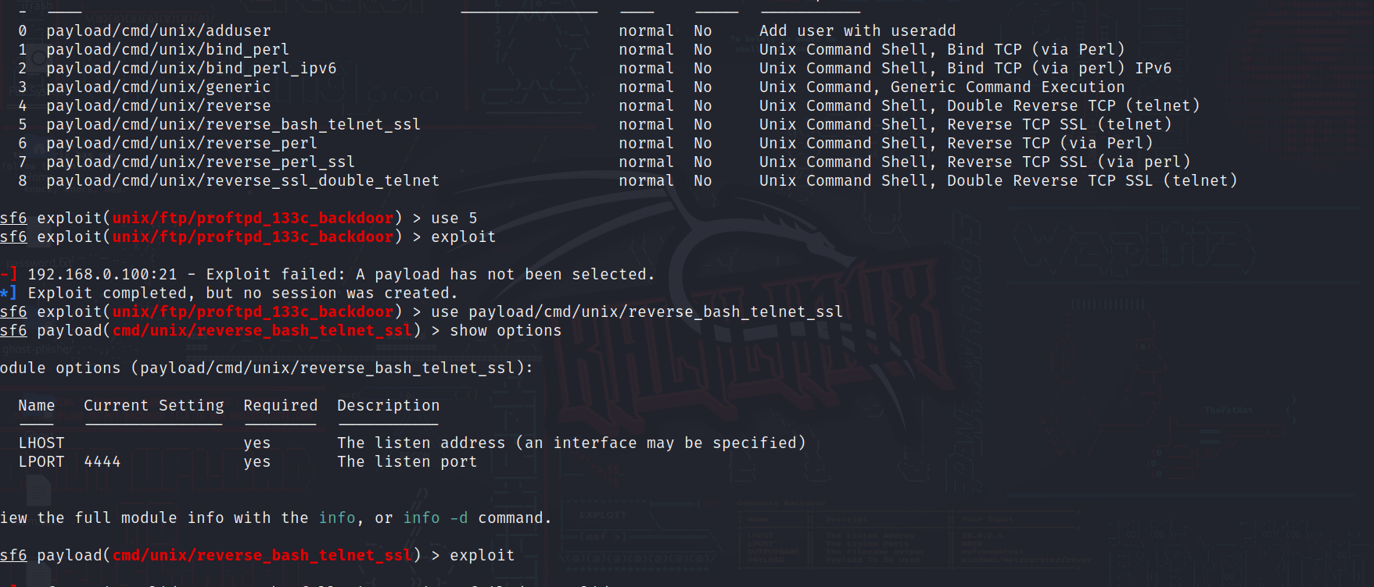

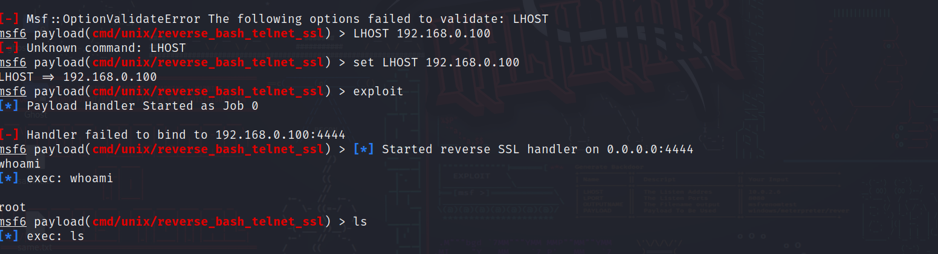

Here we use Tcp 39 port vulnerability since this exploit does not have inbuilt payload so we select manually and done the exploitation and hence we got the shell access and we can see by who am i that we have admin access and we could also list all the directories present in our meta2 machine