**21BCE0999 SAMEER CHAUHAN 8-09-23 Friday**

**TASK-10**

**Aim-we will do vulnerability anaylsis by using sql map tool**

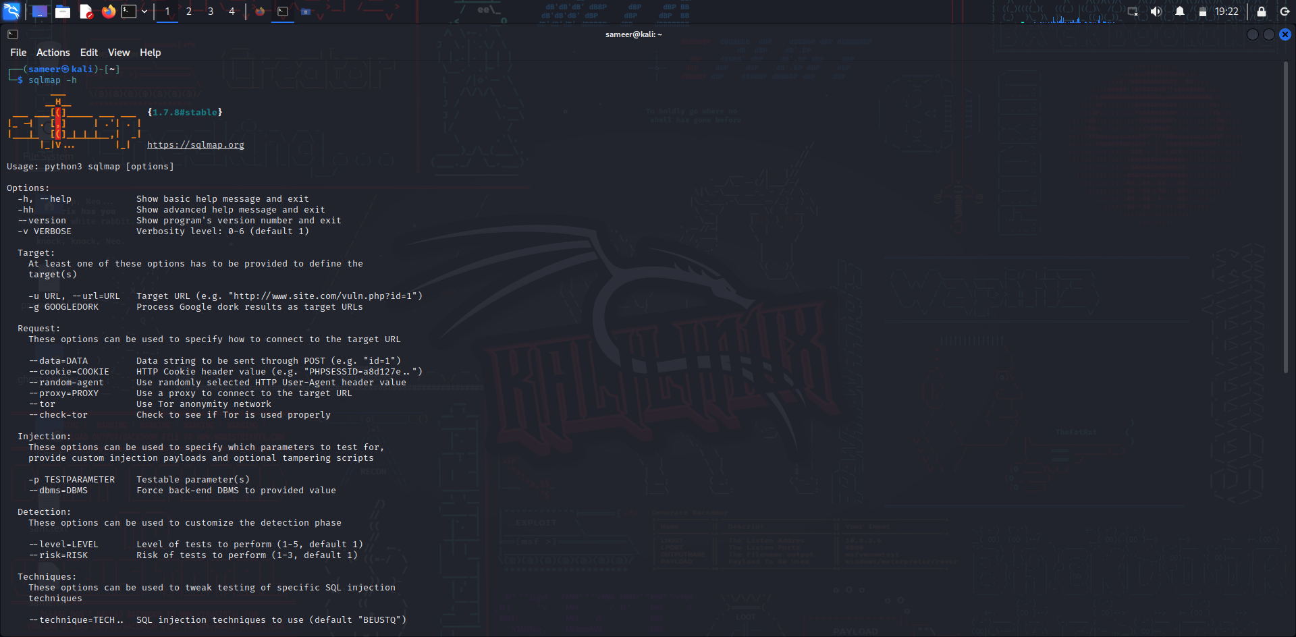

As we can see sql map -h -the help menu where we can see lots of command of sql map

