**Task-13 12-09-23 Sameer Chauhan**

**Aim- one page documentation on local security policy and its uses.**

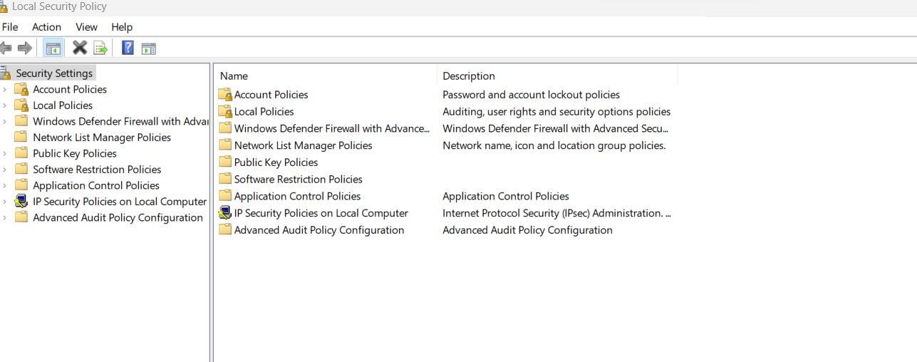

What is local security policy?

The local security policy of a system is a set of information about the security of a local computer. The local security policy information includes the following: The domains trusted to authenticate logon attempts. Which user accounts may access the system and how.

USES -

Local Security Policy allows administrators to define and enforce security policies at the local level, affecting how the computer and its users interact with security-related aspects of the operating system. Some common security settings that can be configured using Local Security Policy include:

1. Password policies: You can set rules for password complexity, length, and expiration.
2. Account lockout policies: You can configure settings that dictate what happens when a user enters incorrect login credentials multiple times.
3. User rights assignment: You can specify which users or groups have specific privileges or rights on the computer.
4. Security options: You can configure various security-related settings, such as whether to enforce a screensaver timeout, disable the guest account, or require Ctrl +Alt +Delete to log in.
5. Audit policies: You can set up auditing for various events on the computer, allowing you to track and review security-related activities.
6. Local firewall rules: You can configure rules for the Windows Firewall, controlling inbound and outbound network traffic.

Where and when it is useful?

Local Security Policy is especially useful for standalone computers or small networks that do not utilize Active Directory or domain-based policies. It provides granular control over security settings to help protect the computer and its resources.

How to access local Security policy?

To access Local Security Policy on a Windows computer, you can typically open the "Local Security Policy" tool from the Administrative Tools folder in the Control Panel or by searching for it in the Windows Start menu. Note that advanced security configurations may require administrative privileges.

Here is Screenshot of my laptop Local Security Policy:

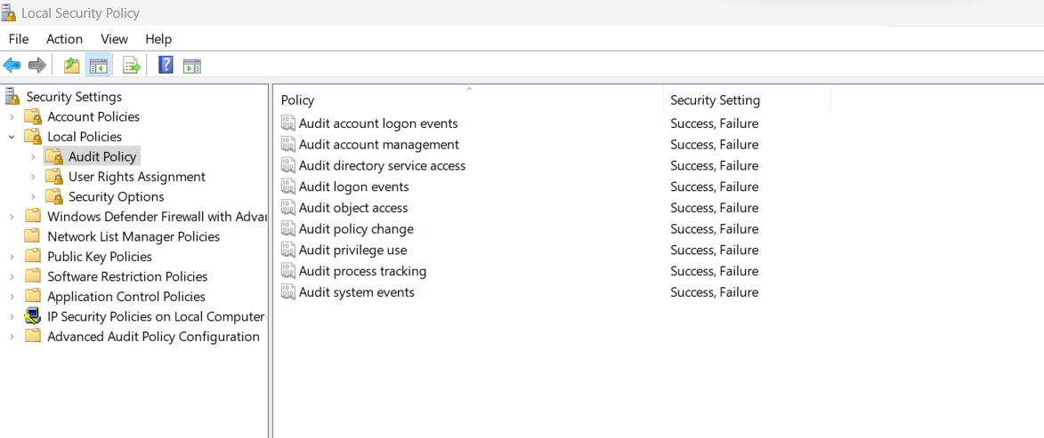

Such configurations are needed for IBM qrador to work properly and generate logs