ASSIGNMENT-2 NAME: M.Satish ,21BCE9633

import numpy as np import pandas as pd

import matplotlib.pyplot as plt import seaborn as sns

dataset=pd.read_csv("car_crashes.csv") dataset

|  |  |  |  |  |  |  |
| --- | --- | --- | --- | --- | --- | --- |
|  | total | speeding | alcohol | not_distracted | no_previous | ins_premium |
| \ |  |  |  |  |  |  |
| 0 | 18.8 | 7.332 | 5.640 | 18.048 | 15.040 | 784.55 |
|  |  |  |  |  |  |  |
| 1 | 18.1 | 7.421 | 4.525 | 16.290 | 17.014 | 1053.48 |
|  |  |  |  |  |  |  |
| 2 | 18.6 | 6.510 | 5.208 | 15.624 | 17.856 | 899.47 |
|  |  |  |  |  |  |  |
| 3 | 22.4 | 4.032 | 5.824 | 21.056 | 21.280 | 827.34 |
|  |  |  |  |  |  |  |
| 4 | 12.0 | 4.200 | 3.360 | 10.920 | 10.680 | 878.41 |
|  |  |  |  |  |  |  |
| 5 | 13.6 | 5.032 | 3.808 | 10.744 | 12.920 | 835.50 |
|  |  |  |  |  |  |  |
| 6 | 10.8 | 4.968 | 3.888 | 9.396 | 8.856 | 1068.73 |
|  |  |  |  |  |  |  |
| 7 | 16.2 | 6.156 | 4.860 | 14.094 | 16.038 | 1137.87 |
|  |  |  |  |  |  |  |
| 8 | 5.9 | 2.006 | 1.593 | 5.900 | 5.900 | 1273.89 |
|  |  |  |  |  |  |  |
| 9 | 17.9 | 3.759 | 5.191 | 16.468 | 16.826 | 1160.13 |
|  |  |  |  |  |  |  |
| 10 | 15.6 | 2.964 | 3.900 | 14.820 | 14.508 | 913.15 |
|  |  |  |  |  |  |  |
| 11 | 17.5 | 9.450 | 7.175 | 14.350 | 15.225 | 861.18 |
|  |  |  |  |  |  |  |
| 12 | 15.3 | 5.508 | 4.437 | 13.005 | 14.994 | 641.96 |
|  |  |  |  |  |  |  |
| 13 | 12.8 | 4.608 | 4.352 | 12.032 | 12.288 | 803.11 |
|  |  |  |  |  |  |  |
| 14 | 14.5 | 3.625 | 4.205 | 13.775 | 13.775 | 710.46 |
|  |  |  |  |  |  |  |
| 15 | 15.7 | 2.669 | 3.925 | 15.229 | 13.659 | 649.06 |
|  |  |  |  |  |  |  |
| 16 | 17.8 | 4.806 | 4.272 | 13.706 | 15.130 | 780.45 |
|  |  |  |  |  |  |  |
| 17 | 21.4 | 4.066 | 4.922 | 16.692 | 16.264 | 872.51 |
|  |  |  |  |  |  |  |
| 18 | 20.5 | 7.175 | 6.765 | 14.965 | 20.090 | 1281.55 |

|  |  |  |  |  |  |  |  |  |
| --- | --- | --- | --- | --- | --- | --- | --- | --- |
|  | | | | | | |  |  |
|  | 19 | 15.1 | 5.738 | 4.530 | 13.137 | 12.684 | 661.88 |
|  |  |  |  |  |  |  |  |  |
|  | 20 | 12.5 | 4.250 | 4.000 | 8.875 | 12.375 | 1048.78 |  |
|  |  |  |  |  |  |  |  |  |
|  | 21 | 8.2 | 1.886 | 2.870 | 7.134 | 6.560 | 1011.14 |  |
|  |  |  |  |  |  |  |  |  |
|  | 22 | 14.1 | 3.384 | 3.948 | 13.395 | 10.857 | 1110.61 |  |
|  |  |  |  |  |  |  |  |  |
|  | 23 | 9.6 | 2.208 | 2.784 | 8.448 | 8.448 | 777.18 |  |
|  |  |  |  |  |  |  |  |  |
|  | 24 | 17.6 | 2.640 | 5.456 | 1.760 | 17.600 | 896.07 |  |
|  |  |  |  |  |  |  |  |  |
|  | 25 | 16.1 | 6.923 | 5.474 | 14.812 | 13.524 | 790.32 |  |
|  |  |  |  |  |  |  |  |  |
|  | 26 | 21.4 | 8.346 | 9.416 | 17.976 | 18.190 | 816.21 |  |
|  |  |  |  |  |  |  |  |  |
|  | 27 | 14.9 | 1.937 | 5.215 | 13.857 | 13.410 | 732.28 |  |
|  |  |  |  |  |  |  |  |  |
|  | 28 | 14.7 | 5.439 | 4.704 | 13.965 | 14.553 | 1029.87 |  |
|  |  |  |  |  |  |  |  |  |
|  | 29 | 11.6 | 4.060 | 3.480 | 10.092 | 9.628 | 746.54 |  |
|  |  |  |  |  |  |  |  |  |
|  | 30 | 11.2 | 1.792 | 3.136 | 9.632 | 8.736 | 1301.52 |  |
|  |  |  |  |  |  |  |  |  |
|  | 31 | 18.4 | 3.496 | 4.968 | 12.328 | 18.032 | 869.85 |  |
|  |  |  |  |  |  |  |  |  |
|  | 32 | 12.3 | 3.936 | 3.567 | 10.824 | 9.840 | 1234.31 |  |
|  |  |  |  |  |  |  |  |  |
|  | 33 | 16.8 | 6.552 | 5.208 | 15.792 | 13.608 | 708.24 |  |
|  |  |  |  |  |  |  |  |  |
|  | 34 | 23.9 | 5.497 | 10.038 | 23.661 | 20.554 | 688.75 |  |
|  |  |  |  |  |  |  |  |  |
|  | 35 | 14.1 | 3.948 | 4.794 | 13.959 | 11.562 | 697.73 |  |
|  |  |  |  |  |  |  |  |  |
|  | 36 | 19.9 | 6.368 | 5.771 | 18.308 | 18.706 | 881.51 |  |
|  |  |  |  |  |  |  |  |  |
|  | 37 | 12.8 | 4.224 | 3.328 | 8.576 | 11.520 | 804.71 |  |
|  |  |  |  |  |  |  |  |  |
|  | 38 | 18.2 | 9.100 | 5.642 | 17.472 | 16.016 | 905.99 |  |
|  |  |  |  |  |  |  |  |  |
|  | 39 | 11.1 | 3.774 | 4.218 | 10.212 | 8.769 | 1148.99 |  |
|  |  |  |  |  |  |  |  |  |
|  | 40 | 23.9 | 9.082 | 9.799 | 22.944 | 19.359 | 858.97 |  |
|  |  |  |  |  |  |  |  |  |
|  | 41 | 19.4 | 6.014 | 6.402 | 19.012 | 16.684 | 669.31 |  |
|  |  |  |  |  |  |  |  |  |
|  | 42 | 19.5 | 4.095 | 5.655 | 15.990 | 15.795 | 767.91 |  |
|  |  |  |  |  |  |  |  |  |
|  | 43 | 19.4 | 7.760 | 7.372 | 17.654 | 16.878 | 1004.75 |  |
|  |  |  |  |  |  |  |  |  |
|  | 44 | 11.3 | 4.859 | 1.808 | 9.944 | 10.848 | 809.38 |  |
|  |  |  |  |  |  |  |  |  |

|  |  |  |  |  |  |  |  |  |
| --- | --- | --- | --- | --- | --- | --- | --- | --- |
|  |  |  |  |  |  |  |  |  |
|  | 45 | 13.6 | 4.080 | 4.080 | 13.056 | 12.920 | 716.20 |  |
|  |  |  |  |  |  |  |  |  |
|  | 46 | 12.7 | 2.413 | 3.429 | 11.049 | 11.176 | 768.95 |  |
|  |  |  |  |  |  |  |  |  |
|  | 47 | 10.6 | 4.452 | 3.498 | 8.692 | 9.116 | 890.03 |  |
|  |  |  |  |  |  |  |  |  |
|  | 48 | 23.8 | 8.092 | 6.664 | 23.086 | 20.706 | 992.61 |  |
|  |  |  |  |  |  |  |  |  |
|  | 49 | 13.8 | 4.968 | 4.554 | 5.382 | 11.592 | 670.31 |  |
|  |  |  |  |  |  |  |  |  |
|  | 50 | 17.4 | 7.308 | 5.568 | 14.094 | 15.660 | 791.14 |  |
|  |  |  |  |  |  |  |  |  |
|  |  | ins_losses | abbrev |  |  |  |  |  |
|  | 0 | 145.08 | AL |  |  |  |  |  |
|  | 1 | 133.93 | AK |  |  |  |  |  |
|  | 2 | 110.35 | AZ |  |  |  |  |  |
|  | 3 | 142.39 | AR |  |  |  |  |  |
|  | 4 | 165.63 | CA |  |  |  |  |  |
|  | 5 | 139.91 | CO |  |  |  |  |  |
|  | 6 | 167.02 | CT |  |  |  |  |  |
|  | 7 | 151.48 | DE |  |  |  |  |  |
|  | 8 | 136.05 | DC |  |  |  |  |  |
|  | 9 | 144.18 | FL |  |  |  |  |  |
|  | 10 | 142.80 | GA |  |  |  |  |  |
|  | 11 | 120.92 | HI |  |  |  |  |  |
|  | 12 | 82.75 | ID |  |  |  |  |  |
|  | 13 | 139.15 | IL |  |  |  |  |  |
|  | 14 | 108.92 | IN |  |  |  |  |  |
|  | 15 | 114.47 | IA |  |  |  |  |  |
|  | 16 | 133.80 | KS |  |  |  |  |  |
|  | 17 | 137.13 | KY |  |  |  |  |  |
|  | 18 | 194.78 | LA |  |  |  |  |  |
|  | 19 | 96.57 | ME |  |  |  |  |  |
|  | 20 | 192.70 | MD |  |  |  |  |  |
|  | 21 | 135.63 | MA |  |  |  |  |  |
|  | 22 | 152.26 | MI |  |  |  |  |  |
|  | 23 | 133.35 | MN |  |  |  |  |  |
|  | 24 | 155.77 | MS |  |  |  |  |  |
|  | 25 | 144.45 | MO |  |  |  |  |  |
|  | 26 | 85.15 | MT |  |  |  |  |  |
|  | 27 | 114.82 | NE |  |  |  |  |  |
|  | 28 | 138.71 | NV |  |  |  |  |  |
|  | 29 | 120.21 | NH |  |  |  |  |  |
|  | 30 | 159.85 | NJ |  |  |  |  |  |
|  | 31 | 120.75 | NM |  |  |  |  |  |
|  | 32 | 150.01 | NY |  |  |  |  |  |
|  | 33 | 127.82 | NC |  |  |  |  |  |
|  | 34 | 109.72 | ND |  |  |  |  |  |
|  |  |  |  |  |  |  |  |  |

|  |  |  |  |
| --- | --- | --- | --- |
|  |  |  |  |
| 35 | 133.52 | OH |
| 36 | 178.86 | OK |
| 37 | 104.61 | OR |
| 38 | 153.86 | PA |
| 39 | 148.58 | RI |
| 40 | 116.29 | SC |
| 41 | 96.87 | SD |
| 42 | 155.57 | TN |
| 43 | 156.83 | TX |
| 44 | 109.48 | UT |
| 45 | 109.61 | VT |
| 46 | 153.72 | VA |
| 47 | 111.62 | WA |
| 48 | 152.56 | WV |
| 49 | 106.62 | WI |
|  | 50 | 122.04 | WY |

dataset.info()

<class 'pandas.core.frame.DataFrame'> RangeIndex: 51 entries, 0 to 50

Data columns (total 8 columns):

# Column Non-Null Count Dtype

|  |  |  |  |  |  |
| --- | --- | --- | --- | --- | --- |
| 0 |  | total | 51 non-null |  | float64 |
| 1 |  | speeding | 51 non-null |  | float64 |
| 2 |  | alcohol | 51 non-null |  | float64 |
| 3 |  | not_distracted | 51 non-null |  | float64 |
| 4 |  | no_previous | 51 non-null |  | float64 |
| 5 |  | ins_premium | 51 non-null |  | float64 |
| 6 |  | ins_losses | 51 non-null |  | float64 |

7 abbrev 51 non-null object dtypes: float64(7), object(1)

memory usage: 3.3+ KB dataset.head(8)

|  |  |  |  |  |  |  |
| --- | --- | --- | --- | --- | --- | --- |
|  | total | speeding | alcohol | not_distracted | no_previous | ins_premium |
| \ |  |  |  |  |  |  |
| 0 | 18.8 | 7.332 | 5.640 | 18.048 | 15.040 | 784.55 |
|  |  |  |  |  |  |  |
| 1 | 18.1 | 7.421 | 4.525 | 16.290 | 17.014 | 1053.48 |
|  |  |  |  |  |  |  |
| 2 | 18.6 | 6.510 | 5.208 | 15.624 | 17.856 | 899.47 |
|  |  |  |  |  |  |  |
| 3 | 22.4 | 4.032 | 5.824 | 21.056 | 21.280 | 827.34 |
|  |  |  |  |  |  |  |
| 4 | 12.0 | 4.200 | 3.360 | 10.920 | 10.680 | 878.41 |
|  |  |  |  |  |  |  |
| 5 | 13.6 | 5.032 | 3.808 | 10.744 | 12.920 | 835.50 |

|  |  |  |  |  |  |  |  |
| --- | --- | --- | --- | --- | --- | --- | --- |
|  |  |  |  |  |  |  |  |
| 6 | 10.8 | 4.968 | 3.888 | 9.396 | 8.856 | 1068.73 |
|  |  |  |  |  |  |  |  |
|  | 7 | 16.2 | 6.156 | 4.860 | 14.094 | 16.038 | 1137.87 |

sns.scatterplot(x="total",y="speeding",data=dataset)

<Axes: xlabel='total', ylabel='speeding'>

|  |  |  |
| --- | --- | --- |
| i  0 | ns_losses abbrev  145.08 AL | |
| 1 | 133.93 | AK |
| 2 | 110.35 | AZ |
| 3 | 142.39 | AR |
| 4 | 165.63 | CA |
| 5 | 139.91 | CO |
| 6 | 167.02 | CT |
| 7 | 151.48 | DE |

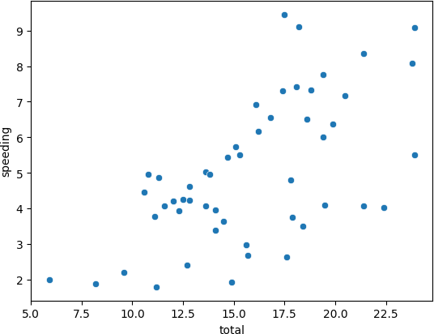

*# Inference:from the plot we can say that as the total increases speeding is decreases*

sns.pairplot(dataset)

plt.title("Pairplot of Car Crashes Dataset") plt.show()

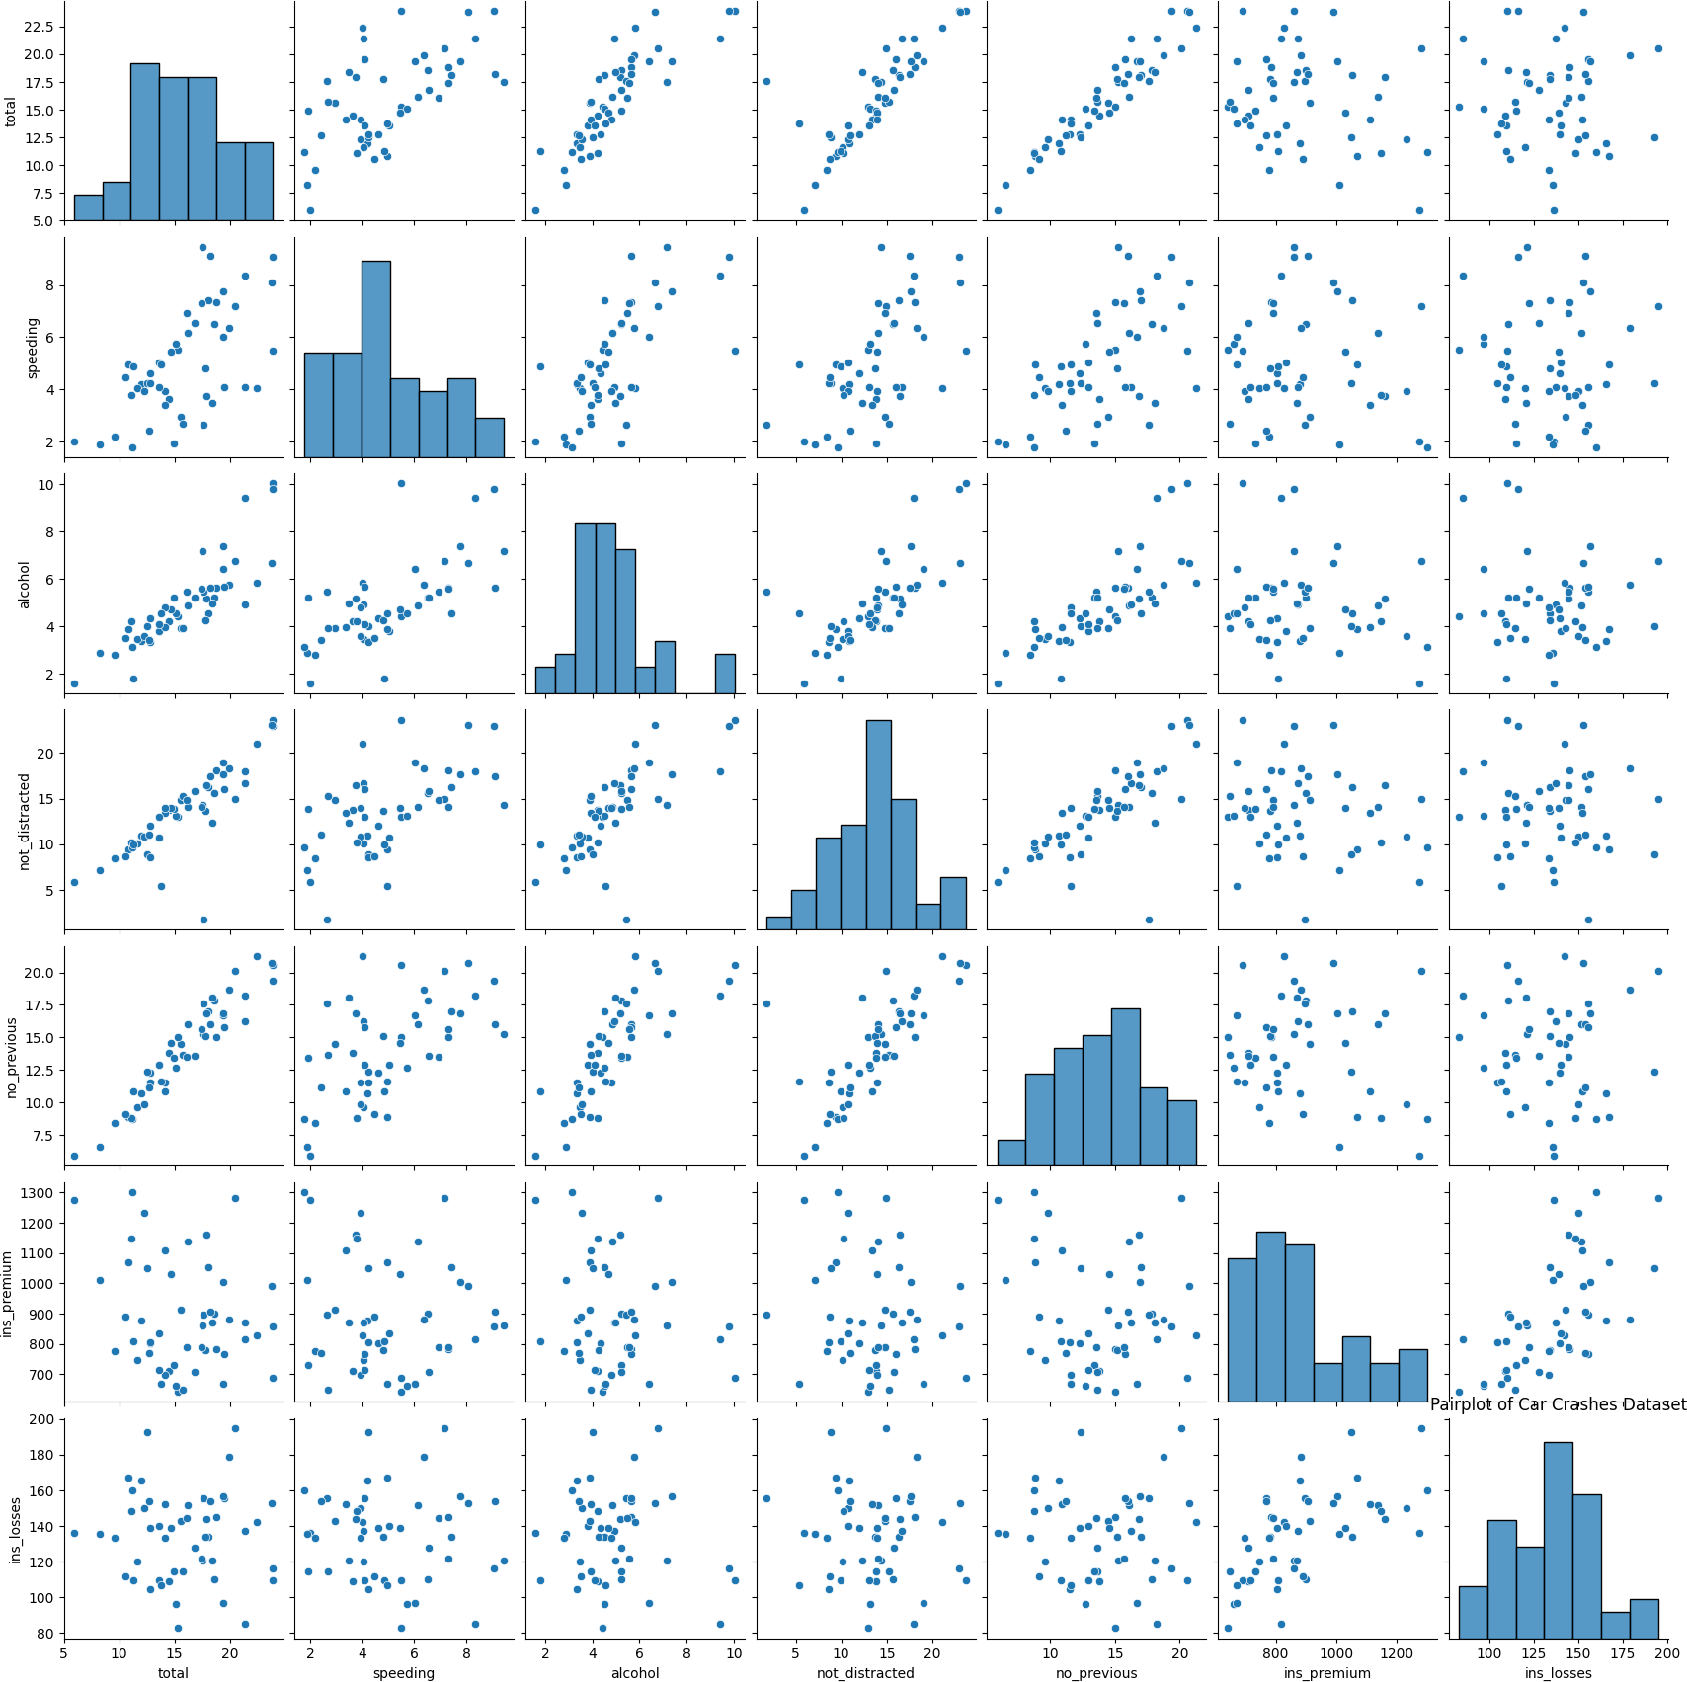

*# Inference: The pairplot provides a quick overview of the relationships between numeric variables in the dataset. It helps identify potential correlations or patterns.*

sns.distplot(dataset["total"], bins=20, kde=True) plt.title("Histogram of Total Number of Accidents") plt.xlabel("Total Accidents")

plt.ylabel("Frequency") plt.show()

<ipython-input-24-c2887f4da83f>:1: UserWarning:

`distplot` is a deprecated function and will be removed in seaborn v0.14.0.

Please adapt your code to use either `displot` (a figure-level function with

similar flexibility) or `histplot` (an axes-level function for histograms).

For a guide to updating your code to use the new functions, please see https://gist.github.com/mwaskom/de44147ed2974457ad6372750bbe5751

sns.distplot(dataset["total"], bins=20, kde=True)

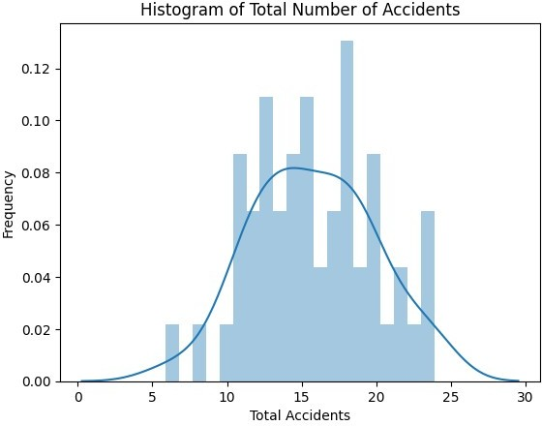

*# Inference: The histogram shows the distribution of total accidents. Most states have a relatively low number of accidents, with a few outliers with significantly higher accident counts.*

sns.boxplot(x="speeding", y="total", data=dataset) plt.title("Boxplot of Speeding vs. Total Accidents") plt.xlabel("Speeding (Yes/No)")

plt.ylabel("Total Accidents") plt.show()

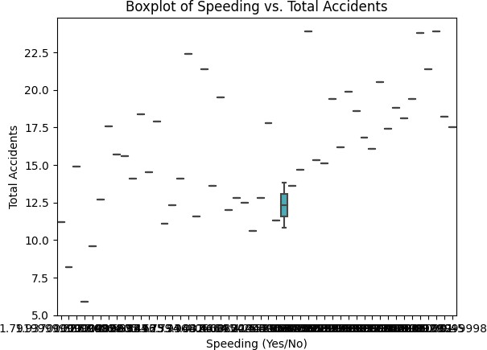

*# Inference: The boxplot illustrates the relationship between speeding (yes/no) and the total number of accidents. It indicates that states with higher speeding rates tend to have a higher median total number of accidents.*

sns.barplot(x="alcohol", y="total", data=dataset, ci=None) plt.title("Barplot of Alcohol Involvement vs. Total Accidents") plt.xlabel("Alcohol Involvement (Yes/No)")

plt.ylabel("Total Accidents") plt.show()

<ipython-input-19-e9d4c62a021d>:1: FutureWarning:

The `ci` parameter is deprecated. Use `errorbar=None` for the same effect.

sns.barplot(x="alcohol", y="total", data=dataset, ci=None)

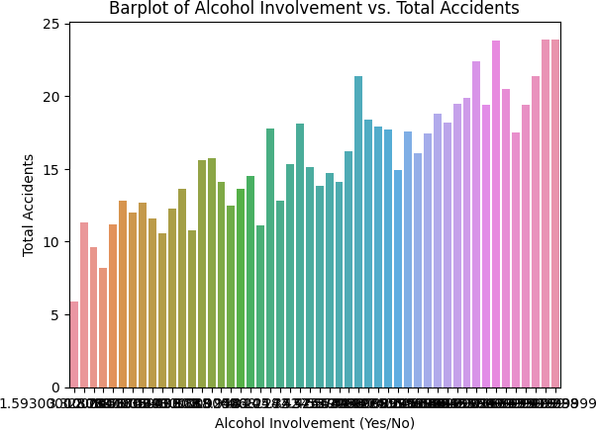

*# Inference: The barplot compares the total number of accidents for states with and without alcohol involvement. It suggests that states with alcohol involvement tend to have a higher average number of accidents.*

correlation_matrix = dataset.corr() sns.heatmap(correlation_matrix, annot=True, cmap="coolwarm") plt.title("Correlation Heatmap")

plt.show()

<ipython-input-21-f966e5b914d1>:1: FutureWarning: The default value of numeric_only in DataFrame.corr is deprecated. In a future version, it will default to False. Select only valid columns or specify the value of numeric_only to silence this warning.

correlation_matrix = dataset.corr()

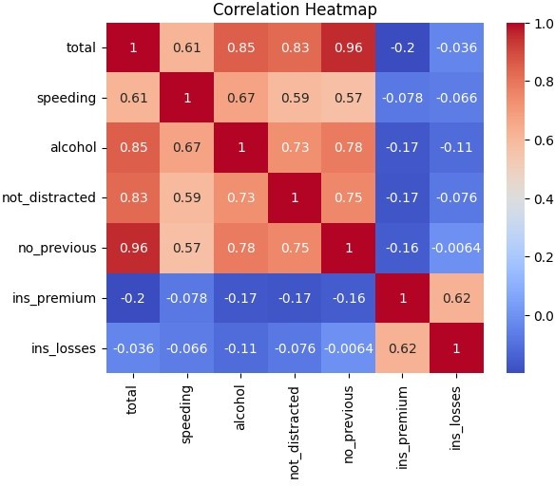

*# Inference: The heatmap displays the correlation between numeric variables in the dataset. Positive correlations are shown in warmer colors, while negative correlations are in cooler colors. It helps identify potential relationships between variables.*

sns.lineplot(x="alcohol",y="speeding",data=dataset) plt.title("LINEPLOT")

Text(0.5, 1.0, 'LINEPLOT')

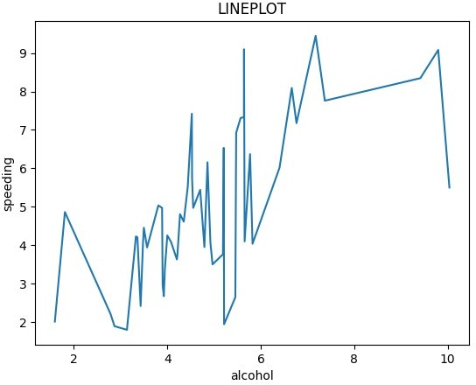

*# Inference: The line plot comparing "Alcohol" and "Speeding" incidents in car crashes shows that alcohol with higher value have higher speeding value.*

sns.jointplot(x="total",y="speeding",data=dataset) plt.title("JOINT")

Text(0.5, 1.0, 'JOINT PLOT')

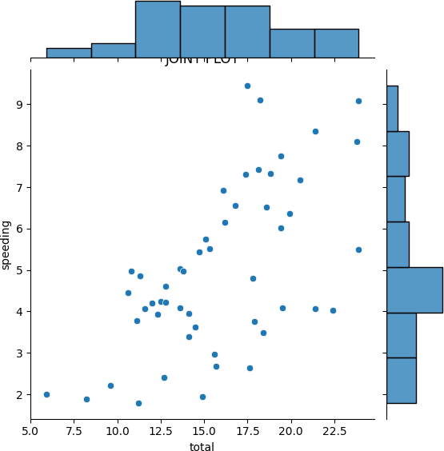

*# INFERENCE :States with a higher rate of "Speeding" incidents tend to have a wider range of total accidents, as indicated by the larger interquartile range (IQR) and the presence of outliers.*