Assignment 3
21BCE8750- K REVANTH
Loading the dataset
import numpy as np
import pandas as pd
import io
from google.colab import files
uploaded=files.upload()
df = pd.read_csv(io.BytesIO(uploaded['penguins_size.csv']))
print(df)
<IPython.core.display.HTML object>
Saving penguins_size.csv to penguins_size.csv
species island culmen_length_mm culmen_depth_mm flipper_length_mm \
0 Adelie Torgersen 39.1 18.7 181.0
1 Adelie Torgersen 39.5 17.4 186.0
2 Adelie Torgersen 40.3 18.0 195.0
3 Adelie Torgersen NaN NaN NaN
4 Adelie Torgersen 36.7 19.3 193.0
.. ... ... ... ... ...
339 Gentoo Biscoe NaN NaN NaN
340 Gentoo Biscoe 46.8 14.3 215.0
341 Gentoo Biscoe 50.4 15.7 222.0
342 Gentoo Biscoe 45.2 14.8 212.0
343 Gentoo Biscoe 49.9 16.1 213.0
body_mass_g sex
0 3750.0 MALE
1 3800.0 FEMALE
2 3250.0 FEMALE
3 NaN NaN
4 3450.0 FEMALE
.. ... ...
339 NaN NaN
340 4850.0 FEMALE
341 5750.0 MALE
342 5200.0 FEMALE
343 5400.0 MALE
[344 rows x 7 columns]
Univariate Analysis
import seaborn as sb
import matplotlib.pyplot as plt
sb.displot(df['island'])
<seaborn.axisgrid.FacetGrid at 0x7b5460bf5f30>
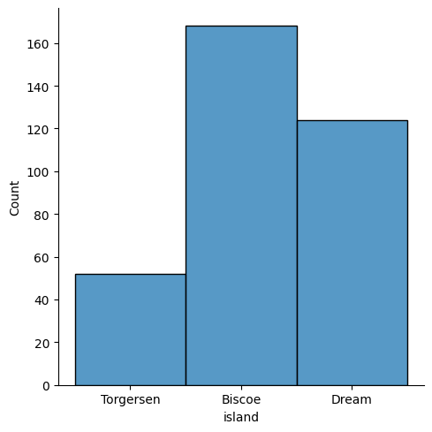
sb.displot(df['species'])
<seaborn.axisgrid.FacetGrid at 0x7b5460b4bd90>
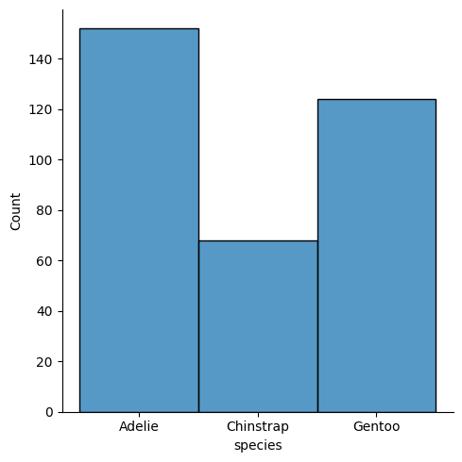
plt.pie(df.species.value_counts() , [0,0.1,0.2] , labels = [ 'Adelie' , 'Gentoo','Chinstrap' ] , autopct ='%1.1f%%',shadow = True,)
plt.title('SPECIES')
plt.show()
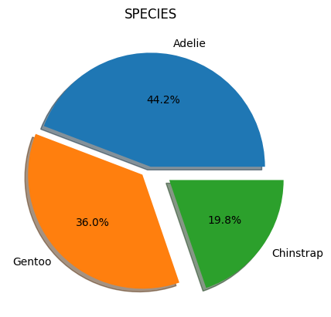
sb.barplot(x =df.sex.value_counts().index,y =df.sex.value_counts() )
<Axes: ylabel='sex'>
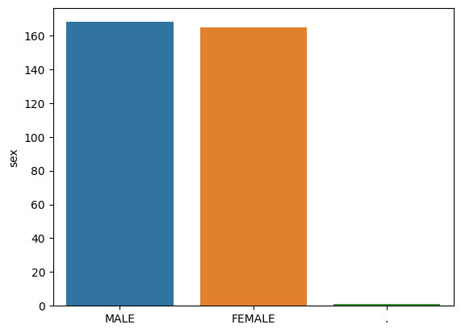
Bivariate Analysis
sb.lineplot(x = df['species'],y=df['island'])
<Axes: xlabel='species', ylabel='island'>
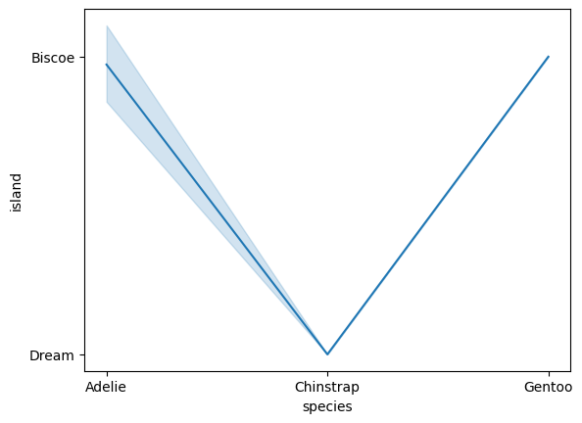
sb.lineplot(x = df['species'],y=df['body_mass_g'])
<Axes: xlabel='species', ylabel='body_mass_g'>
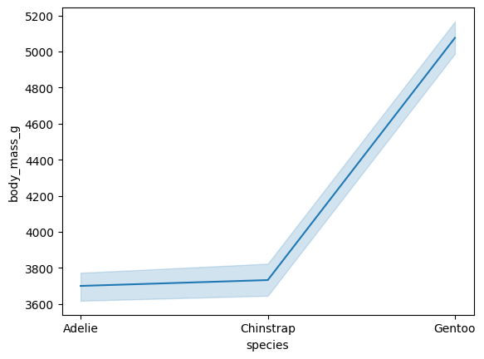
sb.scatterplot(x = df['culmen_depth_mm'],y=df['body_mass_g'])
<Axes: xlabel='culmen_depth_mm', ylabel='body_mass_g'>
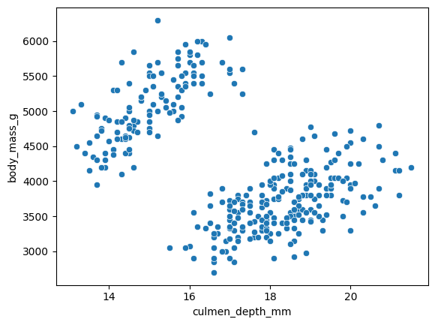
Multivariate Analysis
sb.jointplot(data=df)
<seaborn.axisgrid.JointGrid at 0x7b545ea07880>
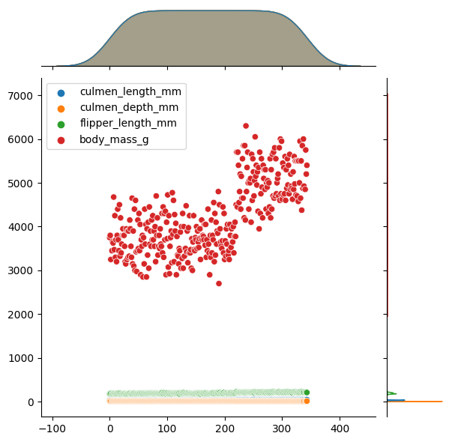
sb.pairplot(df)
<seaborn.axisgrid.PairGrid at 0x7b545e5b47c0>
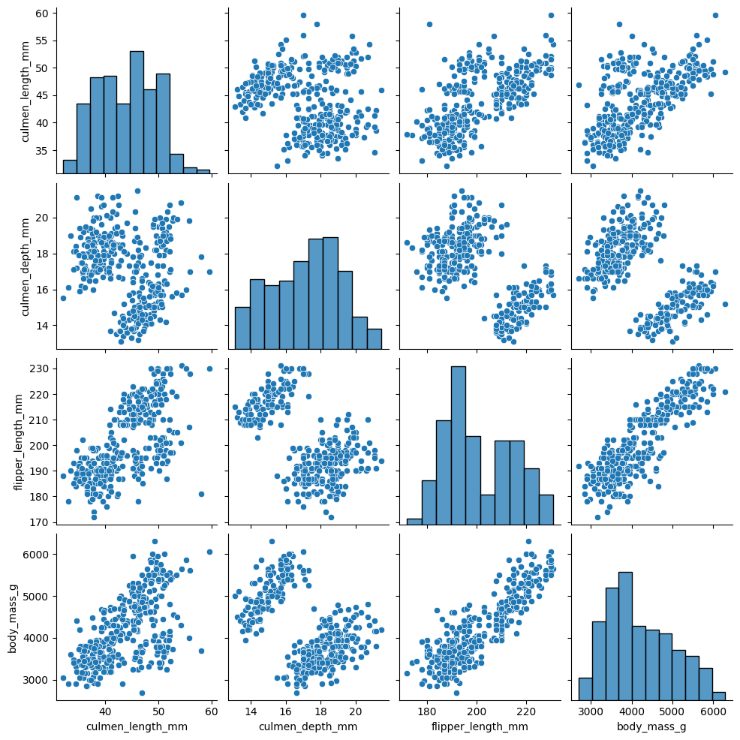
df.plot()
<Axes: >
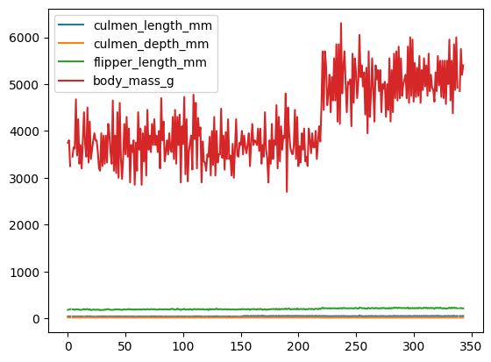
Few descriptive statistics
df.describe()
culmen_length_mm culmen_depth_mm flipper_length_mm body_mass_g
count 342.000000 342.000000 342.000000 342.000000
mean 43.921930 17.151170 200.915205 4201.754386
std 5.459584 1.974793 14.061714 801.954536
min 32.100000 13.100000 172.000000 2700.000000
25% 39.225000 15.600000 190.000000 3550.000000
50% 44.450000 17.300000 197.000000 4050.000000
75% 48.500000 18.700000 213.000000 4750.000000
max 59.600000 21.500000 231.000000 6300.000000
df.info()
<class 'pandas.core.frame.DataFrame'>
RangeIndex: 344 entries, 0 to 343
Data columns (total 7 columns):
# Column Non-Null Count Dtype
--- ------ -------------- -----
0 species 344 non-null object
1 island 344 non-null object
2 culmen_length_mm 342 non-null float64
3 culmen_depth_mm 342 non-null float64
4 flipper_length_mm 342 non-null float64
5 body_mass_g 342 non-null float64
6 sex 334 non-null object
dtypes: float64(4), object(3)
memory usage: 18.9+ KB
Checking for Null Values
df.isnull().any()
species False
island False
culmen_length_mm True
culmen_depth_mm True
flipper_length_mm True
body_mass_g True
sex True
dtype: bool
df.isnull().sum()
species 0
island 0
culmen_length_mm 2
culmen_depth_mm 2
flipper_length_mm 2
body_mass_g 2
sex 10
dtype: int64
Label Encoding
from sklearn.preprocessing import LabelEncoder
le = LabelEncoder()
df['sex'] = le.fit_transform(df['sex'])
df
species island culmen_length_mm culmen_depth_mm flipper_length_mm \
0 Adelie Torgersen 39.1 18.7 181.0
1 Adelie Torgersen 39.5 17.4 186.0
2 Adelie Torgersen 40.3 18.0 195.0
3 Adelie Torgersen NaN NaN NaN
4 Adelie Torgersen 36.7 19.3 193.0
.. ... ... ... ... ...
339 Gentoo Biscoe NaN NaN NaN
340 Gentoo Biscoe 46.8 14.3 215.0
341 Gentoo Biscoe 50.4 15.7 222.0
342 Gentoo Biscoe 45.2 14.8 212.0
343 Gentoo Biscoe 49.9 16.1 213.0
body_mass_g sex
0 3750.0 2
1 3800.0 1
2 3250.0 1
3 NaN 3
4 3450.0 1
.. ... ...
339 NaN 3
340 4850.0 1
341 5750.0 2
342 5200.0 1
343 5400.0 2
[344 rows x 7 columns]
Filling Null Values by using Mean
df.fillna(df.mean() , inplace= True)
df
<ipython-input-19-826902893166>:1: FutureWarning: The default value of numeric_only in DataFrame.mean is deprecated. In a future version, it will default to False. In addition, specifying 'numeric_only=None' is deprecated. Select only valid columns or specify the value of numeric_only to silence this warning.
df.fillna(df.mean() , inplace= True)
species island culmen_length_mm culmen_depth_mm flipper_length_mm \
0 Adelie Torgersen 39.10000 18.70000 181.000000
1 Adelie Torgersen 39.50000 17.40000 186.000000
2 Adelie Torgersen 40.30000 18.00000 195.000000
3 Adelie Torgersen 43.92193 17.15117 200.915205
4 Adelie Torgersen 36.70000 19.30000 193.000000
.. ... ... ... ... ...
339 Gentoo Biscoe 43.92193 17.15117 200.915205
340 Gentoo Biscoe 46.80000 14.30000 215.000000
341 Gentoo Biscoe 50.40000 15.70000 222.000000
342 Gentoo Biscoe 45.20000 14.80000 212.000000
343 Gentoo Biscoe 49.90000 16.10000 213.000000
body_mass_g sex
0 3750.000000 2
1 3800.000000 1
2 3250.000000 1
3 4201.754386 3
4 3450.000000 1
.. ... ...
339 4201.754386 3
340 4850.000000 1
341 5750.000000 2
342 5200.000000 1
343 5400.000000 2
[344 rows x 7 columns]
One hot encoding
df_main = pd.get_dummies(df,columns =['species' , 'island' ])
df_main.head()
culmen_length_mm culmen_depth_mm flipper_length_mm body_mass_g sex \
0 39.10000 18.70000 181.000000 3750.000000 2
1 39.50000 17.40000 186.000000 3800.000000 1
2 40.30000 18.00000 195.000000 3250.000000 1
3 43.92193 17.15117 200.915205 4201.754386 3
4 36.70000 19.30000 193.000000 3450.000000 1
species_Adelie species_Chinstrap species_Gentoo island_Biscoe \
0 1 0 0 0
1 1 0 0 0
2 1 0 0 0
3 1 0 0 0
4 1 0 0 0
island_Dream island_Torgersen
0 0 1
1 0 1
2 0 1
3 0 1
4 0 1
Outliers
sb.boxplot(df['body_mass_g'])
<Axes: >
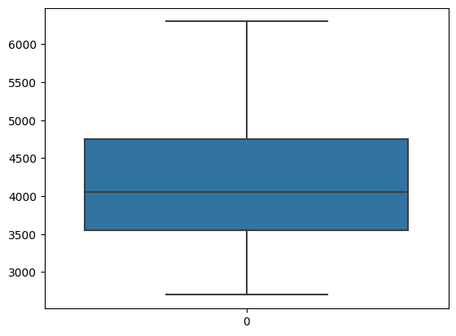
sb.boxplot(df['culmen_length_mm'])
<Axes: >
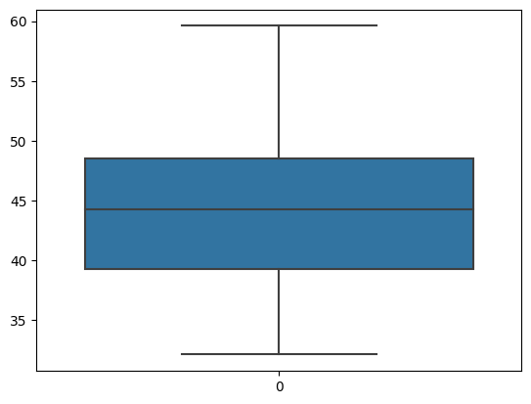
sb.boxplot(df['culmen_depth_mm'])
<Axes: >
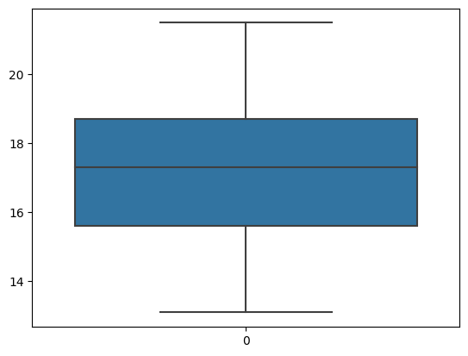
sb.boxplot(df['flipper_length_mm'])
<Axes: >
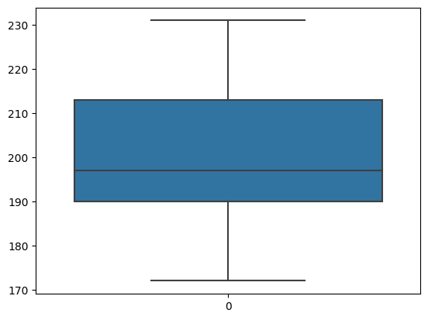
Correlation of independent variables with target
df_main.corr()
culmen_length_mm culmen_depth_mm flipper_length_mm \
culmen_length_mm 1.000000 -0.235053 0.656181
culmen_depth_mm -0.235053 1.000000 -0.583851
flipper_length_mm 0.656181 -0.583851 1.000000
body_mass_g 0.595110 -0.471916 0.871202
sex 0.264024 0.316379 0.193476
species_Adelie -0.834277 0.537305 -0.692055
species_Chinstrap 0.448530 0.320468 -0.180520
species_Gentoo 0.490869 -0.821550 0.865530
island_Biscoe 0.238622 -0.630442 0.609855
island_Dream 0.033950 0.455604 -0.420557
island_Torgersen -0.378494 0.269073 -0.287321
body_mass_g sex species_Adelie species_Chinstrap \
culmen_length_mm 0.595110 0.264024 -0.834277 0.448530
culmen_depth_mm -0.471916 0.316379 0.537305 0.320468
flipper_length_mm 0.871202 0.193476 -0.692055 -0.180520
body_mass_g 1.000000 0.340402 -0.554721 -0.291351
sex 0.340402 1.000000 0.024857 -0.038745
species_Adelie -0.554721 0.024857 1.000000 -0.441643
species_Chinstrap -0.291351 -0.038745 -0.441643 1.000000
species_Gentoo 0.815411 0.006427 -0.667991 -0.372649
island_Biscoe 0.625523 -0.013800 -0.354038 -0.484951
island_Dream -0.459651 -0.036926 0.014743 0.661151
island_Torgersen -0.256785 0.068753 0.474285 -0.209464
species_Gentoo island_Biscoe island_Dream \
culmen_length_mm 0.490869 0.238622 0.033950
culmen_depth_mm -0.821550 -0.630442 0.455604
flipper_length_mm 0.865530 0.609855 -0.420557
body_mass_g 0.815411 0.625523 -0.459651
sex 0.006427 -0.013800 -0.036926
species_Adelie -0.667991 -0.354038 0.014743
species_Chinstrap -0.372649 -0.484951 0.661151
species_Gentoo 1.000000 0.768424 -0.563636
island_Biscoe 0.768424 1.000000 -0.733496
island_Dream -0.563636 -0.733496 1.000000
island_Torgersen -0.316818 -0.412295 -0.316818
island_Torgersen
culmen_length_mm -0.378494
culmen_depth_mm 0.269073
flipper_length_mm -0.287321
body_mass_g -0.256785
sex 0.068753
species_Adelie 0.474285
species_Chinstrap -0.209464
species_Gentoo -0.316818
island_Biscoe -0.412295
island_Dream -0.316818
island_Torgersen 1.000000
plt.figure(figsize=(11,8))
sb.heatmap(df_main.corr(),annot =True)
<Axes: >
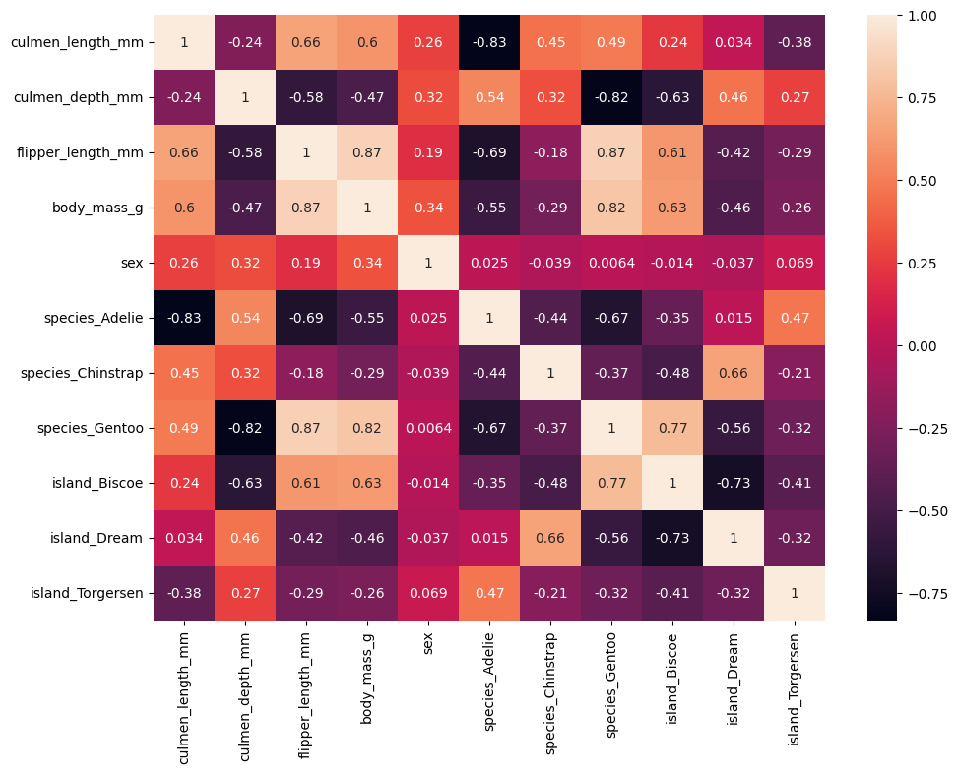
Getting the Dependent and Independent Variables
df_main.head()
culmen_length_mm culmen_depth_mm flipper_length_mm body_mass_g sex \
0 39.10000 18.70000 181.000000 3750.000000 2
1 39.50000 17.40000 186.000000 3800.000000 1
2 40.30000 18.00000 195.000000 3250.000000 1
3 43.92193 17.15117 200.915205 4201.754386 3
4 36.70000 19.30000 193.000000 3450.000000 1
species_Adelie species_Chinstrap species_Gentoo island_Biscoe \
0 1 0 0 0
1 1 0 0 0
2 1 0 0 0
3 1 0 0 0
4 1 0 0 0
island_Dream island_Torgersen
0 0 1
1 0 1
2 0 1
3 0 1
4 0 1
y = df_main['body_mass_g']
y
0 3750.000000
1 3800.000000
2 3250.000000
3 4201.754386
4 3450.000000
...
339 4201.754386
340 4850.000000
341 5750.000000
342 5200.000000
343 5400.000000
Name: body_mass_g, Length: 344, dtype: float64
x=df_main.drop(columns = ['body_mass_g'] , axis=1)
x
culmen_length_mm culmen_depth_mm flipper_length_mm sex \
0 39.10000 18.70000 181.000000 2
1 39.50000 17.40000 186.000000 1
2 40.30000 18.00000 195.000000 1
3 43.92193 17.15117 200.915205 3
4 36.70000 19.30000 193.000000 1
.. ... ... ... ...
339 43.92193 17.15117 200.915205 3
340 46.80000 14.30000 215.000000 1
341 50.40000 15.70000 222.000000 2
342 45.20000 14.80000 212.000000 1
343 49.90000 16.10000 213.000000 2
species_Adelie species_Chinstrap species_Gentoo island_Biscoe \
0 1 0 0 0
1 1 0 0 0
2 1 0 0 0
3 1 0 0 0
4 1 0 0 0
.. ... ... ... ...
339 0 0 1 1
340 0 0 1 1
341 0 0 1 1
342 0 0 1 1
343 0 0 1 1
island_Dream island_Torgersen
0 0 1
1 0 1
2 0 1
3 0 1
4 0 1
.. ... ...
339 0 0
340 0 0
341 0 0
342 0 0
343 0 0
[344 rows x 10 columns]
Scaling the Data
from sklearn.preprocessing import MinMaxScaler
scale =MinMaxScaler()
X_scaled= pd.DataFrame(scale.fit_transform(x),columns =x.columns)
X_scaled.head()
culmen_length_mm culmen_depth_mm flipper_length_mm sex \
0 0.254545 0.666667 0.152542 0.666667
1 0.269091 0.511905 0.237288 0.333333
2 0.298182 0.583333 0.389831 0.333333
3 0.429888 0.482282 0.490088 1.000000
4 0.167273 0.738095 0.355932 0.333333
species_Adelie species_Chinstrap species_Gentoo island_Biscoe \
0 1.0 0.0 0.0 0.0
1 1.0 0.0 0.0 0.0
2 1.0 0.0 0.0 0.0
3 1.0 0.0 0.0 0.0
4 1.0 0.0 0.0 0.0
island_Dream island_Torgersen
0 0.0 1.0
1 0.0 1.0
2 0.0 1.0
3 0.0 1.0
4 0.0 1.0
Split the Given data to Training as well as Testing data
from sklearn.model_selection import train_test_split
X_train,X_test,y_train,y_test = train_test_split(X_scaled,y,test_size=0.3,random_state=42)
Printing Testing as well as Training data shapes
X_train.shape
(240, 10)
X_train.head()
culmen_length_mm culmen_depth_mm flipper_length_mm sex \
31 0.185455 0.595238 0.101695 0.666667
245 0.509091 0.238095 0.728814 0.666667
277 0.487273 0.226190 0.813559 0.666667
165 0.723636 0.595238 0.491525 0.666667
250 0.552727 0.261905 0.847458 0.666667
species_Adelie species_Chinstrap species_Gentoo island_Biscoe \
31 1.0 0.0 0.0 0.0
245 0.0 0.0 1.0 1.0
277 0.0 0.0 1.0 1.0
165 0.0 1.0 0.0 0.0
250 0.0 0.0 1.0 1.0
island_Dream island_Torgersen
31 1.0 0.0
245 0.0 0.0
277 0.0 0.0
165 1.0 0.0
250 0.0 0.0
y_train.shape
(240,)
y_train.head()
31 3900.0
245 5100.0
277 5000.0
165 4050.0
250 5250.0
Name: body_mass_g, dtype: float64
X_test.shape
(104, 10)
X_test.head()
culmen_length_mm culmen_depth_mm flipper_length_mm sex \
194 0.683636 0.714286 0.406780 0.666667
157 0.476364 0.559524 0.440678 0.333333
225 0.523636 0.047619 0.644068 0.333333
208 0.476364 0.416667 0.322034 0.333333
318 0.592727 0.154762 0.525424 0.333333
species_Adelie species_Chinstrap species_Gentoo island_Biscoe \
194 0.0 1.0 0.0 0.0
157 0.0 1.0 0.0 0.0
225 0.0 0.0 1.0 1.0
208 0.0 1.0 0.0 0.0
318 0.0 0.0 1.0 1.0
island_Dream island_Torgersen
194 1.0 0.0
157 1.0 0.0
225 0.0 0.0
208 1.0 0.0
318 0.0 0.0
y_test.shape
(104,)
y_test.head()
194 3550.0
157 3950.0
225 4550.0
208 3250.0
318 4625.0
Name: body_mass_g, dtype: float64

