AI AND ML ASSIGNMENT 4
NAME: REVANTH .K
REG:21BCE8750
import pandas as pd
import numpy as np
df= pd.read_csv("/content/winequality-red.csv")
df.head()
fixed acidity volatile acidity citric acid residual sugar chlorides \
0 7.4 0.70 0.00 1.9 0.076
1 7.8 0.88 0.00 2.6 0.098
2 7.8 0.76 0.04 2.3 0.092
3 11.2 0.28 0.56 1.9 0.075
4 7.4 0.70 0.00 1.9 0.076
free sulfur dioxide total sulfur dioxide density pH sulphates \
0 11.0 34.0 0.9978 3.51 0.56
1 25.0 67.0 0.9968 3.20 0.68
2 15.0 54.0 0.9970 3.26 0.65
3 17.0 60.0 0.9980 3.16 0.58
4 11.0 34.0 0.9978 3.51 0.56
alcohol quality
0 9.4 5
1 9.8 5
2 9.8 5
3 9.8 6
4 9.4 5
df.info()
<class 'pandas.core.frame.DataFrame'>
RangeIndex: 1599 entries, 0 to 1598
Data columns (total 12 columns):
# Column Non-Null Count Dtype
--- ------ -------------- -----
0 fixed acidity 1599 non-null float64
1 volatile acidity 1599 non-null float64
2 citric acid 1599 non-null float64
3 residual sugar 1599 non-null float64
4 chlorides 1599 non-null float64
5 free sulfur dioxide 1599 non-null float64
6 total sulfur dioxide 1599 non-null float64
7 density 1599 non-null float64
8 pH 1599 non-null float64
9 sulphates 1599 non-null float64
10 alcohol 1599 non-null float64
11 quality 1599 non-null int64
dtypes: float64(11), int64(1)
memory usage: 150.0 KB
df.shape
(1599, 12)
df['quality'].value_counts()
5 681
6 638
7 199
4 53
8 18
3 10
Name: quality, dtype: int64
df.isnull().any()
fixed acidity False
volatile acidity False
citric acid False
residual sugar False
chlorides False
free sulfur dioxide False
total sulfur dioxide False
density False
pH False
sulphates False
alcohol False
quality False
dtype: bool
df.corr()
fixed acidity volatile acidity citric acid \
fixed acidity 1.000000 -0.256131 0.671703
volatile acidity -0.256131 1.000000 -0.552496
citric acid 0.671703 -0.552496 1.000000
residual sugar 0.114777 0.001918 0.143577
chlorides 0.093705 0.061298 0.203823
free sulfur dioxide -0.153794 -0.010504 -0.060978
total sulfur dioxide -0.113181 0.076470 0.035533
density 0.668047 0.022026 0.364947
pH -0.682978 0.234937 -0.541904
sulphates 0.183006 -0.260987 0.312770
alcohol -0.061668 -0.202288 0.109903
quality 0.124052 -0.390558 0.226373
residual sugar chlorides free sulfur dioxide \
fixed acidity 0.114777 0.093705 -0.153794
volatile acidity 0.001918 0.061298 -0.010504
citric acid 0.143577 0.203823 -0.060978
residual sugar 1.000000 0.055610 0.187049
chlorides 0.055610 1.000000 0.005562
free sulfur dioxide 0.187049 0.005562 1.000000
total sulfur dioxide 0.203028 0.047400 0.667666
density 0.355283 0.200632 -0.021946
pH -0.085652 -0.265026 0.070377
sulphates 0.005527 0.371260 0.051658
alcohol 0.042075 -0.221141 -0.069408
quality 0.013732 -0.128907 -0.050656
total sulfur dioxide density pH sulphates \
fixed acidity -0.113181 0.668047 -0.682978 0.183006
volatile acidity 0.076470 0.022026 0.234937 -0.260987
citric acid 0.035533 0.364947 -0.541904 0.312770
residual sugar 0.203028 0.355283 -0.085652 0.005527
chlorides 0.047400 0.200632 -0.265026 0.371260
free sulfur dioxide 0.667666 -0.021946 0.070377 0.051658
total sulfur dioxide 1.000000 0.071269 -0.066495 0.042947
density 0.071269 1.000000 -0.341699 0.148506
pH -0.066495 -0.341699 1.000000 -0.196648
sulphates 0.042947 0.148506 -0.196648 1.000000
alcohol -0.205654 -0.496180 0.205633 0.093595
quality -0.185100 -0.174919 -0.057731 0.251397
alcohol quality
fixed acidity -0.061668 0.124052
volatile acidity -0.202288 -0.390558
citric acid 0.109903 0.226373
residual sugar 0.042075 0.013732
chlorides -0.221141 -0.128907
free sulfur dioxide -0.069408 -0.050656
total sulfur dioxide -0.205654 -0.185100
density -0.496180 -0.174919
pH 0.205633 -0.057731
sulphates 0.093595 0.251397
alcohol 1.000000 0.476166
quality 0.476166 1.000000
import seaborn as sns
sns.heatmap(df.corr() , annot = True )
<Axes: >
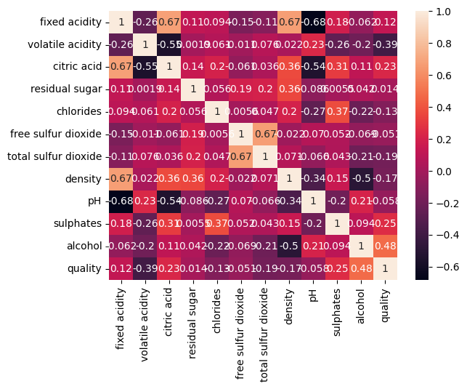
sns.displot(df.alcohol)
<seaborn.axisgrid.FacetGrid at 0x7fdcfab50d60>
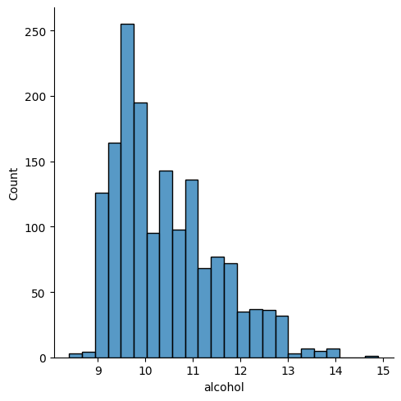
sns.scatterplot(x=df.density,y=df.chlorides)
<Axes: xlabel='density', ylabel='chlorides'>
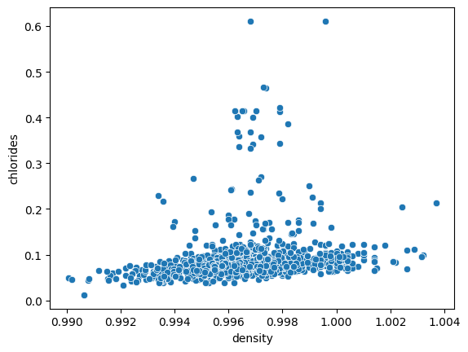
sns.boxplot(df.sulphates)
<Axes: >
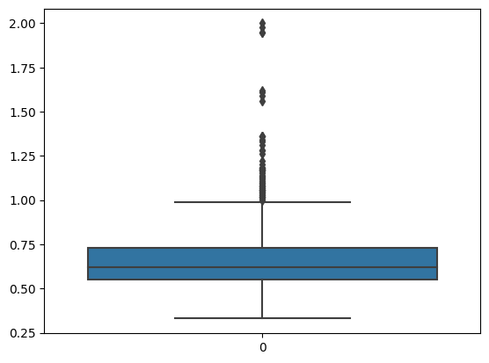
X =df.iloc[:,:-1]
X.head()
fixed acidity volatile acidity citric acid residual sugar chlorides \
0 7.4 0.70 0.00 1.9 0.076
1 7.8 0.88 0.00 2.6 0.098
2 7.8 0.76 0.04 2.3 0.092
3 11.2 0.28 0.56 1.9 0.075
4 7.4 0.70 0.00 1.9 0.076
free sulfur dioxide total sulfur dioxide density pH sulphates \
0 11.0 34.0 0.9978 3.51 0.56
1 25.0 67.0 0.9968 3.20 0.68
2 15.0 54.0 0.9970 3.26 0.65
3 17.0 60.0 0.9980 3.16 0.58
4 11.0 34.0 0.9978 3.51 0.56
alcohol
0 9.4
1 9.8
2 9.8
3 9.8
4 9.4
y =df['quality']
y.head()
0 5
1 5
2 5
3 6
4 5
Name: quality, dtype: int64
from sklearn.model_selection import train_test_split
x_train,x_test,y_train,y_test = train_test_split(X,y,test_size = 0.2345,random_state=25)
x_train.shape
(1224, 11)
x_test.shape
(375, 11)
from sklearn.tree import DecisionTreeClassifier
model1 = DecisionTreeClassifier(max_depth=4,splitter='best',criterion='entropy')
model1.fit(x_train,y_train)
DecisionTreeClassifier(criterion='entropy', max_depth=4)
d_y_predict = model1.predict(x_test)
d_y_predict
array([6, 6, 6, 5, 5, 6, 6, 6, 5, 6, 5, 5, 5, 6, 6, 5, 6, 5, 5, 6, 6, 6,
6, 5, 5, 5, 6, 5, 7, 5, 5, 6, 6, 6, 6, 5, 6, 6, 5, 5, 5, 5, 5, 6,
5, 5, 5, 6, 5, 6, 5, 5, 5, 5, 5, 5, 6, 5, 5, 6, 5, 5, 5, 6, 5, 5,
5, 6, 6, 6, 6, 6, 5, 5, 5, 5, 6, 5, 5, 5, 5, 5, 5, 6, 6, 5, 5, 6,
5, 5, 5, 5, 5, 5, 5, 5, 6, 6, 5, 6, 5, 5, 5, 6, 6, 5, 5, 4, 5, 5,
5, 6, 5, 5, 5, 5, 5, 5, 6, 6, 5, 5, 6, 7, 7, 6, 6, 5, 5, 5, 6, 5,
6, 5, 5, 6, 5, 6, 6, 5, 5, 5, 5, 5, 6, 5, 5, 6, 5, 6, 5, 5, 5, 5,
5, 5, 6, 5, 5, 6, 6, 5, 5, 5, 5, 6, 6, 6, 5, 7, 6, 6, 5, 5, 5, 7,
6, 5, 5, 5, 7, 5, 5, 5, 5, 6, 6, 6, 5, 5, 6, 5, 6, 5, 5, 6, 5, 5,
6, 6, 5, 6, 5, 5, 6, 5, 5, 6, 6, 7, 5, 5, 6, 5, 6, 5, 6, 6, 5, 5,
6, 5, 6, 5, 5, 6, 7, 5, 5, 5, 5, 5, 6, 6, 7, 6, 5, 5, 5, 6, 7, 6,
5, 6, 5, 5, 6, 6, 5, 5, 5, 5, 7, 6, 5, 5, 5, 6, 5, 5, 5, 5, 5, 5,
6, 6, 5, 6, 5, 6, 5, 6, 5, 5, 5, 5, 6, 5, 5, 6, 5, 5, 5, 6, 7, 5,
6, 5, 6, 6, 5, 5, 6, 6, 5, 5, 5, 5, 5, 6, 5, 6, 6, 5, 5, 5, 5, 6,
6, 5, 5, 5, 5, 5, 6, 6, 5, 7, 6, 5, 5, 5, 5, 5, 5, 5, 5, 5, 5, 6,
6, 6, 5, 5, 5, 5, 5, 6, 5, 6, 6, 6, 6, 5, 5, 6, 5, 5, 5, 6, 5, 5,
6, 5, 5, 5, 6, 6, 5, 5, 5, 6, 5, 6, 5, 5, 5, 5, 5, 7, 7, 6, 5, 5,
6])
d_y_predict_train = model1.predict(x_train)
from sklearn.metrics import accuracy_score,classification_report,confusion_matrix
print('Testing Accuracy = ', accuracy_score(y_test,d_y_predict))
print('Training Accuracy = ', accuracy_score(y_train,d_y_predict_train))
Testing Accuracy = 0.5866666666666667
Training Accuracy = 0.6086601307189542
pd.crosstab(y_test,d_y_predict)
col_0 4 5 6 7
quality
3 0 2 0 0
4 0 12 2 0
5 1 133 22 0
6 0 76 78 4
7 0 4 29 9
8 0 1 0 2
print(classification_report(y_test,d_y_predict))
precision recall f1-score support
3 0.00 0.00 0.00 2
4 0.00 0.00 0.00 14
5 0.58 0.85 0.69 156
6 0.60 0.49 0.54 158
7 0.60 0.21 0.32 42
8 0.00 0.00 0.00 3
accuracy 0.59 375
macro avg 0.30 0.26 0.26 375
weighted avg 0.56 0.59 0.55 375
/usr/local/lib/python3.10/dist-packages/sklearn/metrics/_classification.py:1344: UndefinedMetricWarning: Precision and F-score are ill-defined and being set to 0.0 in labels with no predicted samples. Use `zero_division` parameter to control this behavior.
_warn_prf(average, modifier, msg_start, len(result))
/usr/local/lib/python3.10/dist-packages/sklearn/metrics/_classification.py:1344: UndefinedMetricWarning: Precision and F-score are ill-defined and being set to 0.0 in labels with no predicted samples. Use `zero_division` parameter to control this behavior.
_warn_prf(average, modifier, msg_start, len(result))
/usr/local/lib/python3.10/dist-packages/sklearn/metrics/_classification.py:1344: UndefinedMetricWarning: Precision and F-score are ill-defined and being set to 0.0 in labels with no predicted samples. Use `zero_division` parameter to control this behavior.
_warn_prf(average, modifier, msg_start, len(result))
from six import StringIO
from IPython.display import Image
import pydotplus
from sklearn.tree import export_graphviz
dot_data =StringIO()
export_graphviz(model1,out_file=dot_data,feature_names= X.columns,
filled=True,rounded= True,special_characters=True)
graph = pydotplus.graph_from_dot_data(dot_data.getvalue())
Image(graph.create_png())
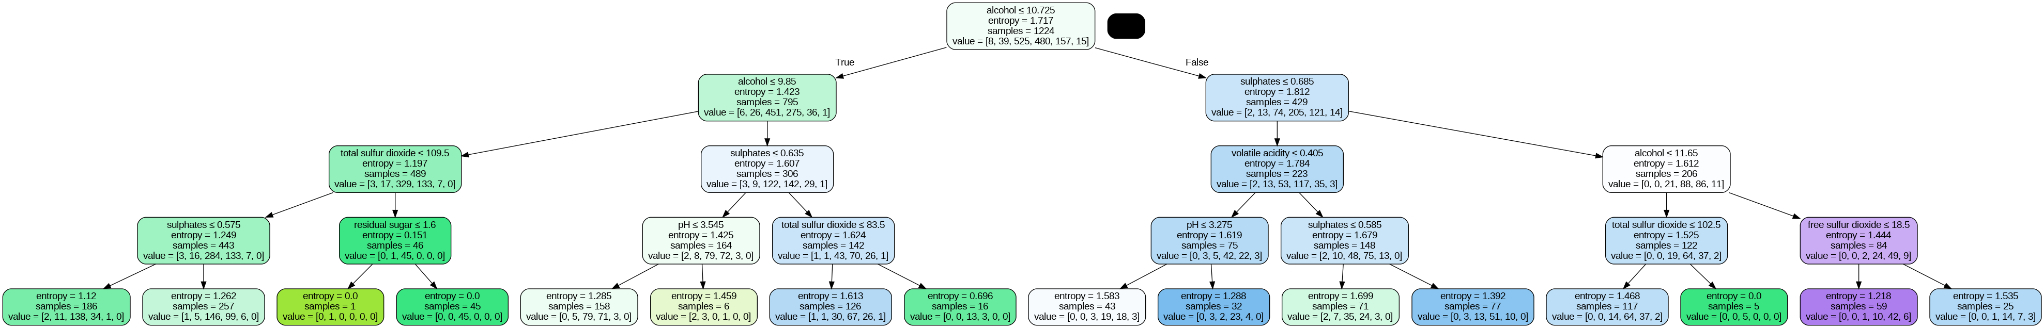
from sklearn.ensemble import RandomForestClassifier
model2 =RandomForestClassifier(criterion='entropy')
model2.fit(x_train,y_train)
RandomForestClassifier(criterion='entropy')
NEXT
r_y_predict = model2.predict(x_test)
r_y_predict_train = model2.predict(x_train)
print('Testing Accuracy = ', accuracy_score(y_test,r_y_predict))
print('Training Accuracy = ', accuracy_score(y_train,r_y_predict_train))
Testing Accuracy = 0.7173333333333334
Training Accuracy = 1.0
pd.crosstab(y_test,r_y_predict)
col_0 5 6 7
quality
3 2 0 0
4 11 3 0
5 124 31 1
6 23 122 13
7 3 16 23
8 0 2 1
print(classification_report(y_test,r_y_predict))
precision recall f1-score support
3 0.00 0.00 0.00 2
4 0.00 0.00 0.00 14
5 0.76 0.79 0.78 156
6 0.70 0.77 0.73 158
7 0.61 0.55 0.57 42
8 0.00 0.00 0.00 3
accuracy 0.72 375
macro avg 0.34 0.35 0.35 375
weighted avg 0.68 0.72 0.70 375
/usr/local/lib/python3.10/dist-packages/sklearn/metrics/_classification.py:1344: UndefinedMetricWarning: Precision and F-score are ill-defined and being set to 0.0 in labels with no predicted samples. Use `zero_division` parameter to control this behavior.
_warn_prf(average, modifier, msg_start, len(result))
/usr/local/lib/python3.10/dist-packages/sklearn/metrics/_classification.py:1344: UndefinedMetricWarning: Precision and F-score are ill-defined and being set to 0.0 in labels with no predicted samples. Use `zero_division` parameter to control this behavior.
_warn_prf(average, modifier, msg_start, len(result))
/usr/local/lib/python3.10/dist-packages/sklearn/metrics/_classification.py:1344: UndefinedMetricWarning: Precision and F-score are ill-defined and being set to 0.0 in labels with no predicted samples. Use `zero_division` parameter to control this behavior.
_warn_prf(average, modifier, msg_start, len(result))
from sklearn.linear_model import LinearRegression
model3 = LinearRegression()
model3.fit(x_train , y_train)
LinearRegression()
lr_y_predict = model3.predict(x_test)
lr_y_predict_train = model3.predict(x_train)
qual = pd.DataFrame( { 'Actual quality' : y_test , 'Predicted quality ' : lr_y_predict})
qual
Actual quality Predicted quality
443 7 6.172683
868 6 6.029141
625 5 5.342639
77 6 5.280204
195 5 4.973205
... ... ...
821 7 6.851054
724 4 5.152206
522 5 5.613748
632 6 5.783782
1270 6 6.897276
[375 rows x 2 columns]
from sklearn import metrics
print(metrics.r2_score(y_test,lr_y_predict))
0.3160722568118429
print(metrics.r2_score(y_train,lr_y_predict_train))
0.37108992262715845
print(metrics.mean_squared_error(y_test,lr_y_predict))
0.41989394229968163
print(np.sqrt(metrics.mean_squared_error(y_test,lr_y_predict)))
0.6479922393822951
from sklearn.linear_model import LogisticRegression
model4 = LogisticRegression()
model4.fit(x_train,y_train)
/usr/local/lib/python3.10/dist-packages/sklearn/linear_model/_logistic.py:458: ConvergenceWarning: lbfgs failed to converge (status=1):
STOP: TOTAL NO. of ITERATIONS REACHED LIMIT.
Increase the number of iterations (max_iter) or scale the data as shown in:
https://scikit-learn.org/stable/modules/preprocessing.html
Please also refer to the documentation for alternative solver options:
https://scikit-learn.org/stable/modules/linear_model.html#logistic-regression
n_iter_i = _check_optimize_result(
LogisticRegression()
lg_y_pred = model4.predict(x_test)
lg_y_pred
array([6, 6, 5, 5, 5, 6, 6, 6, 5, 6, 5, 6, 5, 5, 6, 6, 6, 5, 5, 6, 6, 6,
6, 5, 5, 5, 6, 5, 6, 5, 6, 6, 6, 6, 6, 5, 6, 6, 5, 5, 5, 5, 6, 6,
5, 5, 5, 5, 5, 6, 6, 6, 6, 6, 6, 5, 6, 5, 6, 6, 5, 6, 6, 6, 5, 5,
5, 6, 6, 6, 6, 6, 5, 5, 5, 6, 6, 5, 6, 5, 5, 5, 5, 6, 6, 5, 5, 6,
6, 5, 5, 5, 6, 5, 5, 5, 6, 6, 5, 6, 5, 5, 5, 7, 6, 6, 5, 5, 5, 6,
6, 5, 6, 5, 5, 5, 5, 5, 6, 6, 6, 4, 6, 6, 6, 6, 6, 5, 5, 5, 6, 6,
6, 6, 5, 5, 5, 6, 5, 5, 5, 6, 5, 5, 6, 5, 5, 6, 6, 6, 5, 6, 5, 5,
6, 5, 6, 5, 6, 6, 6, 5, 5, 5, 5, 6, 6, 5, 5, 6, 6, 6, 5, 5, 5, 6,
6, 5, 6, 5, 6, 5, 6, 6, 6, 6, 6, 6, 5, 6, 6, 6, 6, 5, 5, 6, 5, 6,
5, 5, 5, 6, 5, 5, 6, 5, 5, 6, 6, 6, 5, 5, 6, 5, 6, 6, 6, 6, 5, 5,
6, 6, 6, 5, 5, 6, 6, 5, 6, 5, 5, 5, 6, 6, 6, 6, 6, 6, 5, 6, 6, 6,
5, 6, 5, 5, 6, 6, 5, 5, 5, 5, 6, 6, 6, 6, 5, 6, 5, 5, 5, 5, 5, 5,
6, 6, 6, 6, 5, 6, 5, 5, 5, 5, 5, 5, 6, 5, 5, 6, 5, 6, 6, 6, 6, 5,
6, 5, 6, 6, 5, 5, 5, 6, 5, 5, 5, 5, 5, 6, 6, 6, 6, 5, 5, 5, 5, 7,
6, 5, 5, 5, 5, 6, 6, 6, 5, 6, 7, 6, 5, 5, 5, 6, 5, 5, 5, 5, 5, 6,
6, 6, 6, 5, 5, 5, 5, 6, 5, 5, 6, 6, 6, 6, 5, 6, 5, 5, 5, 5, 5, 6,
6, 6, 5, 5, 6, 5, 6, 5, 5, 6, 6, 5, 6, 5, 5, 5, 5, 6, 6, 5, 5, 6,
6])
accuracy_score(y_test , lg_y_pred)
0.6106666666666667
confusion_matrix(y_test , lg_y_pred)
array([[ 0, 0, 2, 0, 0, 0],
[ 0, 0, 10, 4, 0, 0],
[ 0, 1, 122, 31, 2, 0],
[ 0, 0, 50, 107, 1, 0],
[ 0, 0, 3, 39, 0, 0],
[ 0, 0, 0, 3, 0, 0]])
pd.crosstab(y_test , lg_y_pred)
col_0 4 5 6 7
quality
3 0 2 0 0
4 0 10 4 0
5 1 122 31 2
6 0 50 107 1
7 0 3 39 0
8 0 0 3 0
print(classification_report(y_test , lg_y_pred))
precision recall f1-score support
3 0.00 0.00 0.00 2
4 0.00 0.00 0.00 14
5 0.65 0.78 0.71 156
6 0.58 0.68 0.63 158
7 0.00 0.00 0.00 42
8 0.00 0.00 0.00 3
accuracy 0.61 375
macro avg 0.21 0.24 0.22 375
weighted avg 0.52 0.61 0.56 375
/usr/local/lib/python3.10/dist-packages/sklearn/metrics/_classification.py:1344: UndefinedMetricWarning: Precision and F-score are ill-defined and being set to 0.0 in labels with no predicted samples. Use `zero_division` parameter to control this behavior.
_warn_prf(average, modifier, msg_start, len(result))
/usr/local/lib/python3.10/dist-packages/sklearn/metrics/_classification.py:1344: UndefinedMetricWarning: Precision and F-score are ill-defined and being set to 0.0 in labels with no predicted samples. Use `zero_division` parameter to control this behavior.
_warn_prf(average, modifier, msg_start, len(result))
/usr/local/lib/python3.10/dist-packages/sklearn/metrics/_classification.py:1344: UndefinedMetricWarning: Precision and F-score are ill-defined and being set to 0.0 in labels with no predicted samples. Use `zero_division` parameter to control this behavior.
_warn_prf(average, modifier, msg_start, len(result))
probability = model4.predict_proba(x_test)[:,1]
probability
array([0.02231348, 0.04163394, 0.08519507, 0.05083156, 0.00490805,
0.0193458 , 0.01256215, 0.05289513, 0.02781566, 0.01464755,
0.03931959, 0.0107028 , 0.02987398, 0.03434318, 0.01468408,
0.02393854, 0.01709038, 0.01847209, 0.01306171, 0.02298114,
0.02619998, 0.04091116, 0.02199939, 0.01284045, 0.02405573,
0.00785142, 0.02713541, 0.03233056, 0.02981752, 0.01433764,
0.06836174, 0.0186473 , 0.01066855, 0.05500996, 0.01619648,
0.01267665, 0.01578444, 0.02282645, 0.02461835, 0.01978253,
0.0366563 , 0.00363948, 0.03575345, 0.04148333, 0.00707848,
0.00969808, 0.02940425, 0.06298075, 0.00617853, 0.00585006,
0.03995384, 0.02742406, 0.04740601, 0.06184464, 0.03449721,
0.0141726 , 0.02072323, 0.0093657 , 0.04654918, 0.02504415,
0.19823629, 0.02288114, 0.03971682, 0.02271076, 0.01426226,
0.0184628 , 0.02519693, 0.04180825, 0.03298282, 0.03448643,
0.01817787, 0.03430499, 0.00371764, 0.00331719, 0.04773681,
0.01445913, 0.25958839, 0.02240472, 0.01998612, 0.0083854 ,
0.00468811, 0.02310817, 0.00951864, 0.00424974, 0.01706115,
0.03465065, 0.02413885, 0.00796555, 0.03575345, 0.02418073,
0.02603966, 0.04610266, 0.01355445, 0.00806668, 0.08603429,
0.01993684, 0.15239108, 0.02791904, 0.00869844, 0.08992853,
0.00129601, 0.01554423, 0.01371833, 0.00274211, 0.05441823,
0.04367245, 0.02878639, 0.02582325, 0.04713568, 0.02745255,
0.01239106, 0.02392153, 0.0140506 , 0.02836111, 0.00273512,
0.02201674, 0.04002607, 0.03318639, 0.02053827, 0.03047365,
0.03303124, 0.68922827, 0.01217775, 0.02117164, 0.01833082,
0.04086002, 0.00584256, 0.01013715, 0.02880882, 0.02711344,
0.01893144, 0.05205817, 0.02254521, 0.01161684, 0.05260757,
0.01383345, 0.21505973, 0.04839655, 0.01411707, 0.05561837,
0.01286617, 0.05404468, 0.02219081, 0.01462808, 0.03717614,
0.03958877, 0.01387729, 0.02272274, 0.05528297, 0.0707622 ,
0.01789632, 0.02126258, 0.01967015, 0.01286476, 0.08757728,
0.00810907, 0.06652192, 0.0224268 , 0.06754285, 0.01148671,
0.00948688, 0.00258715, 0.03756595, 0.03000267, 0.01241779,
0.01042694, 0.00656652, 0.03977784, 0.07695126, 0.01902549,
0.01501748, 0.0205284 , 0.01929558, 0.03310709, 0.00361206,
0.03418034, 0.04904556, 0.02493929, 0.01874508, 0.03865356,
0.03438198, 0.02647355, 0.01888033, 0.0265591 , 0.07917147,
0.01806826, 0.01693869, 0.01311486, 0.02970983, 0.02702479,
0.00776865, 0.0260961 , 0.0182592 , 0.00638948, 0.00271141,
0.03228054, 0.04512922, 0.03141222, 0.01340568, 0.04955362,
0.01173407, 0.00765801, 0.00767627, 0.02063833, 0.0354255 ,
0.02403632, 0.02600112, 0.00818796, 0.05913576, 0.02411407,
0.01300767, 0.02291231, 0.00375394, 0.03328894, 0.03614571,
0.02786684, 0.01648051, 0.02738449, 0.02614384, 0.00803449,
0.02085605, 0.15377695, 0.01029408, 0.06473149, 0.02467247,
0.03019743, 0.03559981, 0.03135863, 0.02644586, 0.00435409,
0.00575577, 0.04662575, 0.00856089, 0.03598631, 0.03452478,
0.05549676, 0.04745765, 0.05605744, 0.03443901, 0.02355309,
0.03882681, 0.0161406 , 0.00546725, 0.0509455 , 0.02545856,
0.00887054, 0.02979742, 0.02263628, 0.03382728, 0.03877168,
0.02000541, 0.01321581, 0.03124845, 0.01485985, 0.04748688,
0.01652912, 0.02238656, 0.02322026, 0.01755076, 0.05841008,
0.02262814, 0.01682981, 0.00592624, 0.01209896, 0.01786638,
0.00921909, 0.04818858, 0.0693027 , 0.01340651, 0.00421636,
0.03763882, 0.01738477, 0.04006769, 0.0207194 , 0.02333807,
0.01153046, 0.02235526, 0.00466316, 0.03094452, 0.01764527,
0.01911233, 0.03784202, 0.02541535, 0.05042481, 0.01960221,
0.04661615, 0.01649633, 0.0350239 , 0.0174772 , 0.01985802,
0.01149449, 0.00428788, 0.04610148, 0.06126463, 0.02584102,
0.04661615, 0.02836242, 0.21505973, 0.01304011, 0.01312191,
0.00657444, 0.02479886, 0.00921909, 0.01426012, 0.08678045,
0.012808 , 0.01553519, 0.00784356, 0.03019743, 0.01257151,
0.01820413, 0.01728637, 0.05909676, 0.0184561 , 0.04059881,
0.04043128, 0.02357973, 0.01847568, 0.01657043, 0.02786684,
0.03112493, 0.02788704, 0.02614478, 0.07376728, 0.014298 ,
0.00746905, 0.03159653, 0.01252244, 0.03864074, 0.04397804,
0.02887132, 0.05549676, 0.09493548, 0.02529333, 0.0226742 ,
0.18980981, 0.00445433, 0.14474373, 0.01284395, 0.08519507,
0.04278993, 0.01131672, 0.0073023 , 0.03830643, 0.00554878,
0.01308248, 0.02154052, 0.04165767, 0.03118349, 0.00910053,
0.03187074, 0.04858912, 0.01931963, 0.0638396 , 0.01237313,
0.02037462, 0.01250526, 0.03224592, 0.04745765, 0.043191 ,
0.03885703, 0.01485499, 0.05314937, 0.01597418, 0.01482451,
0.03644874, 0.01257615, 0.03145768, 0.02008216, 0.03614414,
0.04299545, 0.08733117, 0.00323518, 0.03650397, 0.0230185 ])

